

**Fly Your Satellite! – Design Booster**

**Alba CubeSat UniPD**

**CubeSat Project File**

Document: AlbaSat_CPF_2024-03-10_v1.0

Date: 10/03/2024

Version: v1.0

|  |
| --- |
| **Prepared by:** |
| Alba CubeSat UniPD team |
|  |
| **Distribution List:** |
| Fly Your Satellite! Team |
| ESA Education |
|  |
|  |

**Document Information**

|  |  |  |  |
| --- | --- | --- | --- |
| **Version** | **Release date** | **Section-Page** | **Changes** |
| 1.0 | 12/03/2023 |  | first release |
| 1.1 | 31/03/2023 | 1.3 | Clarified the mission lifetime objective |
| 1.1 | 31/03/2023 | 1.4 | Updated the analyses results |
| 1.1 | 31/03/2023 | 3.2.1 pag 33, pag 34 | Changed figure 12, response to RID 25 (painting/coating clarification) |
| 1.1 | 31/03/2023 | 3.3.3 pag 54 | Added control mode 9 to allow detumbling from 100 deg/s |
| 1.1 | 31/03/2023 | 3.4.6.1 pag 61 | Typo correction in simulation start time |
| 1.1 | 31/03/2023 | 3.9.2 pag 85 | - Clarified that the deployment of the magnetometer can be confirmed |
| 1.1 | 31/03/2023 | 4.3.2 pag 105 | Clarification that no activation, checkout or maintenance to the CubeSat will be performed after the integration with the deployer |
| 1.2 | 17/04/2023 | 3.5.2 pag 65 | Added information about radiation mitigation techniques |
| 1.2 | 17/04/2023 | 3.6.2 pag 67 | Added information about SW patching |
| 1.3 | 15/05/2023 | 1.3 | Mission phases have been explained and re-defined |
| 1.3 | 23/03/2023 | 3.2.1 | Clarification of IS design details |
| 1.3 | 30/05/2023 | 3.9.2 pag 85 | Confirmed magnetometer refurbishable capability |
| 1.3 | 31/05/2023 | 3.2.1.3 | Clarification of the sensor architecture |
| 1.3 | 31/05/2023 | 3.3.3 | Added tables and modified information about ADCS modes |
| 1.3 | 01/06/2023 | 3.3.4 | Information on the power budget of ADCS modes and the duty cycle of components has been included. |
| 1.2 | 01/06/2023  02/06/2023  05/06/2023 | 3.8.2  3.8.5  3.8.6  3.8.5 | Added FDS-VCD references.  Updated mass budget.  Updated Structural Analysis Summary.  Updated coordinates of center of mass and moment of inertia. |
| 1.3 | 02/06/2023 | 3.3.3 | Removed ADCS pointing, coarse and precise modes, replaced by ADCS nominal mode.  Redefined ADCS safe mode |
| 1.3 | 02/06/2023 | 4.1.1 | Added information about IS model philosophy, partial response to RID 23 |
| 2.0 | 02/06/2023 | 1.4 | MAR summary updated |
| 2.0 | 03/06/2023 | 3.3.4 | Added table about ADCS power budget |
| 2.0 | 03/06/2023 | 3.12.1 | Updated information about the GS |
| 2.0 | 04/06/2023 | 3.6.4 | Updated info about Memory budget |
| 2.0 | 04/06/2023 | 3.6.4.1 | Added OBC flash section |
| 2.0 | 04/06/2023 | 3.6.4.2 | Added CPU budget section |
| 2.0 | 04/06/2023 | 1.1, 1.2, 3.2.2, | Change of payload main goal, change mission data product, change function architecture, change project management plan |
| 2.0 | 04/06/2023 | 3.5.2 | Updated OBDH architecture schemes |
| 2.0 | 04/06/2023 | 3.6.2 | Updated info about OBSW architecture |
| 2.0 | 04/06/2023 | 3.6.3 | Added OBSW Design description section |
| 2.0 | 04/06/2023 | 3.4.1  3.4.2  3.4.3  3.4.4 | Updated EPS design with new components |
| 2.0 | 04/06/2023 | 3.4.5 | Updated inhibits measures description plus kill switch diagram |
| 2.0 | 04/06/2023 | 3.4.6.2 | Updated power budget table |
| 2.0 | 06/06/2023 | 3.4.6.1 | Updated the average and maximum values for the power generation |
| 2.0 | 08/06/2023 | 3.7.1  3.7.4 | Updated link and data budgets, new safe downlink mode added |
| 2.0 | 09/06/2023 | 3.7.3 | Justification for modulation choice added |
| 2.0 | 09/06/2023 | 3.4.4.1 | Addition of battery protection features |
| 2.0 | 19/10/2023 | 3.4.5 | Addition of kill switch and remove before flight pins images |
| 2.1 | 25/11/2023 | 3.4.3  3.4.5 | Addition of the PV modules diagram and MPPTs configuration  Update of the inhibits and of the p31u diagram |
| 2.1 | 28/11/2023 | 3.3.4 | ADCS power budget values were updated |
| 2.1 | 29/11/2023 | 3.1.4 | Introduction to radiation mitigation techniques, only for the OBC. |
| 2.1 | 29/11/2023 |  | Addition of section Error/fault handling, providing software measures to mitigate radiation-related problems and to increase data reliability. |
| 2.1 | 29/11/2023 | **Errore. L'origine riferimento non è stata trovata.** | Update OBDH physical architecture scheme. |
| 2.1 | 29/11/2023 | 3.5 | Updated every figure layout and numbering. Removed the radiation mitigation section. |
| 2.1 | 29/11/2023 | 3.6 | Updated every figure layout and numbering. |
| 2.1 | 30/11/2023 | 3.8.4 | Updated text about the protrusion from the CubeSat of some components. |
| 2.1 | 30/11/2023 | 3.8.6 | Updated tables. |
| 2.1 | 30/11/2023 | 3.9.6 | Updated text and figure. |
| 2.1 | 30/11/2023 | 3.10 | Updated information about Thermal Analysis |
| 2.1 | 30/11/2023 | 1.2 | Added information related to Impact Sensor and CCR Data Product |
| 2.1 | 30/11/2023 | 3.2.5 | Update of the Model Philosophy and general minor corrections |
| 2.1 | 30/11/2023 | 4.4.4.3 | Insertion of Functional Scheme, justification of CAD, TRL discussion |
| 2.1 | 30/11/2023 | 3.2.2 | Refuses corrections |
| 2.1 | 30/11/2023 | 3.2.2.2 | Added electrical schematic and board architecture |
| 2.1 | 30/11/2023 | 3.2.5 | Added physical and functional architecture of the QPL |
| 3.0 | 06/02/2024 | 6, 6.1, 6.2, 6.3, 6.4, 6.5, 6.6.3, 6.6.4 | “Legal & Regulatory Compliance Plan” added |
| 3.0 | 08/02/2024 | 2.5  2.5.1  2.5.2 | Defined what procedures are  Uploaded the procedures list  Defined the procedure format+Example provided |
| 3.0 | 08/02/2024 | 1.5 | Typos/grammar quick correction |
| 3.0 | 08/02/2024  09/02/2024 | 1.3.1  1.3.2  1.6.3 page 30, line 24 | Added extra clarifications |
| 3.0 | 10/02/2024 | 1.7.3 | Updated information |
| 3.0 | 10/02/2024 | 2.4 | Updated description and table |
| 3.0 | 15/02/2024 | 3.12.4  3.12.6 | Updated information about software for gs and interface pc-rotator |
| 3.0 | 20/02/2024 | 1  1.2  1.3.3  1.5  3.1.1  3.2.4  4.4.3.3 |  |
| 3.0 | 20/02/2024 | 1.7.1 | Activation Sequence |
| 3.0 | 23/02/2024 | 3.12.4 | Updated information about software for gs |
| 3.0 | 23/02/2024  04/02/2024 | 3.8  3.8.2  3.9.6  3.8.5  3.8.6 | Updated text  Added reference to FDS-VCD requirements  Added reference to FDS-VCD requirements  Updated mass budget  Updated structural report conclusions |
| 3.0 | 26/02/2024  28/02/2024 | 1.7.2  1.7.4  1.6.2  1.6.3  1.6.4  1.6.5  1.7.2 | Updated text  Uploaded table |
| 3.0 | 28/02/2024 | 3.12.4 | Updated information about software for gs |
| 3.0 | 28/02/2024 | 3.7 | Updated link budget, data budget and packet encapsulation |
| 3.0 | 28/02/2024 | 3.12.7.1 | Updated text |
| 3.0 | 01/03/2024 | 3.2.1 | Specifications about the analyses and tests performed on the Impact Sensor added with references to the relative report documentations. EQM figure added |
| 3.0 | 01/03/2024 | 3.12.2  3.12.4 | Updated information about antenna and software for gs |
| 3.0 | 03/03/2024 | 1.4.4 | Added avoidance maneuver analysis |
|  | 04/03/2024 | 1.1 | Mission description, objective and success criteria for CCR paload updated |
|  | 04/03/2024 | 1.2 | Mission data product for CCR paload updated |
|  | 04/03/2024 | 1.5.1 | operation mode for CCR paload updated |
| 3.0 | 03/03/2024 | 1.4.5 | Added Zero Debris Policy compliance analysis |
| 3.0 | 06/03/2024 | 3.2.2 | Updated text |
| 3.0 | 06/03/2024 | 3.2.2.2 | Modified figure 33, added figure 34 |

In the new version of the document the new text or data are highlighted in grey. If new sections or chapters are added, only the heading is highlighted in grey.

Contents

List of Abbreviations 11

Introduction 13

1 Mission description 14

1.1 Mission statement and Objectives 14

1.2 Mission data products 18

1.3 Mission Phases 20

1.3.1 LEOP: 21

1.3.2 Commissioning: 23

1.3.3 Routine: 23

1.3.4 Disposal: 23

1.4 Mission Analysis Report Summary 24

1.4.1 Worst case: 25

1.4.2 Nominal case: 25

1.4.3 Demisibility analysis results 26

1.4.4 Collision Avoidance Manoeuvre 27

1.4.5 Zero Debris Policy 28

1.5 CubeSat Operational Modes 29

1.5.1 Payload operations 30

1.6 Modes definition 31

1.6.1 Off mode 31

1.6.2 Activation sequence 32

1.6.3 Safe mode 33

1.6.5 Nominal mode 37

1.7 Timelines 40

1.7.1 Activation Sequence 41

1.7.2 Nominal pass timeline 41

1.7.3 Mission Critical periods 44

1.7.4 Mission disposal 46

1.8 Space sustainability Rating (Optional) 46

2 Operations Plan 47

2.1 Operational phase concept 47

2.2 Adaptability Table 47

2.3 Operability Table 48

2.4 Operational Database 49

2.5 Operational Procedures 51

2.5.1 Operational procedures list 52

2.5.2 Procedure format/rules and example 54

3 Design Definition & Justification 56

3.1 System Description 56

3.1.1 Physical architecture 57

3.1.2 Coordinate reference frames 59

3.1.3 Spacecraft System Configuration 60

3.1.4 Radiation protection/mitigation 63

3.2 Payloads 64

3.2.1 Impact Sensor 64

3.2.2 Micro-vibration Sensor 71

3.2.3 Quantum Payload 77

3.2.4 CCR Payload 81

3.3 Attitude Determination and Control Subsystem 89

3.3.1 ADCS Quick Facts Table 89

3.3.2 Physical architecture 89

3.3.3 ADCS mode definitions 95

3.3.4 ADCS budgets 100

3.3.5 ADCS Control and determination algorithms 104

3.3.6 ADCS Analysis Report Summary 104

3.4 Electrical Power Subsystem 105

3.4.1 EPS Quick Facts Table 105

3.4.2 Functional and physical architecture 105

3.4.3 Solar arrays 106

3.4.4 Batteries 108

3.4.5 Inhibits 110

3.4.6 Power and energy budget 113

3.5 On-board Data Handling 116

3.5.1 OBDH Quick Facts Table 116

3.5.2 Functional and physical architecture 116

3.6 On-board software 118

3.6.1 OBSW Quick Facts Table 118

3.6.2 OBSW Architecture 118

3.6.3 OBSW Design Description 120

3.6.4 Memory Budget 127

3.6.5 Software Development and Verification Plan 129

3.7 Telemetry, Tracking and Command 130

3.7.1 TT&C Quick Facts Table 130

3.7.2 Functional architecture 131

3.7.3 Physical architecture 132

3.7.4 Link and Data Budget Summary 134

3.8 Structures 140

3.8.1 Structures Quick Facts Table 140

3.8.2 Physical architecture 140

3.8.3 Structural Materials 143

3.8.4 Interfaces 144

3.8.5 Mass budget and Moments of Inertia 146

3.8.6 Structural Analysis Summary 149

3.9 Mechanisms 150

3.9.1 Mechanisms Quick Facts Table 150

3.9.2 Deployable magnetometer 150

3.9.3 Deployable antenna system 151

3.9.4 Momentum wheel 152

3.9.5 Mechanisms Analysis Results 153

3.9.6 Separation springs and deployment switches 153

3.10 Thermal Control 154

3.10.1 Thermal Quick Facts Table 154

3.10.2 Functional and physical description 154

3.10.3 Component temperature limits 155

3.10.4 Thermal Analysis Summary 155

3.11 Electromagnetic Compatibility (EMC) 157

3.11.1 EMC Control plan 157

3.11.2 Grounding scheme 160

3.12 Ground Segment 162

3.12.1 GS Quick Facts Table 162

3.12.2 Physical architecture 162

3.12.3 Functional architecture 163

3.12.4 Software (optional for BDR) 163

3.12.5 Database (optional for BDR) 164

3.12.6 Operational interfaces (optional for BDR) 164

3.12.7 Licensing 164

3.12.8 Secondary or back-up ground station(s) 165

3.13 Quantum Ground Station 165

3.13.1 Scheme of the QPL QGS 166

3.13.2 The QGS GaliQEye telescope 166

3.13.3 The QGS transceiver apparatus 167

4 Manufacturing, assembly, integration and verification plan 168

4.1 CubeSat Model Philosophy 168

4.1.1 Space Segment model philosophy 168

4.1.2 Ground segment model philosophy 169

4.2 System Development Overview 170

4.3 System Verification Plan 172

4.3.1 Development flow during the FYS!-DB programme 172

4.3.2 Development flow after the FYS!-DB programme 174

4.4 Subsystems Development and Verification Plan 177

4.4.1 ADCS, EPS, TCS, TT&C development process 177

4.4.2 OBC development process 178

4.4.3 CCR development process 178

4.4.4 IS, MVS and QPL development process 179

4.5 Manufacturing, Assembly & Integration, Preparation for Testing 183

4.5.1 Preparation for testing 183

4.6 Facilities 185

4.7 Ground Support Equipment (GSE) 186

5 Project Management Plan 188

5.1 Organigram 188

5.2 Handover plan 193

5.3 Cost Budget 193

5.3.1 FlatSat EM 193

5.3.2 ProtoFlight Model (PFM) 194

5.3.3 Ground Station 194

5.3.4 Project funding 196

5.4 Academic outputs 196

5.5 Outreach 197

6 Legal & Regulatory Compliance Plan 199

6.1 List of international treaties ratified by Italy 199

6.2 National registry of space objects launched into outer space 199

6.3 National space law 200

6.4 Governmental interfaces 200

6.5 Legal practices and required administrative procedures 200

6.6 Preparatory steps undertaken 202

6.6.1 IARU frequency coordination 202

6.6.2 ITU frequency notification 202

6.6.3 Mission authorisation 202

6.6.4 UNOOSA Registration 202

Appendix a – poster 204

Appendix B – Facilities images 205

# List of Abbreviations

ADCS Attitude Determination and Control Subsystem

AOS Acquisition of Signal

ASI Italian Space Agency

BBM BreadBoard Model

BDR Baseline Design Review

CCR Corner Cube Retroreflectors

COTS Commercial Off The Shelf

DM Development Model

EKF Extended Kalman Filter

EM Engineering Model

ESA European Space Agency

EPS Electric Power Subsystem

EQM Equivalent Qualification Model

EVT Environment

FAR Flight Acceptance Review

FDIR Fault Detection Isolation and Recovery

fft fast fourier transform

FFT Full Functional Test

FM Flight Model

FOV Field Of View

GNSS Global Navigation Satellite System

GS Ground Station

INC Inclination

IARU International Amateur Radio Union

IS Impact Sensor

IS_CB IS Control Board

IS_DET IS Detector

IS_SP IS Support Plate

ISS International Space Station

ITU International Telecommunication Union

LEO Low Earth Orbit

LEOP Launch and Early Operations Phase

LOS Loss Of Signal

LTAN Local Time of the Ascending Node

MAIV Manufacturing, Assembly, Integration and Verification

MCU Micro Controller Unit

MED Momentum Exchange Devices

MEMS Micro Electro-Mechanical Systems

MISE/MIMIT Ministry of Enterprises and Made in Italy

MRR Modulating Retro Reflector

MVS Micro Vibration Sensor

OBC On Board Computer

OBDH On Board Data Handling

OBSW On Board Software

PCB Printed Circuit Board

PCDU Power Control and Distribution Unit

PD Proportional Derivative

PSD Power Spectral Density

QGS Quantum Ground Station

QPL Quantum PayLoad

RAAN Right Ascension of the Ascending Node

RFT Reduced Functional Test

SLR Satellite Laser Ranging

SNR Signal Noise Ratio

SoC State of Charge

SSO Sun Synchronous Orbit

SWaP Size, Weight and Power

SWO Serial Wiewer Output

TC Telecommand

TBC To Be Confirmed

TBD To Be Determined

TCA Time of Closest Approach

TLM Telemetry

TRL Technology Readiness Level

TT&C Telemetry, Tracking and Command

UNOOSA United Nations Office for Outer Space Affairs

V&V Validation and Verification

WBS Work Breakdown Structure

WCC Worst Cold Case

WHC Worst Hot Case

WP Work Package

# Introduction

Alba CubeSat UniPD is a student team of University of Padova that aims at launching in space a CubeSat made by students. The main objective of the team is educational: it was funded in 2019 to allow the students to make a hand-on activity during their studies.

The proposed mission has four independent objectives: (1) to collect in-situ measurements of the sub-mm space debris environment in LEO, (2) to study the micro-vibration environment on the satellite throughout different mission phases, (3) to do orbit and attitude determination through laser ranging; (4) to investigate alternative systems for possible Satellite Quantum Communication applications on nanosatellites. The data collected by these technical experiments will enrich the current knowledge of the space environment and will support the research activities currently carried out within the University of Padova.

The team is developing AlbaSat, a 2U CubeSat equipped with four payloads. The first payload is an impact sensor that will be able to count the number of debris impacting on the satellite. It will be placed on the outer face that points towards the motion direction. The second payload is a Commercial Off The Shelf (COTS) sensor that measures the micro-vibrations on board the satellite throughout different mission phases. The third is a Modulating RetroReflector (MRR). It consists of an ensemble of a CCR together with a stack of a thin layer of deformable glass and a dielectric gel that in their entirety form a deformable lens with defocusing properties. As it deforms, it changes the divergence of the laser beam coming from ground thus obtaining a modulation in the intensity of the light collected Quantum Ground Station (QGS). The fourth payload consists in a number of Corner Cube Retroreflectors (CCRs) that are placed on different CubeSat faces. They will be employed to precisely evaluate the position of AlbaSat using Satellite Laser Ranging (SLR) techniques.

COTS components will be extensively used for the 2U platform that include the following subsystems: Telemetry, Tracking and Control System (TT&C), Electric Power System (EPS), Attitude Determination Control System (ADCS), On-Board Computer (OBC).

The team defined the mission phases, the main operational modes and the mission requirements. In addition, the COTS components have been selected and numerical simulations have been performed to verify the system. The payloads have been dimensioned and tested to verify their functions. In addition, the impact sensor underwent an environmental test campaign at the ESEC facilities. The system budgets have been evaluated. This document describes the proposed mission and reports the results of the analyses performed and the COTS components that have been selected. In addition, the document shows the MAIV activities roadmap, the model philosophy chosen and the major milestones of the project. Finally, an overview of the project organization, handover plan and outreaching plan is provided.

# Mission description

## Mission statement and Objectives

Alba CubeSat UniPD was created to offer students a hand-on experience during their academic studies. Hence, the main goal of the proposed mission is educational: by participating to the project students can familiarize with space missions, boosting their hard skills and gaining the ability to work in group. In order to enhance the project educational offerings, the mission objectives were chosen from research activities conducted at the University of Padova. These activities are in the framework of (1) space debris, (2) highly-stable pointing mechanisms, and (3) satellite Quantum Communication and (4) pointing, acquisition and tracking of small satellites with laser payloads. The proposed mission has four independent objectives:

1. to collect in-situ measurements of the sub-mm space debris environment in LEO;
2. to study the micro-vibration environment on the satellite due to MW;
3. to investigate alternative systems for possible Satellite Quantum Communication applications on nanosatellites;
4. to do precise orbit determination through laser ranging.

**Collect in-situ measures of the space debris environment**

Space debris are a threat to operative satellites. Accurate models of the space debris environment are of fundamental importance to evaluate the vulnerability of the satellites and the probability of accidental collisions with uncontrolled objects. The small debris population cannot be observed from ground and the available models require validation through in-situ measurements [1,2].

Some mission and payloads have been proposed, e.g., the ESA “Debris inOrbit Evaluator” (DEBIE I, DEBIE II) [3], the DRAGONS experiment on board the ISS Space Debris Sensor, the “in-situ micro-debris measurement system” from JAXA [2], the piezoelectric sensor developed by University of Texas at Austin onboard the Armadillo CubeSat [5], and the solar panel-based impact detector SOLID [6].

With respect to the previous mission, the proposed sensor employs only resistive stripes printed on a thin film of non-conductive material and it is miniaturized to be hosted on a 2U CubeSat face. The data collected by the sensor will be useful in the validation process of the debris environment models. Before the launch of the mission the number of the impacts with sub-mm debris will be estimated using different debris environment models. These previsions will be compared with the impacts measured in-situ by the sensor. The success criteria of the payload are:

1. The sensor activates correctly (20%)
2. The sensor demonstrates full functionality in space (60%)
3. The sensor survives until the end of the nominal operations phase (20%)

The first success criterium is verified by obtaining the switching on signal in the Telemetry (TM). The full functionality is verified performing tests after the deployment of the CubeSat. The tests results are compared with the tests performed on ground, the sensor demonstrates full functionality if the on-orbit tests results are comparable with the ones performed on ground within proper margins. The ability to measure an impact is included in the full functionality of the sensor. This can be proven only in the eventuality of an impact. The last success criterium is verified if the sensor still functioning when the reentry phase command is given to the system.

1. D. Mehrholz, L. Leushacke, W. Flury, R. Jehn, H. Klinkrad, M. Landgraf, *Detecting, tracking and imaging space debris*, (2002) ESA Bulletin 109
2. M. Nakamura et al., *Development of in-situ micro-debris measurement system*, Advances in Space Research 56 (2015), 436–448
3. J. Kuitunen, G. Drolshagen, J.A.M. McDonnell, H. Svedhem, M. Leese, H. Mannermaa, M. Kaipiainen, V. Sipinen, *DEBIE - first standard in-situ debris monitoring instrument*, Proceedings of the Third European Conference on Space Debris. p. 185-190, 2001
4. P. Anz-Meador, M. Ward, A. Manis, K. Nornoo, B. Dolan, C. Claunch, J. Rivera, *The Space Debris Sensor Experiment*, 1st International Orbital Debris (IOC) Conference; December 09, 2019
5. K. M. Brumbaugh, H. C. Kjellberg, E. G. Lightsey, A. Wolf, R. Laufer, *In-situ sub-millimeter space debris detection using CubeSats*, Advances in the Astronautical Sciences, February 2012
6. W. Bauer, O. Romberg, H. Krag, G. H. Visser, D. Digirolamo, M. F. Barschke, S. Montenegro, *Debris in-situ impact detection by utilization of CubeSat solar panels*, The 4S Symposium 2016

**Study the micro-vibration environment on the satellite**

Micro-vibrations on spacecraft represent an issue for payloads requiring high pointing accuracy and/or stability over time [1], and they might represent a particular concern for CubeSats and small satellites that, usually, are not equipped with very-high performance attitude control systems. The behaviour of micro-vibrations on ground differs from the one on orbit due to the different conditions between the two environments e.g., different boundary conditions, different mounting status of flexible accessories, structure dynamic bias induced by gravity or air damping. In addition, there is a lack of information about micro- vibrations on small satellites in the published scientific literature. Hence, collecting reliable measures of the possible vibrations spectra in realistic operational scenarios represents a significant research activity.

The main mission objective is, thus, to collect information on micro-vibrations experienced by payloads on a CubeSat caused by the Momentum Wheel, in fact, represents one of the most important microvibrations contribution. The data collected by a dedicated sensor is used to understand how the effect of the former is spread inside the satellite whenever the MW is powered on. The results will enrich the knowledge on micro-vibrations on CubeSats and the lessons learned can be used as a baseline for future CubeSat missions and to generally improve the technology for high pointing accuracy systems. Furthermore, there is no CubeSat that has ever investigated such field with a dedicated payload so far.

To reach this objective, micro-vibrations will be measured on board using COTS accelerometer. The success criteria are:

1. The sensor activates correctly (20%)
2. The sensor demonstrates full functionality in space (20%)
3. The sensor collects 300MB of data (60%)

The first success criterium is verified by obtaining the switching on signal in the TM. The full functionality is verified performing tests after the deployment of the CubeSat. The tests results are compared with the tests performed on ground, the sensor demonstrates full functionality if the on-orbit tests results are comparable with the ones performed on ground within proper margins. The third success criterium derives from the fact that 300MB is the equivalent data volume correspondent to the information coming from 100.000 measurements per axis. This is considered a statistically significant number of measurements.

1. C. Dennehy, O. S. Alvarez-Salazar, Spacecraft Micro-Vibration: A Survey of Problems, Experiences, Potential Solutions, and Some Lessons Learned, European Conference on Spacecraft Structures, Materials & Environmental Testing (ECSSMET 2018), 28 May–1 June 2018.
2. K. Jules, P. P. Lin, Monitoring the microgravity environment quality on-board the international space station using soft computing techniques, 52nd international astronautical congress, 2001.
3. R. J. Sicker, T. J. Kacpura, Advanced microgravity acceleration measurement systems (AMAMS), Headquarters Program Office, OBPR Programs/Projects, Microgravity Science, 2002.
4. S. J. C. Dyne, D. E. L. Tunbridge, P. P. Collins, The vibration environment on a satellite in orbit. High accuracy platform control in space, IEE Colloquium on IET, 1-6/12/1993
5. D. Addari, G.S. Aglietti, M. Remedia, Experimental and numerical investigation of coupled microvibration dynamics for satellite reaction wheels, Journal of Sound and Vibration, Volume 386, 2017, Pages 225-241, ISSN 0022-460X
6. Frank Steiera, Torben Runtea, Anneke Monskya, Timo Klocka, Gregory Ladureeb, Managing the microvibration impact on satellite performances, Acta Astronautica, Volume 162, 2019, Pages 461-468, ISSN 0094-5765
7. Abdeljelil Mankour, Amine Smahat, R. Guy, R. Wang, M. Khatir, Experimental investigation of microvibrations induced by reaction wheels on earth observation satellite, Advances inSpaceResearch, Volume68, Issue11,2021, Pages 4484-4495, ISSN 0273-1177

**Investigate alternative systems for possible Satellite Quantum Communication applications on nanosatellites**

The security of telecommunication systems is typically ensured by cryptographic protocols that are based on computational assumptions (computational security). For instance, the complexity of factorizing large prime numbers is at the basis of the Rivest-Shamir-Adleman public-key cryptosystem. However, this technique will be irremediably compromised with the arrival of quantum computers, which can provide an exponential speed-up in performing complex computational tasks, as factorizing prime numbers. Quantum Key Distribution (QKD), once paired with the symmetric cryptosystem called One Time Pad (OTP), offers a solution to this issue since the security of the key generation process is guaranteed by physical laws such as monogamy and no-cloning theorem. This type of security is called unconditional security and it does not require additional assumptions as in the case of computational security.

Quantum Communications (QC) typically requires weak optical signal that reach the quantum level. These signals suffer from the high attenuation of fibres or ground-to-ground free-space link (no QKD is possible over some hundreds of kilometres). For this reason, Satellite Quantum Communication (SQC) can be exploited to overcome such limit as losses on a satellite-to-ground link are far lower than a ground-to-ground. As a matter of fact, SQC had become the centre of several studies and research to reach global coverage with an SQC satellite network, bringing QKD everywhere.

Within this framework, the CubeSat technology will represent a pivotal point in the implementation of the global SQC network. Moreover, proper ground stations, with the capability to correctly detect polarized single-photon (the most effective qubit encoding for a free-space QKD link), shall be designed and deployed to fully exploit such satellite network.

The Quantum payload (QPL) aims at providing a reference system that can be used by any ground station to promote itself to a “quantum ground station” (QGS), able to interface with the future SQC network. Furthermore, as the role of “space quantum engineer” is yet to be totally defined, the possibility to perform experiments with a dedicated quantum payload and ground station can be a key point for the new generation of students aiming at acquiring new skills. The success criteria for this payload are:

1. At least one contact between the QGS and a satellite with CCR or MRR to demonstrate the capability of the quantum source simulator (located in the QGS) to provide enough power to be detected back after the reflection by a satellite (30%).
2. At least one passage with active modulation to demonstrate that the QPL technology can work in the space environment (30%).
3. At least one passage with injection into the quantum receiver to demonstrate that our technology can emulate a real quantum communication satellite (30%).
4. Multiple passages with different modulation and injection into the quantum receiver to evaluate the effectiveness of the QGS (10%).

The first criterium is verified by reading back the auxiliary beacon signal in a camera that will be used for the pointing. The second criterium will be verified by identifying a modulation in the received auxiliary beacon signal with the same pattern configured in the QPL. The third criterium will be verified by identifying the same pattern of modulation in the received quantum signal. The fourth criterium will be verified repeating the third criterium at least for two passages.

**Perform orbit and attitude determination through laser ranging**

The capability of tracking a satellite during its lifetime and after its failure/end of life is of critical importance to ensure a safe environment in space. One of the possible techniques to achieve this goal is the Satellite Laser Ranging (SLR).

SLR has been used in many important scientific missions for precise orbit determination (e.g., GOCE [1] and Galileo [2]). Several examples of CubeSat using this technique can be found such as Nice Cube [3], BeoCube [4] and CUBETH [5]. In order to reach this objective, a number of COTS Corner Cube Retroreflectors will be placed onboard the satellite. In addition to the precise orbit determination, the payload will allow to determine which face of the satellite is in view of the laser ground station. An example of this is proposed by the STECCOsat mission (Paris & Carletta).

While of critical relevance in the context of the clean space approach, the scientific relevance of the obtainable data is secondar in respect of the other payloads that are hosted on the CubeSat. For this reason the design with the intent of accommodating the necessities of the other payloads first. Hence, the CCRs payload can be considered a secondary payload of the mission.

The data will be collected though the International Laser Ranging Service (ILRS).  The success criteria are:

* Contact between at least one LR station and the satellite (30%)
* Contact between at least one LR station and the satellite after attitude control loss due to a failure or end-of-life (30%)
* The position estimated through the SLR is within the accuracy (3σ) of the one estimated using the GNSS receiver (30%)
* During nominal operations, the estimation obtained through the SLR of which face of the satellite is currently in view of the laser ground station is coherent with the data collected by the AODCS (10%)

The first success criterium demonstrates that the CCRs are correctly dimensioned to perform SLR. The second success criterium confirms the possibility to detect the satellite from ground after the loss of the attitude control. Both the success criteria are verified if an ILRS station provides the position of the satellite to the team but they will be checked at different time: the first is verified during the operative life of the satellite, the latter after the loss of the satellite attitude control. The third success criterium is verified if the measure of the satellite position gained employing the CCRs is within the uncertainty band of the value obtained using the GNSS receiver. According to the datasheet, the selected GNSS receiver precision of the position of the satellite is 1.5 m. The expected precision of the measure obtained using the CCRs is higher than 0.1 m. The fourth success criterium is verified if the results of the observation in terms of identification of which face of the satellite is in view during observation is coherent with the data obtained from the ADCS at the same time.

1. D. Strugarek, K. Sosnica, A. Jaggi, Characteristics of GOCE orbits based on Satellite Laser Ranging, Advances in space research, Volume 63, Issue 1, 1 January 2019, 417-431
2. K. Sosnica, K. Kazmierski, G. Bury, Validation of Galileo orbits using SLR with a focus on satellites launched into incorrect orbital planes, Journal of Geodesy, July 2017
3. F. Millour, et al., TheNice Cube (Nice3) nanosatellite project, Complex days 2018, Université Côte d’Azur, Jan 2018, Nice, France. Pp.1-12.
4. B. Grzesik, U. Bestmann, E. Stoll, BeoCube – a platform forflexible precise orbit determination, Small Satelite Systems Symposium, June 2016.
5. A. B. Ivanov, et al., CUBETH: nano-satellite mission for orbit and attitude determination using low- cost GNSS receivers, 66thInternational Astronautical Congress, Jerusalem, Israel. 2015.
6. Paris C., Carletta S. “STECCOsat: a laser ranged nanosatellite” 5th IASS Conference on University Satellite Missions and CubeSat Workshop

## Mission data products

The mission objectives are in the framework of (1) space debris, (2) highly-stable pointing mechanisms, and (3) satellite Quantum Communication and (4) pointing, acquisition and tracking of small satellites with laser payloads. The data collected by the technical experiments performed during the mission will enrich the current knowledge of the space environment and will support the research activities currently carried out within the University of Padova.

The data collected by the impact sensor will be processed in the space debris framework and will be used to validate the models of the sub-mm space debris environment. As a matter of fact, the sub-mm debris cannot be observed from ground so in-situ measurements must be taken in order to validate the models currently available. The impact sensor monitors the status of the detector, i.e., which conductive lines are intact and which ones are broken, indicating an impact. It produces a binary word representing the stripes status, which is processed on ground. Data will be collected 4 times a day, for a total volume of 2.4kb; they will provide information on the probability of impact with a sub-mm debris in a specific orbit. The results will be provided to the scientific community through publication into scientific articles. In addition, an impact sensor will be produced during the development of the mission. With respect to previous models, this impact sensor employs only resistive stripes, and it is miniaturized to be hosted on a 2U CubeSat face and to respect a CubeSat SWaP contraints.

For what concerns the data obtained by the micro-vibration sensor, they will enrich the current knowledge on the micro-vibration environment on CubeSats, hence working within the framework 2. In the last years the pointing precision requirements of the payloads mounted on CubeSats are becoming increasingly stringent. However, there is a lack of knowledge on the micro-vibration environment onboard the CubeSats. The second mission objective will fill this knowledge gap by measuring micro-vibrations caused by the momentum wheel, which are one of the most important contributors to microvibrations on board. Micro-vibrations will be measured with a bandwidth between 0.1 Hz and 500 Hz and with a resolution of 100 µg. The mission will generate 300MB of data that will deepen the knowledge on the micro-vibration onboard CubeSats. The data will be elaborated by the team and published in scientific journals. In addition, the data obtained by measurements in space will be compared with the results of the numerical simulations and the tests performed before the launch. The results of this study will be published to provide guidelines to future mission on how to simulate and tests the micro-vibration environment.

The aim of the third objective is to create a new method to test optical receivers for Quantum Communication (QC) within the framework 4, such as Quantum Ground Stations . Currently, QGSs can be tested using the only available satellite for quantum communications, i.e. the Micius satellite developed by the Chinese Academy of Science. In the proposed mission a payload will be developed, capable to increase the test functionalities while keeping the Size, Weight and Power (SWaP) cost low compared to the Micius solution. The outcome of this project is a payload that can be exploited by a given QGS to calibrate the required setup to correctly interface with a Satellite Quantum Communication (SQC) payload.

The information collected through laser ranging measurement will allow the tracking of the satellite even after the end of life. For the ground segment the team will rely on the International Laser Ranging Service. The number of observations and duration will depend on the availability of the station network. The data obtained will be processed using a dedicated algorithm and compared with the one gained from the GNSS to ensure the goodness of the measure. Data collection will continue even after the nominal end of the mission allowing the trackability of the satellite when non operative and even in tumbling conditions.

## Mission Phases

The mission has been divided into four different phases (Figure 1), differentiated by the operational requirements of each one:

1. LEOP
2. Commissioning
3. Routine
4. Disposal

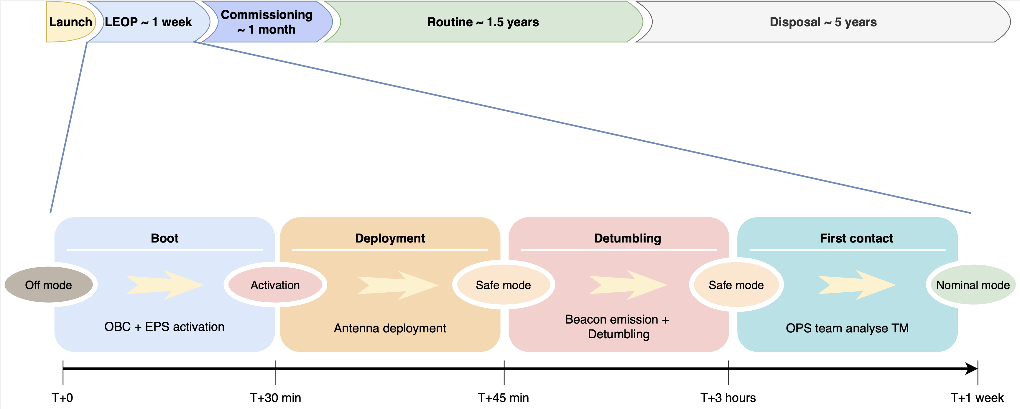

Figure 1: Mission phases

The LEOP phase is characterized by a sequence of activities with the objective of bringing the spacecraft from the initial launch state to its nominal state. Some of the milestones of this phase are deployment of the antenna, detumbling of the spacecraft and achievement of a first contact between S/C and ground. After the ground team has verified that all the systems are behaving nominally, the spacecraft is commanded into its nominal state and the next phase, commissioning, begins.

The commissioning phase main objective is to test and verify the performances of the subsystems and payloads, while maintaining the satellite in a stable state. When all the components are ready for nominal operations, the routine phase is entered.

In the routine phase the operations are carried out in a repetitive schedule for most of the time, thus minimizing the number of operators that need to closely monitor the satellite. If a contingency situation occurs, the satellite will autonomously interrupt the planned schedule and wait for a ground intervention in a safe state.

The routine phase is followed by the disposal phase where the satellite is brought to a safe state waiting for natural re-entry.

The duration of the first three mission phases, from LEOP to Routine, is expected to be 1.5 years, with possible mission extensions at the end. Then, after the disposal of the spacecraft, the re-entry time will depend on the solar activity and other parameters; the expected duration is around 5 years.

### LEOP:

Launch and Early Orbit Phase (LEOP) lasts from the in-orbit deployment to the achievement of nominal mode. It is the most critical part of the mission as the satellite is exposed to a challenging environment during launch (e.g., vibrations, shocks, temperature changes) and to the space environment for the first time. Furthermore, many of the activities during LEOP are, unlike in routine phase, irreversible events, and the state and position of the spacecraft are not well known until the achievement of the first contact. For these reasons, it is essential to have frequent updates of the satellite state, to react quickly to non-nominal situations. Therefore, a high level of redundancy in the ground system is mandatory to cope with issues during this crucial phase of space operations. Hence, since multiple ground stations are used to receive the telemetry through radioamateurs networks. The LEOP phase is divided into a series of sub-phases that are intended to be executed in sequence: activation, detumbling and first contact.

#### Activation sequence:

All sub-systems are turned off during launch and until the deployment. After that the satellite is released from the deployer, the kill switches are un-pressed and the PCDU automatically boots the OBC and EPS subsystems. After that, the OBC will start the activation sequence of the satellite. A timer of 45 minutes is started, during which the solar panels recharge the batteries if the satellite is in sunlight. When EPS is power positive and 30 minutes have elapsed in the timer (FDS-VCD 4.9.4), the other subsystems are activated and the procedure for the deployment of the antennas is started by triggering the disposable retention mechanism. Furthermore, when the full 45 minutes timer has elapsed (FDS-VCD 4.9.5), the satellite enters safe mode, and subsequently the TT&C subsystem starts to emit the beacon.

|  |  |
| --- | --- |
| Initial state | |
| Mode: | Off |

|  |  |
| --- | --- |
| Event | Mission Elapsed Time (MET) |
| Deployment |  |
| EPS power positive | T+0 |
| OBC + EPS activation | T+0 |
| Antenna deployment | T+30 min |
| TT&C starts beacon emission | T+45 min |

|  |  |
| --- | --- |
| Final state | |
| Mode: | Safe |

#### Detumbling (~3 hours):

After that the activation sequence is complete, the spacecraft is in safe mode. If it is determined that the rotational rate is higher than 0.5 deg/s, and if the battery has enough charge, the detumbling mode will be activated. The spacecraft is compatible with initial tumbling rates of up to 90 deg/s (FDS-VCD 4.4.1.1).

The detumbling mode shall reduce the rotational rate to a threshold of 0.5 deg/s and, after the detumbling is complete, the spacecraft will autonomously go back to safe mode, therefore transition to using the B-dot attitude control.

|  |  |
| --- | --- |
| Initial state | |
| Mode: | Safe |

|  |  |
| --- | --- |
| Event | Mission Elapsed Time (MET) |
| ADCS starts detumbling | T+45 min |
| Rotational rate < 0.5 deg/s | T+3 hours |
| Automatic transition in Safe mode | T+3 hours |

|  |  |
| --- | --- |
| Final state | |
| Mode: | Safe |

#### First contact (max 13 hours):

This is the first major milestone of the mission. The exact position and the orbit of the satellite are still unknown; therefore, the first orbit determination will be performed using launcher data and the GPS data transmitted by the spacecraft with the beacon. The GS will search the satellite using its predicted orbit and, when radio-contact is achieved, the operations team will perform a series of health checks on the satellite. Then the capability of the spacecraft to receive telecommands is verified using a ping TC and listening for the ping TM. If all the parameters checked are nominal and the detumbling has been completed, then the spacecraft will be commanded into nominal mode and the LEOP-completion flag will be set to one so that, if the OBSW is rebooted, it will not perform LEOP specific activities. In nominal mode the ADCS will provide a nadir pointing attitude and the spacecraft will transmit a beacon every 60 seconds. Radioamateurs networks (e.g., SatNOGS) are utilized to increase the number of ground stations available to receive telemetry.

If some contingency situation arises or there are non-nominal parameters prior to entering nominal mode, a combination of FDIR, reboots and adjustments by TC will be utilized to mitigate the risks and bring the spacecraft to a nominal situation.

|  |  |
| --- | --- |
| Initial state | |
| Mode: | Safe |

|  |  |
| --- | --- |
| Event | Relative Elapsed Time |
| GS receives beacon | T+0 secs |
| GS send test commands | T+1 min |
| OPS team analyze telemetry | T+15 min |
| S/C commanded into Idle mode | T>90 min |

|  |  |
| --- | --- |
| Final state | |
| Mode: | Nominal |

### Commissioning:

After the LEOP phase, the satellite is in a stable configuration and ready. The commissioning phase is designed to test the platform and payload, transitioning the spacecraft into its fully operational capabilities. During this phase, not only the subsystems of the satellite but also the payloads components are tested. Therefore, the nominal procedures for GS passes are verified, the IS is activated and the QPL and MVS are tested and validated. The payloads may require special calibration procedures that will involve additional ground support with respect to the routine phase.

Some examples of activities that will be performed during the commissioning are:

* Analysis of the received TTC signal.
* Calibration of batteries SoC estimation.
* Activation and analysis of the payloads.

The calibration activities are expected to require specific non-routine procedures by operators. However, these tasks are not intended to be the driving factors for system design.

### Routine:

During this phase the spacecraft operations are performed with routine processes, telemetry is collected and analyzed to verify the nominal behavior of all subsystems, and mission planning is executed governing day-to-day tasks of the mission. In case of non-nominal situations, the operations team will intervene to recover the spacecraft as quickly as possible. As a general overview, the satellite will collect the IS data and output the beacon while staying in its nominal mode, it will perform GS passes and occasionally perform QPL activities with the GaliQEye telescope (Appendix B) at disposal of the QuantumFuture Group of the Information Engineering Department of the University of Padua. The MVS will be activated and will collect data during the daily period without GS contact. The QPL will be activated instead of a GS pass in the periods with 4 daily contacts if requested by the QuantumFuture team.

### Disposal:

After the nominal mission lifetime has been completed, the spacecraft will be brought to a safe state, terminating RF emissions and discharging the batteries, while waiting for the reentry in atmosphere.

## Mission Analysis Report Summary

The orbit range has been selected considering both the 25 years of maximum lifetime (FDS-VCD 4.11.4, ECSS-U-AS-10C [3] / ISO 24113:2011 6.3.3.1), the anticipated 5 years of maximum lifetime after End Of Life (EOL), and the operational requirements of at least 1.5 years of lifetime (TS-VCD SYS-MIS-700).

A set of simulations has been run in DRAMA (through the OSCAR module), as recommended in ESSB-HB-U-002 Issue 1 section A.2.17 [2], to evaluate the lifetime for different orbit designs. The orbits considered in the analyses are Sun-Syncronous Orbits (SSOs) with different altitudes.

The analyses have been separated into two cases:

1. **Worst case:** this analysis considers the worst possible conditions (in terms of solar activity, S/C mass and cross section) to assure that in any case the orbit is compatible with the 25 years limit for the maximum lifetime.
2. **Nominal case:** In this case the parameters used are those associated with nominal operations, except for solar activity that is set to a worst case. This analysis is used to find the altitude range that allow the compliance with the 5 years after EOL of lifetime and with 1.5 years of minimum lifetime.

The satellite parameters are reported in Table 1:

Table 1: Satellite parameters considered in the orbital simulations

|  |  |  |
| --- | --- | --- |
| Parameter | Value | |
| **Nominal case** | **Worst case** |
| Mass | 2.16 kg | 2.6 kg |
| Drag area | 0.0226 for 1 years, then 0.027 (tumbling) for the remaining time. | 0.01 |
| Drag coeff. | 2.2 | 2.2 |
| SRP coeff. | 1.3 | 1.3 |

The main results are summarized hereunder.

### Worst case:

Table 2: Worst case scenario lifetime (max possible S/C mass, min possible Drag Area, min possible solar activity with 50% margin)

|  |  |  |  |
| --- | --- | --- | --- |
| Orbit ID | Altitude [km] | Inclination [deg] | Lifetime (5% margin) |
| Worst possible case |
| 1 | 408 (ISS) | 51.6 (ISS) | ~ 4 years |
| 2 | 470 | SSO | ~ 8 years |
| 3 | 500 | SSO | ~ 14 years |
| 4 | 530 | SSO | ~ 21 years |
| 5 | 535 | SSO | ~ 25 years |

The worst-case scenario imposes an upper limit to the altitude of around 535 km to assure compliance with FDS-VCD 4.11.4.

### Nominal case:

Table 3: Nominal case scenario lifetime (nominal S/C mass, nominal Drag Area, nominal solar activity)

|  |  |  |  |  |
| --- | --- | --- | --- | --- |
|  | Lifetime (years) | | | |
| Altitude (km) | 2025 | 2026 | 2027 | 2034 |
| 475 | 1,7 | 3,5 | 5,5 | 1,3 |
| 480 | 2,0 | 4,1 | 5,8 | 1,4 |
| 485 | 2,2 | 4,9 | 6,1 | 1,6 |
| 490 | 2,6 | 5,8 | 6,3 | 1,7 |
| 492 | 2,7 | 6,1 | 6,4 | 1,7 |
| 495 | 3,0 | 6,6 | 6,5 | 1,8 |
| 500 | 3,5 | 6,9 | 6,7 | 1,9 |

The nominal-case scenario imposes an altitude range that span from 485km (TS-VCD SYS-MIS-700) to 495km (5 years limit).

The required range in altitude for compliance with the requirements is found to be between 485km and 495km. However, the lack of precision in the lifetime predictions (see ALB_MAR for further discussion) does not justify a 5km change in the altitude, therefore the nominal altitude considered for the mission is 500km, with a lower bound of 485km.

|  |  |
| --- | --- |
| Altitude range | 500 km – 485 km |
| Nominal altitude | 500 km |

In terms of inclination, a lower bound of INC > 45.4 deg is set to grant passages over the expected ground station location (Padova). Hence, **the CubeSat mission is compatible with any orbit within the altitude range of approximately 485 – 500 km and with INC> 45.4 deg.**  The mission orbit does not pose any requirement on RAAN/LTAN, an LTAN of 10AM is preferred but not necessary and an LTAN of 12AM is to be avoided since it does not allow the batteries to recharge enough.

A 500 km SSO is a good candidate to meet both payloads and ESA requirements in terms of lifetime and it is frequently accessed by other missions as assessed by a literature study (see ALB_MAR for further details). An extensive analysis of the orbit evolution has been performed for the selected 500km SSO orbit. For this analysis the parameters are selected considering the nominal case scenario. The software used for the simulations are GMAT and DRAMA. The analyses of the eclipse and ground station pass times has been performed considering the various cases in terms of power availability, namely an initial LTAN of 6am, 8am, 10am and 12am. The results are summarized in the following tables (Table 4, Table 5), for the extensive analyses of the results refer to the mission analysis report (ALB_MAR). The following results include the altitude lowering due to atmospheric drag.

**Eclipse time:**

Table 4: Eclipse time (in minutes) in different LTAN values

|  |  |  |  |  |
| --- | --- | --- | --- | --- |
| **LTAN** | **6 AM** | **8 AM** | **10 AM** | **12 AM** |
| **Mean eclipse time (min)** | 19.3 | 25.2 | 33.2 | 35.8 |
| **Mean light time (min)** | 75.3 | 69.5 | 61.4 | 58.8 |
| **Max eclipse time (min)** | 25.8 | 33.2 | 37.0 | 37.0 |
| **Min eclipse time (min)** | 0 | 3.3 | 25.3 | 32.5 |

**Contact time:**

For this analysis the ground contacts have been restricted to those with a minimum elevation of 10 degrees and the Ground Station (GS) location is set in Padova. In this case, the results are independent from the initial RAAN therefore the results are presented with varying altitudes.

Table 5: Results of the ground stations contacts in different orbits

|  |  |  |  |  |
| --- | --- | --- | --- | --- |
|  | **500 km SSO** | **550 km SSO** | **600 km SSO** | **408 km ISS** |
| **Mean # of passes per day** | 3.4 | 3.6 | 3.8 | 5.3 |
| **Max interval between passes (h)** | 12.9 | 13.0 | 13.1 | 18.2 |
| **Max # of passes per day** | 5 | 4 | 4 | 6 |
| **Min # of passes per day** | 2 | 2 | 2 | 4 |
| **Mean contact time (min)** | 5.3 | 5.8 | 6.3 | 5.1 |
| **Mean total contact time per day (min)** | 17.8 | 21.0 | 23.9 | 26.9 |

### Demisibility analysis results

An analysis of the reentry casualty risk has been performed using SARA tool inside DRAMA software. A high-level model of the CubeSat has been used, refer to ALB_SDMR for further details. The results of the study are summarized in Table 6 and Figure 2. The casualty and fatality probability are below the requested value of 10-4 (FDS-VCD 4.11.5 / req. 6.3.4.2).

Table 6: Results of the demisibility analysis

|  |  |
| --- | --- |
| Total casualty area | 0.467382 m2 |
| Total impact mass | 0.3 kg |
| Total number of fragments | 1 |
| Total number of floating fragments | 1 |
| Total casualty probability | 5.97E-6 |
| Total fatality probability | 5.57E-6 |

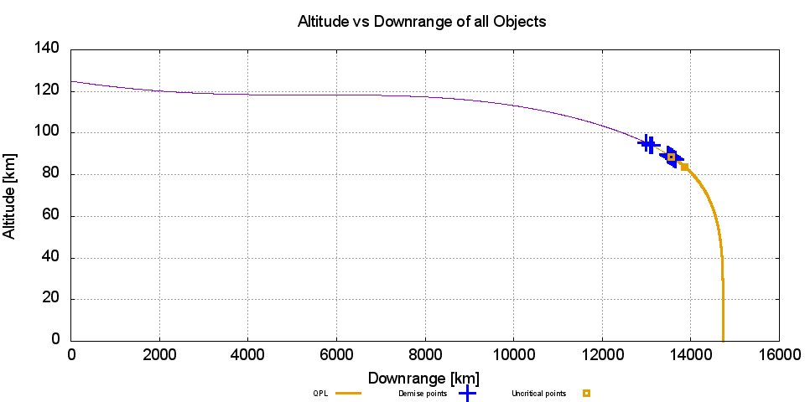

Figure 2: Results of SARA analysis

### Collision Avoidance Manoeuvre

Since the CubeSat is not equipped with a propulsion system, the only way to perform an avoidance manoeuvre is by changing its attitude, achieving a change of the surface affected by drag form 0.0227 to 0.01 .

The effectiveness of this manoeuvre has been studied by using a python script that includes the orekit package, the script takes into account:

* The possibility of sending the command from the GS
* A fixed ellipsoid representing both the spacecraft and the impacting object uncertainty in position
* Very accurate attitude change
* Impact to take place at altitude 500km (conservative choice)
* Different TCA

The simulation has been performed 1000 times per TCA to obtain statistically acceptable outputs and through different years to evaluate the manoeuvrability with different solar activities. Results are reported in Figure 3.

### Zero Debris Policy

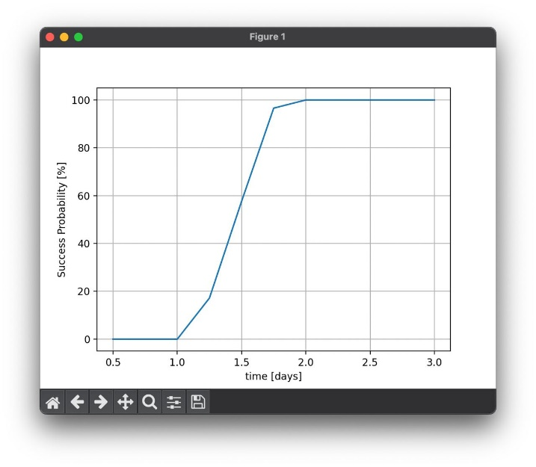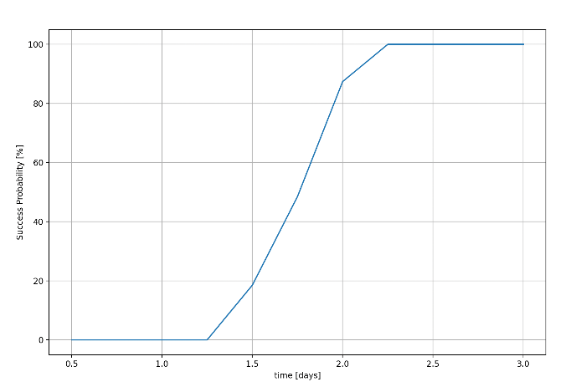

(a)

(b)

Figure 3: Manoeuvre success probabilities for different TCA, (a) year 2024, (b) year 2027

A probabilistic analysis of the orbit lifetime and collision probability has been performed by using DRAMA’s python package, according to the new requirements specified in the document ESSB-ST-U-007 (2023). In the analysis the starting point has been moved through a full solar cycle, starting from March 30, 2025 until March 30, 2036; the parameters at the beginning are summarized in the next table.

Table 7: Initial parameters of the orbit lifetime and collision probability.

|  |  |
| --- | --- |
| **Parameter** | **Value** |
| Semi-major axis [km] | 6878.14 |
| Eccentricity | 0.001 |
| Inclination [deg] | 97.4 |
| Right ascension of the ascending node [deg] | 0 |
| Angle of perigee [deg] | 0 |
| Mean anomaly [deg] | 0 |
| Cross-sectional area [m2] | 0.0227 |
| Mass [kg] | 2.2 |
| Drag coefficient | 2.2 |
| Reflectivity coefficient | 1.3 |

Since the eccentricity of the orbit is below 0.3 at the end of life, for the orbit lifetime the 50th percentile has been used and the results shows a value, for the lifetime, equals to 4.568 years, that is less than the 5 years requested for spacecrafts not having recurrent maneuver capability, and thus satisfactory.

With regard to the collision probability with objects larger than 1cm after the end of mission (1.5 years), the analysis shows that all of the considered cases, its value does not exceeds the threshold of stated in the ESSB-ST-U-007 (2023).

## CubeSat Operational Modes

The satellite functional architecture is divided into 5 different system modes, they are:

1. Off mode
2. Activation sequence
3. Safe mode
4. Detumbling mode
5. Nominal mode

The system modes are related to the respective ADCS subsystem modes, each mode has a unique attitude that relates to the same mode name in the ADCS subsystem.

Furthermore, every component has a series of sub-modes that are related to the general system modes, this means that every time the satellite switches its operational modes, all the components change their internal sub-mode in accordance. However, a subsystem can change its sub-mode following a TC or a OBSW command, without necessarily affecting the system mode. For example, during Nominal mode the IS can be turned on and off without changing the satellite operating mode.

AlbaSat is designed to be launched as piggyback payload and therefore must fulfill the requirement of being entirely switched off until after separation from the deployer (FDS-VCD 4.2.1). Therefore, the system starts in Off mode where the satellite is completely switched off except for the launcher separation detection circuit. After the deployment, the spacecraft transits through the activation sequence and then autonomously enters safe mode. If the estimated rotational rate is higher than 0.5 deg/s, the system automatically enters Detumble mode. **Errore. L'origine riferimento non è stata trovata.** shows all allowable mode transitions. Blue lines indicate an automatic (i.e., triggered by the FDIR or OBSW) mode transition, while red lines indicate mode transitions that need to be commanded from the ground, both by a time-tagged command or by a direct command.

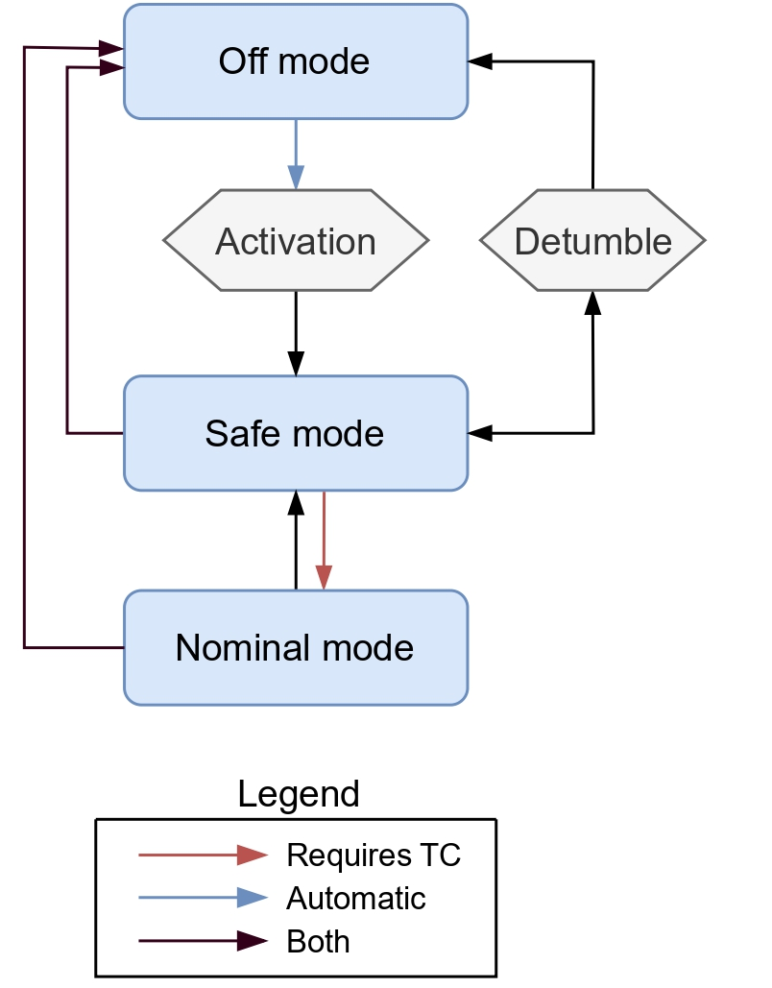

Figure 4: Diagram of the allowable mode transitions

### Payload operations

Due to the low level of operational complexity of the payloads, there is not a dedicated P/L mode. Instead, the payloads are activated directly from Nominal mode by specific commands received from the GS. Their operational concept is as follows:

* The Impact Sensor (IS) will be activated as soon as possible in the routine phase with a telecommand from the GS, and it will remain active for most of the time in a nominal situation. Once activated, it will output its status with a sample frequency of 1Hz, this generates a data rate of around 500bps. This data will be analyzed by the OBC and will be transmitted to the ground only in two cases:

1. The status of one strip changes (i.e., an impact happened). In this case the OBC will store the information about the time of the event and other relevant information and will transmit those data in the next available passage. The presence of a new sampled impact will be indicated in a telemetry parameter as a 0-1 flag.
2. The spacecraft is in contact with the GS. In this case the GS can send a command requesting the instantaneous status of the IS. This request will be a standard routine request to be sent at every pass.

* The Micro-Vibrations Sensor (MVS) will perform data sampling during precise windows that will be defined by ground commands in the form of time-tagged commands. The maximum amount of data collected will depend on the amount of predicted downloadable data in the next available GS contact. The data produced will be stored on-board and downloaded at the next available pass.
* The Quantum Future PayLoad (QPL) will be activated by a time-tagged command. The activation will be scheduled to begin 60 seconds before the selected pass over the laser ground station and will end 60 seconds after the pass. The QPL will modulate its system using a PWM pseudo-random test sequence with symbol rate below 10 Hz. The data analysis will be performed only at the QGS. The pass selected for this payload will probably interfere with the radio frequency contact with the GS, therefore the activation of the QPL will be scheduled when there are no major downlink or uplink data to be exchanged. This out of routine scenario is justified by the fact that the QPL needs to be validated and does not require frequent activations to achieve its mission goals.

Due to its intrinsic nature the CCR payload is not taken into account in the operational concept.

Table 8 shows the status of each component in the various modes. In this table the nominal mode is represented in its baseline configuration (i.e., with the payloads off), from this configuration the payloads can be turned on after a ground request.

Table 8: Active components

|  |  |  |  |  |  |
| --- | --- | --- | --- | --- | --- |
|  |  | **Nominal**  **mode** | **Safe mode** | **Detumble mode** | **Off**  **mode** |
|  |  |  |  |  |  |
|  | Fine sun sensor | On | Off | Off | Off |
| ADCS | Coarse sun sensor | On | Off | Off | Off |
|  | Rate sensor | On | Off | On | Off |
|  | Magnetometer | On | On | On | Off |
|  | Magnetorquers | On | On | On | Off |
|  | Momentum Wheel | On | Off | Idle | Off |
|  | GPS | On | On | On | Off |
| OBC | OBC | On | On | On | Off |
| Payloads | IS | Off / On | Off | Off | Off |
|  | MVS | Off / On | Off | Off | Off |
|  | QPF | Off / On | Off | Off | Off |
| EPS | PCDU | On | On | On | Off (TBC) |
| TTC | Transceiver | Rx / beacon / Tx | Rx / beacon | Rx / beacon | Off |

## Modes definition

In the following sections the different system modes will be presented.

### Off mode

Table 9: Off mode overview

|  |  |
| --- | --- |
| Entry from: | Any other mode |
| Exit to: | Activation sequence |
| Purpose: | Avoid permanent damage + launch configuration |

Off mode is not a proper operational mode, as all the systems are off. The S/C is in this mode during launch until the kill switches are un-pressed and if the battery voltage drops below a certain threshold. This mode is a logical starting point for the booting of the satellite.

When the kill switches are opened, the Power Control and Distribution Unit (PCDU) will cease all power supply to the various components, including most of its own internal electronics, apart from the ability to recharge the battery using solar panels. The only active circuits at this point are the analog detection circuit for deployment detection and the battery charge control boards within the battery. Once the satellite separates from the launcher or recovers from a complete power failure, the PCDU is the first unit to initialize and begin functioning.

### Activation sequence

Table 10: Activation sequence overview

|  |  |
| --- | --- |
| Entry from: | Off mode |
| Exit to: | Safe mode |
| Purpose: | Activate the satellite |

During the transition from Off to Safe mode, the S/C goes through an activation sequence. It is not a real mode but just an operational transition. This transition occurs every time the satellite resets or when the satellite has been activated for the first time. The purpose of this mode is to activate the necessary subsystems (OBC and EPS) and determine if it is the first activation after launch, in which case the antenna is deployed after a 30-minute timer, and the transmission of the beacon is turned off until further 15 minutes have elapsed (45 minutes total).

During the activation sequence, no radio signal is emitted (the beacon is not transmitted).

Furthermore, upon activation the boot count number is logged in the memory together with the log-on uptime, to see for how long the satellite was up until the reset (i.e., time between two resets). This information is then included in the telemetry package to understand the status of the satellite in case of some anomaly. If it is determined that the boot count is equal to zero, and therefore the satellite has just been deployed in orbit, a timer will be started.

When 30 minutes have elapsed in the timer (FDS-VCD 4.9.4) or if the boot count is greater than zero, the deployment sequence is entered.

If it is determined that the deployment of the antennas has already happened, the satellite will enter safe mode. Otherwise, the antennas will be deployed (if the battery has enough power) and, after the verification of a successful deployment, the satellite will wait for the 45 minutes mark on the launch timer (FDS-VCD 4.9.5) and then will enter safe mode.

If the deployment has not been successful, the system will re-check the battery voltage and try again to deploy. An option to force the exit from the deployment loop with a telecommand (TC) is implemented in case the deployment is reported as not successful. This will avoid remaining stuck in that loop in case of a malfunction in the deployment sensors (false negative deployment) or other cases. Furthermore, the capability of receiving and executing TC is included in each loop, for example while waiting for the timers to elapse, to be able to intervene in case of malfunction.

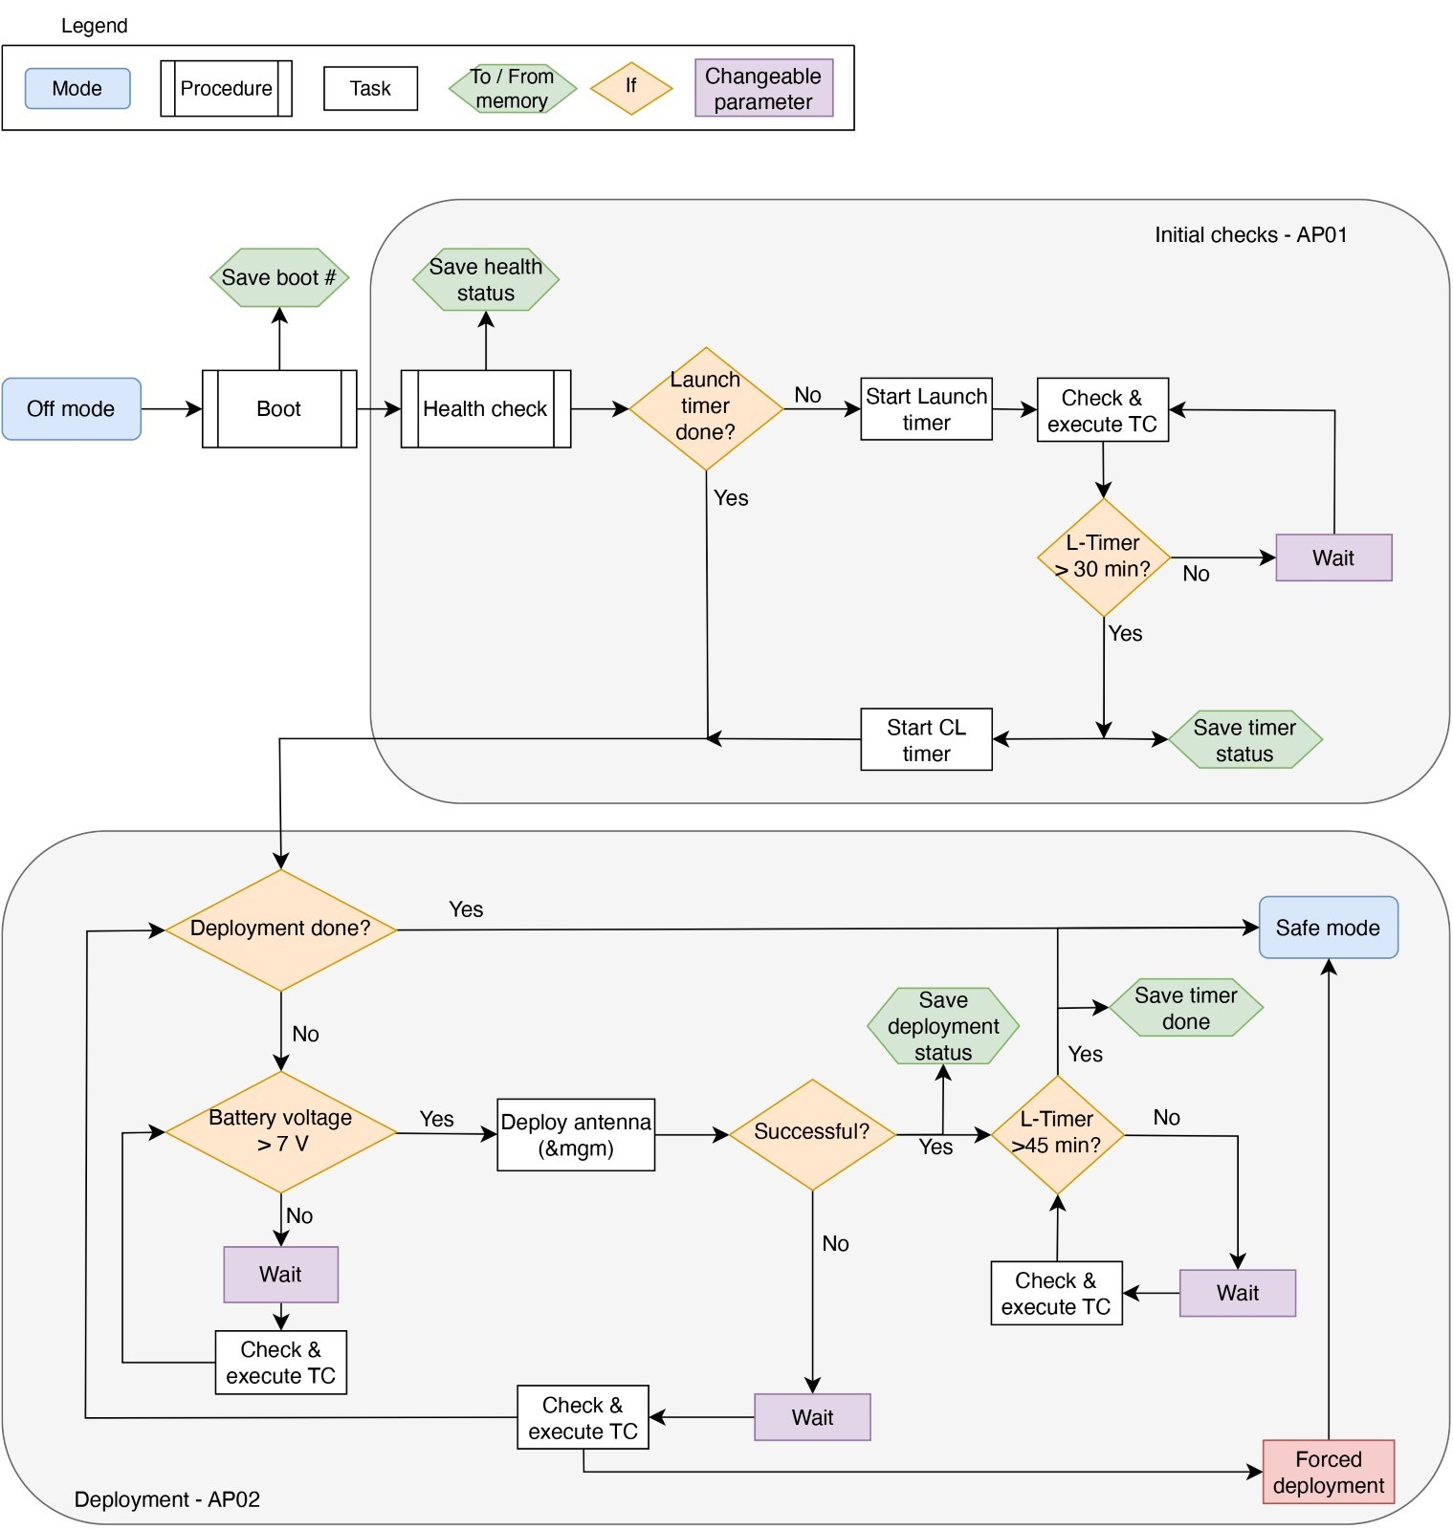

Figure 5: Activation sequence procedures

### 

### Safe mode

Table 11: Safe mode overview

|  |  |
| --- | --- |
| Entry from: | Every other mode |
| Exit to: | Nominal mode, Off mode, Detumble mode |
| Purpose: | Maintain the satellite in a stable and safe state |

The purpose of safe mode is to bring the spacecraft into a stable and safe state, maximizing the chances of survival in potentially critical situations.

To achieve this, the spacecraft is configured in the simplest way possible, with minimal power consumption and with the most reliable configuration of the systems. This is done to conserve resources and ensure that the spacecraft remains observable from the ground, allowing operators to understand the spacecraft condition and take necessary corrective actions if needed. In safe mode, all non-essential systems on the spacecraft are turned off. Only the necessary sensors and actuators required for power supply and attitude control are activated. The ADCS uses only magnetorquers and magnetometers in the B-dot control mode.

If the rotational rate of the spacecraft exceeds 0.5 deg/s, and if the battery voltage is over a 7 V, the detumbling mode will be entered to reduce the rotational rate.

During safe mode, the spacecraft continues to transmit a beacon containing telemetry (TM) data. This allows operators on the ground to receive information about the spacecraft status and health. However, the transmission of the beacon may be interrupted if a specific command is received from the Ground Station (GS), or if the battery voltage drops below 6.5 V, indicating a low power situation.

The observability and robustness of this mode is also used in the transition between the initial activation sequence and the nominal mode, as the spacecraft will enter safe mode autonomously after launch and then wait for the first contact in this state.

This mode can be entered both via an automatic trigger and via a direct ground command. The satellite exits the safe mode only if it receives specific commands from the ground and certain conditions are met. Note that, in the case of the entry trigger, the transition will occur even if only one condition is met. Differently, to exit safe mode, all the parameters need to be in their nominal ranges. To conclude, safe mode can be entered both automatically and by command, but it can only be exited by command.

**Table 11: Safe mode main procedures**

|  |  |  |
| --- | --- | --- |
| **ID** | **Name** | **Description** |
| **SP01** | Beacon | Transmits the beacon heartbeat every 60 seconds to increase the observability of the spacecraft. The beacon can be switched off following a request from ground and will remain off until a specific command is received, even in the case of a system-wide reset. The beacon can also be turned off in a low power situation. |
| **SP02** | Checks | Allows to collect the telemetry and verify the status of all subsystems, including battery voltage and the time of last contact with the GS. |
| **SP03** | ADCS | Activate ADCS safe mode control (B-dot) and check if the rotational rate exceeds a 0.5 deg/s threshold, in which case the transition to detumble mode is triggered. An option to disable ADCS is also included as a “safe to operate” flag, in order to have the ability to disable it in case of a failure in its functioning. |
| **SP04** | Exit | Allows to perform the transition into Nominal mode. This is done after verifying that there are not active failure flags or out of range parameters and that a specific TC from ground is received. |

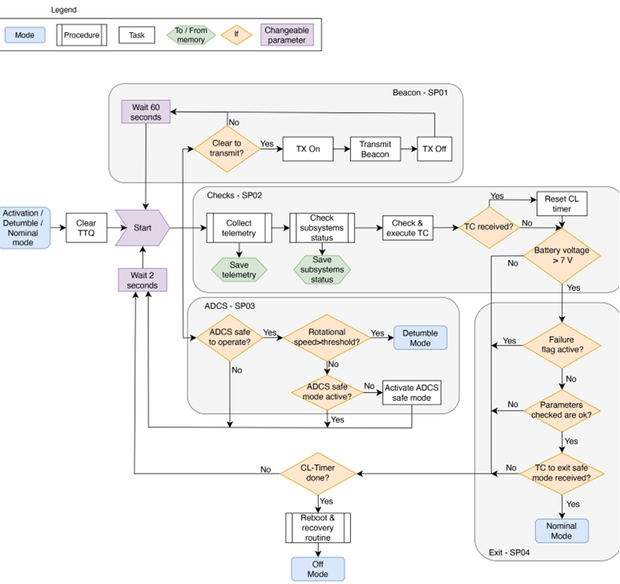

Figure 6: Safe mode procedures

**1.6.4 Detumbling mode**

Table 12: Detumbling mode overview

|  |  |
| --- | --- |
| Entry from: | Safe mode |
| Exit to: | Safe mode |
| Purpose: | Reduce the rotational rate of the satellite |

The purpose of this mode is to reduce the rotational rate of the satellite. This mode can be activated both by an on-board trigger from safe mode and via a ground command. In this mode all payloads are off, together with every non-essential system, as in safe mode.   
The ADCS Detumbling mode is activated and can reduce the rotational rate of the satellite from up to 90 deg/s, in compliance with FSD-VCD 4.4.1.1. For additional details on the ADCS mode definition refer to ALB_ADCS-ARPT. At the end of the detumbling manoeuvre, the spacecraft attitude rate is lower than 0.5 deg/s on each axis. Once this threshold is achieved, the spacecraft will automatically transition back into safe mode. The detumbling mode is a higher-level mode with respect to safe mode, as it consumes more power and uses more sophisticated attitude control architecture. Therefore, if the detumbling mode cannot be kept due to a low power situation or a failure in the detumbling mechanism, the system will automatically fall back into safe mode. During this mode, the spacecraft will continue to emit the beacon.

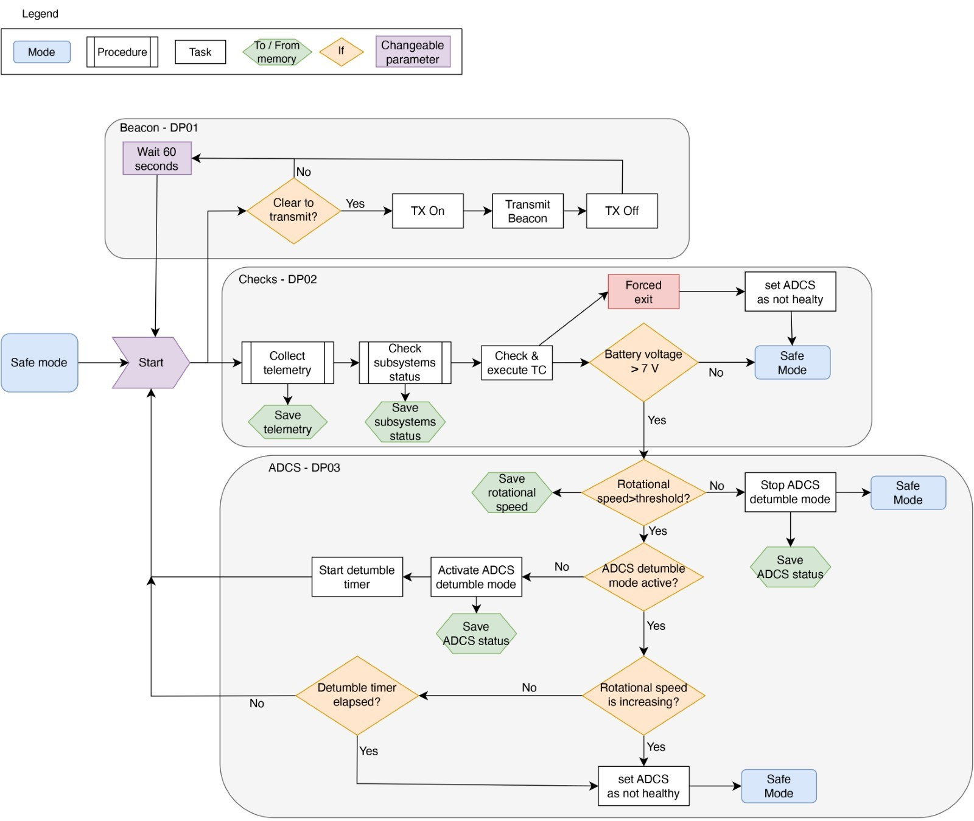

Figure 7: Detumbling mode procedures

Table 13: Detumbling mode main procedures

|  |  |  |
| --- | --- | --- |
| **ID** | **Name** | **Description** |
| **DP01** | Beacon | Transmits the beacon heartbeat every 60 seconds to increase the observability of the spacecraft. The beacon can be switched off following a request from ground and will remain off until a specific command is received, even in the case of a system-wide reset. The beacon can also be turned off in a low power situation. |
| **DP02** | Checks | Allows to collect the telemetry and verify the status of all subsystems, including battery voltage and the time of last contact with the GS. Furthermore, an option to force the exit from the detumble mode by TC is included in case there is some kind of malfunction in the ADCS subsystem. |
| **DP03** | ADCS | Allows to check if the rotational speed of the spacecraft is higher than the pre-defined threshold, therefore discriminating if the system can exit to safe mode or if the detumble needs to continue. In the latter case, verify if the ADCS is in detumbling mode and, if not, activate the ADCS mode and start a detumbling timer.  Then it allows to verify that the rotational speed is not increasing, as this would indicate an ADCS failure, and to check that the detumbling timer is not elapsed. If one of those checks set the ADCS as not healthy, the spacecraft will fall back into safe mode. Otherwise, the detumbling mode will continue. |

### Nominal mode

Table 14: Nominal mode overview

|  |  |
| --- | --- |
| Entry from: | Safe mode |
| Exit to: | Safe mode |
| Purpose: | Perform routine operations and payloads activities |

The satellite is expected to be for most of its operational lifetime in nominal mode. This is the only mode in which the payloads can be switched on. Since there are not dedicated modes to payloads operations or communication with the ground, the satellite will remain in nominal mode to perform all the routine operations and will switch to other modes only in case of a contingency.

The main purpose of this mode is to maintain the satellite in an operational condition, ready to activate the payloads or transmit data. Therefore, the ADCS maintains a nadir pointing attitude with a pointing error lower than ±20 degrees and the TTC subsystem transmits the beacon every 60 seconds and listens for commands from the ground. During the ground contacts, the operations team will uplink to the satellite a series of telecommands (TC) that are immediately executed on-board, and a series of time-tagged commands that are stored in the timetag queue (TTQ) on the satellite and are executed at their assigned times.

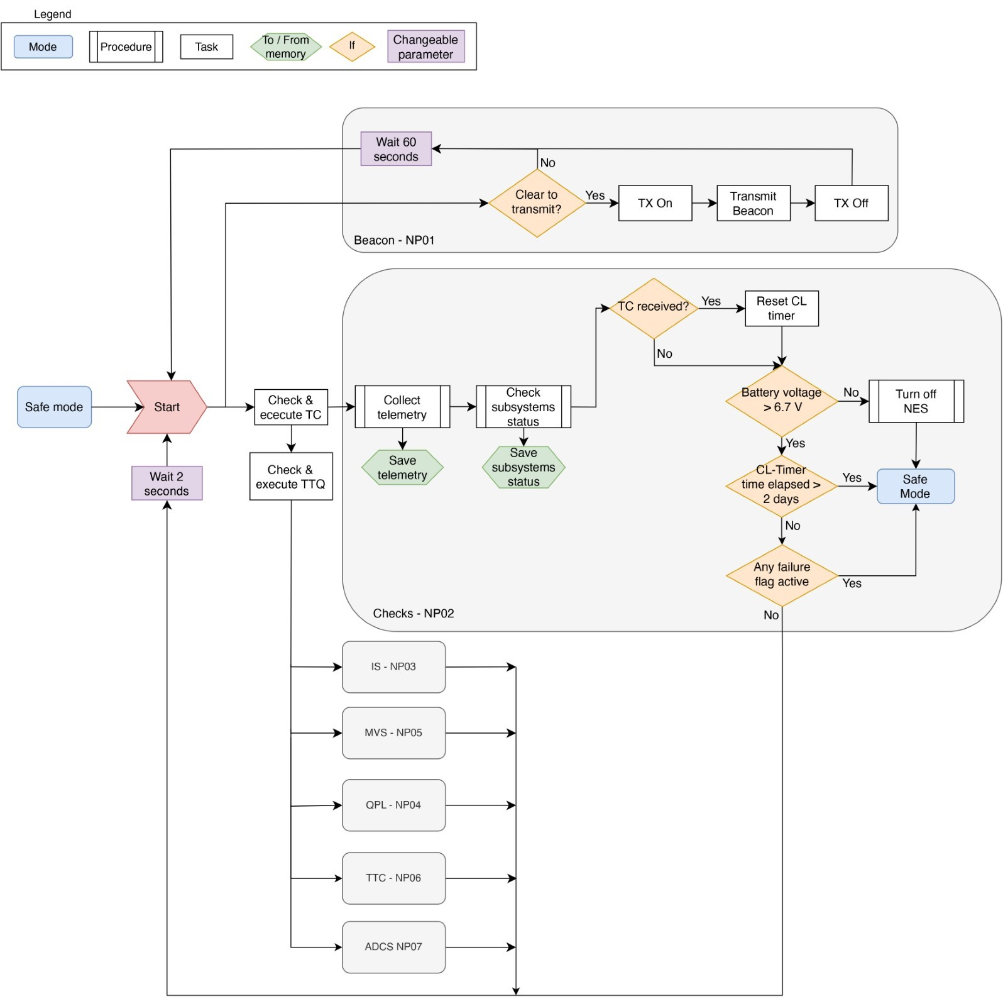

Figure 8: Nominal Mode Procedures

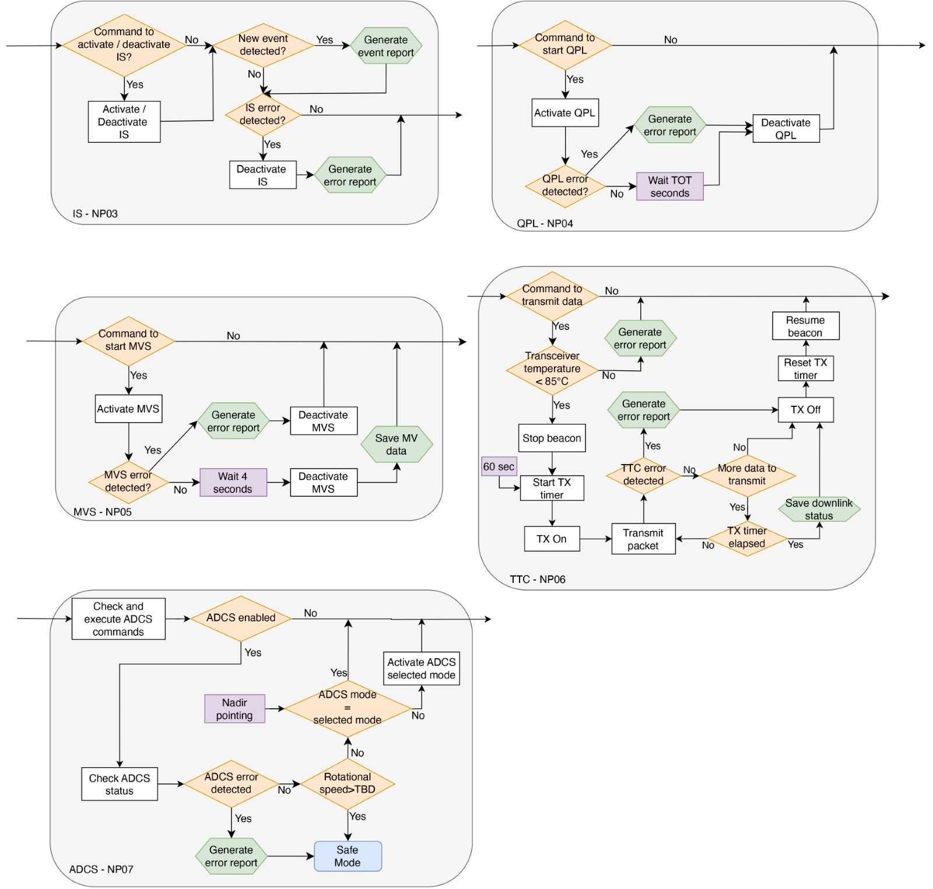

Figure 9: Nominal mode procedures

Table 15: Nominal mode main procedures

|  |  |  |
| --- | --- | --- |
| ID | Name | Description |
| NP01 | Beacon | Transmits the beacon heartbeat every 60 seconds (TBC) to increase the observability of the spacecraft. The beacon can be switched off following a request from ground and will remain off until a specific command is received, even in the case of a system-wide reset. |
| NP02 | Checks | Allows to verify the status of all subsystems, including battery voltage and the time of last contact with the GS. If a non-nominal parameter is detected the FDIR will be triggered raising a failure flag and the spacecraft can transition into safe mode, effectively stopping all the other procedures running and turning off the non-essential subsystems (NES). |
| NP03 | IS | Allows to turn on or off the impact sensor using a TC. Furthermore, it will check the status of the IS, reporting eventual impacts or errors. An error in this case can also include overheating. |
| NP04 | QPL | Provides the framework for the operations of the modulating retro reflector (QPL), activating it on request (nominally from a time-tagged command) and deactivating it after a period contained in the activation command. The modulation of the mirror will be performed following a signal present in the on-board memory that can be modified from ground.  If an error (therefore including overheating) is detected while the QPL is active, the OBSW will automatically turn it off. |
| NP05 | MVS | Allows to collect MV data by activating the sensor on request (nominally from a time-tagged command) and deactivating it after a pre-determined period (the default is 4 second but can be modified). The sampled data are stored on board and downloaded as soon as possible. |
| NP06 | TTC | The transmission of data can be triggered by a direct command received from the GS, the transmission can last for a maximum of 60 seconds then, if there is additional data to be downloaded, another command needs to be sent to continue the transmission. During the downlink of data, the transmission of the beacon will be suspended. Also, during the transmission, the OBSW will perform checks of the status of the components and will end the procedure if an error is raised (thus including a check of the temperature of the transceiver).  In accordance with requirements FDS-VCD 4.9.8.2; 4.9.8.1 |
| NP07 | ADCS | Allows to check the status of the ADCS subsystem, change its sub-mode following a TC or by-pass it completely by disabling it in case of an ADCS failure. Furthermore, verify the rotational speed of the spacecraft and enter safe mode in case it is greater than a threshold. If an error is detected while the ADCS is enabled, it will trigger the transition to safe mode. The internal functional flow of every ADCS sub-mode (e.g., Nadir pointing) is described inside the ADCS document and therefore not reported here, in this context it is described only the verification that the ADCS active sub-mode corresponds to the desired one (that by default is nadir pointing). |

## Timelines

Due to the preliminary status of the project the detailed timelines of the mission have not been defined yet. It is worth noting that -due to the mission complexity and the high number of variables – constant adjustments are expected to ensure the integrity of the space flight and a smooth running mission.

### Activation Sequence

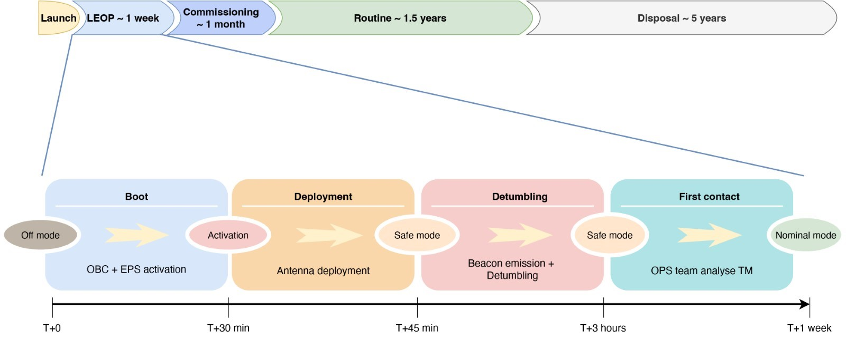

Figure 10: Activation sequence

### 1.7.2 Nominal pass timeline

The nominal pass timeline gives a description of the daily activities during the routine phase and any other repeat cycle of routine operations. The routine phase is characterized by repetitive routine operations aimed at maximizing the mission return. In this case, the mission return is composed by scientific data from the payloads and educational activity for the students. The operations of the satellite are scheduled daily through the utilization of mission planning tools. The nominal mode main procedures that take place during routine operations are listed in the table below. The nominal pass timeline begins with the acquisition of signal and ends with the mission disposal protocol.

The task of mission planning (MP) is to schedule all the mission related activities to efficiently manage the available resources and maximize the mission return. Since this mission is characterized by a LEO satellite that needs to perform its activities throughout the entire lifetime, the most appropriate mission planning type is repetitive planning. This means that the MP process is carried out daily by the operators, adjusting the routine operations to the specific needs and events of the day, but using a predefined template for the generation of a timeline.  The output of the MP process is a plan in form of a timeline, also called sequence of events (SoE), which contains the activities to be performed at specific times. To produce the timeline, the MPS is based on the following concepts:

1. Telecommand (TC): the basic building block of the timeline. It is a command that perform a discrete action
2. Procedure: a logical sequence of TCs, telemetry (TM) checks and scripts needed to achieve a specific objective (e.g., mode transition, switch on a component). The procedures can either be executed directly from the operators (real-time procedures) or automatically by the OBSW at their assigned time (time- tagged procedures). The time-tagged (TT) procedures are extracted from the SoE and uplinked to the satellite, where are stored in the time-tagged queue (TTQ) (See section 2.5)
3. Event: point in time geometrically defined by the orbit or manually added by the operator (e.g., AOS, eclipse start)
4. Hook: reference event used as a temporal fixed point to schedule a template
5. Template: Temporal sequence of procedures referenced in time by a hook, needed to perform a conclusive activity.  The templates are used by the operators and MPS to easily schedule activities (e.g., a routine pass). Figure 11 shows some of the defined templates used in the MP.

The updated timeline is automatically saved and stored in the mission database by the mission planning software, in the form of an excel table.  The TTQ on-board the satellite is updated daily and contains scheduled activities for two days in advance.

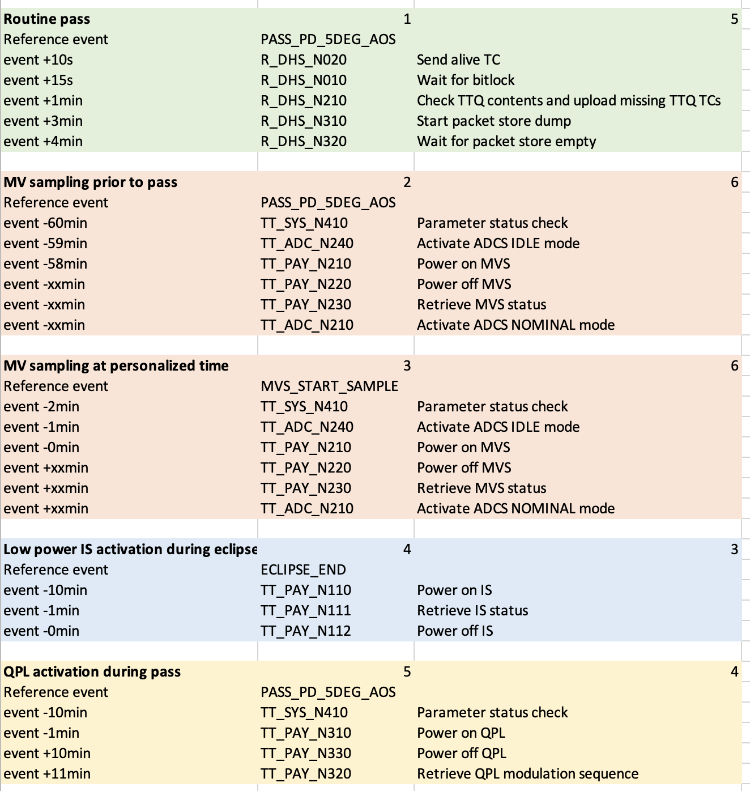

Figure 11: example of templates

The following table describes the mission planning process, namely the steps that the operators need to go through for the generation of the timeline. Steps below 1 (0.X) represent activities that need to be completed before the actual MPP can begin, but don’t need to be repeated every time. The last column indicates if the correspondent step is performed automatically by the MP software (MPS) or if an action from the operator is needed (OP). A schematic of the interfaces for this process is presented in Figure 10 and an example of the actual timeline is presented in Table m, in this case the activities are presented starting from the most recent.

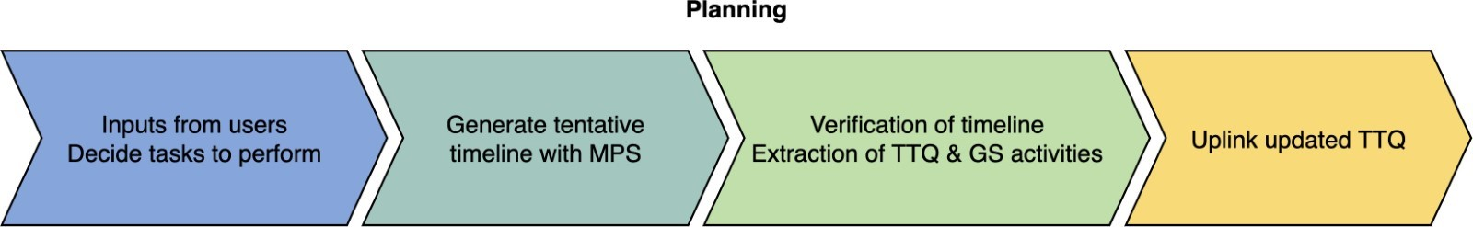

Figure 12: AGGIUNGERE DIDASCALIA

Table 16: AGGIUNGERE DIDASCALIA

|  |  |  |
| --- | --- | --- |
| **Step** | **Description** |  |
| 0.1 | Definition of telecommands and telemetry parameters. | OP |
| 0.2 | Definition of procedures. | OP |
| 0.3 | Definition of templates. | OP |
| 1.1 | Download the latest orbital predictions (TLE format). | MPS |
| 1.2 | Propagate the orbit for the planning period and generate the events. | MPS |
| 2.1 | Define the tasks to be performed (e.g., QPL, MVS, ...) and the GS availability. | OP |
| 2.2 | Transform the relevant events in hooks based on the requested tasks. | MPS |
| 2.3 | Assign the procedures from the specific templates to the identified hooks. | MPS |
| 2.4 | Generate a first iteration timeline. | MPS |
| 3.1 | Verify the nominal resource consumption. | MPS |
| 3.1.1 | If step 3.1 is not successful then generate a second iteration timeline reducing the appropriate resource consumption. | MPS |
| 3.2 | Save the generated timeline in a spreadsheet. | MPS |
| 3.3 | Verify the consistency of the timeline. | OP |
| 3.4 | Modify the timeline if needed. | OP |
| 4.1 | Extract the TTQ from the confirmed timeline and produce the actual commands to be uplinked to the satellite. | MPS |
| 4.2 | Load the SoE in the ground station architecture for execution of the procedures. | TBD |
|  |  |  |

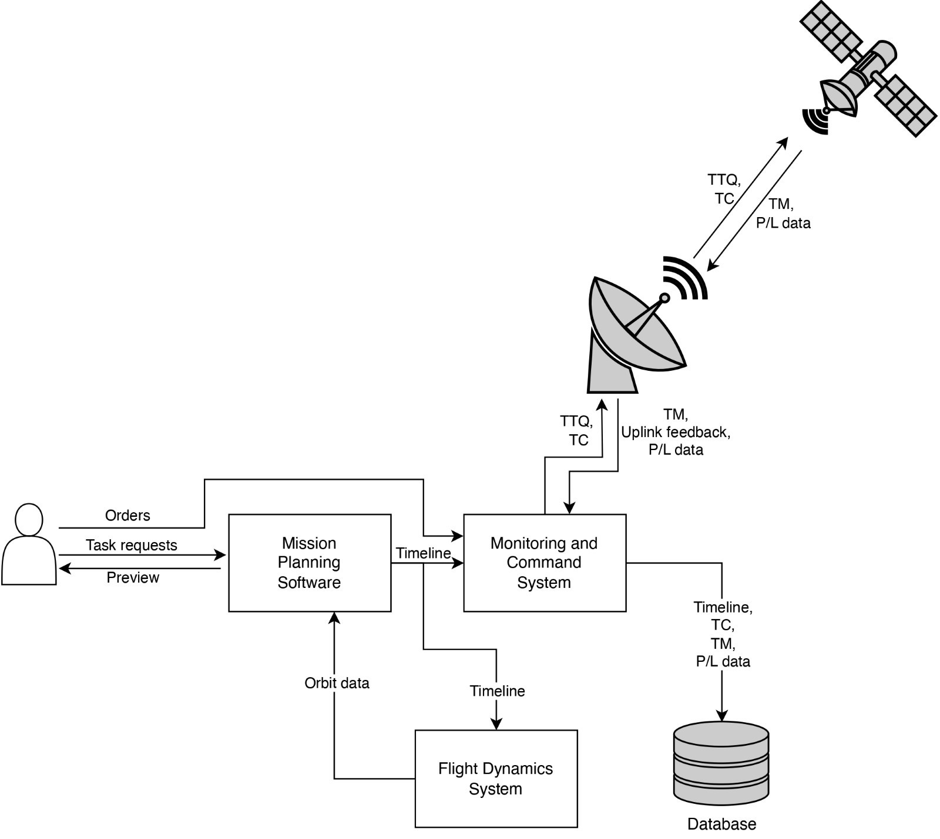

Figure 13: Schematic of the interfaces

### 1.7.3 Mission Critical periods

Mission critical periods are periods of the mission with dense operational activity and/or non-nominal mission situations.

The main mission critical periods are:

* No comms
* Safe Mode
* Debris Impact
* Failure of antenna deployment sensor

**No comms**

On board the satellite there is a watchdog timer (CL-timer) of two days that is reset at every successful GS pass. When the timer elapses, a series of recovery procedures will be commenced in the spacecraft, such as TTC and system wide resets. The on-board TTQ should not cover more than two days in advance, therefore no activities will be performed on-board besides the components that have been left active from the last contact. If the no comms period extends for 7 days (TBC), the satellite will automatically enter safe mode to minimize the possible failure modes. After another 7 days (TBC) without comms, the beacon emission will automatically stop, together with any RF transmission, to avoid a zombie-sat scenario. However, the satellite TTC system will remain active to listen to for eventual Telecommands.

From the ground side, a series of contingency procedures will be initiated as soon as the failure connection with the satellite occurs, those procedures may include sending TC in the blind, antenna and ground system recycle.

**Safe Mode**

As mentioned in section 1.6.3, the spacecraft can enter safe mode in a series of non-routine situations, if the OBSW needs some commanding from the ground to resolve a specific scenario. In this situation, the OBC will execute a series of FDIR checks and procedures to try identifying and potentially resolve the problem. In the meantime, the safe mode is designed to be as robust and reliable as possible, to keep the satellite in a stable state. The ground operators will execute a series of contingency procedures such as retrieving the beacon parameters and, if possible, additional parameters stored in the satellite via TCs. Once the problem is identified, if needed, the OPS team will develop and test correction procedures to be sent to the spacecraft. After the problem has been resolved, either by correction actions or not, the GS will send a series of TC to commence the transition from safe to nominal mode.

**Debris Impact**

If the impact occurs in the +X face, the IS shall detect the impact, either saving the event’s time if it is active, or without the precise time if it is off. The new status of the IS is then included in the beacon telemetry so that the operators are notified as soon as the beacon is received. If the energy of the impact is high enough to cause the satellite to start spinning, the OBC will enter safe mode and, if the situation is appropriate, even detumbling mode. Again, the new impact detection is included in the beacon so that the operators can understand the cause of safe mode and verify the status of the satellite after the impact.

**Failure of antenna deployment sensor**

The antennas are deployed automatically or with TC by a redundant control mechanism. To safeguard against prolonged activation of the deployment systems, a safety time limit has been integrated into the system. Prolonged activation could potentially lead to damage, rendering the deployment system unusable. Reusability becomes crucial in scenarios where it is uncertain whether the antenna has deployed successfully, necessitating additional deployment attempts. Additionally, the safety limit serves as a precaution against inadvertently depleting the data satellite batteries if the system is activated for an extended period.

If at the first predicted pass the antennas are in a non-deployed state, the GS will not receive any data from the satellite. In this situation, the operators will commence a contingency procedure to tackle this scenario.

In order to distinguish between failure in the deployment mechanism and a failure in the deployment sensor, the GS will send a ping TC in the blind using independent satellite position information (such as TLE) and listen for the response. If the antennas are deployed then the ping response will be received from ground and the power received will clearly indicate a successful deployment. In this case, a series of TC will be sent, comprising a TC that will force the satellite to exit the deployment sequence.

If the response to the ping TC is not received, then the automatic antenna deployment may have failed. In this case the GS will send the TC for the redundant deployment in the blind and will continue to repeat the TC while the operators asses other possible failure scenarios.

### 1.7.4 Mission disposal

Mission disposal is the last stage of the satellite lifetime that takes place after the end of the mission. During this phase it is compulsory to avoid generating new debris, therefore it is mandatory to avoid accidental collisions. The overall probability of successful disposal shall be kept above 0.9 through the end of life. Note that Cubesats are nanosatellites with no propulsion or navigation system, so that the disposal will be an uncontrolled re-entry. The spacecraft in free drift from its operational orbit must fulfill the two conditions listed below:

* Natural orbital decay duration < 5 years
* Cumulative collision probability with space debris larger than 1 cm lower than during the orbit lifetime

## Space sustainability Rating (Optional)

# Operations Plan

## Operational phase concept

Starting from safe mode, and unless a specific command is received, the spacecraft sends a beacon with key telemetry (TM) parameters to assess the health status every 60 seconds at 1200bps. The data encoding is made public so that everyone can receive and decode the TM data. When the transceiver is not transmitting, it listens to commands from the ground. If and only if it receives a specific command from the GS, it transmits stored telemetry or payloads data.

Both the downlink and the uplink operate in UHF at ~435MHz. This restricts the time dedicated to downlinking data at every pass. This is not critical since 3 of 4 payloads have very limited data to be downloaded. The MVS will restrict its operations to allow all its data to be downloaded in a single pass. Therefore, the activation of the MVS can be tuned not to interfere with uplink passes that require high bandwidth, e.g., software updates.

To allow the operators to stop all the transmissions if needed, the strategy of using a timer to the transmission is used. Therefore, the downlink can last for a maximum of 60 seconds (TBC). Then, if there is more data to be downlinked, the satellite waits for a go/no go command from the ground to proceed with the transmission to comply with FDS-VCD 4.9.8. If the communication window does not allow downloading all the stored data, the OBDH will manage the on-board memory deleting the additional data starting from the oldest. Furthermore, the mission planning will be modified to account for the lower data budget.

The data rate is set initially to 1200bps, and it is upgraded to 9600bps if the transmission is behaving nominally. The data rate can be downgraded to 1200bps with a command from the ground if necessary.

## Adaptability Table

Table 17: Adaptability table.

|  |  |  |
| --- | --- | --- |
| **Adaptability in flight** | **Y/N** | **[How/Why not implemented]** |
| Dump memories in flight | Y | Implemented through PUS services, in particular ST[06] “Memory management”, ST[15] “On-board storage and retrieval” and ST[13] “Large data transfer”. |
| Update memories in flight | Y | Implemented through PUS services, in particular ST[06] “Memory management”, ST[15] “On-board storage and retrieval” and ST[13] “Large data transfer”. |
| Update telemetry acquisitions/rates for different parameters | Y | Implemented through PUS services, in particular ST[03] “Housekeeping” and ST[15] “On-board storage and retrieval”. |
| Reset the satellite from ground | Y | The CubeSat can be reset from ground via GS command. Satellite reset consists of resetting all MCUs and power cycling all subsystems. Implemented through PUS services. |
| Save and reuse context in case of a restart | Y | System state is saved in memory before resetting and can be downloaded via GS command. Implemented through PUS services, in particular ST[03] “Housekeeping”, ST[06] “Memory management” and ST[15] “On-board storage and retrieval”. |
| Save last history in the case of a restart | Y | Last history is saved in memory before resetting and can be downloaded via GS command. Implemented through PUS services, in particular ST[03] “Housekeeping”, ST[06] “Memory management” and ST[15] “On-board storage and retrieval”. |
| Reconfigure the SW | Y | The SW can be patched and reconfigured in flight. Implemented through PUS services, in particular ST[15] “On-board storage and retrieval” and ST[13] “Large data transfer”. |
| Routes for controlling the CubeSat | Y | When the system is operating nominally, the satellite is controlled via TC from the GS. Commands are processed by the TTC subsystem and translate to OBC functions. In case of malfunction, the command route avoids the OBC and directly reaches EPS. |

Table 18: On-Board Memories Table

|  |  |  |  |
| --- | --- | --- | --- |
| **Subsystem** | **Memory** | **Dump** | **Update** |
| OBC | FRAM | Y | Y |
| SDRAM | Y | Y |
| NOR | Y | Y |
| ADCS | EEPROM | Y | Y |
| Flash (MCU internal) | Y | Y |
| MicroSD | Y | Y |
| IS | Flash | Y | Y |
| SRAM | Y | Y |
| EEPROM | Y | Y |
| MVS | Flash (MCU internal) | Y | Y |
| Flash (external) | Y | Y |

## Operability Table

Table 19: Operability table.

|  |  |  |  |
| --- | --- | --- | --- |
| **ID** | **Service Type** | **Y/N** | **[How/Why not] implemented** |
| ST[01] | Request verification | Y | Full implementation |
| ST[02] | Device access | Y | Full implementation except “Distributing software CPDU commands” capability of the Device access subservice type. |
| ST[03] | Housekeeping | Y | Full implementation |
| ST[04] | Parameter statistics reporting | Y | Full implementation |
| ST[05] | Event reporting | Y | Full implementation |
| ST[06] | Memory management | Y | Full implementation |
| ST[07] | (reserved) |  |  |
| ST[08] | Function management | Y | Full implementation |
| ST[09] | Time management | Y | Full implementation |
| ST[10] | (reserved) |  |  |
| ST[11] | Time-based scheduling | Y | Full implementation |
| ST[12] | On-board monitoring | Y | Full implementation |
| ST[13] | Large packet transfer | Y | Full implementation |
| ST[14] | Real time forwarding control | Y | Full implementation |
| ST[15] | On-board storage and retrieval | Y | Full implementation |
| ST[16] | (reserved) |  |  |
| ST[17] | Test | Y | Full implementation |
| ST[18] | On-board control procedure | N | Unnecessary complication. Can be replaced by a combination of other implemented STs |
| ST[19] | Event-action | Y | Full implementation |
| ST[20] | Parameter management | Y | Full implementation except “Managing parameter definitions” subservice type |
| ST[21] | Request sequencing | N | Unnecessary complication. The sequence of requests can be manually performed instead |
| ST[22] | Position-based scheduling | Y | Full implementation |
| ST[23] | File management | Y | Full implementation |

## Operational Database

Table (add number when other tables will be completed) presents the list of telemetry parameters identified. Every telemetry parameter is identified by a unique code in the form of TM ABC NXXX. This code is composed of:

* + - TM: Telemetry
    - ABC: Alphabetical code that identifies the subsystem
    - XXX: Number within the subsystem

The first three columns in table (number) represent:

1. Column 1 indicates where each parameter is located within the hexadecimal data packet
2. Column 2 specifies whether each parameter requires a sign, which determines whether the value can be positive or negative
3. Column 3 specifies the size of each parameter in the data packet. Knowing this size is crucial for correctly interpreting the data

For example, let’s consider the parameter ’TM TLM N110’ in the hexadecimal data packet below:

* It is located at position 1 (offset 0) within the packet
* The parameter occupies 2 bytes, which are equivalent to 4 hexadecimal digits (’06A3’)
* When we convert ‘06A3’ to decimal, we obtain the value 1699

Considering the following parameter, TM OBC N110:

* This parameter starts at the third position (fifth digit when counting) within the data packet
* Like the previous parameter, it also consists of 2 bytes, represented as ’01EA’ in hexadecimal
* Converting ’01EA’ to decimal yields the value 490

06A301EA611E453508170BB80BB80BB80BB80BB80BB80BB8002800280028002800280028002802000 A000900050006000200030005000200010005000200060003000031280001DDB00005000F0200010001000 1004E00580061004E0058006100150027004D002C000B005C000C03611E45350000002C0000000C000A2 C28001500720200000000

|  |  |  |  |  |  |
| --- | --- | --- | --- | --- | --- |
| **Offset** | **Signedness** | **Size (bytes)** | **ID** | **Units** | **Description** |
| 0 | U | 2 | TM TLM N110 | - | TLM Identifier |
| 2 | U | 2 | TM OBC N110 | ms | Millisecond part of the UNIX time |
| 4 | U | 4 | TM OBC N120 | s | On-board UNIX time |
| 8 | U | 2 | TM OBC N210 | ms | Time to process the telemetry |
| 10 | U | 2 | TM EPS N110 | mV | Voltage of SP #1 |
| 12 | U | 2 | TM EPS N120 | mV | Voltage of SP #2 |
| 14 | U | 2 | TM EPS N130 | mV | Voltage of SP #3 |
| 16 | U | 2 | TM EPS N140 | mV | Voltage of SP #4 |
| 18 | U | 2 | TM EPS N150 | mV | Voltage of SP #5 |
| 20 | U | 2 | TM EPS N160 | mV | Voltage of SP #6 |
| 22 | U | 2 | TM EPS N170 | mV | Voltage of SP #7 |
| 24 | U | 2 | TM EPS N210 | mA | Current of SP #1 |
| 26 | U | 2 | TM EPS N220 | mA | Current of SP #2 |
| 28 | U | 2 | TM EPS N230 | mA | Current of SP #3 |
| 30 | U | 2 | TM EPS N240 | mA | Current of SP #4 |
| 32 | U | 2 | TM EPS N250 | mA | Current of SP #5 |

|  |  |  |  |  |  |
| --- | --- | --- | --- | --- | --- |
| **Offset** | **Signedness** | **Size (bytes)** | **ID** | **Units** | **Description** |
| 34 | U | 2 | TM EPS N260 | mA | Current of SP #6 |
| 36 | U | 2 | TM EPS N270 | mA | Current of SP #7 |
| 38 | U | 1 | TM EPS N310 | - | EPS battery mode |
| 39 | S | 2 | TM EPS N410 | °C | Temperature of battery #1 |
| 41 | S | 2 | TM EPS N420 | °C | Temperature of battery #2 |
| 43 | S | 2 | TM EPS N510 | °C | Temperature of solar panel #1 |
| 45 | S | 2 | TM EPS N520 | °C | Temperature of solar panel #2 |
| 47 | S | 2 | TM EPS N530 | °C | Temperature of solar panel #3 |
| 49 | S | 2 | TM EPS N540 | °C | Temperature of solar panel #4 |
| 51 | S | 2 | TM EPS N550 | °C | Temperature of solar panel #5 |
| 53 | S | 2 | TM EPS N560 | °C | Temperature of solar panel #6 |
| 55 | S | 2 | TM EPS N570 | °C | Temperature of solar panel #7 |
| 57 | U | 2 | TM EPS N610 | mA | Total current from solar panels |
| 59 | U | 2 | TM EPS N620 | mA | Total current absorbed by system |
| 61 | U | 2 | TM EPS N710 | mV | Battery voltage |
| 63 | S | 2 | TM UHF N110 | °C | Temperature of transceiver PA |
| 65 | U | 4 | TM UHF N210 | - | Transceiver total TX count |
| 69 | U | 4 | TM UHF N220 | - | Transceiver total RX count |
| 73 | S | 2 | TM UHF N310 | dBm | Last radio-contact RSSI |
| 75 | S | 2 | TM OBC N310 | °C | OBC temperature |
| 77 | U | 1 | TM GPS N110 | mA | GPS current draw |
| 78 | S | 2 | TM ADC N110 | °/s | Gyroscope X |
| 80 | S | 2 | TM ADC N120 | °/s | Gyroscope Y |
| 82 | S | 2 | TM ADC N130 | °/s | Gyroscope Z |
| 84 | S | 2 | TM ADC N210 | mG | Magnetometer ext X |
| 86 | S | 2 | TM ADC N220 | mG | Magnetometer ext Y |
| 88 | S | 2 | TM ADC N230 | mG | Magnetometer ext Z |
| 90 | S | 2 | TM ADC N240 | mG | Magnetometer X |
| 92 | S | 2 | TM ADC N250 | mG | Magnetometer Y |
| 94 | S | 2 | TM ADC N260 | mG | Magnetometer Z |
| 96 | U | 2 | TM ADC N310 | mV | Coarse Sun Sensor +X |
| 98 | U | 2 | TM ADC N320 | mV | Coarse Sun Sensor +Y |
| 100 | U | 2 | TM ADC N330 | mV | Coarse Sun Sensor +Z |
| 102 | U | 2 | TM ADC N340 | mV | Coarse Sun Sensor -X |
| 104 | U | 2 | TM ADC N350 | mV | Coarse Sun Sensor -Y |
| 106 | U | 2 | TM ADC N360 | mV | Coarse Sun Sensor -Z |
| 108 | S | 2 | TM ADC N370 | °/s | Momentum wheel velocity |
| 110 | U | 1 | TM GPS N110 | - | GPS Status Flag |
| 111 | U | 4 | TM GPS N210 | - | GPS fix time (UNIX) |
| 115 | S | 4 | TM GPS N310 | ° | GPS Latitude |
| 119 | S | 4 | TM GPS N320 | ° | GPS Longitude |
| 123 | S | 4 | TM GPS N330 | m | GPS Altitude |
| 127 | S | 2 | TM OBC N410 | °C | OBC temperature |
| 129 | S | 2 | TM OBC N510 | - | OBC bootcounter |
| 131 | U | 1 | TM OBC N610 | - | OBC mode |
| 132 | U | 1 | TM PAY N110 | - | Status of MV P/L |
| 133 | U | 1 | TM PAY N210 | - | Status of IS P/L |
| 134 | U | 1 | TM PAY N310 | - | Status of QF P/L |
| 135 | U | 1 | TM PAY N220 | - | Indication of new data from the IS |

Table (number): Telemetry parameters

## Operational Procedures

A Flight Operations Procedures (FOPs) is a tested and validated set of instructions that define the actions to achieve a specific operational objective. The complete set of FOPs encompasses the planned operations for both the space and ground segments and provides an exhaustive list of activities and checks to be performed for a particular purpose. This includes precise details regarding the sequence and timing of each step, along with supplementary comments clarifying the activities and establishing go/no-go criteria for critical events.

An operations procedure may be called up by a mission timeline, an automatically executing schedule, another procedure or it can be initiated manually.

The procedures are divided into:

* Real time procedures: to be executed in the MCC directly by operators or a ground station automation tool
* Time tagged procedures: they are not real procedures, as they contain only a series of telecommands to be stored on-board an executed at an assigned time

Flight procedures can be “atomic” or “elementary” and contain only a few instructions around one activity (e.g., switch on of transmitter) or they can be encompassing to cover a long complex activity (e.g., in-orbit test of a payload).

Every procedure is identified by a unique code in the form of TT ABC NXXX for time tagged procedures or R ABC NXXX for real time procedures. The alphabetical code ’ABC’ identified the subsystem involved while the numerical code ’NXXX’ is the number within the subsystem

In the context of routine operations, most of the tasks are executed using time-tagged commands. These commands are transmitted to the spacecraft during scheduled contacts. Each command comes with a specific time stamp, indicating that it won’t be executed immediately upon reception but will instead be stored onboard until its designated execution time. The verification of command execution can be conducted during the subsequent communication pass, allowing for indirect verification. This can be achieved using mechanisms provided by the data handling system or by monitoring the telemetry data.

### Operational procedures list

Table 20: Procedures list

|  |  |  |  |  |
| --- | --- | --- | --- | --- |
| ID | DESCRIPTION | TYPE | SUBSYSTEM | NUMBER |
| GND_ALL_N110 | Prepare ground segment for UHF pass | GND | ALL | N110 |
| GND_ALL_N210 | Disconnect ground segment after UHF pass | GND | ALL | N210 |
| R_SYS_N110 | Force antenna deployment | R | SYS | N110 |
| R_SYS_N210 | Mode transition nominal to SAFE | R | SYS | N210 |
| R_SYS_N214 | Mode transition detumble to SAFE | R | SYS | N214 |
| R_SYS_N211 | Mode transition safe to NOMINAL | R | SYS | N211 |
| R_SYS_N212 | Mode transition safe to DETUMBLE | R | SYS | N212 |
| R_SYS_N213 | Mode transition safe to OFF | R | SYS | N213 |
| R_SYS_N220 | OBSW reboot | R | SYS | N220 |
| R_SYS_N230 | System reboot | R | SYS | N230 |
| R_SYS_N310 | Parameter readout | R | SYS | N310 |
| R_SYS_N410 | Parameter status check | R | SYS | N410 |
| R_DHS_N010 | Wait for bitlock | R | DHS | N010 |
| R_DHS_N020 | Send alive TC | R | DHS | N020 |
| R_DHS_N110 | Enable beacon TM | R | DHS | N110 |
| R_DHS_N115 | Disable beacon TM | R | DHS | N115 |
| R_DHS_N210 | Check TTQ and upload missing TTQ TCs | R | DHS | N210 |
| R_DHS_N220 | Retrieve TTQ | R | DHS | N220 |
| R_DHS_N230 | Delete TTQ | R | DHS | N230 |
| R_DHS_N300 | Configure TM store rate | R | DHS | N300 |
| R_DHS_N310 | Start packet store dump | R | DHS | N310 |
| R_DHS_N320 | Wait for packet store empty | R | DHS | N320 |
| R_DHS_N330 | Check packet store status | R | DHS | N330 |
| R_DHS_N410 | Write and readback batch of parameters | R | DHS | N410 |
| R_ADC_N210 | Activate ADCS NOMINAL mode | R | ADC | N210 |
| R_ADC_N220 | Activate ADCS SAFE mode | R | ADC | N220 |
| R_ADC_N230 | Activate ADCS DETUMBLING mode | R | ADC | N230 |
| R_ADC_N240 | Activate ADCS OFF mode | R | ADC | N240 |
| R_ADC_N310 | Upload orbit TLE data | R | ADC | N310 |
| R_ADC_N410 | Initialize ADCS | R | ADC | N410 |
| R_ADC_N110 | Power on ADCS | R | ADC | N110 |
| R_ADC_N120 | Power off ADCS | R | ADC | N120 |
| R_ADC_N130 | Disable ADCS | R | ADC | N130 |
| R_UHF_N310 | Set beacon emission interval | R | UHF | N310 |
| R_UHF_N410 | Inhibit UHF TX | R | UHF | N410 |
| R_UHF_N420 | Enable UHF TX | R | UHF | N420 |
| R_EPS_N210 | Power on solar panel temperature sensors | R | EPS | N210 |
| R_EPS_N215 | Power off solar panel temperature sensors | R | EPS | N215 |
| R_GPS_N120 | Read GPS receiver status | R | GPS | N120 |
| R_GPS_N130 | Read GPS receiver temperature | R | GPS | N130 |
| R_GPS_N210 | Power on GPS receiver | R | GPS | N210 |
| R_GPS_N220 | Power off GPS receiver | R | GPS | N220 |
| R_OBC_N110 | Retrieve checksums of all OBSW files | R | OBC | N110 |
| R_OBC_N120 | Download FDIR configuration | R | OBC | N120 |
| R_OBC_N210 | Apply binary OBSW patch | R | OBC | N210 |
| R_OBC_N310 | Create file on flash filesystem | R | OBC | N310 |
| R_OBC_N320 | Bulk upload of OBSW image | R | OBC | N320 |
| R_OBC_N330 | Check for missing chunks and reupload | R | OBC | N330 |
| R_OBC_N340 | Get checksum of OBSW binary | R | OBC | N340 |
| R_OBC_N350 | Upload small file | R | OBC | N350 |
| R_OBC_N360 | Get checksum of small file | R | OBC | N360 |
| R_OBC_N410 | Set onboard time | R | OBC | N410 |
| R_OBC_N420 | Delete file from flash filesystem | R | OBC | N420 |
| R_OBC_N425 | Delete packet store and reset pointers | R | OBC | N425 |
| R_OBC_N426 | Delete packet store files individually | R | OBC | N426 |
| R_OBC_N500 | Set boot image and counter | R | OBC | N500 |
| R_PAY_N110 | Power on IS | R | PAY | N110 |
| R_PAY_N111 | Retrieve IS status | R | PAY | N111 |
| R_PAY_N112 | Power off IS | R | PAY | N112 |
| R_PAY_N210 | Power on MVS | R | PAY | N210 |
| R_PAY_N220 | Power off MVS | R | PAY | N220 |
| R_PAY_N230 | Retrieve MVS status | R | PAY | N230 |
| R_PAY_N310 | Power on QPL | R | PAY | N310 |
| R_PAY_N320 | Retrieve QPL modulation sequence | R | PAY | N320 |
| R_PAY_N330 | Power off QPL | R | PAY | N330 |
| TT_SYS_N210 | Mode transition nominal to SAFE | TT | SYS | N210 |
| TT_SYS_N220 | OBSW reboot | TT | SYS | N220 |
| TT_SYS_N230 | System reboot | TT | SYS | N230 |
| TT_SYS_N310 | Parameter readout | TT | SYS | N310 |
| TT_SYS_N410 | Parameter status check | TT | SYS | N410 |
| TT_DHS_N110 | Enable beacon TM | TT | DHS | N110 |
| TT_DHS_N115 | Disable beacon TM | TT | DHS | N115 |
| TT_DHS_N300 | Configure TM store rate | TT | DHS | N300 |
| TT_ADC_N210 | Activate ADCS NOMINAL mode | TT | ADC | N210 |
| TT_ADC_N220 | Activate ADCS SAFE mode | TT | ADC | N220 |
| TT_ADC_N230 | Activate ADCS DETUMBLING mode | TT | ADC | N230 |
| TT_ADC_N240 | Activate ADCS IDLE mode | TT | ADC | N240 |
| TT_ADC_N410 | Initialize ADCS | TT | ADC | N410 |
| TT_ADC_N110 | Power on ADCS | TT | ADC | N110 |
| TT_ADC_N120 | Power off ADCS | TT | ADC | N120 |
| TT_ADC_N130 | Disable ADCS | TT | ADC | N130 |
| TT_UHF_N310 | Set beacon emission interval | TT | UHF | N310 |
| TT_UHF_N410 | Inhibit UHF TX | TT | UHF | N410 |
| TT_UHF_N420 | Enable UHF TX | TT | UHF | N420 |
| TT_EPS_N210 | Power on solar panel temperature sensors | TT | EPS | N210 |
| TT_EPS_N215 | Power off solar panel temperature sensors | TT | EPS | N215 |
| TT_GPS_N120 | Read GPS receiver status | TT | GPS | N120 |
| TT_GPS_N130 | Read GPS receiver temperature | TT | GPS | N130 |
| TT_GPS_N210 | Power on GPS receiver | TT | GPS | N210 |
| TT_GPS_N220 | Power off GPS receiver | TT | GPS | N220 |
| TT_GPS_N250 | Power cycle GPS receiver | TT | GPS | N250 |
| TT_OBC_N110 | Retrieve checksums of all OBSW files | TT | OBC | N110 |
| TT_OBC_N420 | Delete file from flash filesystem | TT | OBC | N420 |
| TT_OBC_N425 | Delete packet store and reset pointers | TT | OBC | N425 |
| TT_OBC_N426 | Delete packet store files individually | TT | OBC | N426 |
| TT_PAY_N110 | Power on IS | TT | PAY | N110 |
| TT_PAY_N111 | Retrieve IS status | TT | PAY | N111 |
| TT_PAY_N112 | Power off IS | TT | PAY | N112 |
| TT_PAY_N210 | Power on MVS | TT | PAY | N210 |
| TT_PAY_N220 | Power off MVS | TT | PAY | N220 |
| TT_PAY_N230 | Retrieve MVS status | TT | PAY | N230 |
| TT_PAY_N310 | Power on QPL | TT | PAY | N310 |
| TT_PAY_N320 | Retrieve QPL modulation sequence | TT | PAY | N320 |
| TT_PAY_N330 | Power off QPL | TT | PAY | N330 |

### Procedure format/rules and example

The procedures are written using Excel sheets, characterized by:

* a header describing the procedure and the context
* the procedure body, eventually divided in sections, comprising the actual procedure’s steps

The operator will execute the procedure directly using the excel sheet, while for time tagged procedures the list of TC and the associated times will be extracted from the procedure and saved in the operational database ready to be used by the mission control software. Figure 14 presents an example procedure, comprising the header and some steps of the procedure body.

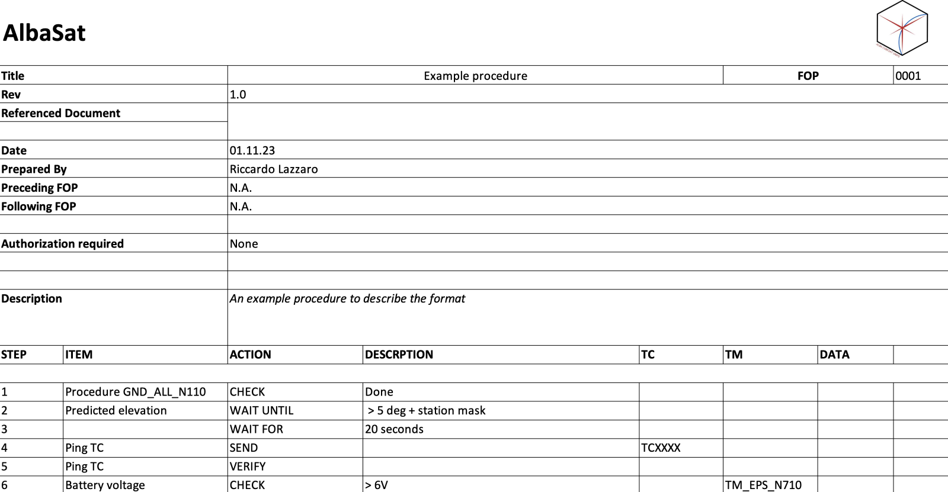

Figure 14: Example procedure

# Design Definition & Justification

## System Description

The system is based on a 2U CubeSat platform. The main functional requirements of the satellite bus are:

* to give support to payloads in terms of structural rigidity, power and data handling;
* to provide power supply to the satellite subsystems (through solar panels and batteries);
* to perform attitude determination and control in order to point the space debris sensors in the direction of the velocity vector and the corner cube retroreflector to ground;
* to transmit telemetry and payload data to the ground control centre.

A high-level functional architecture of the system is shown in Figure Figure . A more detailed description of the Operational Modes is described in Section 1.5.

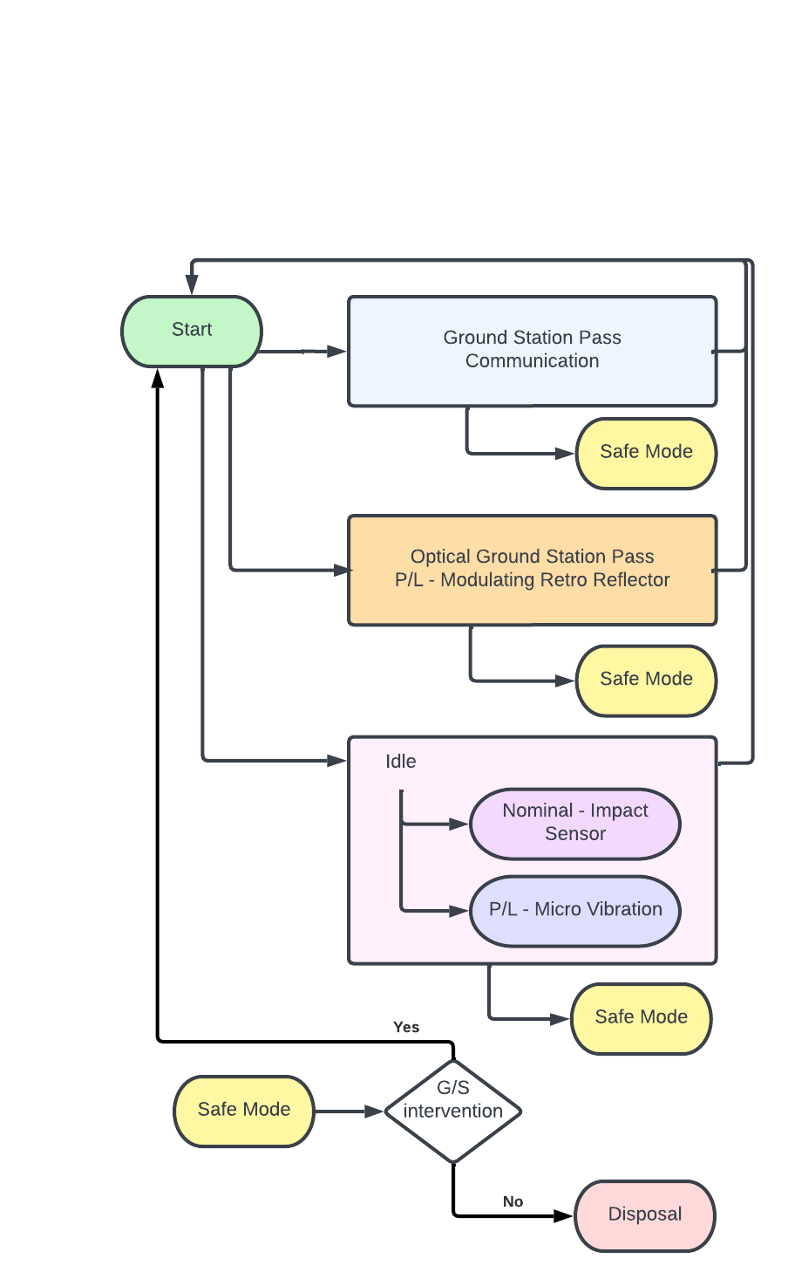

Figure 15: Functional architecture of the system.

### Physical architecture

Commercial Off The Shelf (COTS) are extensively used to build the satellite. The Impact Sensor, together with the micro-vibration sensor and the QuantumFuture Payload, are currently under development in house. It must be noted that several space debris sensor breadboards have been already developed and tested in the University of Padova’s CISAS Hypervelocity Impact Facility in the last decade. Additionally, the Quantum Future group, that is the responsible for the development of the QPL, collaborates with Dynamic Optics to realize a custom prototype of the payload.

All the subsystems will comply with the PC-104 standard and will be mounted in vertical orientation. Table 21 shows the expected volume envelope of the subsystems when mounted inside the satellite while Figure 16 shows a graphical representation of it. A 10% margin is considered over the total envelope.

Table 21: Expected volume envelope of the subsystems.

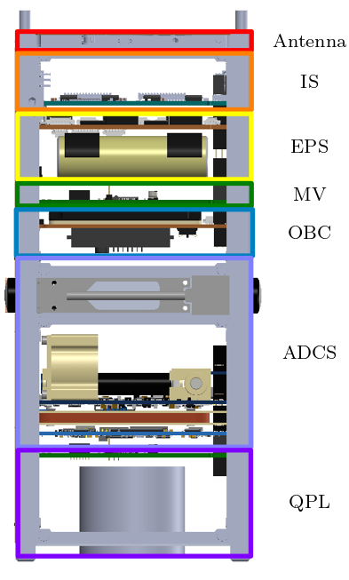

Figure 16: Visual representation of the envelope of each subsystem.

|  |  |
| --- | --- |
| **Subsystem** | **Expected Envelope (U)** |
| Antenna | 0.05 |
| P/L IS (Impact sensor board) | 0.25 |
| EPS | 0.22 |
| P/L MVS (Micro Vibration Sensor) | 0.12 |
| OBC | 0.12 |
| ADCS (considering magnetometer and sun sensors) | 0.62 |
| P/L QFP (MRR and board) | 0.42 |
| Total Envelope | 1.80 |
| Total Envelope + 10% margin | 1.98 |

The physical architecture of the system is shown in Figure 17. All the subsystems communicate through a CAN bus architecture, exception made for the payloads that communicate directly with the OBC using different protocols such as: I2C and UART.

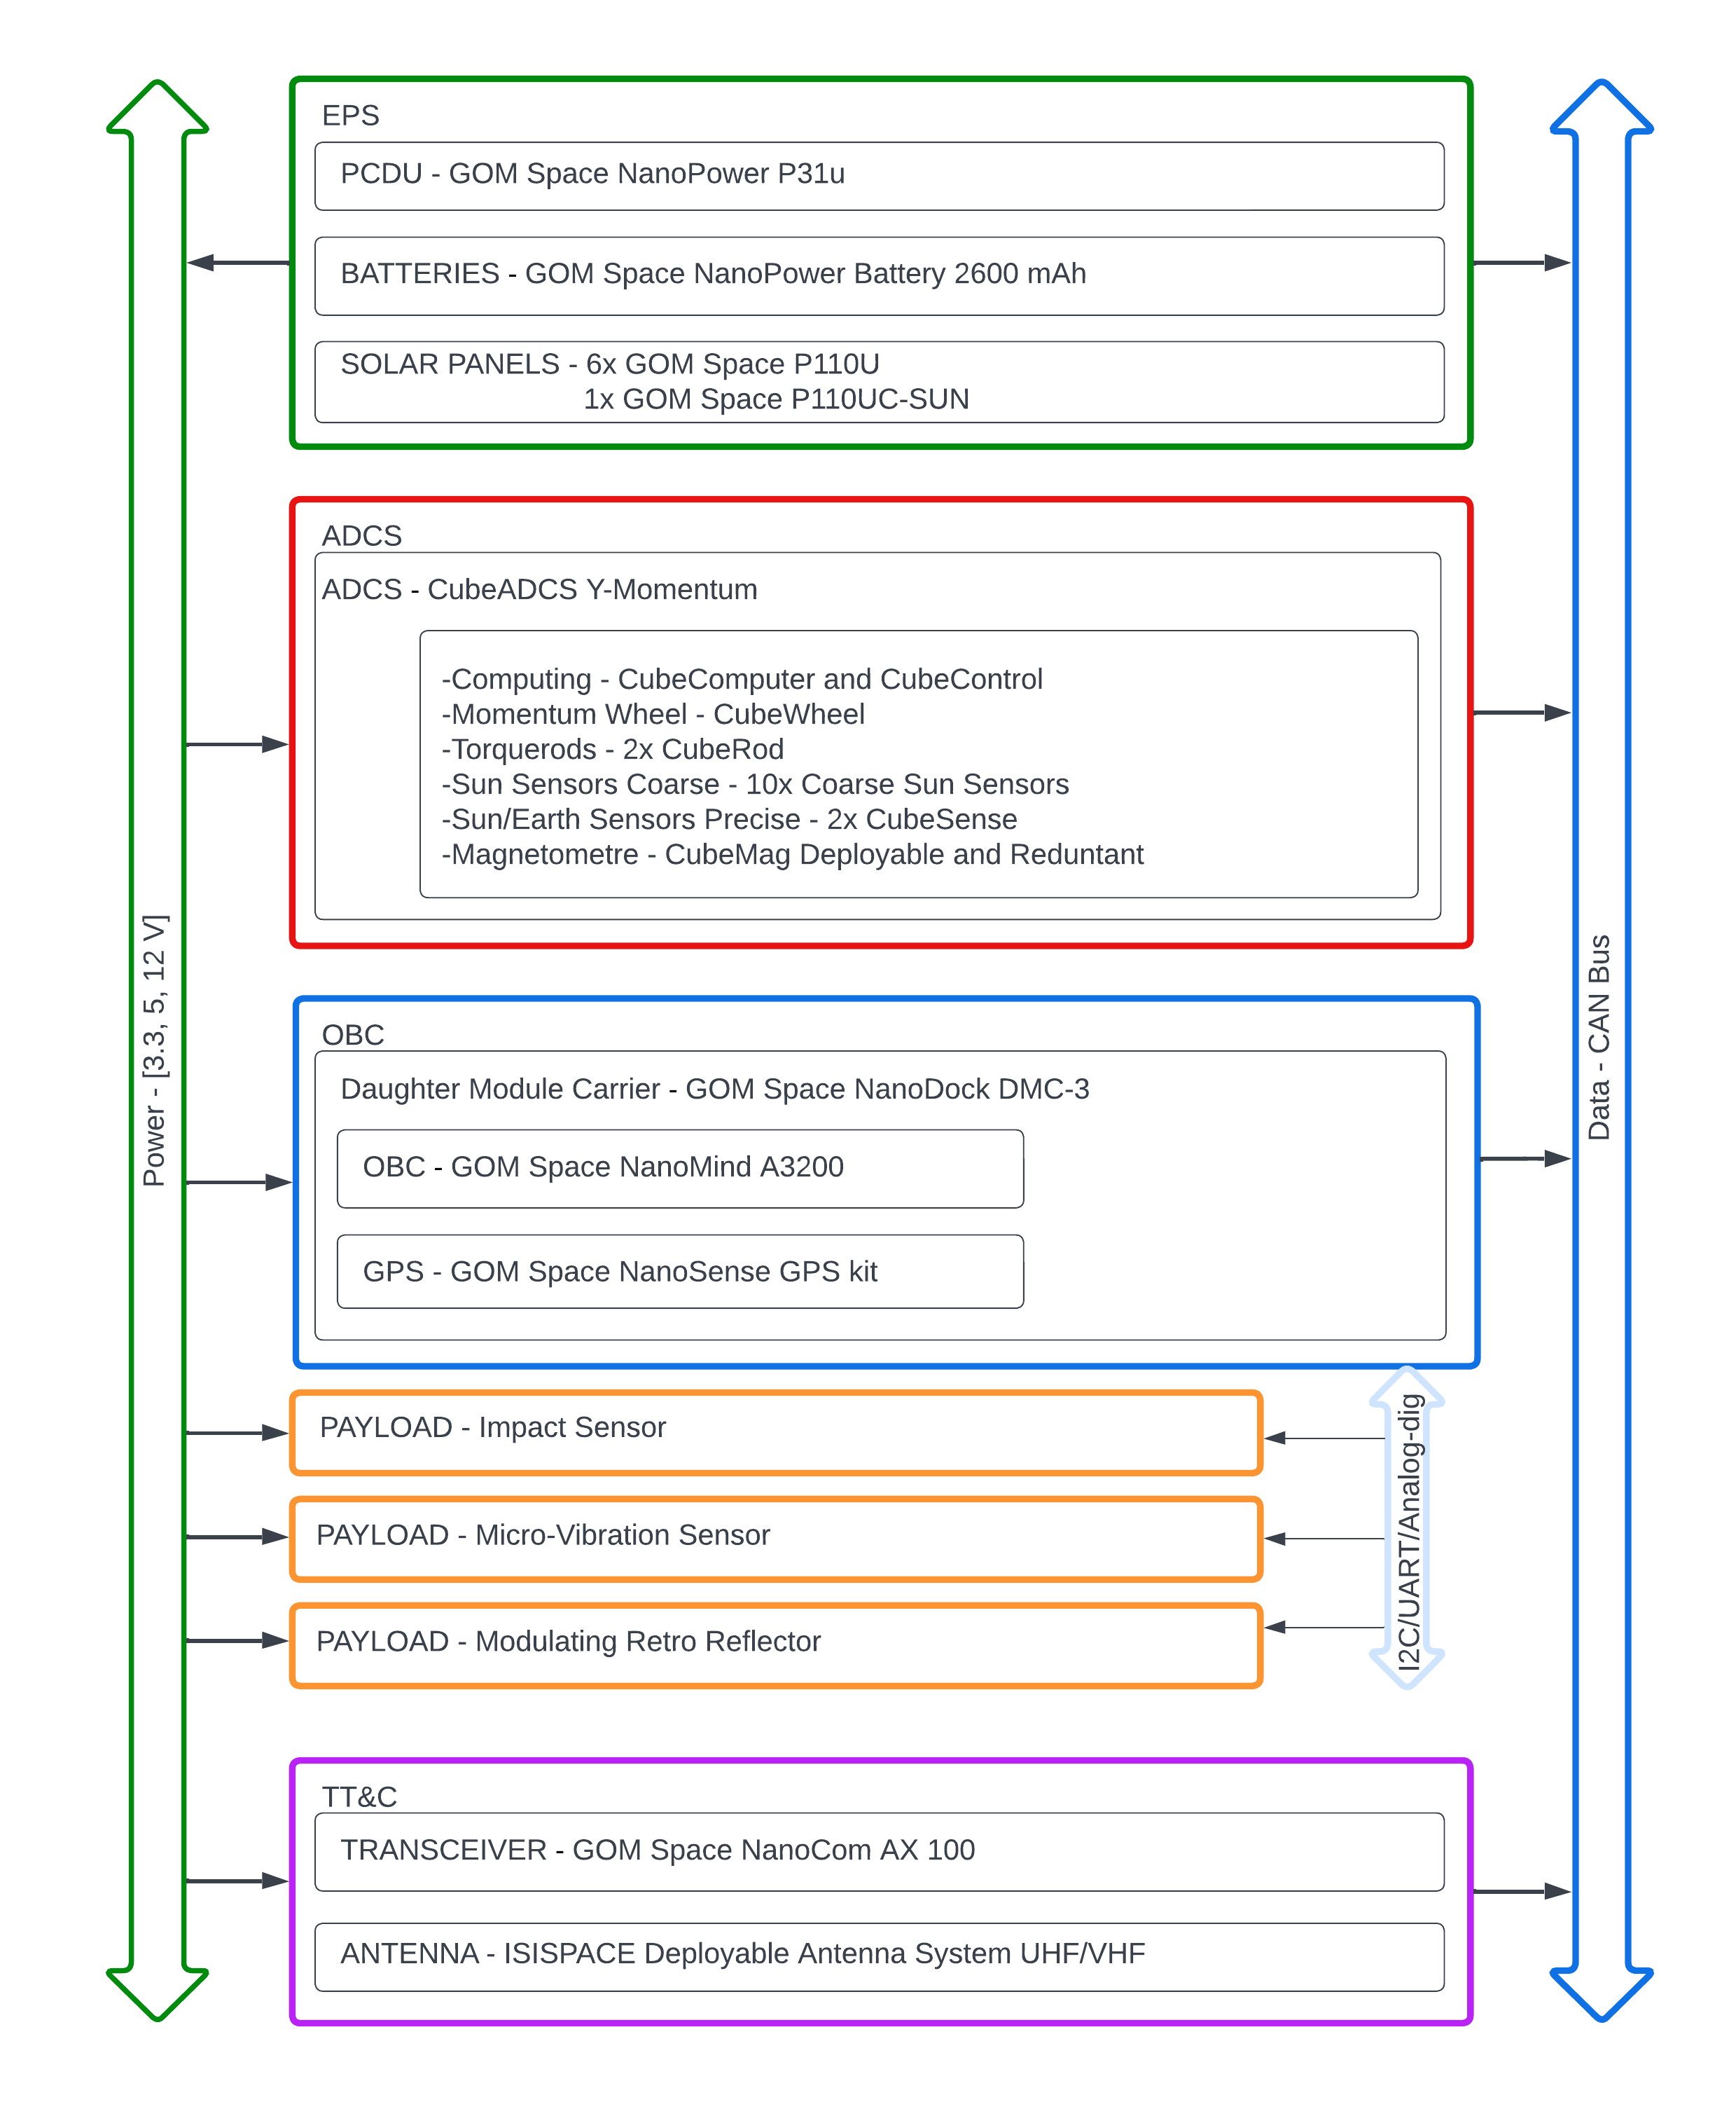

Figure 17: Physical architecture of the system.

### Coordinate reference frames

The following list reports the complete set of reference frames considered (Figure 18Figure ) and gives their definitions. The origin of each reference frame is attached to a body of the system. The frame rotates rigidly with the body geometry, except for the LVLH frame that is an orbital frame.

* Local Vertical Local Horizontal (LVLH): it is the standard orbital frame in which is towards the direction of the Nadir, is the opposite to the direction of the orbital angular momentum and . The origin is coincident with the barycentre of the CubeSat.
* Body Fixed Frame (BODY): it is a fixed frame with origin at the barycentre of the satellite.

Considering the Geometric Fixed Frame, the Impact sensor will be placed on the face, and the QPL on the face. The face will point towards the Nadir direction. The coordinate system complies with the requirement FDS-VCD 4.1.1.

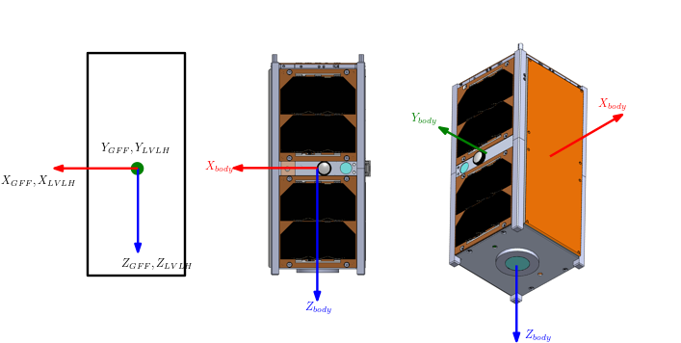

Figure 18: Reference frames used on the satellite.

The ADCS has a different reference frame that is used from all the sensors and actuators as reference. The figure below represents the axes orientation.

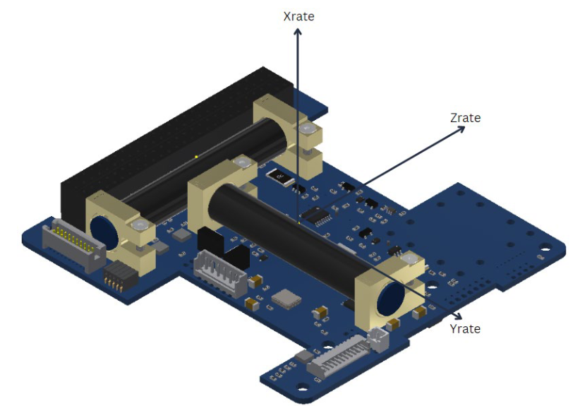

### Spacecraft System Configuration

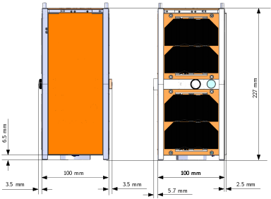Figure 19 shows the dimension of CubeSat in the stowed configuration. The satellite is compliant with the requirement 4.1.17 and 4.1.5 of the FDS-VCD. In **Errore. L'origine riferimento non è stata trovata.** the position of the two killer switches and the two separation springs on the face of the CubeSat are highlighted. A complete view of the satellite is visible in the exploded view, the key components are labeled and referred to the table in the same technical drawing.

Figure 19: CubeSat dimensions in stowed configuration. LEFT: view of the face. RIGHT: view of the face.

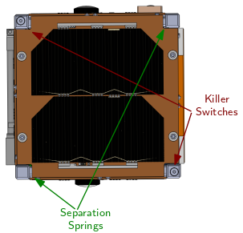

Figure 20: View of the face of the CubeSat.

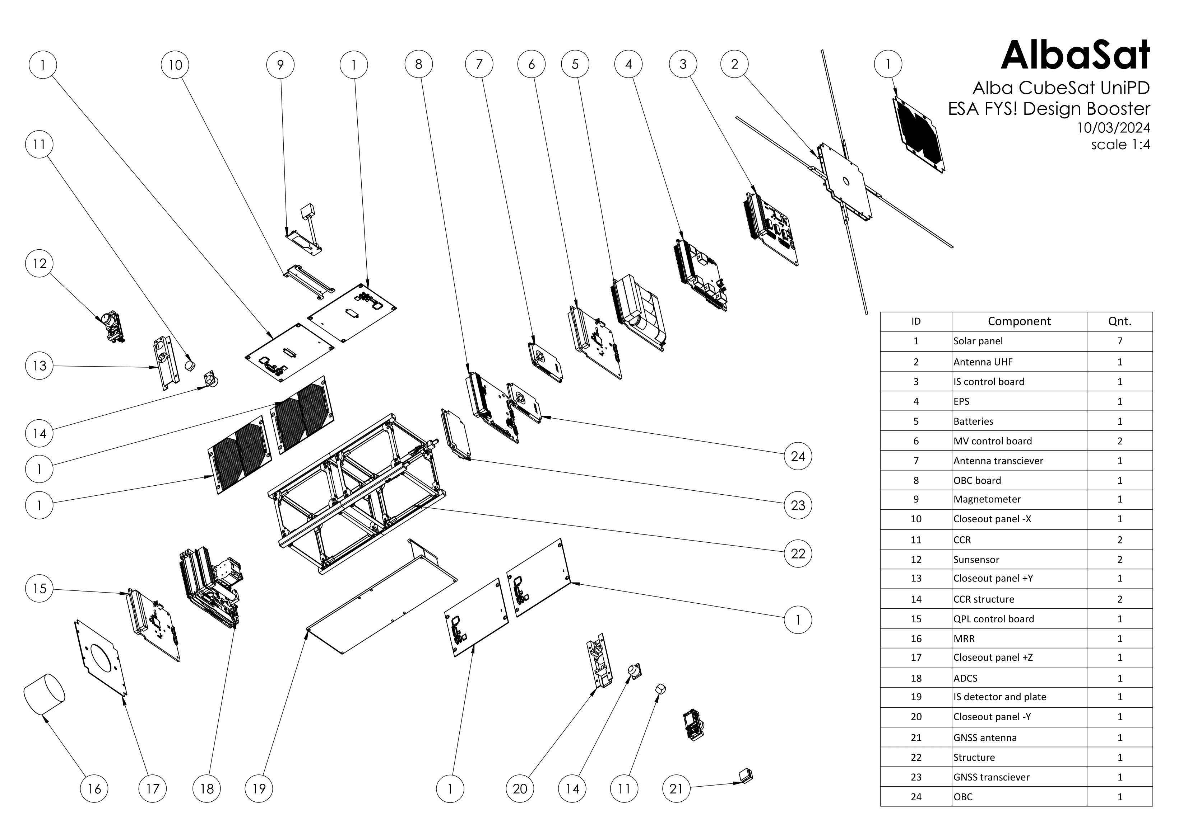

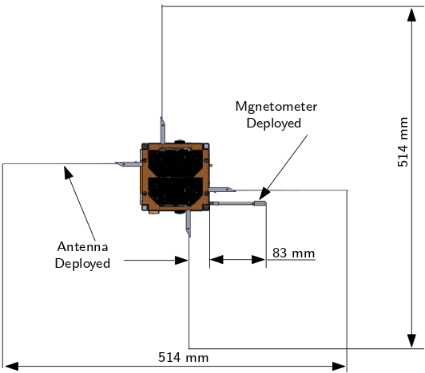Figure 21 shows the CubeSat in its deployed configuration from the face. The deployable mechanism are the antenna and the magnetometer. An isometric representation is visible in Figure 22. The magnetometer once deployed protrude from the face of the satellite of 83 mm.

Figure 21: Dimensions of the deployed components: antenna and magnetometer.

Figure 22: Isometric view of the CubeSat in a deployed configuration.

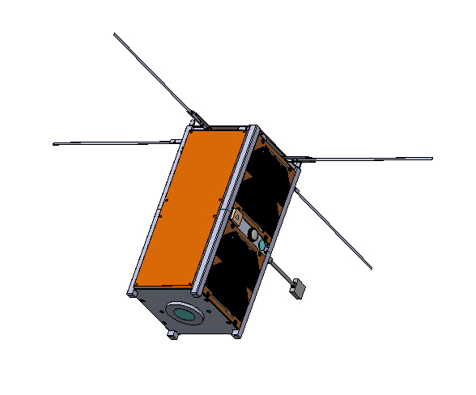

### Radiation protection/mitigation

Cosmic radiation may lead to data degradation while in memory, with the main problem being single or burst-like bit flipping. With the OBC not being rad-hard, software measures must be taken to increase data reliability. Fault handling procedures are presented in Section .

## Payloads

### Impact Sensor

#### Impact Sensor Quick Facts Table

The CubeSat is equipped with an Impact Sensor to allow the measure of impacts with sub-mm space debris in LEO. Table 22 shows the main characteristics of the payload.

Table 22: Impact Sensor main characteristics

|  |  |
| --- | --- |
| Mass | 240 g (TBC) |
| Data Rate | Nominal: 4 B per day  Worst Case: 2.4 kb per day |
| Average power consumption | 0.25 W (TBC) |
| Detector sensible area | 68 x 211 mm |
| Resolution | 160 μm |

#### General Description

This section presents the preliminary design of the payload. The team consolidated the design of the payload through numerical analyses, functional tests of the software performed on a breadboard model of the sensor (ALB_PAY-TRPT_IS), functional and vibration tests performed on the DM (ALB_PAY-TRPT_IS_DM), and environmental tests on the EQM (ALB_PAY-IS_VIBE-TRPT and ALB_PAY-IS_TVAC-TRPT). Impact analysis using the DRAMA software is presented in the Payload Performance Analysis Report (ALB_PAY-ARPT_IS).

The aim of the payload is to collect in-situ measurements of the sub-mm space debris environment in LEO (requirement SAT-MIS-100). The impact sensor has been developed starting from the literature and from the strong background vested in our university in this field. Its architecture is based on solutions already tested in space, such as the DRAGONS experiment on board the ISS Space Debris Sensor [3]. With respect to previous models, this impact sensor employs only resistive stripes, and it is miniaturized to be hosted on a 2U CubeSat face.

The impact sensor consists of a support plate having a face covered by a series of conductive stripes arranged on a thin nonconductive film, exposed to the space environment and placed on the face of the CubeSat, therefore the axis shall be aligned with the velocity direction of the satellite (Requirement PL_IS-CON-101). The stripes are parallel to the direction. An impact is detected when one or more stripes are severed. The impact sensor is switched on and off by the OBC depending on the mode of the satellite (PL_IS-FKT-104). When it is on, it continuously monitors the status of the stripes.

The sensor reads the stripes status (SYS-MIS-100) with a sampling frequency of 1 Hz (PL_IS-PRF-102), and transmits to the OBC (PL_IS-INT-106) only in one of these occurrences:

* if requested by the OBC
* if the stripes status changes (i.e., at the event of an impact).

The routine activity of the impact sensor system shall be:

* receive periodically a status check request by the OBC, output sensor state (error message)
* spontaneously send complete strip status to the OBC if an event is detected
* respond to commands from OBC.

#### Physical and functional architecture

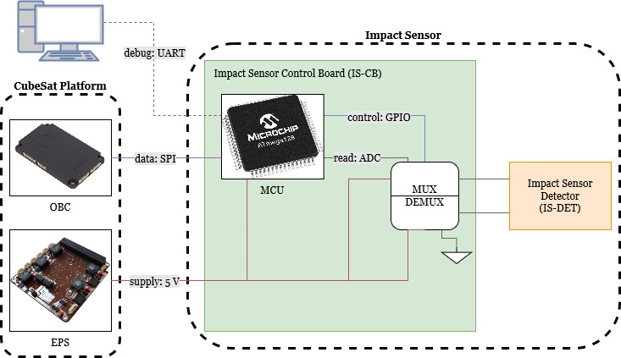

Figure 23: Functional scheme of the impact sensor.

Figure 23 shows the functional diagram of the IS system. The two main components of the sensor (Control Board and Detector) are shown with their connections. The other subsystems involved in the functional interface are represented: OBC for the communication and EPS for the power supply.

Figure 24Figure shows the schematic view of the preliminary circuit design of the development model of the sensor. The control circuitry consists of a Micro Controller Unit (MCU), a multiplexer (mux) and a demultiplexer (demux). The stripes are connected on one side to the mux and on the other side to the demux. The mux is connected to the MCU and both the MCU and the demux are connected to ground. Due to the chosen connection layout, the maximum number of readable stripes depends on the square number of select lines of the mux/demux couple.

The connection layout, using a 1:n mux and a n:1 demux, allows to control n2 stripes. Each mux channel is connected to n consecutive stripes, and each demux channel is connected to n stripes, each one appertaining to a different mux channel. Blocking diodes are used in order to allow the selection of a single line by the control circuit.

The IS software loops through the stripes measuring their state (one bit per stripe: 0, intact; 1, broken). It memorizes the status of the stripes and, if it changes, the IS software sends the new status to the OBC (binary word) via an UART connection. Each stripe is identified by a combination of the 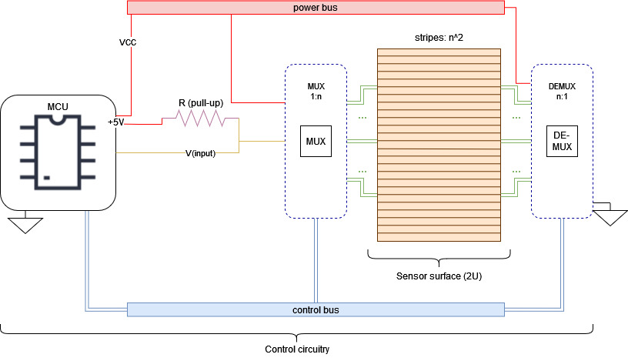selected pins of the mux and the demux. To read the stripes, a slower loop selects the mux line to check, and a faster one loops through the demux lines, to read the stripes consecutively and map their state. When a stripe is selected, it is connected through the pull-up 10 kΩ resistor to the +5 V source, which allows reading. For instance, with only two channels connected (n=4), it is possible to read 42=16 stripes, identifiable with the selected channel of the mux (0,1,2,3) and the selected channel of the demux (0,1,2,3). The IS software reads the stripes in order, by locking onto each mux channel and looping on the demux channels. The sequence of stripes to be read (ID: mux/demux) is 0/0, 0/1, 0/2, 0/3, 1/0, 1/1, 1/2, 1/3, etc. until the last one to be 3/3. Each stripe status is saved as a bit (0, intact, closed circuit; 1, broken, open circuit), and so status data are a 16-bit word formed in this way. This logic is extendable to a larger number of lines. The sensor keeps sampling after an impact. A functionality test using a breadboard model (Figure 25) is reported in the Impact Sensor Payload Test Report document (ALB_PAY-TRPT_IS).

Figure 24: Electrical scheme of the impact sensor.

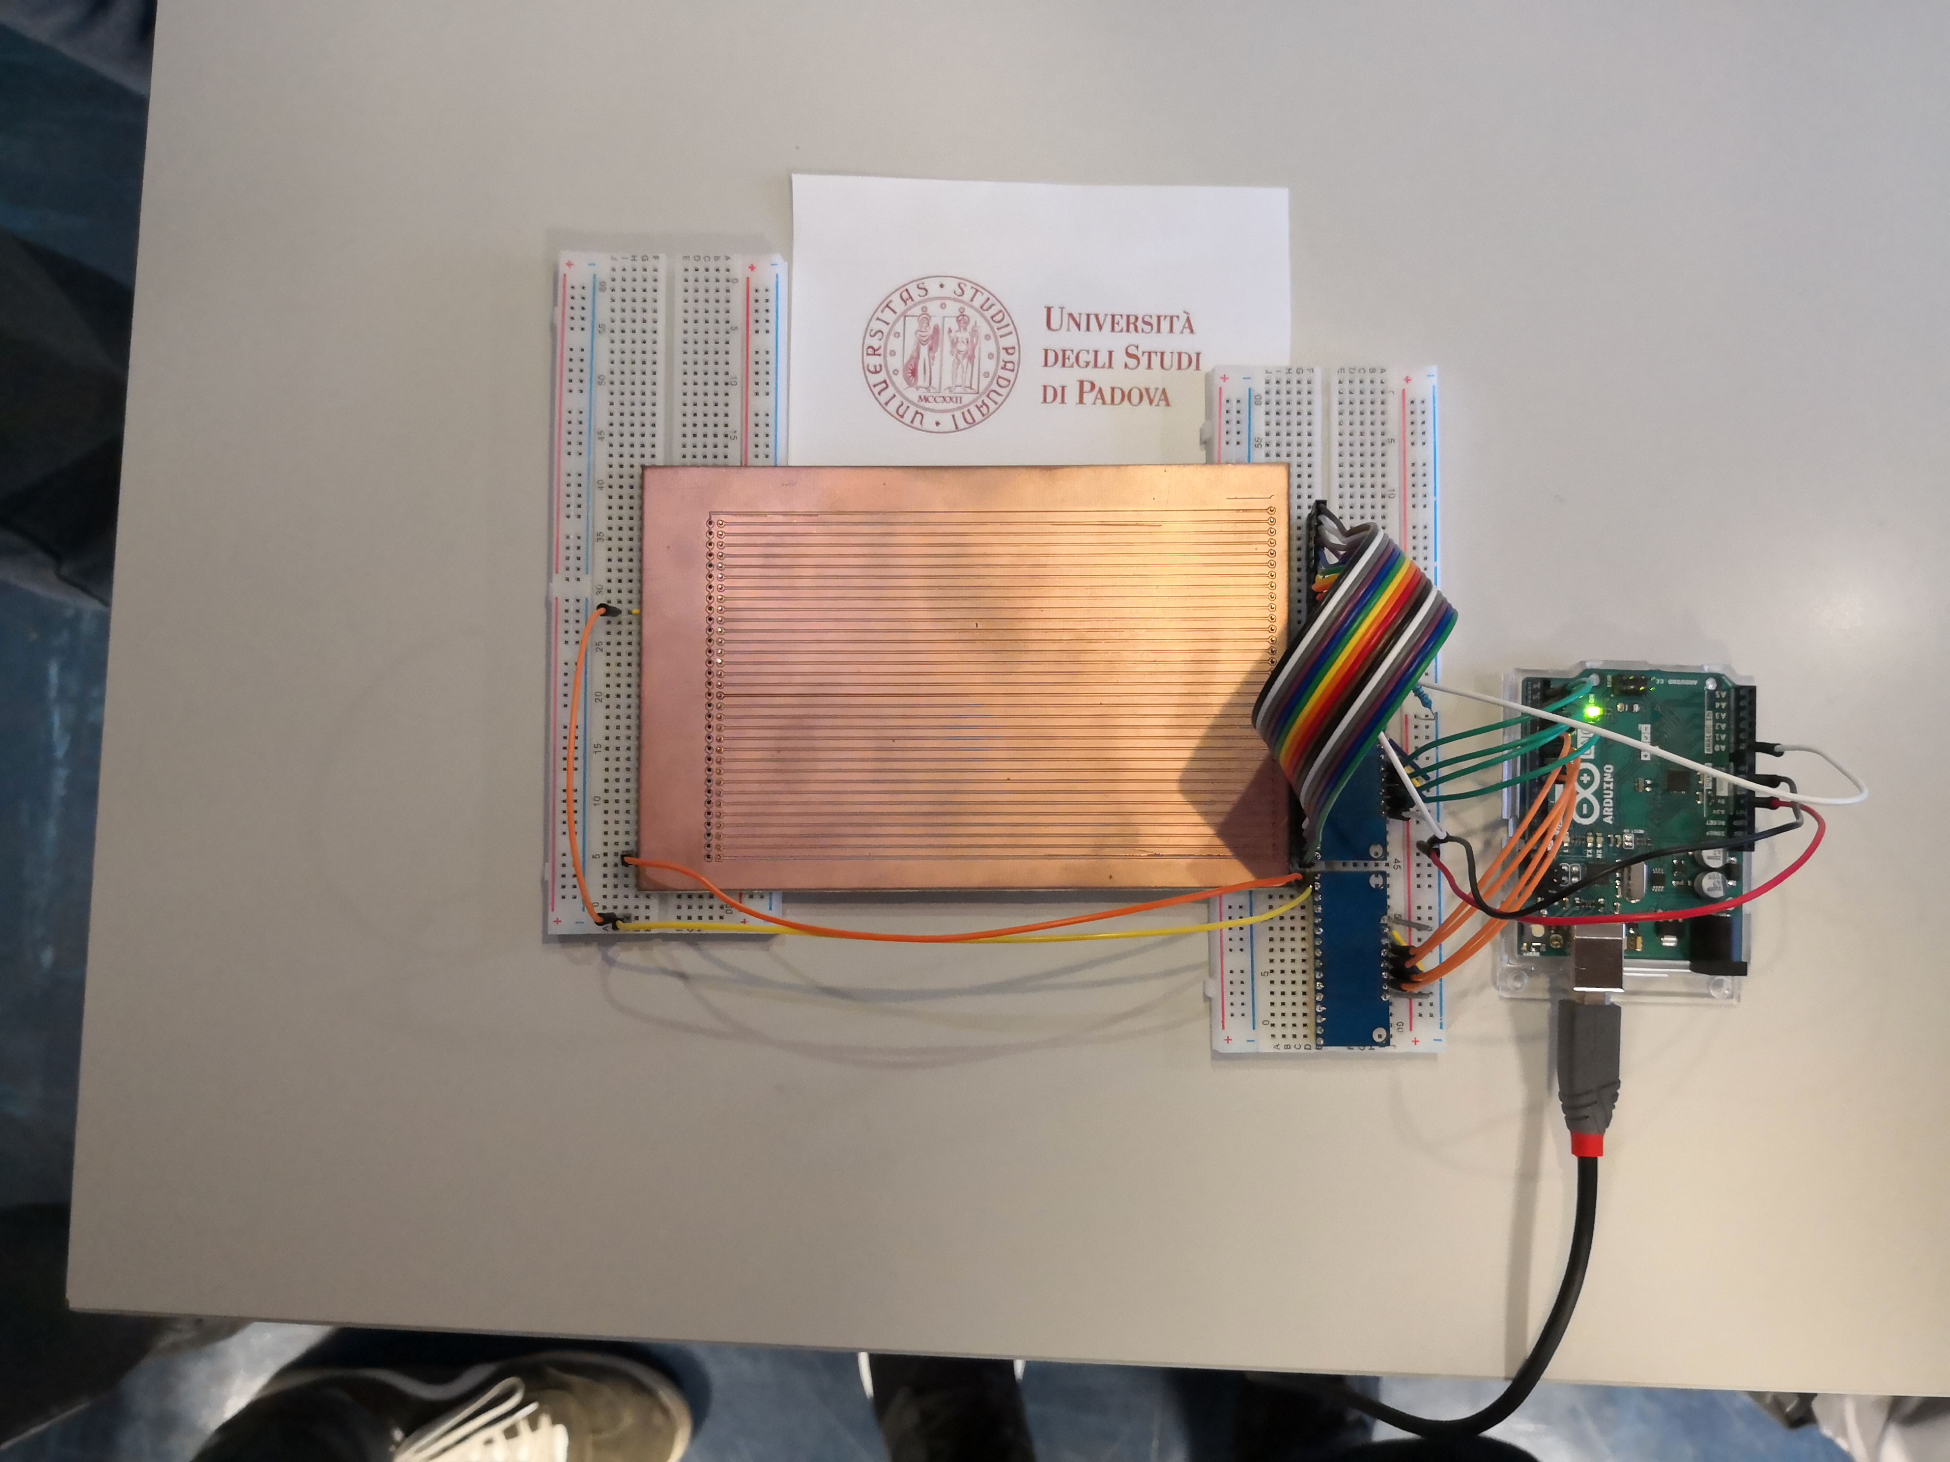

Figure 25: bread board model of the Impact Sensor.

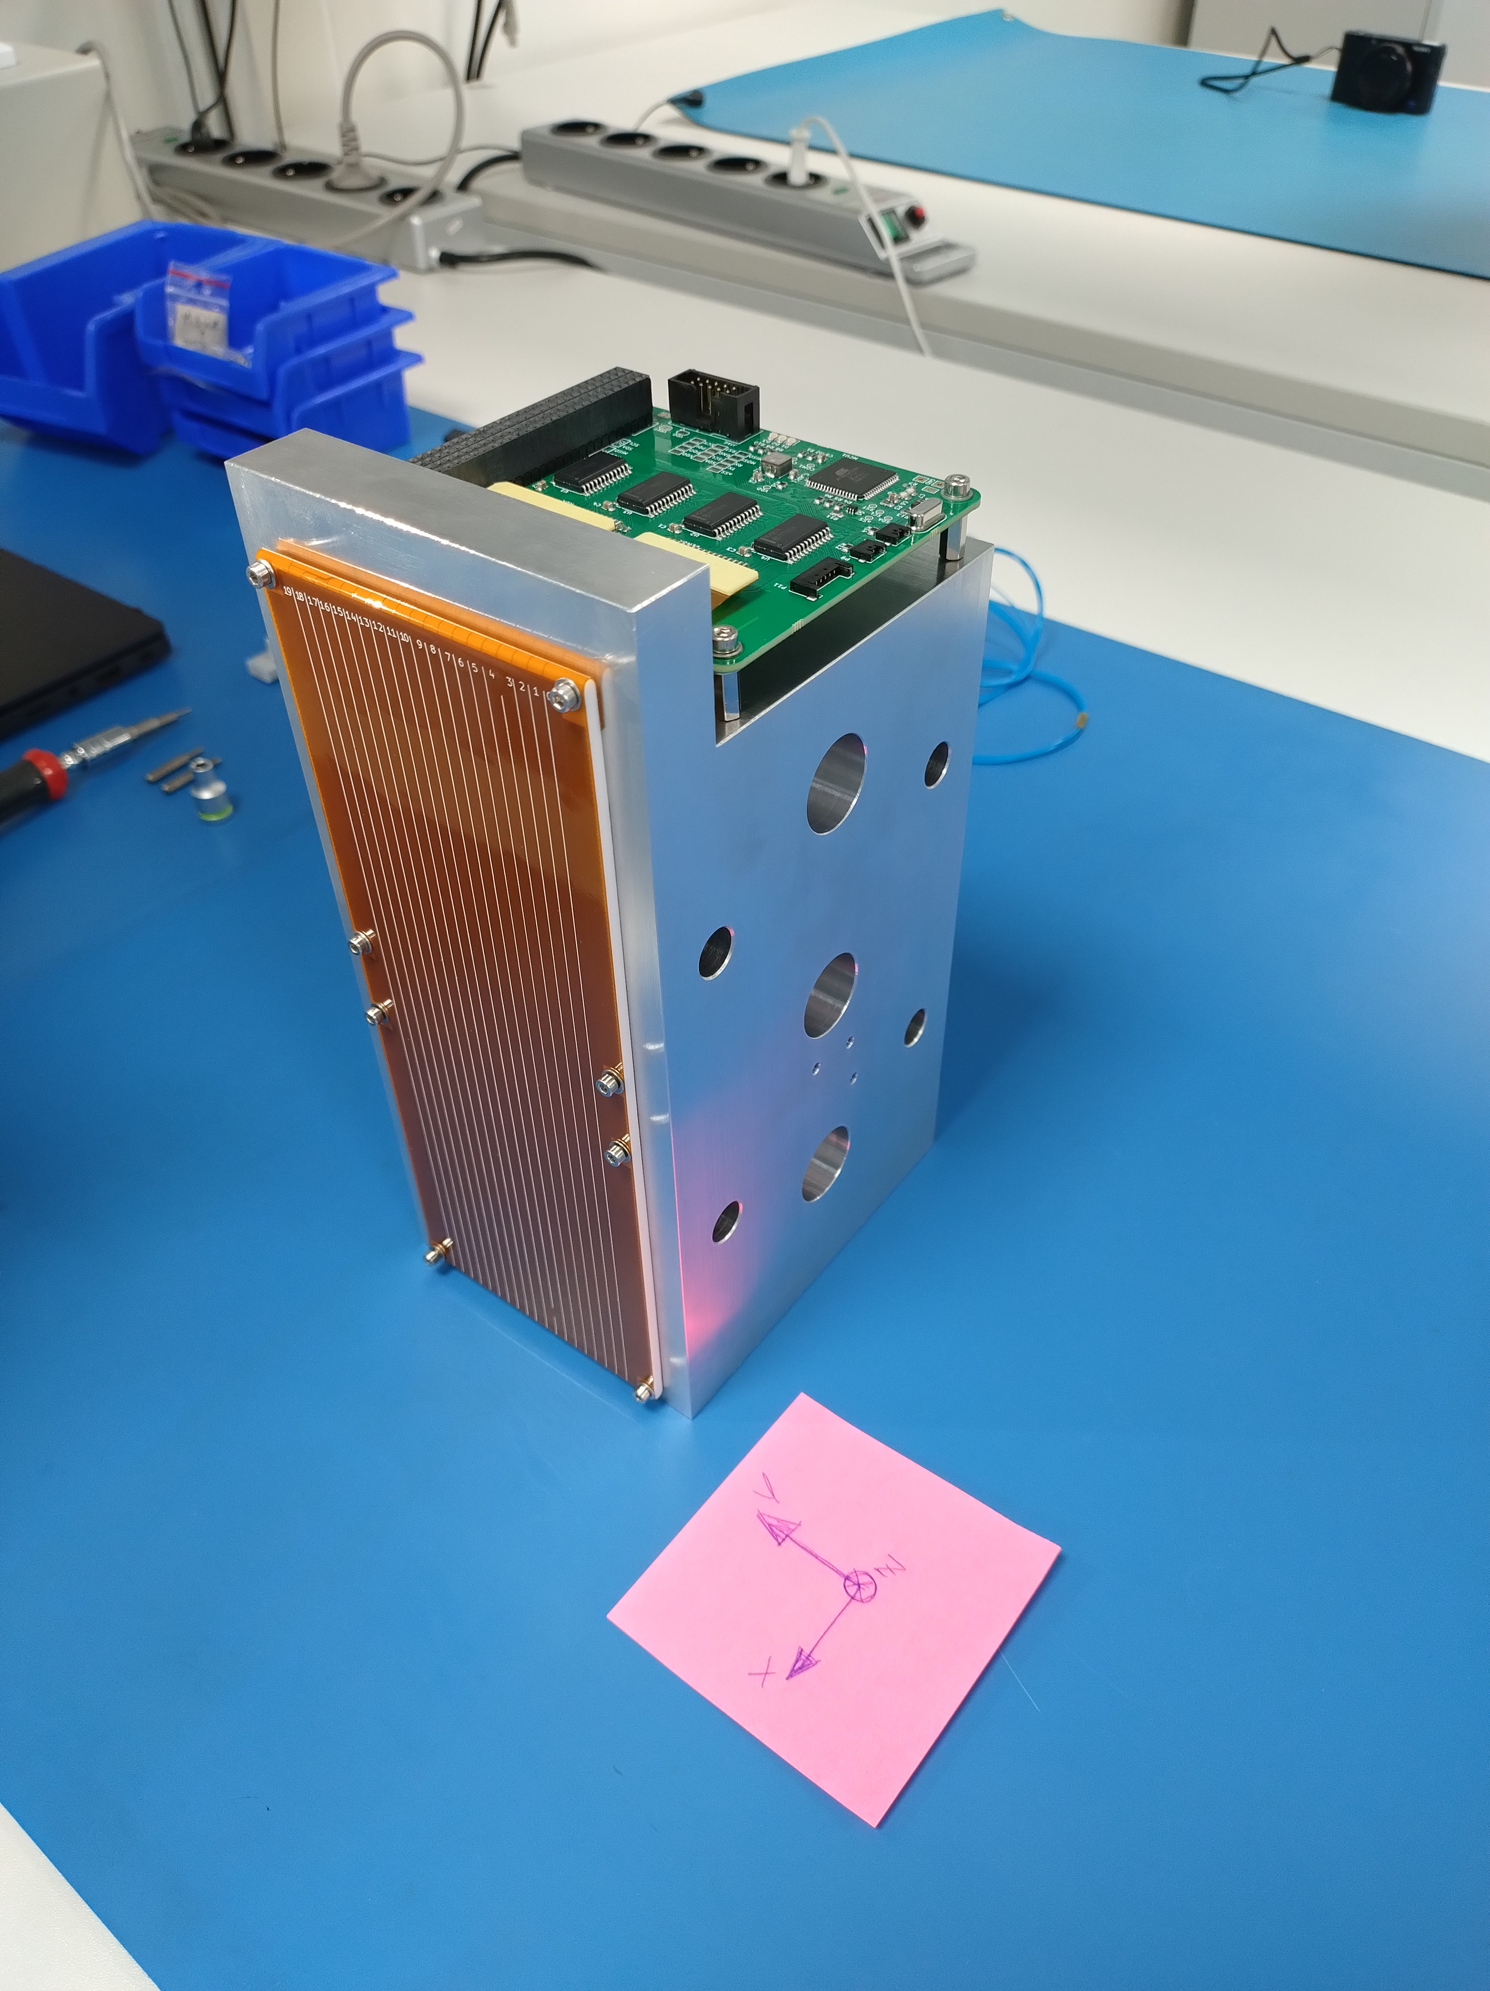

Figure 26: EQM of the Impact Sensor mounted on the interface for the qualification vibration tests.

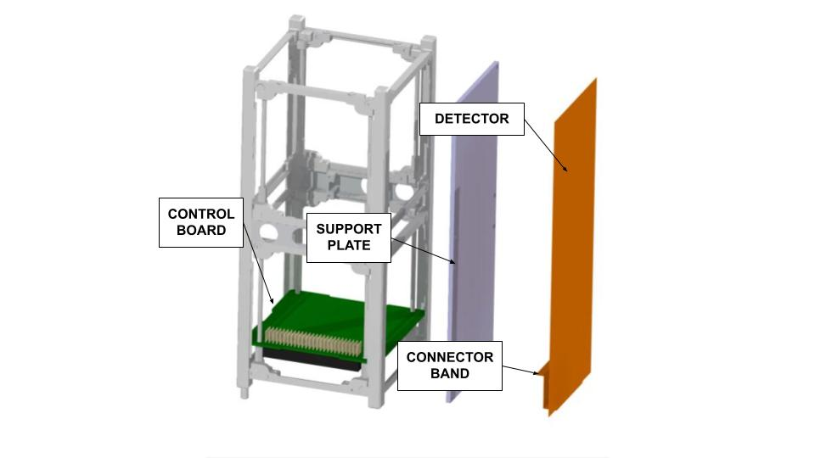

Figure 27: Impact sensor physical architecture

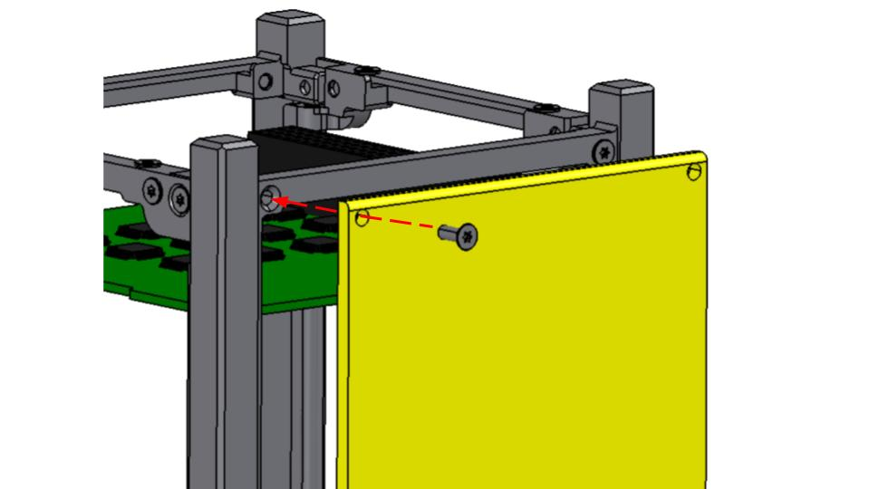

Figure 28: Representation of the mounting of the IS

The physical architecture of the Impact Sensor is shown in **Errore. L'origine riferimento non è stata trovata.**. The sensor is composed by:

* Support plate
* Detector
* Connectors band
* Control Board

The support plate has two purposes: (1) it provides structural rigidity to the detector and (2) it shields the CubeSat from the impact with detected space debris. The support plate, on which the sensor is attached, consists of a Teflon plate 3 mm thick. Teflon has been selected as it already has flight heritage and has good and well-known properties (low thermal expansion coefficient and good mechanical properties). It is fixed to the primary structure of the satellite by 8 screws (**Errore. L'origine riferimento non è stata trovata.Errore. L'origine riferimento non è stata trovata.**) exploiting the mounting holes designed for the solar array already present in the structure.

Considering constraints imposed by the CubeSat Design Specification (CDS) [1] and the envelope of the physical interfaces, the detector has a sensible area of 68 mm x 211 mm (**Errore. L'origine riferimento non è stata trovata.Errore. L'origine riferimento non è stata trovata.**). In this area are placed the conductive stripes. They are realized by etching a thin copper layer (thickness 35 μm) on a film of polyimide (Kapton) (thickness 0.29 mm) using the technology of flexible PCBs. Polyimide is widely used for space applications and its properties are well known. The stripes have a width of 80 μm and the space between two adjacent stripes is 80 μm. This allows the sensor to be capable of always (independently of the position of the impact) detecting craters with a diameter greater or equal to 160 μm (PL_IS-PRF-101). Craters with a diameter as small as about 80 μm could be detected if a conductive stripe is severed. With this setup, the number of stripes that can be printed in the width of the sensor (68 mm) is 440. In order to read the 440 lines of the sensor, a 32-channel multiplexer and a 32-channel demultiplexer are used.

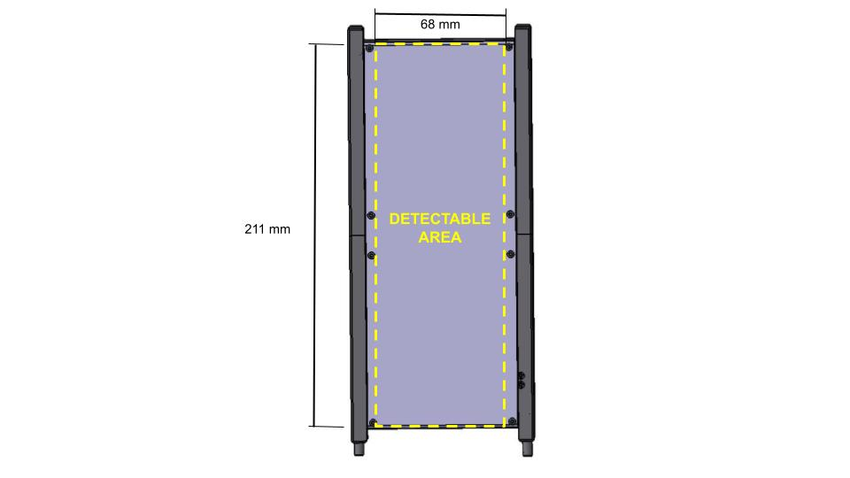

Figure 29: Area where an impact with a space debris can be detected.

The Control Board (standard PC104) contains the electronics components of the control circuitry: MCU, mux, demux and the interfaces with satellite and detector Connectors Band. All the control circuitry is contained on a single PC104 board.

#### External Environment

From preliminary calculations the presence of the Atomic Oxygen (AO) in LEO environment causes a kapton surfaces degradation of [0.6-6] μm per year. This degradation seems to be not critical since the external Kapton layer is of the order of 0.1 mm. Therefore, an AO protection coating proposed in reference [2] is not necessary.

The detailed analyses about AO and radiation environment are reported in the dedicated Analysis Report (ALB_PAY-ARPT_IS-RAD)

The thermal analyses reported in ALB_THR-ARPT demonstrate that the ranges of temperature experienced by the sensor are within the operational limits of the electronics and materials of the sensor (Requirement PL_IS-ENV-105).

#### Technical budgets

**Data budget**

The sensor sample rate is 1 Hz. Since one bit is used to define the status of each stripe, 440 bits are necessary to fully read the sensor. Considering a sampling rate of 1 Hz the data rate is 440 bps, adding a 20% margin (technology under development), the data rate estimation is 520 bps. However, while the sampling rate is 1 Hz, the status is completely dumped only if a change in it occurs. Hence, 520 bps is a worst case scenario. In the 4 passages over the GS, 2.78 kb are hence sent in total, keeping in mind that more could be stored in the OBC (very unlikely). A safety algorithm to suppress the sending of too much data is planned to be implemented in the payload software.

In the routine case (see section 3.2.1.2), the sensor only sends an error message to OBC when requested, of 1B size, which corresponds to an almost negligible data rate, so 4 B per day are nominally sent to the GS, if no event happens.

**Power budget**

Power consumption is roughly estimated to be 0.25 W (PL_IS_PRF-110) considering the power consumption of the EQM of the sensor.

**Bibliography:**

[1] CubeSat Design Specification (1U – 12U), REV 14.1, CP-CDS-R14.1

[2] M. Nakamura, Y. Kitazawa, H. Matsumoto, O. Okudaira, T. Hanada, A. Sakurai, K. Funakoshi, T. Yasaka, S. Hasegawa, M. Kobayashi, Development of in-situ micro-debris measurement system, Advances in Space Research, Volume 56, Issue 3, 2015, Pages 436-448, ISSN 0273-1177

[3] P. Anz-Meador, M. Ward, A. Manis, K. Nornoo, B. Dolan, C. Claunch, J. Rivera, The Space Debris Sensor Experiment, International Orbital Debris (IOC) Conference, 2019

### Micro-vibration Sensor

#### Payload quick facts table

The main purpose of this payload is to provide information about the micro-vibrations (MV) onboard the CubeSat throughout the mission phases. In particular, the main target of the payload is the measurement and the characterization of the microvibrations caused by the Momentum Wheel (MW) onboard AlbaSat. The purpose of it is to understand how their effect is spread inside the satellite when it is working.

The measurement is carried on by sensing the acceleration magnitudes along the three axes , , and in the time domain. A digital signal processor stage transforms the information carried in the time domain in the frequency spectrum by performing an FFT. Eventually the FFTs obtained from the process are used to compute the PSD mean from a specific number of time based acquisitions. The results are then sent to the OBC and transmitted to the GS.

The core of the payload is thus represented by a triaxial accelerometer which shall be able to detect the amplitudes of the micro-vibrations for each axis in a 0.1-500 Hz bandwidth and a digital signal processor that processes the data and interfaces the MVS board to the OBC. Table 23 shows the main characteristics of the payload.

Table 23: Micro-vibration sensor main characteristics

|  |  |
| --- | --- |
| Sensor | 3-axis MEMS accelerometer |
| Bandwidth | 0.1 - 500 Hz |
| Sensible axes | x, y, z |
| Accelerometer range | ±2 g |
| Resolution | 100 µg |

#### Physical and functional architecture

According to [1, 2, 3, 6], micro-vibrations are defined for a bandwidth that extends to a maximum of 1 kHz and for amplitudes of µg (micro-g). However, the interest on the field focuses on frequencies which usually do not exceed 500 Hz. This is mainly because the structures of the spacecrafts tend to filter the high frequency vibrations components [5].

Figure 30 shows the working principle of the Micro-Vibrations Sensor (MVS).

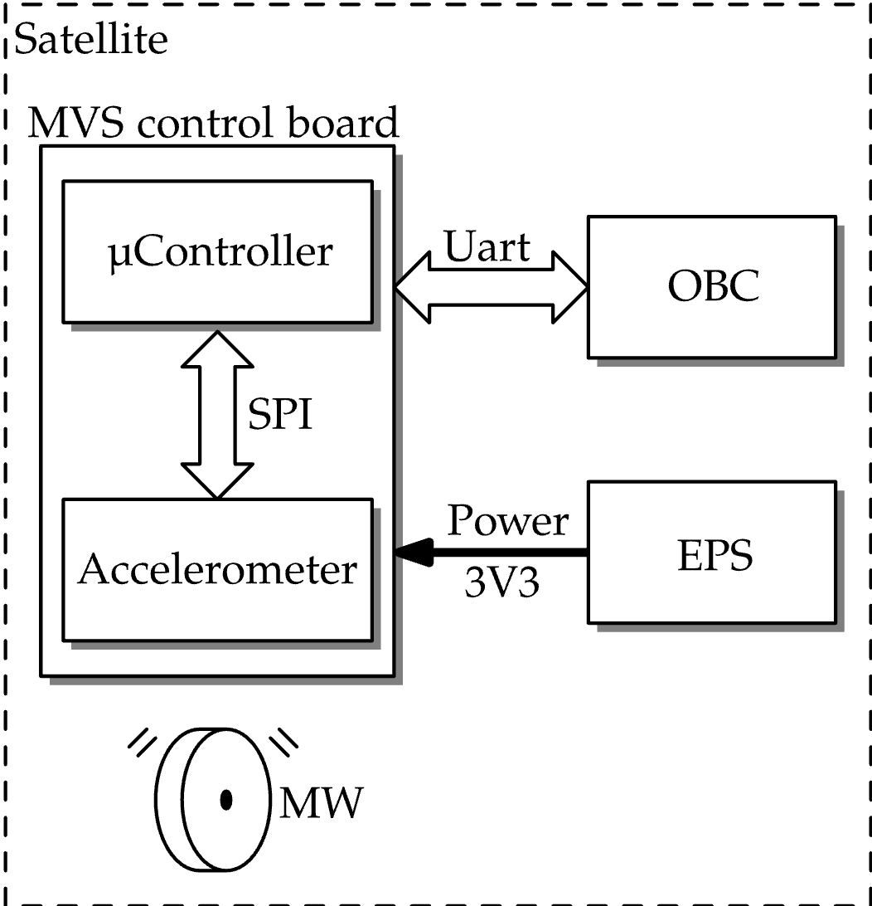

Figure 30: Working principle of the Micro-Vibration Sensor

The MVS board hosts an accelerometer, which is represented as the transducer, that measures the microvibrations generated by the MW. Together with the transducer, the MVS features the acquisition chain and it is responsible for the on-board analysis of the samples collected. A Fast Fourier Transform (FFT) and a Power Spectral Density (PSD) analysis of the signal is performed onboard. Then, the elaborated data is exchanged with the On-Board Computer which stores it in its memory. Data is eventually transmitted to the ground station at the first available passage.

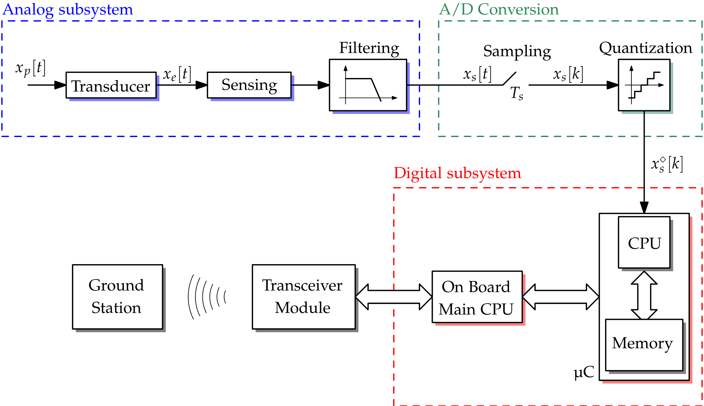

Figure 31: Architecture of the micro-vibration sensor

During the acquisition process, following a command from the OBC, the MVS is turned on and the accelerometer samples the micro-vibrations. The data collected by the accelerometer are elaborated and then transmitted to the OBC. **Errore. L'origine riferimento non è stata trovata.** shows the architecture of the MVS:

* The *transducer* is responsible for translating the physical energy generated by the micro-vibrations into electrical energy: it is represented by the triaxial accelerometer;
* the *sensing block* provides signal conditioning in order to exploit the optimum voltage excursion for the following stages to work properly;
* the *filtering stage* filters out the unwanted high frequency components to prevent aliasing during signal digitalization;
* the *Analog to Digital Converter* (ADC) block translates the analogue nature of the signal into a digital quantity more suitable for numerical processing: such stage is made by two main components:
  + the sampling (and hold) component which discretizes continuous time;
  + the quantization component (quantizer) which discretizes continuous signal amplitude;
* the microcontroller unit, denoted as μC, receives the digitalized data from the quantizer and represents the interface between the transducer and the On Board Computer; its main components are the following:
  + a *CPU* receives the resulting digital signal converted by the previous stages and processes it before sending it to the Cubesat On Board Computer (OBC). Furthermore, it provides synchronization and control signals;
  + a memory unit which temporarily stores the raw and processed data, supporting the CPU.

There are three main type of accelerometer which have been considered for the design:

* piezo-capacitive accelerometers;
* piezo-resistive accelerometers;
* Micro Electro-Mechanical Systems (MEMS) accelerometers.

The team developed a dedicated PCB that hosts a MEMS accelerometer and the entire signal processing chain. MEMS accelerometers have reached a high degree of both reliability and accuracy. Being built on a chip, they can be found along with the entire chain of signal conditioning and quantization directly providing the acceleration along the three axes to the μC throught the SPI protocol. Data will be sent to the OBC by means of the UART communication protocol. The digital signal processor chosen is a microcontroller unit (μC): the STM32U575 from the ST microelectronics.

Requirement of resolution and bandwidth are most crucial. In general, high resolution is obtained at expense of a lower bandwidth. The parameters of the sensor are reported in Table 24.

Table 24: MEMS accelerometer specifications

|  |  |  |
| --- | --- | --- |
| **Parameter** | **Value** | **Unit** |
| Accelerometer range | ±2, ±4, ±8 | g |
| Resolution | 3.9 (at ±2g range) | µg |
| Bandwidth | 0 to 1000 | Hz |
| Sensible axes | x, y, z |  |

The bandwidth of the accelerometer has been selected considering that the main source of micro-vibrations to which the payload is focused on is the momentum wheel.

Further details are exposed in the related MVS payload analysis report (ALB_PAY-ARPT_MVS_2024-03-10_v1.0).

Two MEMS accelerometers have been investigated after the requirements definition:

* the ADXL355 from Analog Devices;
* the IIS3DWB from STMicroelectronics

The former has been chosen because its main features, reported in **Errore. L'origine riferimento non è stata trovata.**, satisfies the payload requirements reported in **Errore. L'origine riferimento non è stata trovata.**. The ADXL355 accelerometer contains all the analog subsystem scheme and the analog to digital conversion scheme such data samples of the accelerations along the three axes are readily available for the microcontroller unit.

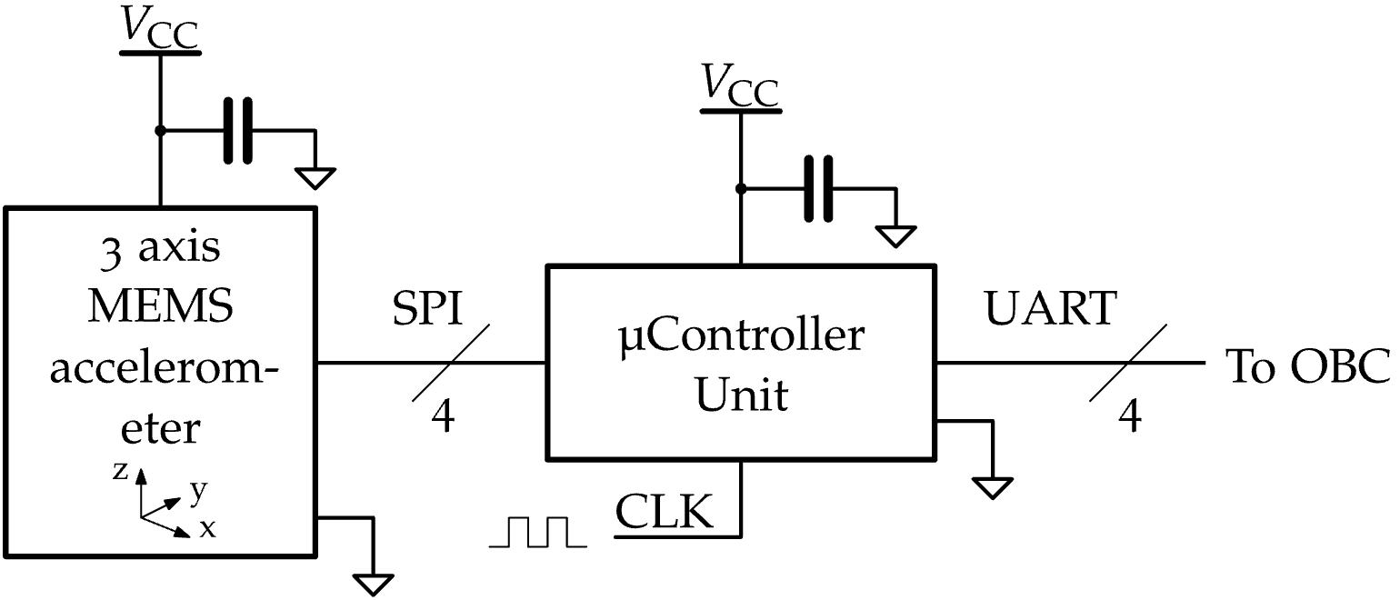

Figure 32: electrical schematic of the MVS payload.

Figure 33: Representation of the MVS board

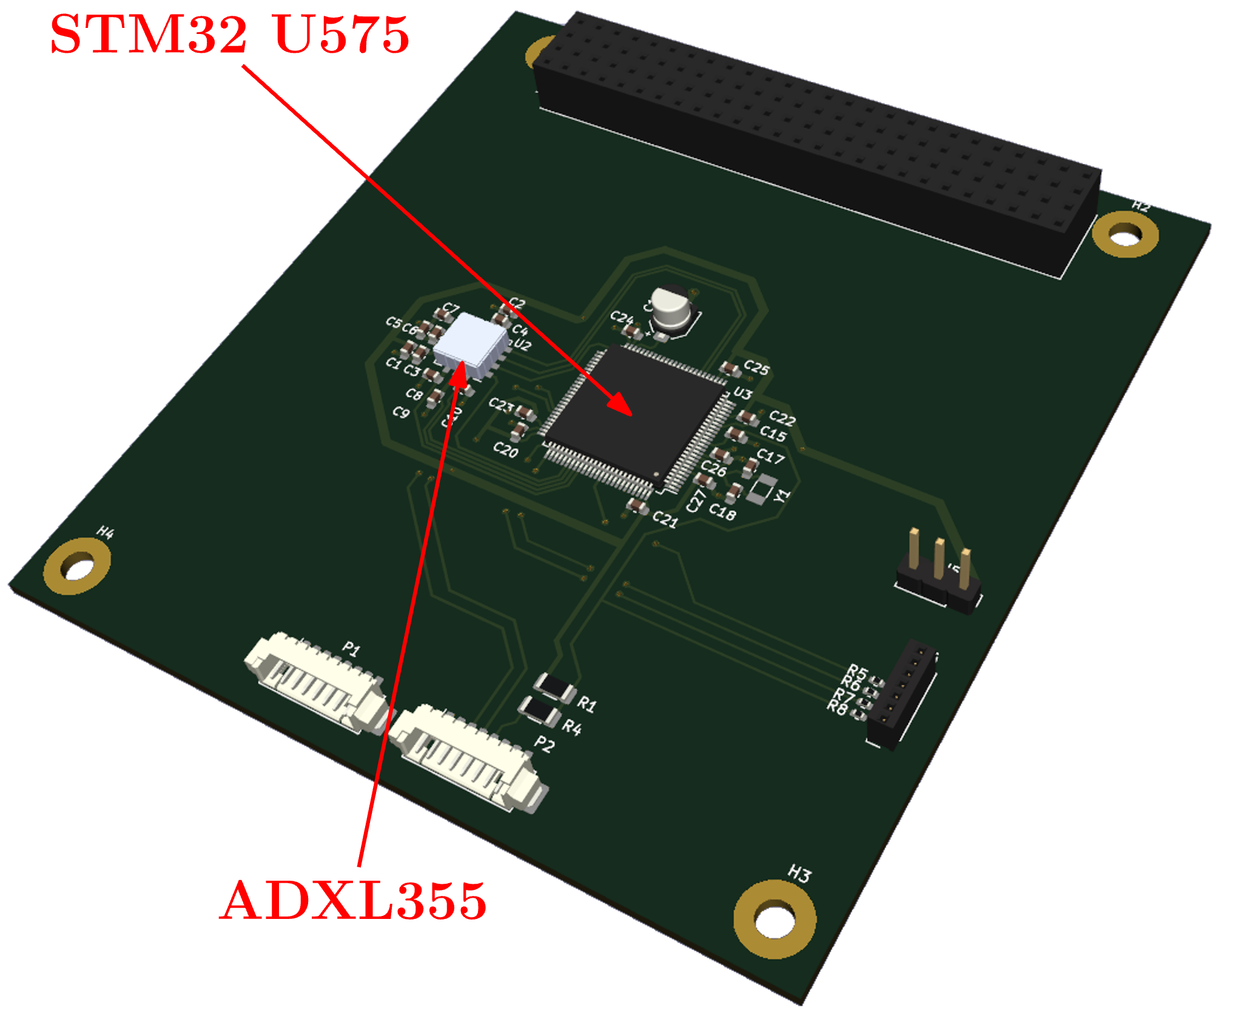

One can refer to the correspondent manufacturer datasheets to check that the requirements are fulfilled [9, 10]. The number of components used for the board is limited, hence the risk of physical space exceeding is very low. This can be also confirmed by the reduced complexity of the electrical schematic reported in Figure 32. A representation of the EQM of the MVS board is reported in **Errore. L'origine riferimento non è stata trovata.**.

The firmware developed for the MVS board is organized as reported in Figure 34. The microcontroller receives from the OBC a string containing the instructions to be executed. The Parser module selects the right command module based on an identification code contained in the OBC string. The ACQ Module and the ADXL355 Module realizes all the procedures to interface the microcontroller with the accelerometer. The Debugger is used only in the initial testing phase and collect debugging information from the microcontroller via SWO (Serial Wiewer Output) without degrading the overall board performance. The results from the acquisitions are sent to the OBC via UART.

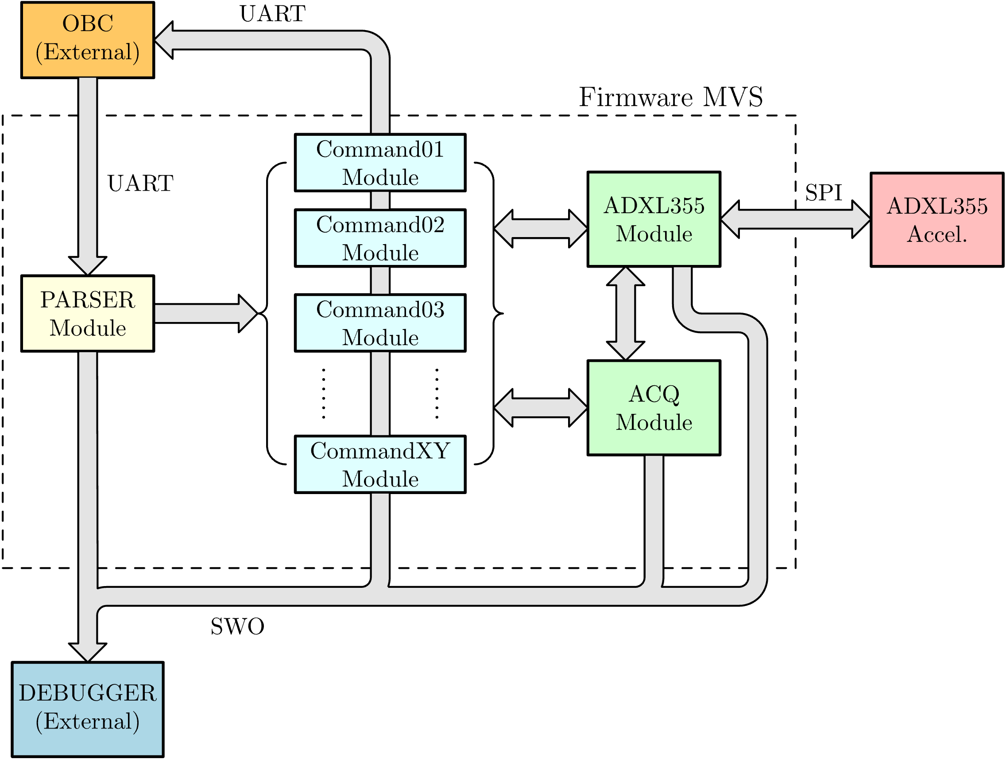

Figure 34: MVS microcontroller firmware modules

#### Payload technical budgets

**Power budget**

The MVS consumes power only during the acquisition mode and the consecutive post-processing phase. The MEMS sensor board is currently underdevelopment and at this stage the power consumption value can only be estimated by a study of the datasheet of the accelerometers and of the microcontrollers. Considering the state of art COTS accelerometers on the market and a generic low power microcontroller, the maximum power consumption of the MVS is estimated to be 30 mW (TBC).

**Mass Budget**

Considering the accelerometer, a typical PC104 board and the microcontroller unit, the total weight doesn’t exceed 50g (TBC). According to datasheets, the ADXL355 weighs 0.4g, STM type microcontroller weights approximately 1.8g and usually a PC104 board reaches 40g (TBC).

**Data storing and transfer budget**

The data generated by the MVS shall not saturate the memory available onboard. Hence, the MVS stops collecting data when the data volume reaches a threshold previously defined and transmitted with the mode activation TC. In order to avoid saturating the memory available onboard, the data collected by the MVS shall be transmitted during the next passage over the GS. Hence, the data stored equals the data transferred to ground.

In order to achieve the mission success criteria, 100.000 measures of the micro-vibration per axis shall be collected for the estimated mission duration. From this value the data volume produced every day by the MVS is evaluated to be equal to 4.38Mb. This data volume needs to be fully transmitted to the GS the first available passage. A safety margin is applied on the data volume that can be transmitted. With this assumption it has been verified that the data are fully transmissible during one passage over the GS.

|  |  |  |
| --- | --- | --- |
| **Quantity** | **Value** | **Unit** |
| Samples per acquisition | 8192 | sample |
| MV amplitude (storing register size) | 16 | b |
| Acquisition size | 131072 | b |
| PSD samples after processing | 5000 | sample |
| PSD size | 80000 | b |
| Number of PSDs per day | 55 |  |
| Size of data produced per day | 4.38 | Mb |
| Size of data produced throughout mission period | 300 | MB |

#### Analysis assumptions and results

The analysis performed allowed to obtain the value presented in the previous section. For more details on the assumptions and calculations please refer to the ALB_PAY-ARPT_MVS_2024-03-10_v1.0.

#### Bibliography:

[1] D. Addari, G.S. Aglietti, and M. Remedia. Experimental and numerical investigation of coupled microvibration dynamics for satellite reaction wheels. 386:225–241.

[2] A R Prashant, M Madheswaran, Varun Kartik, V Ramesh Naidu, P Govindan, and P Aravindakshan. System development for micro vibration measurements on spacecrafts. In 2016 International Conference on Control, Instrumentation, Communication and Computational Technologies (ICCICCT), pages 98–103. IEEE

[3] Geert Smet and Sandro Patti. A mechanisms perspective on microvibration – good practices and lessons learned.

[4] Dengyun Yu, Guangyuan Wang, and Yu Zhao. On-orbit measurement and analysis of the microvibration in a remote-sensing satellite. 1(2):191–195.

[5] Weiyong Zhou, Dongxu Li, Qing Luo, and Kun Liu. Analysis and testing of microvibrations produced by momentum wheel assemblies. 25(4):640–649.

[6] M. P. Le, Micro-disturbances in reaction wheels. Technische Universiteit Eindhoven, 2017.

[7] S. Taniwaki, M. Kudo, M. Sato, Y. Ohkami, Analysis of Retainer Induced Disturbances of  
Reaction Wheel, Journal of System Design and Dynamics, Vol. 1, No. 2, pp. 307–317, 2007.  
doi:10.1299/jsdd.1.307

[8] Weiyong ZHOU, Dongxu LI, Qing LUO, Kun LIU, Analysis and Testing of Microvibrations Produced by Momentum Wheel Assemblies, Chinese Journal of Aeronautics, Volume 25, Issue 4, 2012, Pages 640-649, ISSN 1000-9361

[9] Analog Devices, ADXL354/355 triaxial accelerometer datasheet

[10] STMicroelectronics, IIS3DWB triaxial accelerometer datasheet

### Quantum Payload

#### Quick facts table

|  |  |
| --- | --- |
| Target modulation frequency | 100 Hz |
| Size | 0.35 U |
| Elements in the satellite face | MRR visible from earth |
| Maximum power consumption | 1W |
| Maximum mass | 250 g |

#### General description

The main goal of the QPL is to create a new method to test optical receiver for quantum communication such as QGS. Currently, QGSs can be tested using the only available satellite for quantum communications, i.e., Micius satellite developed by the Chinese Academy of Science [1]. Indeed, this creates a bottleneck in the QGSs development. Alternative solutions can be corner-cube reflectors of standard satellites, but this limits the test functionality losing the capability of checking synchronization and polarization alignment. Here, we want to develop a payload that can increase the test functionalities while keeping the SWaP cost low compared to Micius solution.

The possibility to have an active Corner Cube Retroreflector (CCR), i.e. a Modulating RetroReflector (MRR), can increase the capability of distinguish the returning single-photon from the background noise as proposed in [2]. In fact, from this point of view the MRR acts like a photon source on the CubeSat.

This solution (*Scenario A*) would represent a new technology as the MRR has never been integrated on a satellite and can lead to significant improvement in SQC (according to ESA roadmap ID 86). Furthermore, this will also imply a reduced setup on the QGS as it will not be required a dedicated modulating system, thus simplifying its operability, and reducing its cost.

The preliminary identified MRR prototype (TRL2) provided by Boston Micromachines (https://bostonmicromachines.com/) will not be delivered as the company moved to very low priority the production of this new prototype. To overcome this issue, we started a collaboration with Dynamic Optics (https://www.dynamic-optics.it/) to realize a custom prototype. The custom realization will give us more flexibility on the design and requirements while increasing the risks and complexity (time required) of the payload development.

 An extra countermeasure should consider replacing the MRR with a standard CCR. In this case (*Scenario B*), the QGS should also be equipped with an additional modulating system. Indeed, this solution can still bring to excellent educational and scientific outcomes. At the moment we consider *Scenario B* to be just an emergency alternative to *Scenario A* in case of complete failure during the mission.

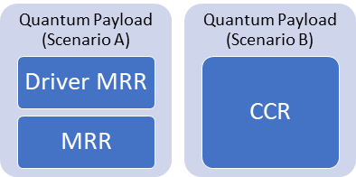

Figure 35: Schematic representing the two scenarios: scenario-A that will be the main risky strategy, and scenario-B that will be the simpler backup solution.

By employing an MRR coupled with a deformable lens system, the proposed mission aims at demonstrating new technology for Quantum Communication. As a matter of fact, the future SQC network will require both compact satellites and effective ground stations, able to detect polarized single-photon. By exploiting the MRR, a given QGS will be able to calibrate the required setup to correctly interface with an SQC payload. The outcome of this project will be fundamental in the developing and testing of future MRR with also polarization capabilities for an effective application to real Quantum Communication scenarios. For instance, by exploiting three MRR with a proper polarization plate each, it can be possible to generate three different polarizations so to emulate a full QKD scheme.

#### Method

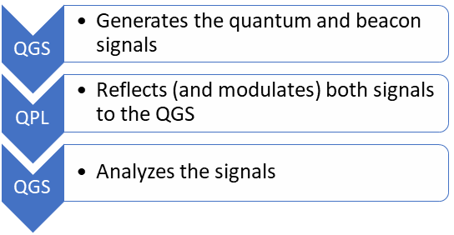

Figure 36: Simplified functional model for the interaction between the QGS and the QPL.

QGSs for quantum communication require as input an optical signal typically made by weak-coherent pulses as the quantum-key distribution case [3]. To emulate this signal, we propose the current method:

* The QGS shines two lasers to the QPL:
  + A high-power continuous wave bacon at 980 nm
  + A medium-power pulsed quantum signal at 1550 nm
* The incoming beams are collected and reflected by the MRR
* The reflected beams travel back to the QGS and are injected my means of the QGS into the quantum receiver to test the synchronization and the single-photon detection apparatus

In the Scenario A the quantum signal pulses will be modulated in intensity by the MRR, while in the Scenario B they will be modulated in the QGS.

The performance of the QGS will be evaluated using the quantum signal. Its primary requirement is to be mirrored by the QPL with a power near the quantum level after the reflection. The QGS will employ an auxiliary beacon signal to simplify the pointing acquisition and tracking system.

#### Physical and functional architecture of the quantum payload

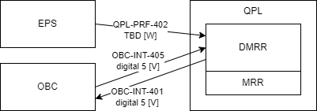

Figure 37: Diagram showing the tree main interface between the QPL and the OBC (QPL.I.1, QPL.I.2) and the EPS (QPL.I.3).

The payload is composed by two elements: an MRR and its electronic driver circuit (DMRR). The MRR is a corner-cube reflector of 2 inches diameter attached to a deformable lens system (DLS). This DLS is composed of a stack of two ring-shaped piezoelectric actuators sandwiching an active transparent gel that is contained inside two thin deformable lenses. This system is capable of bending within a specific range, applying a specific defocus to the propagating laser beam once it is reflected from the CCR. To control the piezo-electric extension, a high-voltage circuit (DMRR) is controlled by one digital signal (PWM) provided by a digital output of the OBC (QPL-INT-405). When QPL-INT-405 is high, the DMRR provides a high voltage signal to the input of the MRR activating the DLS and, in turn, changing the focal length of the reflected laser beam. When QPL-INT-405 is low, it releases the power from the piezo bringing it back to normal CRR behavior. The target frequency of the modulation is around 100 Hz but different frequencies will be tested thanks to the PWM. The overall system controlled by a sinusoidal signal allows to achieve a modulation of the laser beam returning to the QGS, since different focal lengths imply different broadenings of the spot size at the ground level, hence different mean photon numbers collected by the QGS telescope.

Furthermore, the DMRR feedbacks to the OBC an digital output ranging from 0 to 5 V (QPL-INT-401) that is an attenuated copy of the QPL-INT-405 signal for operativity check. The DMRR will be powered by a regulated output from the batteries (QPL-PRF-402) at 5 V. The payload power consumption includes both static and dynamic components, where the latter depends on the frequency modulation of the MRR and represents the major contribution. The maximum modulation frequency will be precisely evaluated after the final design taking into account the maximum available power and the actual performances of the modulating stage in terms of frequency response.

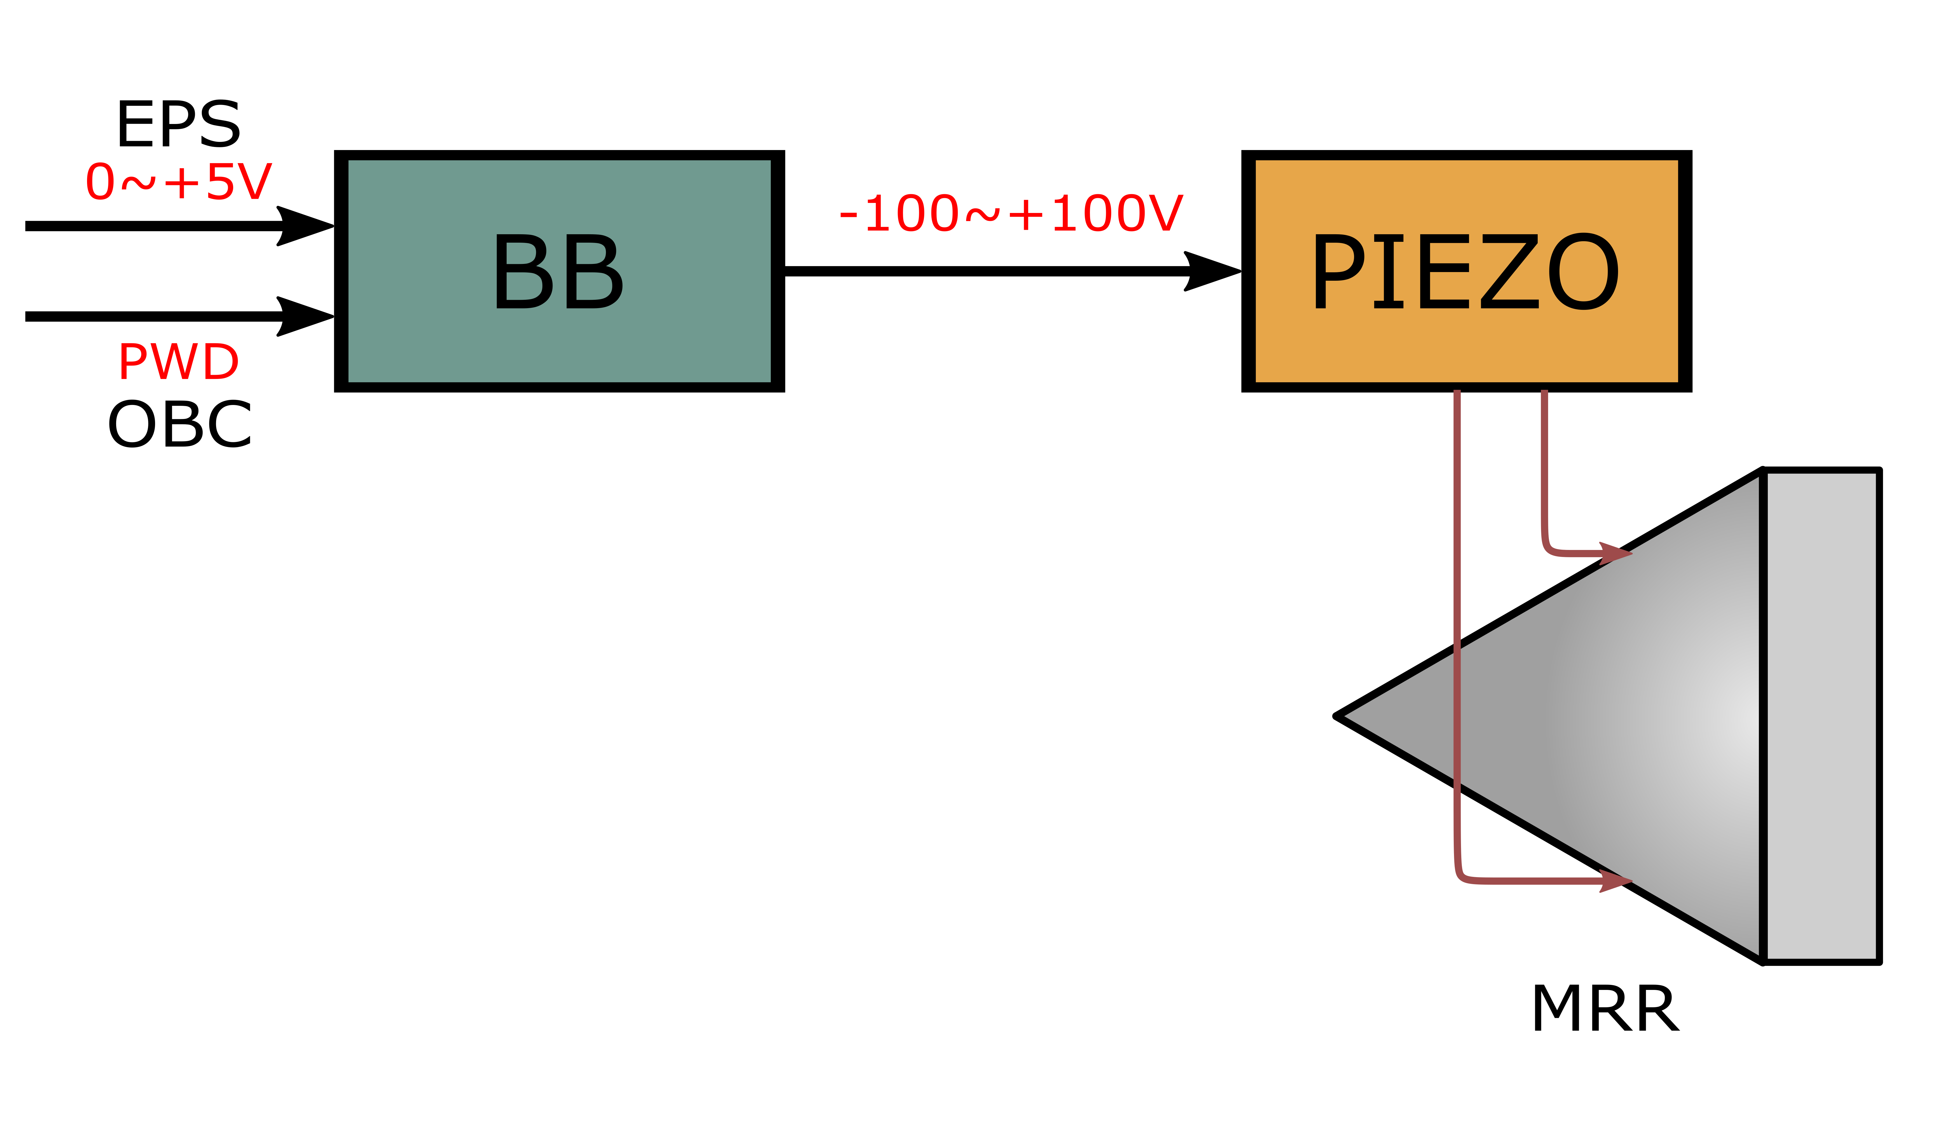

Figure 38: Detailed representation of the QPL apparatus composed by the DMRR (costituted by the Buck Boost, BB) and the MRR.

The provided CAD representation of the MRR is consistent with the developed design and in agreement with the volumes occupied by the other payloads inside the CubeSat. The actual developed model tested so far follows the indications agreed with the Structures and Mechanisms team.

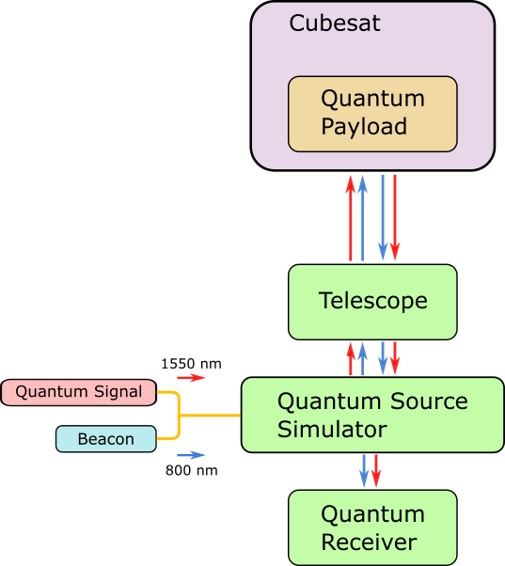

**Bibliography:**

[1] Liao, SK., Cai, WQ., Liu, WY. et al. Satellite-to-ground quantum key distribution. Nature 549, 43–47 (2017). <https://doi.org/10.1038/nature23655>

[2] Vallone et al, Experimental Satellite Quantum Communications, Phys. Rev. Lett. 115, 040502, 2015 <https://journals.aps.org/prl/abstract/10.1103/PhysRevLett.115.040502>

[3] C. C. W. Lim, M. Curty, N. Walenta, F. Xu, and H. Zbinden, “Concise security bounds for practical decoy-state quantum key distribution,” Physical Review A, vol. 89, no. 2, Feb. 2014, doi: 10.1103/physreva.89.022307.

### CCR Payload

The initial design of the payload presented at BDR was composed of 6 CCRs in addition to the MRR. Two of those remains in the current design while the four on the face of the satellite are no more present. This change was related to the need for the QPL and the CCR payload to work together without causing disturbances to one another. In fact, the already difficult task to individually identify the four different CCRs in the +Z was made impossible by the presence of the MRR positioned in the middle of the face. Even when “turned-off” the disturbance generated would be too high. The possible scientific outcome of the QPL is considered of higher relevance in respect to the one gained from the CCR payload. For this reason, the CCR payload is now considered a secondary payload. Hence, the four CCR on the +Z face are removed from the design to do not interfere with the MRR. At the same time the MRR will be kept “turned-on” when not operative, this way the MRR will act as standard CCR and can be used to perform laser ranging.

The major change in the design bring a consequently modification in the obtainable results. To still gain some information regarding the attitude of the satellite during the laser ranging observation, different types of CCRs are used. This allow the end-user to be able to identify unequivocally which CCR, hence which face of the CubeSat, is in view of the ground station.

#### Quick facts table

The CubeSat will be equipped with Corner Cube Retroreflectors (CCRs) to allow precise orbit determination through laser ranging from ground. The payload is composed by two dedicated CCRs placed on the +Y and -Y faces of the satellite and borrows the MRR from QPL when not operative Table shows the main parameters of the payload.

Table 25: CCRs main characteristics

|  |  |  |  |
| --- | --- | --- | --- |
|  | CCR 1 | CCR2 | MRR |
| Laser beam wavelength [nm] | 532 | | |
| Diameter of CCR [mm] | 12.7 | 12.7 | 25.4 |
| Coating | silver coated | Uncoated | Uncoated |
| Mass [g] | 6 | 6 | NA |
| Expected Orbit determination accuracy | < 10 cm (TBC) | | |

#### Functional and physical architecture

Corner Cube Retroreflectors are optical devices design to reflect light back towards the source regardless of the incidence angle. To perform orbit determination a laser is shine from a dedicated ground station towards the prepared satellite, the CCRs on board of the satellite itself when lit reflect the laser beam back towards the source where it is collected by a photon detector. A time-of-flight measurement is hence computed and a distance measurement obtained. With multiple measure from different ground station is possible to determine with high precision the orbit of the satellite. Alternatively, the measure from a single station can be used to improve the information gained from the GNSS on board of the satellite to improve the precision of the orbit estimation. This payload is completely passive as its function is to reflect a laser beam coming from ground. Hence, the payload does not require dedicated electronics for functioning and no power is drawn from the EPS. The team will rely on the International Laser Ranging Service (ILRS) to perform SLR measures. To exploit the possibility to track the satellite in multiple moments and configuration, CCRs are mounted on different external faces of the satellite wherever it is possible without compromising the other payloads. This solution provide the capability to track the satellite even in the case of attitude loss and eventually after the end of life of the satellite itself when it will be resonabl tumbling.

A part from the MRR, a total of 2 CCRs are mounted on the satellite: 1 on the face and 1 on the face. On the face no CCRs are mounted due to the presence of the Impact Sensor Payload. Regarding the face, no CCRs are mounted due to the presence of the deployable magnetometer. The is occupied b the antenna and a solar panel. Lastly on the the MRR is present.

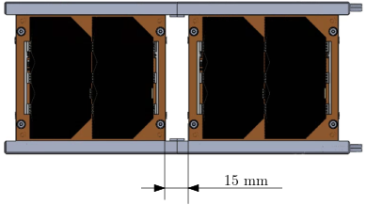

Figure 39: Maximum space available between solar panels on the +Y and -Y faces. To not modify an other part of the satellite, the CCR shall fit within 15 mm of space.

A first round of simulation to understand which dimensions of CRR, between the commercial ones, was the most suited for the mission was performed. This first analysis is based on the link budget and performed only for the coated CCR. In fact, its lower reflectivity, 0.78 in respect to 0.93 of the uncoated, implies a lower results in terms of probability of detection.

Four cases are considered and briefly presented in Section 3.2.3.3 .

Due to physical limitations on the satellite the final choice fell on the 12.7mm.  
In fact those are the biggest commercial available that, due to type of structure and solar panels chosen for the mission, can fit on the lateral faces of the satellite without the need of modifying an other components. See Figure .

To be able to distinguish the different CCR during observation, one will be uncoated, while the other will have a silver coating. This translate s in different and recognizable far field diffraction patterns. Both the CCRs are compatible with the 532 nm laser wavelength .This ensures the compatibility with the most of the station on the ILRS network all the one located in Europe.

Regarding the mounting configuration, each CCR is attached to the CubeSat structure thanks to a custom holding structure as in **Errore. L'origine riferimento non è stata trovata.**. The structure has an envelope of 20.3mm x 14.1 mm x 13.5 mm and it is machined out of aluminium. The CCR is glued to the holding structure thanks to space grade epoxy. The estimated mass of each of this structure is 4 grams. The holding structure is then fastened to the external face of the satellites through two M2.5 screw.

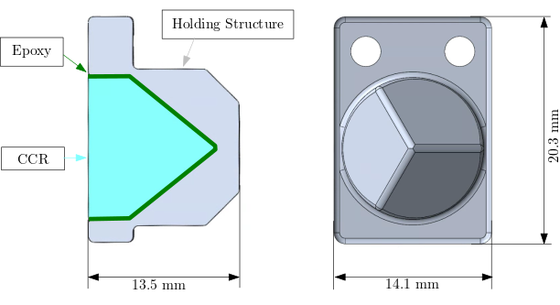

Figure 40: CCR holding structure.

#### Technical budgets

A summary of the analyses done to choose payload design is shown below. For the full analysis report, see the Payload Performance Analysis Report (PAY-ARPT_CCR).

**Link budget**

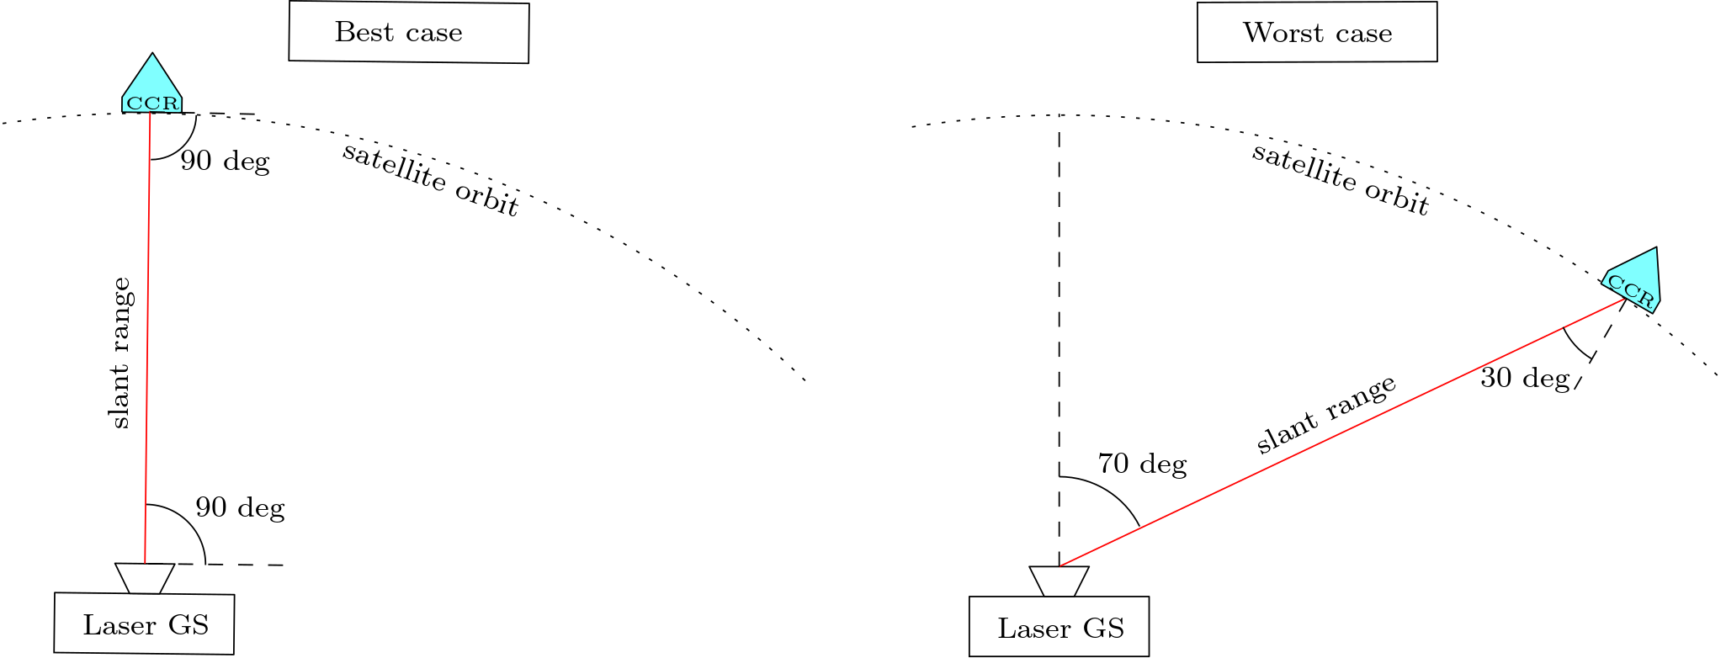

Figure 41: Link budget best (LEFT) and worst (RIGHT) cases configurations.

The link budget analysis is used to correctly dimension the CCRs granting the feasibility of the mission. The laser link equation returns the number of detected satellite photoelectrons per laser pulse and consequently the probability of signal detection. Part of the parameters in the equation are dependent on the ground station and are made publicly available by the ILRS network.

For these simulations the following assumptions has been taken into considerations:

* is the angle between the local vertical over the laser ground station and the vector that points the satellite. It varies between 0 deg and 70 deg.
* Due to the symmetry of the scenario only half the pass is computed.

. The maximum value of has been set at 70 degrees, so 20 degrees over the horizon. The maximum incidence angle that permits to a CCR to reflect the laser beam is 30 deg.

The simulations are performed for the best, = 0 deg and =90 deg, and worst case, = 70 deg and =60 deg as shown in **Errore. L'origine riferimento non è stata trovata.**. The simulation was performed considering CCRs with the following commercially available diameters: 7.16 mm, 10 mm, 12.7 mm, 25.4 mm.

For every candidate orbit, the mean photon count and the signal detection probability was evaluated in both night and daylight conditions. Atmospheric, optic and distance losses are considered while the velocity aberration is not considered. Every station with a signal detection probability above 50% is considered suitable for laser ranging. Table and show the percentage of the ILRS stations that have the probability of return of the signal higher than 50% for the night and daylight cases respectively.

Table 26:Percentile number of station with a probability of detection over 50%. Best case θzen = 0 deg and θinc =90 deg

|  |  |  |  |  |
| --- | --- | --- | --- | --- |
| BEST CASE | 7.16 mm | 10 mm | 12.7 mm | 25.4 mm |
| Night | 97.4% | 97.4% | 97.4% | 97.4% |
| Daylight | 41.0 % | 41.0 % | 41.0 % | 41.0 % |

Table 27: Percentile number of station with a probability of detection over 50%. Best case θzen = 90 deg and θinc =60 deg

|  |  |  |  |  |
| --- | --- | --- | --- | --- |
| WORST CASE | 7.16 mm | 10 mm | 12.7 mm | 25.4 mm |
| Night | 25.6% | 33.3% | 43.6% | 84.6% |
| Daylight | 2.56% | 5.33% | 7.69% | 30.7% |

The best candidate would be the 25.4 mm CCR, but due to the special limitations the choice is the 12.7 mm ones. This is one of the major design choice. To be able to individually identify the different CCRs but keep at the same time the highest possible probability of detection, the choice fell on using different coatings. In fact the Far Field Diffraction Patterns of coated and uncoated CCRs is different and hence identifiable. The satellite will be equipped with one 12.7 mm uncoated CCR and one 12.7 mm silver coated CCR.

The link budget analysis is performed now for the three total CCR mounted on the satellite, the two just described and the MRR. The same conditions for worst and best cases are considered. A total of 39 laser ground station is considered, of them only 29 are capable of daylight tracking. The simulation is repeated three times for three different altitudes: 470 km, 500km and 530 km.

|  |  |  |  |  |  |  |  |  |  |
| --- | --- | --- | --- | --- | --- | --- | --- | --- | --- |
| WORST CASE | Uncoated | | | Coated | | | MRR | | |
| Diameter [mm] | 12.7 | | | 12.7 | | | 25.4 | | |
| Satellite altitude [km] | 470 | 500 | 530 | 470 | 500 | 530 | 470 | 500 | 530 |
| % station with over 50% detection probability  Night  39 stations | 46.2% | 43.6% | 43.6% | 46.2% | 41.0% | 41.0% | 87.2% | 84.6% | 84.6% |
| % station with over 50% detection probability  Daylight  29 stations | 13.8% | 10.3% | 10.3% | 13.8% | 10.3% | 10.3% | 44.8% | 41.4% | 41.4% |

|  |  |  |  |  |  |  |  |  |  |
| --- | --- | --- | --- | --- | --- | --- | --- | --- | --- |
| BEST CASE | Uncoated | | | Coated | | | MRR | | |
| Diameter [mm] | 12.7 | | | 12.7 | | | 25.4 | | |
| Satellite altitude [km] | 470 | 500 | 530 | 470 | 500 | 530 | 470 | 500 | 530 |
| % station with over 50% detection probability  Night | 97.4% | 97.4% | 97.4% | 97.4% | 97.4% | 97.4% | 100% | 100% | 100% |
| % station with over 50% detection probability  Daylight | 55.2% | 55.2% | 55.2% | 55.2% | 55.2% | 55.2% | 55.2% | 55.2% | 55.2% |

**Power budget**

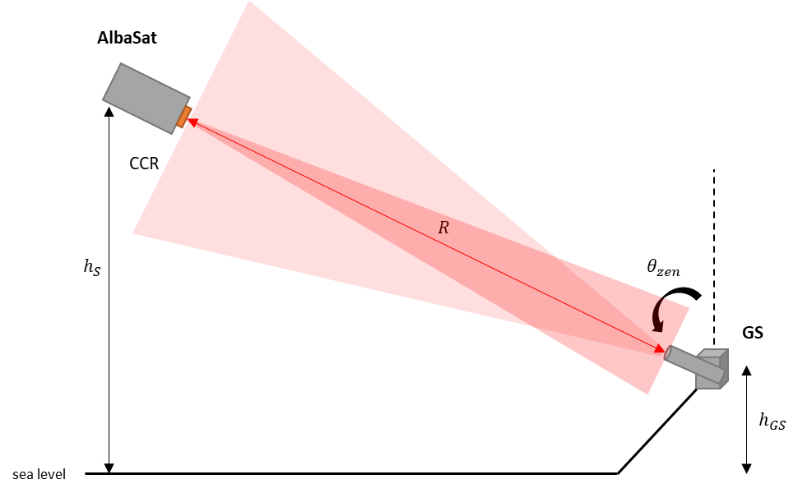The propagation and clipping equations for a gaussian beam were used to evaluate the average power return and the SNR. Thanks to the symmetry of the scenario, half of the pass angles are considered in the simulation. In this scenario the spacecraft attitude tracks ground station (pointing errors not considered) during the passage. Only one CCR is mounted on the face. The simulation was performed considering CCRs with the following commercially available diameters: 7.16 mm, 10 mm, 12.7 mm, 25.4 mm. A representation is shown in the figure below.

The power return and the SNR are evaluated for every ILRS station considering angles between . The maximum value of has been set at 70 degrees because for greater angles the losses related to the atmosphere do not guarantee the return of the signal. Figure and Figure Figure shows the value of the SNR at the variation of the CCR diameter that the European ground station of the ILRS can reach. A return signal is considered acceptable when the Signal Noise ratio (SNR) exceeds 2 (3 dB), highlighted by a in dotted red line in Figure and Figure . BORL station is not capable of daytime laser ranging to LEO satellites. Other stations show increasing performance with the increasing of the CCR diameter. The analyses show that the minimum diameter for having a value of for the 90% of the EU stations for the 65% of the considered angle range is 12.7 mm.

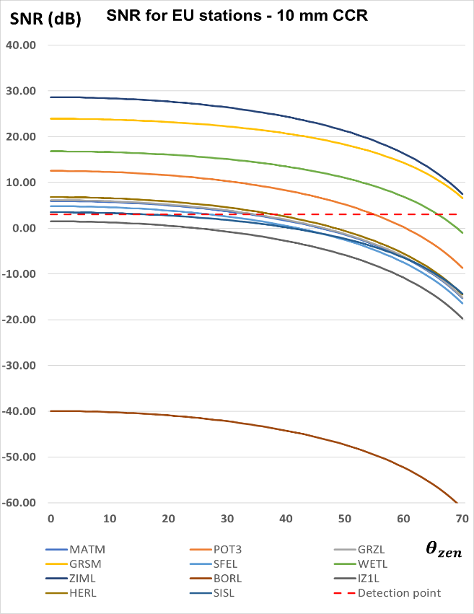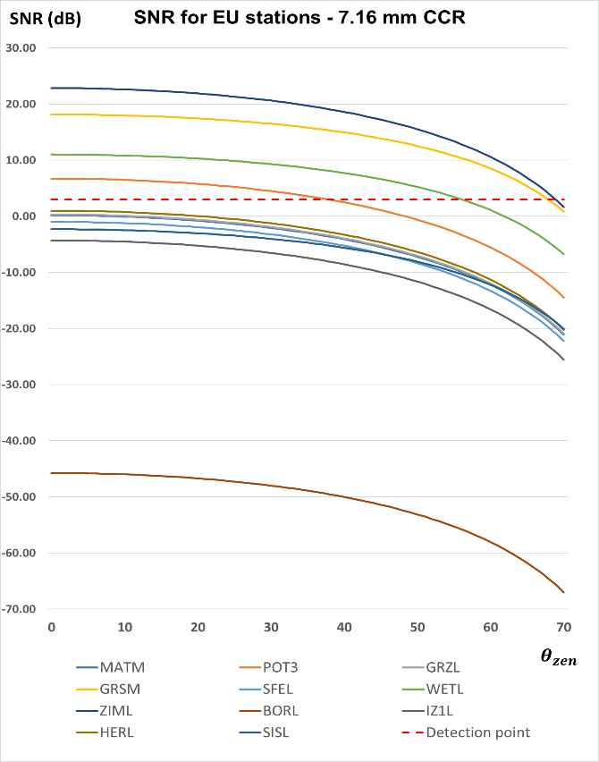

Figure : SNR for EU stations considering a CCR diameter of 7.16 mm (left) and 10 mm (right)

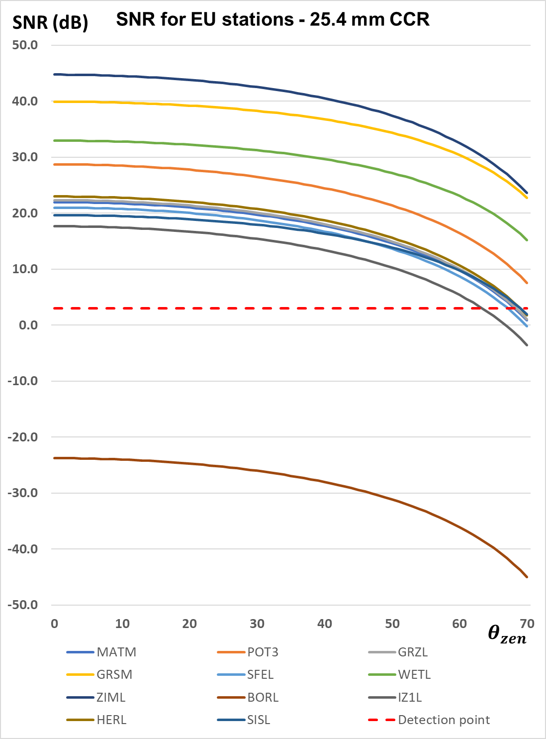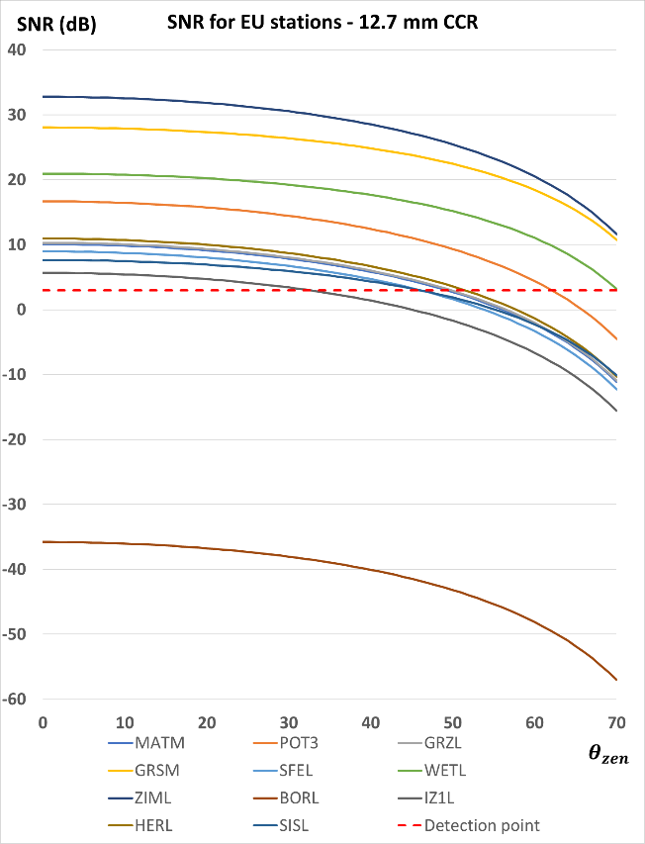

Figure : SNR for EU stations considering a CCR diameter of 12.7 mm (left) and 25.4 mm (right)

**Visibility from ground**

To evaluate the visibility from ground, multiple simulations have been implemented using iOTA, In-Orbit Tumbling Analysis simulator. iOTA is an ESA licenced software able to simulate, apart from other things, laser ranging observations on a controlled or uncontrolled satellite. The detailed simulation is reported in the Payload Performance Analysis Report (PAY-ARPT_CCR). The first set of simulation is performed with the satellite maintaining a nadir pointed attitude, while a second set is performed with the satellite left free to tumble. The simulation duration is set to two weeks and only the European Laser Ranging station of the ILRS network are considered, 19 total. The simulations parameter are reported in Table .

Table 28: iOTA simulations parameters

|  |  |
| --- | --- |
| Altitude [km] | 500 |
| Inclination [deg] | 97.4 |
| Starting Epoch | 07/08/2028 |
| Ending Epoch | 21/08/2028 |
| Number of LS stations | 19 |

When nadir pointing the satellite is visible from ground for around the 0.8% of the time, while when tumbling the percentile increase up to 2.5% of the time.

In both case, the MRR is the one that spends most time on view of the laser ground station.

## Attitude Determination and Control Subsystem

### ADCS Quick Facts Table

|  |  |  |
| --- | --- | --- |
| CubeADCS Y-momentum | Manufacturer | CUBEspace |
| Mass | 376 g |
| Dimensions | 88.1 x 94.5 x 61.5 mm |
| Thermal range | -25 to +70 °C |
| Power supply | 3.3 V, 5 V, Vbat |
| Sensors | MEMS rate sensor, fine sun sensor, coarse sun sensor, magnetometer, redundant magnetometer, GNSS receiver |
| Actuators | Torquerods (x2), coil, momentum wheel |

### Physical architecture

The CubeADCS Y-Momentum produced by CubeSpace was selected as the ADCS of AlbaSat. This solution has been selected after a trade-off analysis for two main reasons: (1) it guarantees the performances required by the satellite and (2) the components are already integrated when provided to the final user.

The CubeADCS Y-Momentum guarantees a 3-axis stabilized attitude. This allows to keep the IS pointed in the direction of the velocity vector and the MRR pointed in the Nadir direction. In addition, the subsystem permits to perform pitch manoeuvres in the orbital plane by controlling the speed of a momentum wheel. The sensors and the actuators included in the CubeADCS Y-Momentum can be selected by the user accordingly to the mission requirements. Those selected for the mission are reported in Table 29.

Table 29: Components of the selected integrated ADCS

|  |  |  |
| --- | --- | --- |
|  | **Name** | **Quantity** |
| Sensors | Fine sun sensor | 2 |
| Coarse sun sensor (up to 10) | 6 |
| Rate sensor | 3 |
| Magnetometer | 1 |
| Redundant magnetometer | 1 |
| Actuators | Magnetorquer | 2 |
| Coil | 1 |
| Momentum Wheel | 1 |

The sensors and actuators are integrated on PC104 boards. These PCBs are connected to an interface board which communicate with a controller and with a computer. The system physical architecture is shown in **Errore. L'origine riferimento non è stata trovata.Errore. L'origine riferimento non è stata trovata.**. The ADCS Y-Momentum must be supplied with regulated 3.3 V and 5 V and raw battery voltage (between 6.5 V and 16 V). The ADCS has internal power switches for the different components, all of which are controlled by computer. Figure 45 shows an example of the power switching connections. The switch states are available as telemetry and can also be toggled using a telecommand.

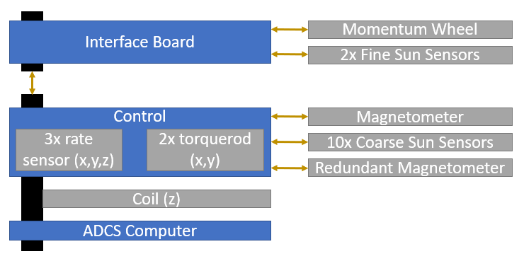

Figure : ADCS physical architecture

The ADCS subsystem can communicate with the other subsystems using three communication protocols, namely: I2C, UART and CAN. The system uses a CAN bus as a communication interface between the satellite subsystems. The ADCS computer has an optional CAN interface. The combination of a CAN transceiver and a CAN controller module on ADCS computer allows the ADCS to interface at CAN bus voltage levels of 3.3 V or 5 V. The description of the electrical interfaces and the PC104 bus pin description is provided in the datasheet at Sec. 5. The characteristics of each component are reported in the followings.

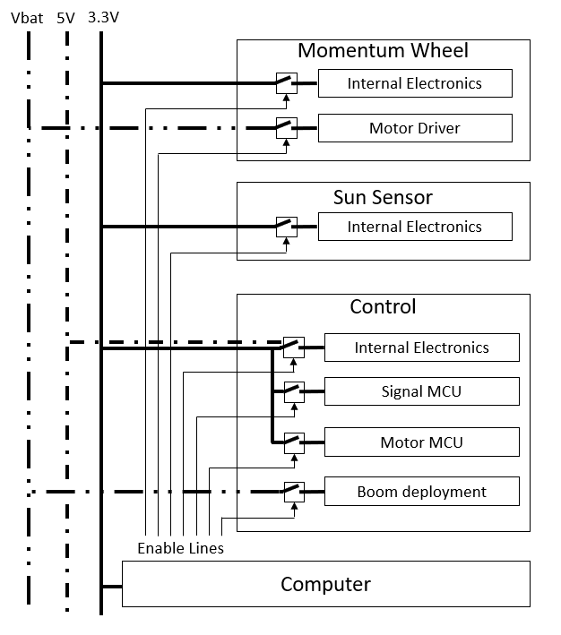

Figure : ADCS power switching connections.

**Fine Sun Sensor**

The ADCS uses a small camera called CubeSense as a Fine Sun Sensor. This sensor should be mounted to the satellite side panels with the lens protruding in order to avoid limiting its FOV.

Table 30: Fine Sun Sensor characteristics

|  |  |  |
| --- | --- | --- |
| **Parameter** | **Value** | **Notes** |
| Physical |  |  |
| Mass | 19.7 g | Without harnesses |
| Dimensions | 43 x 17.7 x 27.5 mm | Camera modules |
| Electrical |  |  |
| Supply Voltage | 3.3V |  |
| Average Power | 100mW | At 1Hz update rate |
| Peak Power | 200 mW | During image capture |
| Performance |  |  |
| Sun sensor accuracy | <0.22 deg | Entire FoV 2 sigma |
| Update rate | 2 Hz |  |
| Sun Sensor FoV | 170 deg vertical/horizontal and 180 deg diagonal |  |
| Image size | 1024x1024 | Grayscale Images |
| Environmental |  |  |
| Operating temperature | -20°C to 70°C |  |

**Coarse sun sensor**

Ten Coarse Sun Sensors (CSS) can be interfaced with the CubeADCS. The CSS are photodiodes mounted on a PCB with dimensions 3.8 x 10.8 x 1.7 mm. Six sun sensor are necessary to obtain a coarse Sun vector throughout the entire sunlit part of the orbit. The additional sun sensors are used for redundancy purposes. The CSS shall be attached on the outer faces of the CubeSat using epoxy since they don’t have mounting holes. Each CSS is connected to the control board of the ADCS by a Molex PicoBlade 2-way in-line connector. The ten 2-way harnesses are terminated in a single 20-way female connector, of which the male connector is populated on the control board of the ADCS.

Table 31: Coarse Sun Sensor characteristics

|  |  |  |
| --- | --- | --- |
| **Parameter** | **Value** | **Notes** |
| Physical |  |  |
| Mass | 0.2 g | PCB an 50 mm connector stub |
| Dimensions | 3.8 x 10.8 x 1.7 mm |  |
| Electrical |  |  |
| Average Power | <5mW | At 1Hz update rate |
| Performance |  |  |
| Sun sensor accuracy | <10 deg | 1 sigma |
| Update rate | 1 Hz |  |
| Environmental |  |  |
| Operating temperature | -40°C to 125°C |  |
| Vibration | 8g RMS random |  |
| Radiation | 24k Rad |  |

**Magnetometers**

The integrated ADCS features two magnetometers: a primary deployable magnetometer and one fixed inside the satellite for redundancy. The primary magnetometer is housed on a PCB enclosed in an aluminium box with measures 16.8 x 16.4 x 6.5 mm. The magnetometer is mounted on a face of the CubeSat in a stowed position using screws and bolts. It is released once the satellite is deployed into orbit. Once deployed, the magnetometer is 8 cm distant from the face of the CubeSat thus reducing the electromagnetic interference and lowering the measurement noise. The deployable boom consists of a rod with the magnetometer in its enclosure at one end and a mounting bracket with a spring on the other. The spring provides a torque of 0.014 Nm at the base of the boom. The magnetometer is deployed by activating a nichrome burn circuit for 5 s. This will require 0.62 A for a battery voltage of 8 V. The magnetometer interfaces with the control board module using an Omnetics Nano Circular 11-way in-line connector set. The harness is terminated in an 11-way Molex PicoBlade female connector. The maximum total length of the harness between the control board and the in-line connection is 350 mm. The in-line Omnetics connector has a diameter of 4 mm.

The redundant magnetometer has the same specifications of the primary with the only difference that is not deployable. The magnetometer interfaces with the controller employing an Omnetics Nano Circular 6-way in-line connector set. The harness is terminated in a 6-way Molex Micro-Latch female connector. The maximum total length of the harness between the control board and the in-line connection is 350 mm. The in-line Omnetics connector has a diameter of 4 mm.

Table 32: Magnetometer characteristics

|  |  |  |  |
| --- | --- | --- | --- |
| **Parameter** | **Deployable** | **Redundant** | **Notes** |
| Physical |  |  |  |
| Mass | 15.5 g | 3.5 g |  |
| Dimensions | 82.6 x 17 x 6.5 mm | 23.4 x 16.8 x 8.1 mm |  |
| Electrical |  |  |  |
| Average Power | 50mW | 35 mW | At 1Hz update rate |
| Performance |  |  |  |
| Measurement noise | <50 nT | < 50 nT | 1 sigma (per X/Y/Z channel) |
| Update rate | 1 Hz | 1 Hz |  |
| Environmental |  |  |  |
| Operating temperature | -20°C to 85°C |  |  |
| Vibration | 14.16 g RMS random | 8 g RMS random |  |
| Radiation | 24k Rad | 24krad |  |

**Rate sensors**

Three MEMS rate sensors are integrated on the control board of the ADCS. They align with the X/Y/Z axes of the ADCS frame.

Table 33: Rate sensor characteristics

|  |  |  |
| --- | --- | --- |
| **Parameter** | **Deployable** | **Notes** |
| Performance |  |  |
| Nonlinearity | 0.05 | % of FS |
| Update rate | 1 Hz |  |
| Angular Random Walk | 0.08 deg/(sqrt(h)) |  |
| Bias instability | 1.2 deg/h |  |
| Environment |  |  |
| Operating temperature | -10 to 70° |  |
| Vibration | 8 g RMS random |  |
| Radiation | 24k Rad |  |

**Magnetorquers**

The CubeADCS features three magnetorquers (two torquerods and a coil). The direction of their magnetic momentum is aligned with the three axes of the ADCS frame respectively.

Table 34: Magnetorquers characteristics

|  |  |  |
| --- | --- | --- |
| **Parameter** | **Small rod** | **Single coil** |
| Mass | 28 g | 46 g |
| Dimensions | 18 x 14 x 62 mm | 90 x 96 x8 mm |
| Performance |  |  |
| Magnetic Moment | 0.24 Am2 | 0.13 Am2 |
| Magnetic Gain | 2.8 Am2/A | 2.1Am2/A |
| Linearity (0-5 V) | 97.5% | NA |
| Electrical |  |  |
| Resistance | 29-31 ohm | 79-81 ohm |
| Max Current | 150 mA | 150 mA |
| Environmental |  |  |
| Operating Temp | -20 to 70 °C | |
| Vibration | 14g RMS | |
| Outgassing of heat shrink | TML = 0.36%, CVCM = 0.04% | |
| End Caps | Alodine Aluminium | |

**Momentum Wheel**

The momentum wheel is mounted on the connector interface of the ADCS. It has three sets of four M2 mounting holes on three different faces. The outer dimensions of the momentum wheel are 28 mm x 28 mm x 26.1 mm.

Table 35: Momentum wheel characteristics

|  |  |  |
| --- | --- | --- |
| **Parameter** | **Value** | **Notes** |
| Mass | 50 g | Harness excluded |
| Dimensions | 28 x 28 x 26.1 mm |  |
| Performance |  |  |
| Maximum momentum | 1.7 mNms |  |
| Maximum wheel speed | ±8000 rpm |  |
| Maximum torque | 0.23 mNm |  |
| Static imbalance | <0.003 gcm |  |
| Dynamic imbalance | <0.005 gcm2 |  |
| Electrical |  |  |
| Supply Voltage | 3.3 V & Vbat |  |
| Idle power | 65 mW | @0 RPM |
| Average power | 150 mW | @2000 RPM |
| Peak Power | 0.65 W | @ max torque |
| Environmental |  |  |
| Operating Temp | -10 to 60 °C |  |
| Vibration | 14 g RMS |  |
| Radiation | 24 kRad |  |

**GNSS receiver**

The nanoSense GPS kit has been chosen for determining the position and the velocity of the satellite using the GNSS. The kit contains a NovATEL GPS module and a GPS antenna. The GPS module can be mounted on the NanoDock used to host the OBC and the transceiver.

Table 36: GNSS receiver characteristics

|  |  |
| --- | --- |
| **Parameter** | **Value** |
| Mass | 31 g |
| Dimensions | 46 x 72 x 11 mm |
| Precision, position | 1.5 m |
| Precision, velocity | 0.03 m/s |
| Power | 3.3 V, <400 mA |

### ADCS mode definitions

The ADCS has three operative modes, namely: ADCS detumbling mode, ADCS nominal mode and ADCS safe mode. For each mode a specific set of sensor and actuators is used.

Table 37: Correspondence between system modes and ADCS modes

|  |  |
| --- | --- |
| **System mode** | **ADCS mode** |
| Deployment | ADCS Detumbling |
| Safe | ADCS Safe |
| Nominal | ADCS Nominal |
| Detumbling | ADCS Detumbling |

#### CubeADCS Y-Momentum operational modes

**Estimation modes**

The Estimation Mode determines which sensor measurements are used and what information  
is estimated.

|  |  |  |  |
| --- | --- | --- | --- |
| **Enumeration Value** | **Estimation Mode** | **Sensor used** | **Estimated information** |
| **0** | No attitude estimation | None | None |
| **1** | MEMS rate sensing | X, Y, Z –axis rate sensors | X, Y, Z angular rates |
| **2** | Magnetometers rate filter | Magnetometer | X, Y, Z angular rates |
| **3** | Magnetometers rate filter with pitch angle estimator | Magnetometer | X, Y, Z angular rates;  Pitch angle |
| **4** | Magnetometer and fine or coarse Sun TRIAD algorithm | Magnetometer; CSS and/or Sun sensor | Roll, Pitch, Yaw angles;  X, Y, Z angular rates |
| **5** | Full-state EKF | Magnetometer; Sun sensor; Nadir sensor | Roll, Pitch, Yaw angles;  X, Y, Z angular rates |
| **6** | MEMS Gyro EKF | X, Y, Z-axis rate sensors; Magnetometers; Sun sensor; Nadir sensor | Roll, Pitch, Yaw angles;  X, Y, Z angular rates; X, Y, Z gyro bias |

* **Estimation Mode 1:** it does not perform any estimation algorithms, but rather uses the rate sensor measurement directly. It provides angular rate measurements for all the body axes.
* **Estimation Mode 2:** it makes use of successive magnetometer measurements in a robust Kalman filter to estimate the , and angular rates.
* **Estimation Mode 3:** it is the same as Mode 2, but also includes simple pitch estimation from magnetometer measurements only.
* **Estimation Mode 4:** it makes use of the magnetometer rate filter of mode 2 to estimate the X, Y and Z angular rates. Additionally, it employs a TRIAD algorithm to estimate attitude angles. However, it does not function in eclipse.
* **Estimation Mode 5:** it uses an EKF to estimate the full attitude state. The EKF requires the satellite moment of inertia tensor and the estimated control torque in order to propagate the attitude state.
* **Estimation Mode 6:** it uses an EKF and the rate sensor measurement to estimate the full attitude state and rate sensor offsets. It does not require the satellite moment of inertia tensor and the estimated control torque.

**Control modes**

|  |  |  |  |  |
| --- | --- | --- | --- | --- |
| **Stage** | **Enumeration Value** | **Control mode** | **Actuators used** | **Required estimated state** |
| **-** | **0** | No control | None | None |
| **Detumbling** | **1** | Detumbling control | Y-magnetorquer | None |
| **2** | Y-Thomson spin | XYZ magnetorquers | Y-body rate |
| **9** | Fast-spin Detumbling control | XYZ magnetorquers | None |
| **Y-Momentum** | **3** | Y-Momentum wheel  (initial pitch acquisition) | Y-Momentum wheel & XYZ magnetorquers | X, Y, Z body rates & pitch angle |
| **4** | Y-Momentum wheel (steady state) | Y-Momentum wheel & XYZ magnetorquers | X, Y, Z body rates & pitch angle |

* **Control mode 1:** it uses a Bdot Detumbling magnetic controller to dump the and body rates from angular rates below 30 deg/s. Only instantaneous magnetometer measurements are required and only the magnetorquer is used. At rates above 30 deg/s the normal detumbling control will cause the satellite rates to increase instead of decrease. As specified below, Mode 9 can detumble initial body rates higher than 30 deg/s.
* **Control mode 2:** it adds Y-Thomson Spin to Mode 1 using the and magnetorquers. It requires an estimate for the angular rate. Therefore, either Estimation mode 1 or 2 must be active.
* **Control mode 9:** it uses a magnetic controller running at 1 Hz using all magnetorquers and instantaneous magnetometer measurements. Mode 9 can detumble initial body rates in all axes as high as 100 deg/s down to zero. [FDS-VCD 4.4.1.1]

Note: since the magnetometer rate filter (Estimation Mode 2) will not be accurate for body rates above approximately 35 deg/s, the MEMS rate sensors (Estimation Mode 1) should be used. Therefore, Control Mode 9 should be used in combination with Estimation Mode 1 and not with Estimation Mode 2.

* The Y-Momentum control stage contains two separate control modes: **Control mode 3:** this mode can be accessed only after Mode 2.During this mode, the rotational speed of the MW is increased until it reaches an initial reference momentum. This should absorb most of the body Y-Thomson spin, while maintaining a slow pitch rotation about the Y-axis. The process will persist until the estimated pitch angle is within 25 degrees of the reference pitch angle.
* **Control mode 4:** in this mode, a PD controller is employed to regulate the pitch angle towards the desired one. In this mode, the magnetorquers are used to maintain the wheel momentum to a reference value and to damp nutation in the x- and z-body axes.

It is necessary for the Y-momentum stage that either the magnetometer rate filter with pitch estimation (Estimation Mode 3), the Full-state EKF (Estimation Mode 5) or the MEMS Gyro EKF (Estimation Mode 6) are active, in order to have the pitch angle and body rate estimates.

#### ADCS modes

**ADCS Detumbling mode**

The ADCS detumbling mode is used to recover the satellite from any initial tumble rate lower than 90 deg/s (in compliance with requirement 4.4.1.1 reported in the FSD-VCD). This requirement refers to the spacecraft deployment phase, note that in this phase the magnetometer is used in the stowed configuration, since deploying the magnetometer when the satellite is not in a slow tumble could make it difficult to observe the deployment and could lead to a non nominal deployment. If the tumbling rate is lower than 30 deg/s control mode 1 is used, otherwise control mode 9 is used. At the end of the detumbling maneuver, the spacecraft attitude rate is lower than ~0.5 deg/s (TBC) on each axis. At this stage the ADCS enters control mode 2 and the satellite can be subsequently transitioned to ADCS Safe Mode.

The ADCS detumbling mode is entered automatically or through TC, in compliance with requirement ADCS-FKT-914 in the TS-VCD. The TC is used to force the entry in the mode by ground. During this mode the MW is in an idle state, so it requires some power (~65mW) even though it is not rotating. In addition, the rate sensors are active, but they are not included in the control loop.

|  |  |  |  |
| --- | --- | --- | --- |
| **Control modes** | **Estimation modes** | **Sensors used** | **Actuators used** |
| 1 | 2 | Magnetometer | Y magnetorquer |
| 2 | 2 | Magnetometer | XYZ magnetorquers |
| 9 | 1 | Magnetometer | XYZ magnetorquers |

**ADCS Nominal mode**

|  |  |  |  |  |
| --- | --- | --- | --- | --- |
| **Control mode** | **Estimation mode** | **Sensors used** | **Actuators used** | **Notes** |
| 3 | 3 | Magnetometer, GNSS receiver | Magnetorquers, Momentum wheel | Used only when MW does not rotate at the start of the mode |
| 4 | 3 | Magnetometer, GNSS receiver | Magnetorquers, Momentum wheel | Used only when MW does not rotate at the start of the mode |
| 5 | Magnetometer, GNSS receiver, coarse sun sensor, fine sun sensor | Magnetorquers, Momentum wheel | The computer is active to apply the kalman filter |
| 6 | X,Y,Z – axis rate sensors, Magnetometer, GNSS receiver, coarse sun sensor, fine sun sensor | Magnetorquers, Momentum wheel | The angular rates are measured so the Euler dynamic model is not required |

The **ADCS nominal** **mode** is entered if the corresponding system mode requires the Nadir Pointing attitude. To enter ADCS Nominal Mode, the satellite must first transition to Control Mode 3 and then to Control Mode 4, which is the steady state mode for ADCS Nominal Mode. The transition between these control modes occurs automatically.

Control mode 3 can be used with estimation mode 3, 5, 6. Since this control mode is used only to enter the control mode 4 and a precise attitude determination is not required in this phase, the team has decided to use control mode 3 in combination with the estimation mode 3.

Control mode 4 can be used with estimation mode 3, 5, 6. Since the pointing accuracy required is better than 20 deg, control mode 4 is used with estimation mode 5.

**ADCS Safe mode**

During this mode non-vital sensors/actuators are not utilized. Specifically, the MW is off and the magnetorquers are employed to counteract orbital disturbances, together with the rate sensors if needed. The magnetometer used is the redundant one. If the tumbling rate is lower than 30 deg/s the primary control mode employed is mode 1. The selected mode is subsequently transitioned to mode 2 for exiting the ADCS safe mode, which can be used with Estimation Mode 2, 3 and 4.

This transition particularly depends on the CubeSat is either in eclipse condition or not. In case it can see the Sun, the ADCS enters Control Mode 2 from Control Mode 1 in Estimation Mode 2 and then transitions to Estimation Mode 4 (TRIAD). This last one can be used to initialize the EKF state vector so that a faster EKF convergence time is achieved. Thus, after this transition, the ADCS can move to ADCS Nominal Mode. On the contrary, if the CubeSat is in eclipse condition, the ADCS still enters Control Mode 2 in Estimation Mode 2, but then transitions to Estimation Mode 3, since the 4th one will not yield attitude estimate in eclipse. At this point, the ADCS can be transitioned to ADCS Nominal Mode.

|  |  |  |  |
| --- | --- | --- | --- |
| **Control mode** | **Estimation mode** | **Sensors used** | **Actuators used** |
| 1 | None | Redundant Magnetometer | Y magnetorquer |
| 2 | 2, 3 or 4 | Magnetometer | XYZ magnetorquers |

**Valid estimation and control combinations**

In the next two tables are displayed all allowed combinations of estimation and control modes (Table 38) and the allowed control mode transitions (Table 39), respectively. The green OK entries are the preferred combinations and reflect nominal modes for optimal performance. The red entries are not allowed and as a consequence an attempt to switch to an estimation mode or control with these combinations will fail. The orange OK entries are also acceptable, since they are allowed by the ADCS, but they should be used after consultation with CubeSpace.

Table 38: Combinations of estimation and control modes

|  |  |  |  |  |  |
| --- | --- | --- | --- | --- | --- |
|  |  | **Control Mode** | | | |
|  |  | **None**  (ID=0) | **Detumbling & fast modes** (ID=1,9) | **Y-Thomson**  (ID=2) | **Y- Momentum** (ID=3,4) |
| **Estimation modes** | None (ID=0) | OK | OK | X | X |
| MEMS rate (ID=1) | OK | OK | OK | X |
| Magnetometer rate (ID=2) | OK | OK | OK | X |
| Magnetometer rate + pitch (ID=3) | OK | OK | OK | OK |
| TRIAD (ID=4) | OK | OK | OK | OK |
| Full-state EKF (ID=5) | OK | OK | OK | OK |
| MEMS Gyro EKF (ID=6) | OK | OK | OK | OK |

Table 39: Valid transitions between the control modes of the ADCS

|  |  |  |  |  |  |
| --- | --- | --- | --- | --- | --- |
| **Current Control Mode** | **New Control Mode** | | | | |
|  | **None**  (ID=0) | **Detumbling & fast modes**  (ID=1,9) | **Y-Thomson**  (ID=2) | **Y-Momentum initial**  (ID=3) | **Y-Momentum steady-state**  (ID=4) |
| **None**  (ID=0) | N/A | OK | OK  (But not ideal) | X | OK  (But not ideal) |
| **Detumbling & fast modes**  (ID=1,9) | OK | N/A | OK | X | X |
| **Y-Thomson**  (ID=2) | OK | OK | N/A | OK | X |
| **Y-Momentum initial**  (ID=3) | OK | OK | OK | N/A | OK |
| **Y-Momentum steady-state**  (ID=4) | OK | OK | OK | X | N/A |

### ADCS budgets

In this section the ADCS budgets are reported.

**Actuators sizing budgets**

The sizing budgets are obtained by the preliminary analyses shown in the ADCS-ARPT. The selected ADCS actuators are compliant with these budgets in terms of maximum torque of the selected momentum wheel and magnetic moments of the selected magnetorquers. In the ADCS-ARPT, it is also shown that the angular momentum storable in the selected momentum wheel and the magnetic moments of the selected magnetorquers are sufficient to perform a continuous angular momentum unloading of the wheel, using the three magnetorquers.

|  |  |
| --- | --- |
| **Nadir Pointing analysis** | |
| **Parameter** | **Value** |
| Torque authority | 2.10e-6 Nm |
| Magnetorquers max magnetic moments | [0.0170, 0.0440, 0.0122] |

The ADCS-ARPT also contains simulations of detumbling maneuvers, the time required to perform the maneuvers are reported in Table 40 for two of the analyzed cases.

Table 40: Detumblig time for different initial conditions.

|  |  |
| --- | --- |
| **Detumbling analysis** | |
| **Initial angular velocity [deg/s]** | **Detumbling time [h]** |
| [90, 90, 90] | ~ 7.5 |
| [10, 10, 20] | ~ 3.5 |

**Pointing budgets**

In the following table the results of a preliminary pointing error budget calculation, which is performed in the ADCS-ARPT, are reported in terms of maximum absolute performance error (APE) per axis. Only the ADCS Nominal Mode requires pointing accuracy, hence the budget is computed only for this mode. The obtained accuracies are compliant with the requirement ADCS-PRF-902 (TS-VCD) on the APE.

Table 41: ADCS pointing budgets results

|  |  |
| --- | --- |
| **APE** | **Value (2**σ) |
| APE(x) | 0.332 deg |
| APE(y) | 0.422 deg |
| APE(z) | 0.332 deg |

**Geolocation budgets**

|  |  |
| --- | --- |
| **Parameter** | **Value** |
| **Position determination precision** | TBD |
| **Velocity determination precision** | TBD |

**Power budgets**

For the calculation of average powers, a 5% margin has been assumed for each component. Note that the ADCS power consumption never exceed 0.9667 W, in compliance with requirement ADCS-PRF-923 in the TS-VCD.

Table 42: ADCS average power consumption for each mode

|  |  |  |
| --- | --- | --- |
| **System mode** | **ADCS mode** | **Average Power Consumption [mW]** |
| Deployment | ADCS Detumbling | 684 |
| Safe | ADCS Safe | 139 |
| Nominal | ADCS Nominal | 645 |
| Detumbling | ADCS Detumbling | 684 |

**Components average power consumption**

The average power consumptions were obtained from the datasheets for all the components except for the magnetorquer rods and coil. Their consumption was obtained from simulations by the method explained in the ADCS-ARPT document. Note that in the calculation of the magnetorquer power consumption during nominal mode, the dumping of the momentum wheel was not considered.

|  |  |  |  |  |
| --- | --- | --- | --- | --- |
| **Component** | **Number** | **Average power consumption [mW]** | | |
| Fine sun sensor | 2 | 100 | | |
| Coarse Sun sensors | 10 | 5 (for all sensors) | | |
| CubeControl (Rate sensors) | 1 | 200 | | |
| Magnetometer | 1 | 50 | | |
| Redundant magnetometer | 1 | 35 | | |
| Magnetorquer rods | 2 | Nominal  3.5 | Detumbling  163 | Safe  0.33 |
| Coil | 1 | Nominal  1.7 | Detumbling  150 | Safe  0 |
| Momentum wheel | 1 | Nominal  150 | Detumbling*  65 | Safe  0 |
| GNSS receiver | 1 | 900 | | |
| Computer | 1 | 120 | | |

*In detumbling mode the wheel is in idle mode.

**Duty Cycles**

|  |  |  |  |
| --- | --- | --- | --- |
| **Component** | **Nominal** | **Detumbling** | **Safe** |
| Fine sun sensor | 64.76 | 0 | 0 |
| Coarse Sun sensors | 100 | 0 | 0 |
| CubeControl (Rate sensors) | 100 | 100 | 0 |
| Magnetometer | 20 | 20 | 0 |
| Redundant magnetometer | 0 | 0 | 20 |
| Magnetorquer rods | 80 | 80 | 80 |
| Coil | 80 | 80 | 80 |
| Momentum wheel | 100 | 43.33 | 0 |
| GNSS receiver | 3.6 | 0.6 | 0.6 |
| Computer | 100 | 100 | 100 |

These duty cycles are considered over one orbit and they are taken as percentage of the average power. Hereunder the justifications for the selected values are reported.

**Nominal mode**

* **Fine sun Sensor**: the fine sun sensor duty cycle is 66% since it collects the measurements during the sunlight part of the orbit and does not operate during the eclipse phase. This is because the mean eclipse time was estimated to be 33.2 min in the nominal orbit, which is 35.24% of the orbital period.
* **Coarse sun sensors**: the coarse sun sensors are considered always active to determine when the spacecraft is in sunlit.
* **Rate sensors**: the rate sensors are always operating but they are included in the control loop only when Estimation Mode 6 is active. When they are not included in the control loop their measurements are used to check and make sure that the spacecraft attitude is being estimated correctly and are included in the telemetry.
* **Magnetometer**: the magnetometer duty cycle of 20% is considered to avoid measurements interference from the magnetorquers.
* **Magnetorquers**: the magnetorquers duty cycle of 80% is considered to avoid interference on the magnetometer measurements.
* **Momentum wheel**: the momentum wheel is considered always active since its actual duty cycle is not known at this stage.
* **GNSS receiver**: the GNSS receiver duty cycle of 3.6% is obtained by considering 6 activations per orbit, where the time to first fix of 34s is specified in the datasheet.
* **Computer**: the computer is considered always active since its actual duty cycle is not known at this stage.

**Detumbling mode**

* **Rate sensors**: the rate sensors are always operating but they are not included in the control loop only during eclipse.
* **Magnetometer**: as in nominal mode
* **Magnetorquers**: as in nominal mode
* **Momentum wheel**: in the ADCS detumbling mode the momentum wheel is in idle mode, its duty cycle is calculated from the values of the wheel average power and the wheel idle power which are given in the datasheet.
* **GNSS receiver**: the GNSS receiver duty cycle of 0.6% is obtained by considering 1 activation per orbit. This is done to decrease the receiver power consumption while maintaining some knowledge of the spacecraft position and velocity.
* **Computer**: as in nominal mode.

**Safe mode**

* **Redundant magnetometer**: as for magnetometer in nominal and detumbling modes.
* **Magnetorquers**: as in nominal and detumbling modes.
* **GNSS receiver**: as in detumbling mode.
* **Computer**: as in nominal and detumbling modes.

### ADCS Control and determination algorithms

The controller used by the ADCS depends on the operational mode of the ADCS. The controller employed in every mode are presented in the following table. The controllers and the estimation filter are integrated in the CubeADCS at the delivery. Specific details them are not provided on the datasheet available online. The sampling frequencies of the sensors are provided in the tables in Sec. 3.3.3.

|  |  |  |
| --- | --- | --- |
| **ADCS mode** | **Controller** | **Estimation filter** |
| ADCS Detumbling | Y-Thomson | - |
| ADCS Safe | PD controller | EKF |
|  | PD controller | EKF |
| Pointing | PD controller | EKF |
| Safe | PD controller | EKF |

### ADCS Analysis Report Summary

The analysis performed showed that the selected ADCS meets the requirements defined for the mission. It is able to make the satellite keep the Nadir pointing attitude and to perform detumbling and GS pointing manoeuvres. The analyses performed are presented in the ADCS-ARPT document.

## Electrical Power Subsystem

### EPS Quick Facts Table

|  |  |  |
| --- | --- | --- |
| NanoPower BP4 + NanoPower P31u | Manufacturer | GOMspace |
| Mass | 200 g |
| Dimensions | 89.3 x 92.9 x 25.6 mm |
| Thermal range | -40 to +125 °C |
| Regulated bus | 3.3, 5 V |
| Battery | Lithium-ion |
| Configurable output switches | 6 (with LCLs) |

### Functional and physical architecture

The EPS generates and distributes electrical power to the whole system. During its operative lifetime, the EPS shall:

* produce direct current;
* store exceeding electrical power;
* regulate and control the electrical power;
* distribute the electrical power to the loads according to their needs.

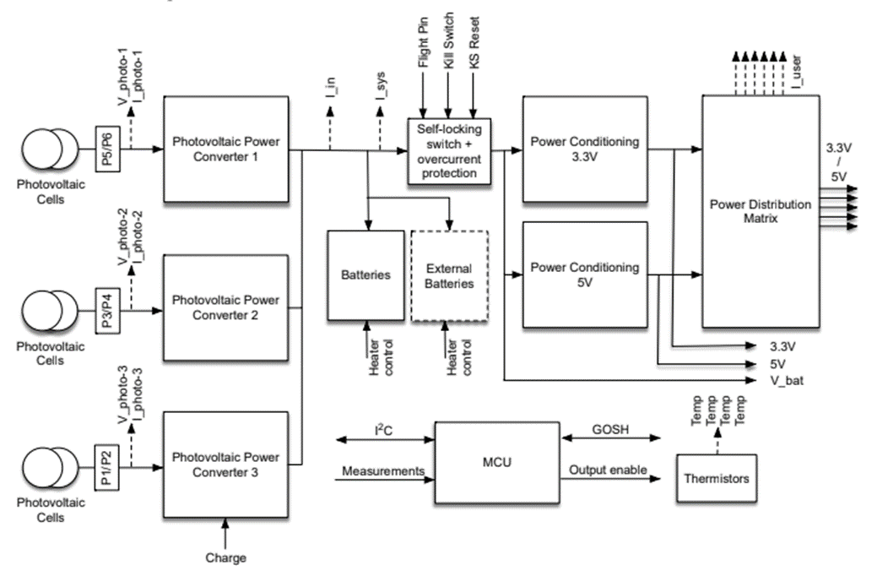

Figure : P31u physical architecture

The EPS will consist of solar arrays, a battery and a Power Control and Distribution Unit (PCDU). The Solar Arrays convert the solar flux into direct current. The current generated by the solar arrays is managed by the PCDU. Specifically, the PCDU conditions and distributes the power to the batteries or directly to the loads. A COTS PCDU is used in the satellite, namely the NanoPower P31u from GOMspace, which is connected to the battery module NanoPower BP4 with four integrated battery cells. Its functional architecture is shown in **Errore. L'origine riferimento non è stata trovata.Errore. L'origine riferimento non è stata trovata.**.

The P31u interfaces to triple junction photovoltaic cells and uses a boost-converter to condition their output power to charge the batteries. The incoming power along with the energy stored in the batteries is used to feed two buck-converters supplying a 3.3 V (5 A) and a 5 V (4 A) output bus. The P31u features six individually controllable output switches with overcurrent shut-down and latch-up protection (requirement FSD_VCD_4.2.14, FDS_VCD_4.2.15), each separately configurable to either 3.3 V or 5.0 V output. The electrical characteristics of the P31u are listed in Table 43.

The previous EPS design included an integrated battery with the p31u. It has been substituted with a new design, due to the no longer availability of the components by the supplier. The new battery model includes the board BP4 which integrates seamlessly with the p31u and contains four cells of 3000 mAh each.

Table 43: Electrical characteristics of the P31u

|  |  |  |  |  |  |
| --- | --- | --- | --- | --- | --- |
| **Parameter** | **Condition** | **Min** | **Typical** | **Max** | **Unit** |
| **Battery**   * Voltage | 2 cells in series connection  2 cells in parallel connection | 6.0  - | 7.2  - | 8.4  - | V |
| **Solar array input**   * Voltage * Current, charge | (Customer selectable)  - | 0.0  0.0 | - | 9.6 | V  A |
| **Output 3.3 V**   * Voltage * Current | Regulated output  -  Tot. current with output channels | 3.29  0.00 | 3.34  - | 3.39  5.00 | V  A |
| **Output 5 V**   * Voltage * Current | Regulated output  -  Tot. current with output channels | 4.89  0.005 | 4.98  - | 5.05  4.00 | V  A |
| **Power consumption** | Power consumed by P31u | - | 160 | - | mW |

### Solar arrays

|  |  |  |
| --- | --- | --- |
|  | Manufacturer | GOMspace |
| Mass | 57-65 g |
| Dimensions | 98.0 x 82.6 x 1.6 mm |
| Thermal range | -40 to +85 °C |
| Efficiency | 30% |
| Maximum power production in LEO | 2.3 W |
| Number of configurations | 3 (110a, 110b, 110c custom) |

The solar arrays are made of triple junction solar cells generating direct current through the photovoltaic effect. Specifically, the photovoltaic string consists of two series-connected AzurSpace 3G30A space qualified triple junction solar cell assemblies with CMX 100 cover glass. The cells are interconnected by three welded, silver plated kovar interconnectors. The same type of interconnectors is used to connect the anode and cathode to 70 μm copper tracks on the panel front. The interconnectors are welded to the top of the cells by the manufacturer of the cells and the welds are covered by adhesive and cover glass.

The solar panels are connected to the PCDU that uses the produced DC to feed the batteries and the loads. The COTS solar array P110 Solar Panel and a custom made solar panel by GomSpace have been chosen. They have different configurations to respond to the different requirements of the users. For AlbaSat, the P110a is used on the -X lower face while the P110b is mounted on the +Y and -Y faces. The 110c is mounted on the –Z face. A fourth custom made configuration, is mounted on the –X upper face. It allows the utilization of the EGSE connection with an umbilical cable. All the configurations include a blocking diode and a temperature sensor. The temperature sensor is mounted close to the diode to enable compensation for its temperature drift. The electrical characteristics of the solar arrays are listed in the Table 44.

Table 44: Electrical characteristics of the solar arrays

|  |  |  |  |  |
| --- | --- | --- | --- | --- |
| **Parameter** | **Condition** | **Min** | **Max** | **Unit** |
| Voltage | Optimal voltage | 4.64 | 4.84 | V |
| Current | Current at optimal voltage | 490 | 508 | mA |
| Power | Maximum power | 2270 | 2400 | mW |
| Efficiency | - | 29.8 | 30.2 | % |

Maximum power point trackers are used to optimize the power production. In order to have non adjacent panels connected to the same MPPTs, we use all the three available MPPTs, respectively:

* 1 for the -X face;
* 1 for the -Z face;
* 1 for the +Y and -Y.

In Figure 47, a more detailed illustration of the photovoltaic module configuration with the disposition of the solar cells and MPPTs is given, including the positioning of the by-pass and blocking diodes.

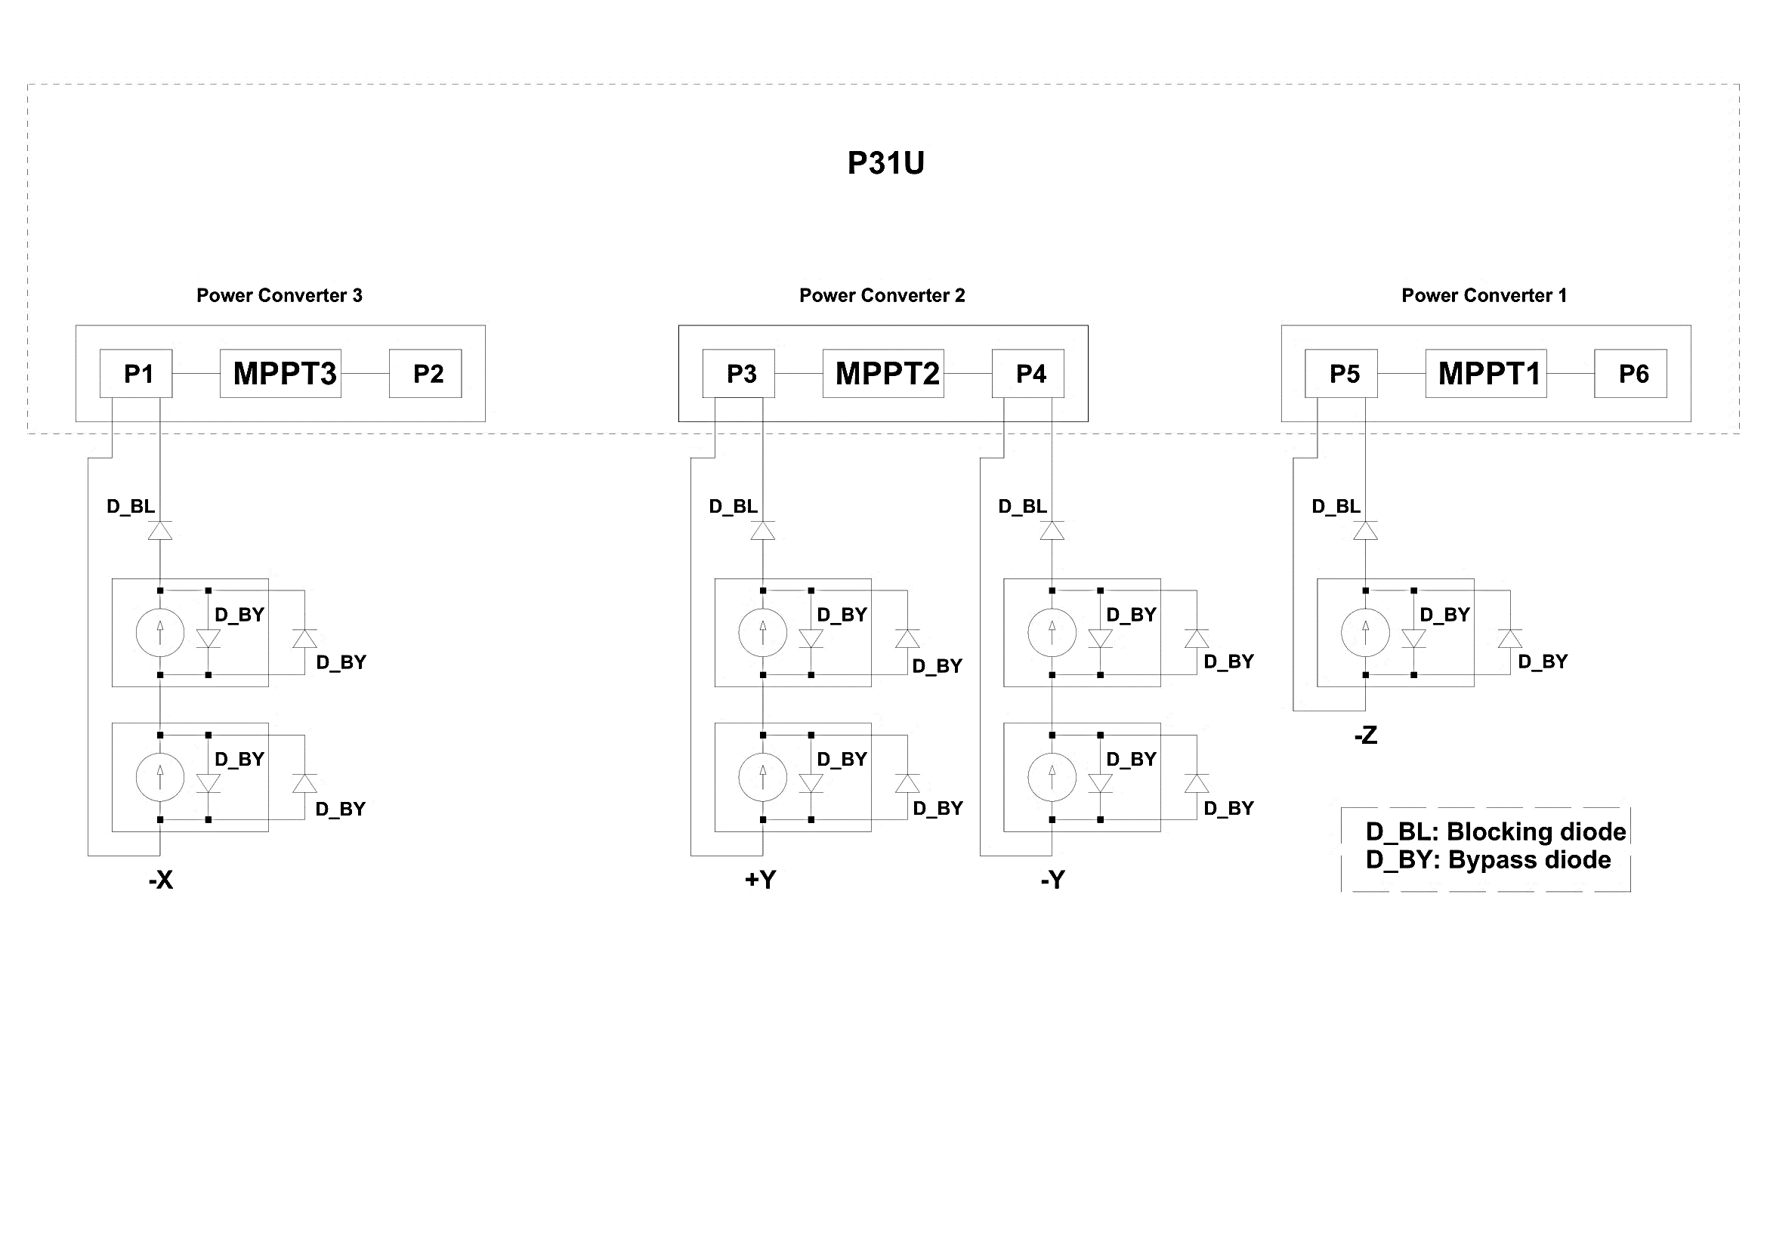

Figure : electrical connections between the photovoltaic modules and the power converters.

### Batteries

The current generated through the solar arrays is partially stored in the batteries to face the eclipse periods (when no current is generated by the solar arrays) and to supply additional power to the loads when requested. The battery has an integrated electric heater to avoid drastic temperature drops (requirement FDS_VCD_4.2.17). This is to avoid a depth of discharge, which increases drastically energy consumption.

The COTS model chosen is the lithium-ion type NanoPower Battery 3000mA, integrated with the BP4, which is integrated with P31u. The characteristics are listed in Table 45 and Table 46 (requirement FDS_VCD_4.2.20, FDS_VCD_4.2.21, FDS_VCD_4.2.23, FDS_VCD_4.2.24).

Table 45: Nanopower Battery 3000mA cell properties

|  |  |  |  |  |  |
| --- | --- | --- | --- | --- | --- |
| **Parameter** | **Condition** | **Min.** | **Typ** | **Max** | **Unit** |
| Nominal Capacity |  |  | 3000 |  | mAh |
| Voltage |  | 2,95 | 3,6 | 4,0 | V |
| Current - Charge | 0 - +50 °C |  | 1500 | 4000 | mAh |
| Current - Discharge | -20 – +75 °C |  | 1500 | 6000 | mA |
|  |  |  |  |  |
| Temperature – Storage (recommended) | 3 months | -20 |  | 45 | °C |
| 12 months | -20 |  | 20 | °C |
| Temperature - Operating | Charge | 0 |  | 50 | °C |
| Discharge | -20 |  | 75 | °C |
| Internal impedance | 1s, 3000mA, 60% SoC  20s, 3000mA, 60% SoC  1Hz |  | 21  36  <=20 | 70 | mΩ  mΩ  mΩ |

Table 46: BP4 properties

|  |  |  |
| --- | --- | --- |
| **Configuration** | **Number of cells** | **3000 mAh cell (Nominal)** |
| 2P-2S | 4 | 43 Wh  6 - 8.4 V  6.0 Ah |

The requirement FDS-VCD 4.13.4 is met since the chosen battery configuration produces 43 Wh, which is less than 100 Wh, and batteries are the only source of stored chemical energy.

The battery cells are equipped with a current-interrupt device (CID) and a vent. The CID is triggered by an increase of an internal pressure because of overcharging or overheating of the cell. The estimated threshold is 1.017 MPa. Triggering the CID causes disconnecting conductive paths inside of a cell to prevent further (dis)charge and it causes a permanent open circuit across the cell. The vent is triggered by an internal pressure exceeding an estimated value of 1.906 MPa, which results into releasing accumulated gases inside of the cell to prevent or reduce a risk of a rupture or an explosion (requirement FDS_VCD_4.2.16).

A sample test is done according to “Requirements for flight certifications and acceptance of commercial off the shelf (COTS) Lithium-Ion (Li-Ion) batteries”, JSC 66548, for physical characteristics, overcharge and external short. Every cell goes through the flight acceptance test (FAT), based on “NASA Aerospace Flight Battery Program”, document no. RP-08-75 Rev. 1.0. The cells are checked for their physical and electromechanical characteristics, i.e., any deformation, open circuit voltage, capacity and internal resistance (requirement FDS_VCD_4.2.14, FDS_VCD_4.2.15). According to the performed analysis ALB_EPS_ARTP_2024-03-10_v1.0, the EPS battery pack is capable of lasting more than 9 months of storage (requirement EPS_FDS_4.2.12). The storage life can be extended to 24 months from the final assembly and integration (requirement EPS_FDS_4.2.7).

#### Battery Protection

The lithium-ion battery is charged with all the available power generated by the solar arrays, which is not drained by the loads on the external power buses. To ensure safe operations and long battery life, the battery is protected against too low and too high voltage. The low voltage protection is implemented in both hardware and software. The hardware low voltage protection will switch off the kill-switch, deactivating the outputs from the p31u and most electronics on the p31u. The hardware high voltage protection will set the input voltage on the solar cell to zero.

Table 47: Configuration for the 8V battery

|  |  |
| --- | --- |
| **Hardware level set points** | **Voltage level (V) - 8V** |
| Switch off | 6.0 |
| Switch on | 6.4 |

The software high voltage protection implements a constant voltage charge scheme which keeps the battery at its maximum voltage while supplying the loads.

The software low voltage protection is a four states system, with a critical, safe, normal and full mode. In normal mode, in case the battery voltage drops below the safety voltage, the p31u changes its output switch configuration to the safe mode configuration. This allows the switch off of the non essential systems. In case the battery voltage drops below the critical voltage, the p31u will switch off all the user’s outputs.

Table 48: Voltage levels corresponding to the modes

|  |  |
| --- | --- |
| **Mode** | **Voltage level (V) - 8V** |
| Full | 8.3 |
| Normal | 7 |
| Safe | 6.7 |
| Critical | 6.5 |

### Inhibits

To facilitate the cessation of the electrical activity of the satellite, a combination of inhibition measures is used. The following inhibition measures comes with the PCDU:

* KS (Connector P11, P10, P8): The kill-switch input, short this input to ground and the P31u will switch ON
* KS_RESET, (Connector P8): The kill-switch reset, short this input to ground and the P31u will switch OFF
* RBF, (Connector P8): The Remove-Before-Flight, if this input is shorted to ground, the P31u can’t be switched ON (requirement for the FDS-VCD: 4.2.1; 4.2.7; 4.2.8; 4.2.9,)
* GND_BRK (Connector P14): Break ground connection on batteries. Short this connector to connect batteries.

The p31u has a built in kill-switch which disconnects the batteries from the buck converter and thereby turning off the satellite. In order to close this switch and to activate the satellite, the p31u has three separation switch inputs (requirement FDS_VCD_4.2.2). If one of these pins is connected to ground, the satellite will start up and remain turned on. Also, the CubeSat deployment switches will be in actuated state while inside the CubeSat Deployer (requirement FDS-VCD 4.2.4). The RBF pin, that shall have a label to be identified (requirement FDS-VCD 4.2.7), cuts off the function of the kill-switch, which is used to ensure that the satellite is turned off even when the kill-switch is released, the pin will not protrude more than 6.5mm from the rails when it is fully inserted into the satellite (electrical requirements FDS-VCD 4.2.10). Moreover, in the flight preparation panel (Figure 48) (Figure 49), it can be seen how the EGSE connection is integrated.

Further mitigation measures will be verified during functional testing (requirements FDS_VCD_4.2.13, FDS_VCD_4.2.3).

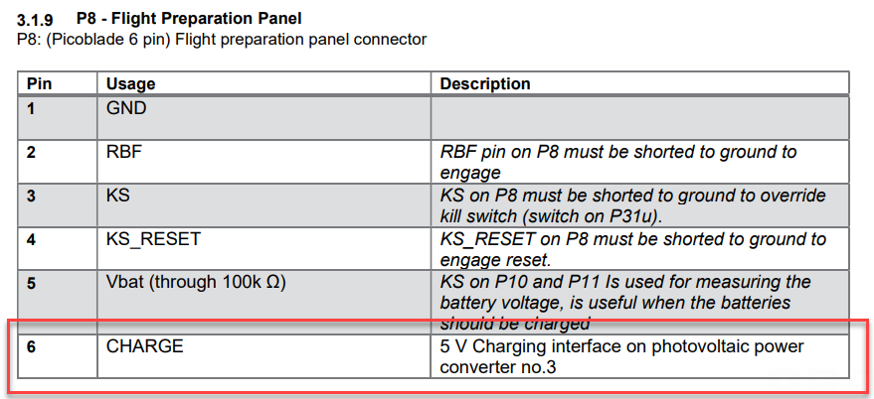

Figure : EGSE connection illustrated in the p31u datasheet.

Further mitigation measures can be evaluated by performing functional tests on the ground. An illustration of the p31u and BP4 inhibits is given in Figure 49. In Figure and Figure , the inhibition measures and their connection to the p31u and to the BP4 are highlighted.

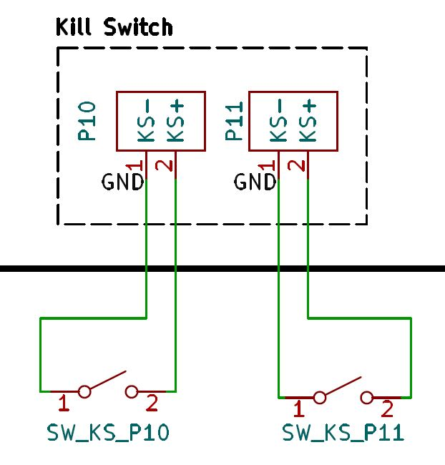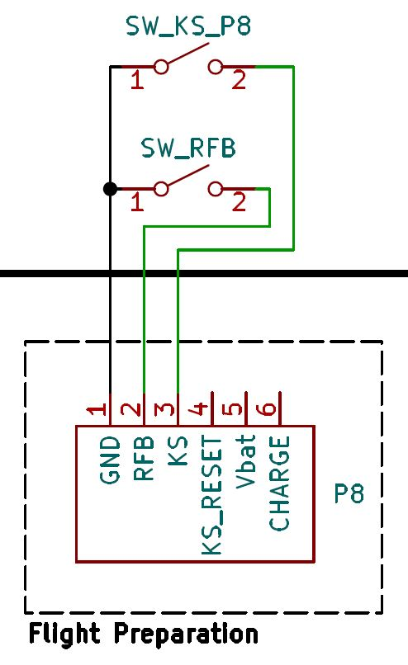

Figure : Kill switch connectors P10 P11 of p31u.

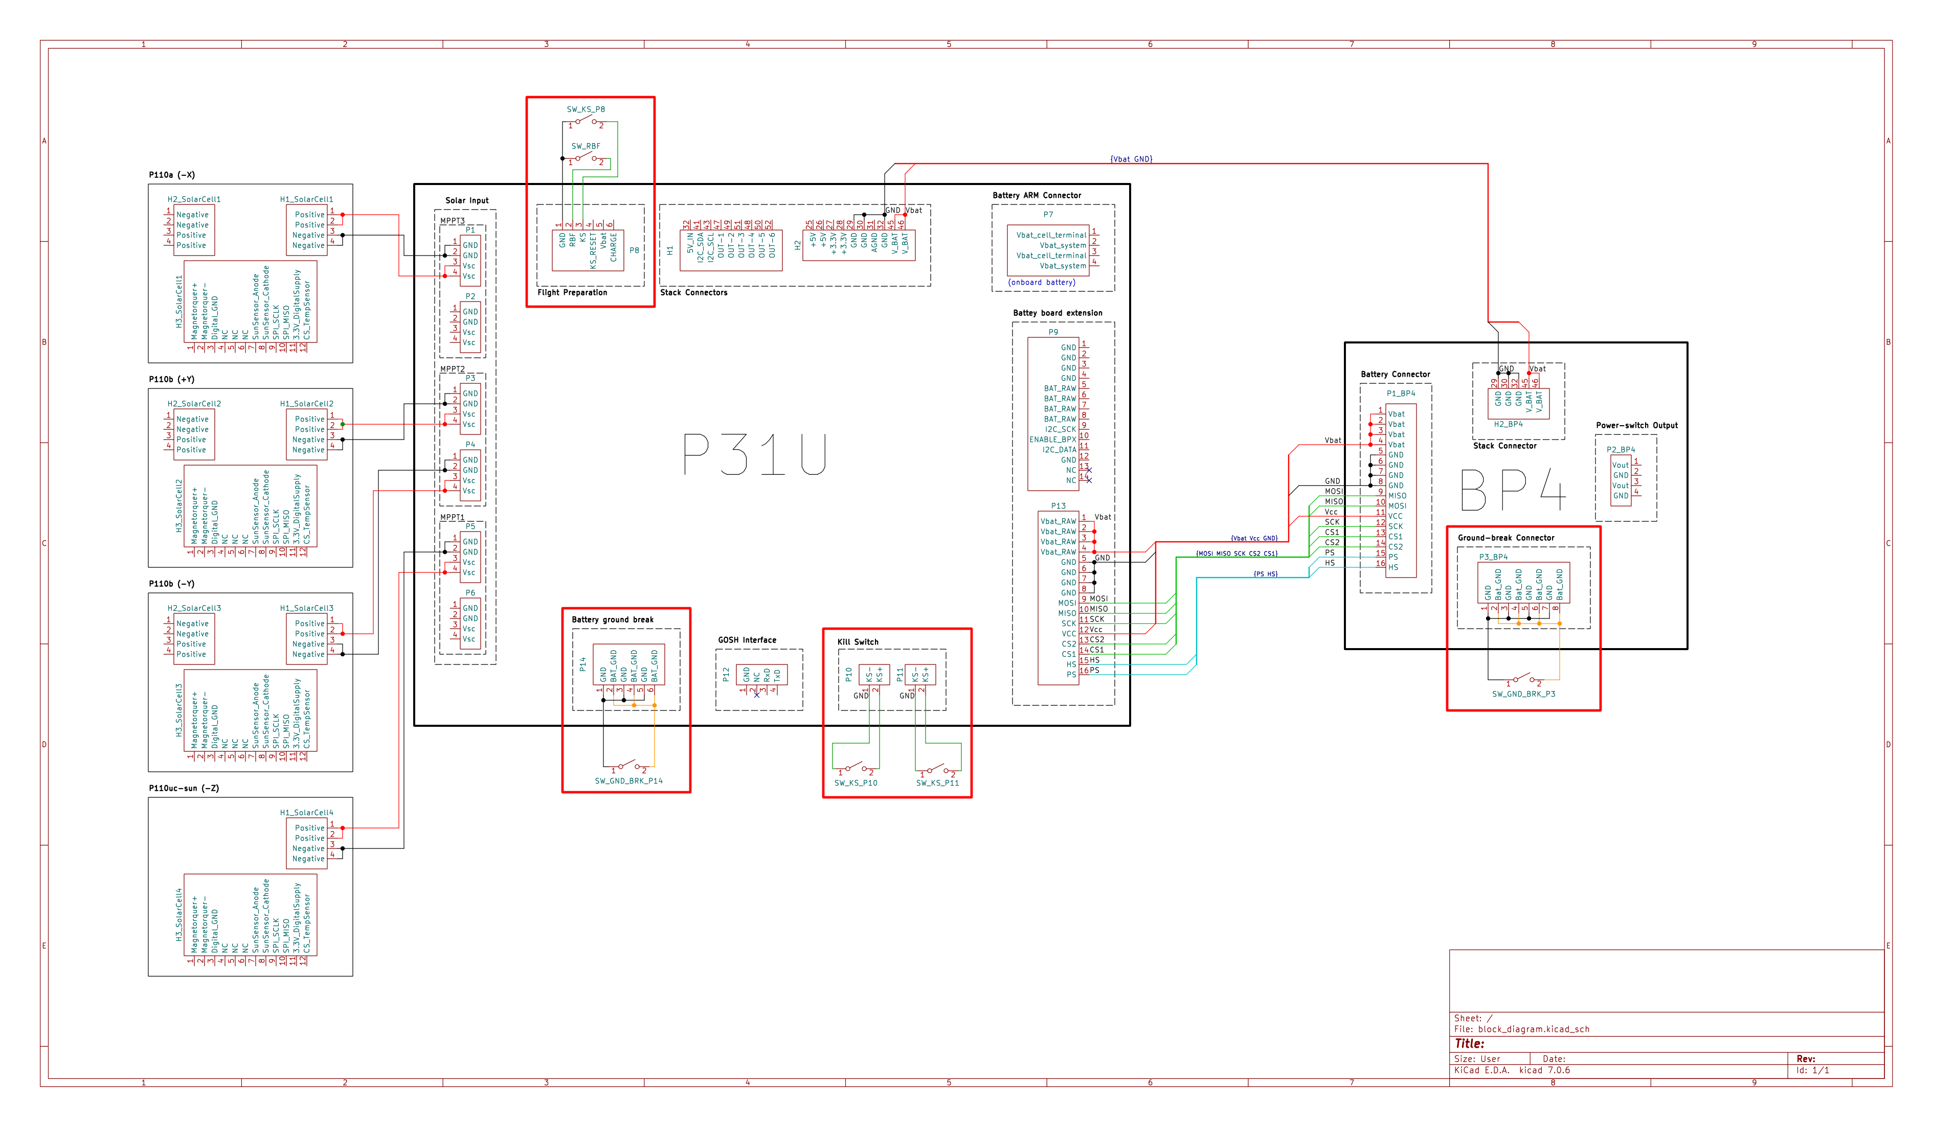

Figure : Electrical connections of the EPS scheme.

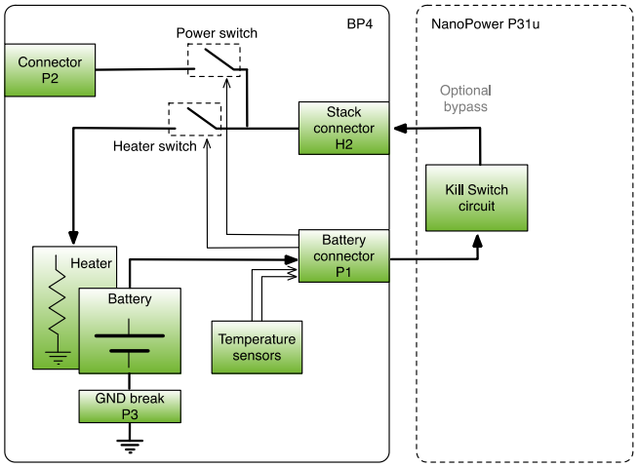

Figure : Inhibition measures diagram.

### Power and energy budget

#### Power generation

In order to assess the power generation of the satellite two orbits have been considered, namely: a SSO midday-midnight and a SSO dawn-dusk. They represent the worst and the best case for the power generation respectively. In addition, it has been considered that the power generation depends on the attitude of the CubeSat. Hence, for the two considered orbits two different attitude profiles were considered: nadir pointing and tumbling. A simulator was developed in the MATLAB environment and simulations have been performed using the orbital parameters reported in Table 49.

Table 49: Orbital parameters used in the power generation simulations

|  |  |  |
| --- | --- | --- |
|  | **Midday - midnight** | **Dawn - dusk** |
| **Date** | 30/03/2027 | 30/03/2027 |
| **Semi major axis** | 6878.00 km | 6878.00 km |
| **Altitude** | 500.00 km | 500.00 km |
| **Orbital period** | 94.614 min | 94.614 min |
| **Inclination** | 97.4 deg | 97.4 deg |
| **Eccentricity** | 0.001 | 0.001 |
| **Argument of perigee** | 0.0 deg | 0.0deg |
| **RAAN** | -171.1 deg | -81.1 deg |
| **True anomaly** | 0.0 deg | 0.0 deg |
| **LTAN** | 0.0 am | 6.0 am |
| **Initial beta angle** | 0.44 deg | 79.12 deg |
| **Final beta angle** | 0.68 deg | 74.51 deg |



The CubeSat is covered by seven modules of 60.63 cm2 of solar arrays. These have an efficiency of 30%. Two solar array modules are mounted on the faces , and while only one is mounted on the face. The faces and are not covered by solar panels since they host the impact sensor and the Quantum Payload respectively. The solar constant is considered equal to 1340 W/m2. Simulations of the power generation are reported in the ALB_EPS-ARPT_2024-03-10. 50

#### Power budget

To estimate the power budget, the peak power consumption of each component has been obtained from the datasheet. A margin was added to the nominal power value at subsystem level according to the ECSS-E-ST-10-02C: the 20% was applied to the payloads (IS, MVS, QPF) since they are under development while the 5% was applied to the COTS components. If the duty cycle is not known, a default value of a 100% is given. For each operative mode the duty cycle of each component has been estimated. The system power consumption of each mode is evaluated by multiplying the peak power consumption for the duty cycle and by summing the results. A 20% margin is considered at system level.

The following table reports the power budget for each mode. In the DC [%] column the duty cycle of the subsystem is reported for each mode. The peak power consumed by the subsystem (in which the margin is considered) is multiplied by the duty cycle. The value obtained is reported in the P [W] column. The values of the P [W] columns are summed to obtain the power consumption of the system, then a 20% margin is applied at system level (blue cells).

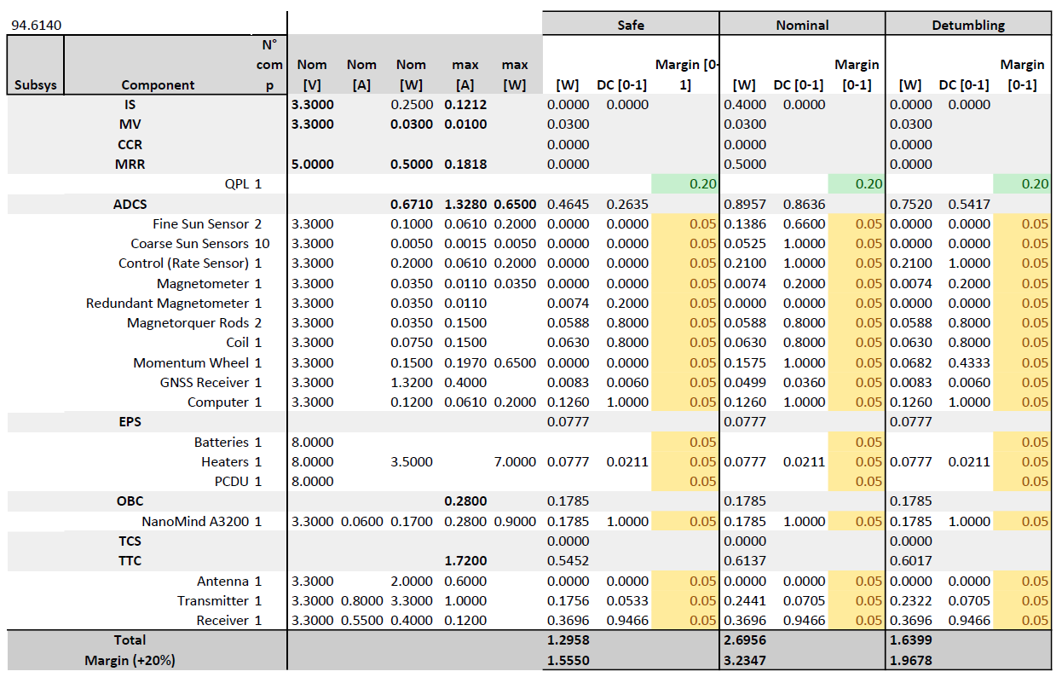

Figure : Power Budget

## On-board Data Handling

### OBDH Quick Facts Table

|  |  |  |
| --- | --- | --- |
| NanoMind A3200 | Manufacturer | GOMspace |
| Mass | 24 g |
| Dimensions | 65 x 40 x 7.1 mm |
| Thermal range | -30 to +85 °C |
| Microcontroller | Atmel AT32UC3C MCU |
| Bus protocols | CAN bus  I2C bus  SPI  UART |
| On-board Storage | OBC NOR Flash (data storage) 128 MB  FRAM (persistent configuration storage) 32 kB  SDRAM 32 MB |
| NanoDock DMC-3 | Manufacturer | GOMspace |
| Mass | 51 g |
| Dimensions | 91.9 x 88.7 x 8.6 mm |
| Thermal range | -40°C to +85°C |
| Features | 2 FSI slots for NanoMind and NanoCom daughterboards |

### Functional and physical architecture

Functional (Figure 53) and physical (Figure 54) architecture are designed to meet mission requirements: a main CAN bus links every major component of the spacecraft allowing a duplex communication between subsystems. The OBC can send and receive parameters and commands to execute OBSW scheduled tasks. Additional ports are used to control payloads and collect their data. This architecture is also represented as a peer-to-peer network where every subsystem and payload acts as a node, and the OBC is responsible for packets routing (close-out of requirements OBC-FKT-1008 and OBC-INT-1007 from ALB_TS-VCD_2024-03-10_v1.0). (As per **Errore. L'origine riferimento non è stata trovata.**, close-out of requirement OBC-INT-1006 from ALB_TS-VCD_2024-03-10_v1.0)

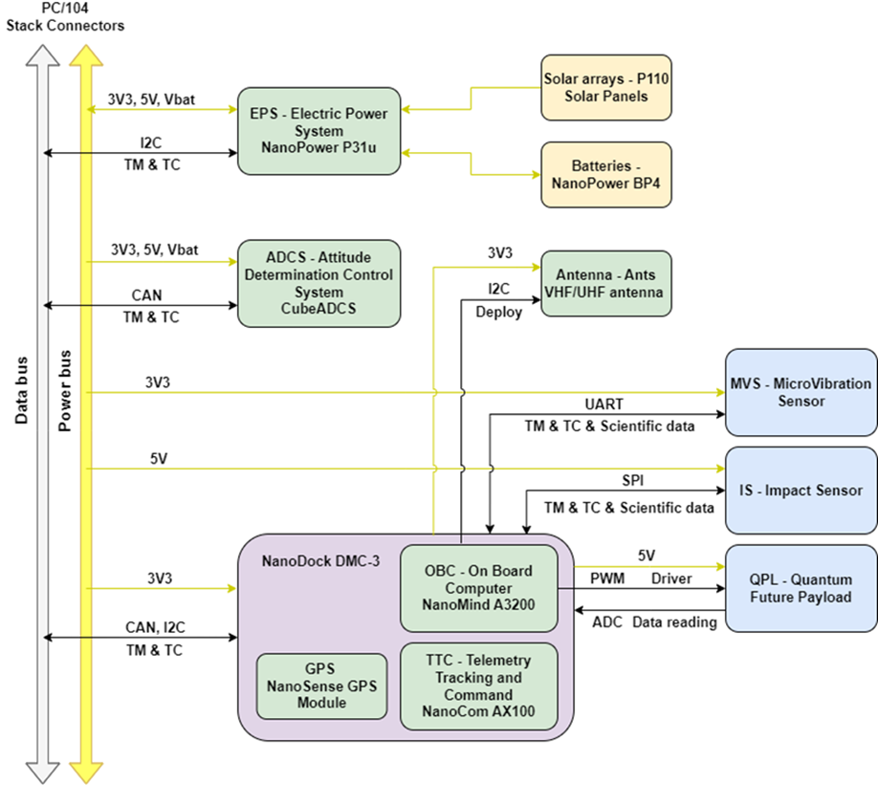

Figure : OBDH functional architecture.

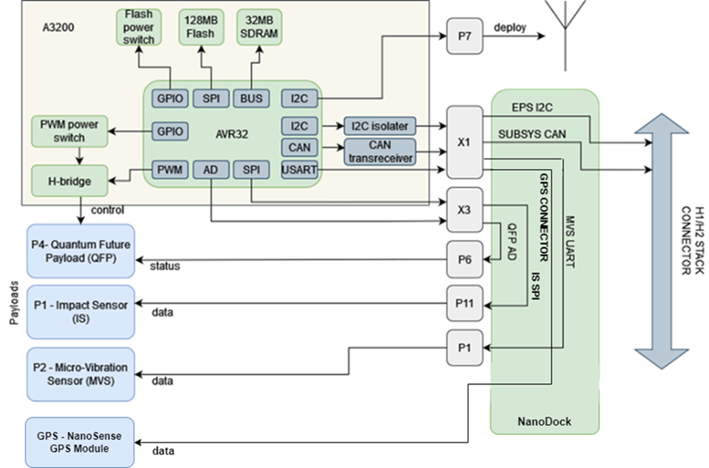

Figure : OBDH physical architecture.

The COTS OBC that was selected for AlbaSat is the NanoMind A3200 produced by GomSpace. The A3200 is based on an Atmel AT32UC3C MCU with a 32-bit RISC architecture. The board, along with the NanoCom AX100 transceiver, is mounted on the NanoDock DMC-3 motherboard. The X1 and X1-2 interfaces give OBC the access to the CubeSat CAN bus.

The A3200 provides P and X ports to communicate with payloads and the NanoDock:

* P1 provides an USART connection for board configuration.
* P2 provides a JTAG connector for software upload.
* P6 provides 3 set of PWM drivers, where one of them is used for controlling the QPL.
* P7 provides an I2C connection to perform the antenna deployment.
* X1 and X3 (also called X1-2 from the NanoDock’s perspective) provide direct FSI connection to the NanoDock.

The NanoDock provides P and X ports to communicate to subsystems, payloads and the A3200:

* P1 is a Breakout Connector to X1 providing a UART interface to the USB connector for debugging access. While in space it is connected to the MVS payload.
* P1 also provides a UART interface permanently connected to the NanoSense GPS receiver.
* P6 to P10 provide 5 individual ADC inputs hardwired to the X1-2 port. In particular, P6 receives data from the QPL.
* P11 provides an additional SPI connection through X1-2.
* P12 provides an additional CAN connection to the CubeSat bus through the stack connector.

Also, the NanoDock, as a PC/104 board, provides a stack connector of two ports H1/H2 of 52 pins each. The CAN bus and power lines of 3.3V and 5V pass through H1/H2.

The CubeSat mass memory is only accessible through the NanoMind MCU.

## On-board software

### OBSW Quick Facts Table

|  |  |
| --- | --- |
| Programming language | C, C++ |
| Operating system | FreeRTOS |
| Memories | MCU internal Flash (application software) 512 kB  OBC NOR Flash (data storage) 128 MB  FRAM (persistent configuration storage) 32 kB  SDRAM 32 MB |

### OBSW Architecture

The in-house developed software on AlbaSat is split between three microcontrollers on:

* On-Board Computer subsystem.
* Impact Sensor payload.
* Micro-Vibration Sensor payload.

Additional software comes already implemented on some COTS hardware, namely the microcontrollers on:

* Attitude Determination & Control subsystem.
* Telemetry, Tracking & Command subsystem.

The software for the satellite includes:

* Firmware, including OBC bootloader, IS and MVS payload bootloaders, and libraries provided by hardware manufacturers.
* System software, namely the OBC RTOS and the file systems on some of the memories.
* Application software, including subsystem-specific and payload-specific code and logic, miscellaneous external libraries, as well as code implementing housekeeping functionalities, FDIR and PUS services. (close-out of requirement OBSW-FKT-2105 from ALB_TS-VCD_2024-03-10_v1.0)

Due to the distributed nature of the system, a layered software architecture (Figure 55) was chosen to guarantee a sufficient level of abstraction between the core OBC functionalities (BIOS and RTOS) and the application level.

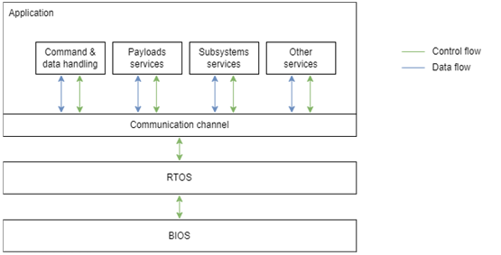

Figure : High-level representation of the software architecture.

The AlbaSat OBSW has the main purpose of providing interconnection between all payloads and subsystems, managing communication on the channel. It is also responsible for storing data, having direct access to the memories installed on the OBC itself, and performs task scheduling through the RTOS layer. The OBSW can also activate or deactivate payloads and subsystems based on power consumption, ground command and other necessities, operating the transition between operating phases (close-out of requirements OBSW-FKT-2106, OBSW-FKT-2112, OBSW-FKT-703, OBC-FKT-1002 and OBSW-FKT-2116 from ALB_TS-VCD_2024-03-10_v1.0).

Additionally, the OBSW oversees payloads and subsystems operation through module-specific code, which also serves as an interface to allow data transfer with the communication channel. Each OBSW module can change its configuration automatically or after receiving a TC command from ground (close-out of requirement OBSW-FKT-2119 from ALB_TS-VCD_2024-03-10_v1.0).

OBSW relies on OBDH for data encapsulation using the CSP network protocol, which is also supported by the A3200 board, and works closely with the AX100 module to allow communication with the ground station and telecommand (close-out of requirements OBDH-FKT-2202 from ALB_TS-VCD_2024-03-10_v1.0).

### OBSW Design Description

#### Physical and functional architecture

##### Operating system

The OBC software is based on **FreeRTOS**, it has been chosen for its **small memory footprint**, **real-time** capabilities, and extensible **open-source** nature.

As the MCU has a very limited internal FLASH of 512kB (section **Errore. L'origine riferimento non è stata trovata.**), it is important to use an OS that is both efficient and lightweight. FreeRTOS suits this need well, as it requires only 4kB of RAM and 32kB of flash memory to run (close-out of requirement OBSW-PRF-2110 from ALB_TS-VCD_2024-03-10_v1.0).

The CubeSat requires deterministic and synchronous behavior to correctly manage tasks, payload communications and memory management. FreeRTOS is known to be reliable, as it prioritizes tasks, and it allows to set up precise timing deadlines. This real-time behavior ensures that nothing is delayed, and operations are carried out in the correct order (close-out of requirement OBC-FKT-1000 from ALB_TS-VCD_2024-03-10_v1.0).

Being open source is also advantageous, as it allows specific customization tailored to CubeSat missions. This also comes with the benefit of a large community of active developers, as well as many libraries and extensions for the base kernel. One such extension is the [FreeRTOS + FAT API that adds support for reading and writing files in a standard way.](https://www.freertos.org/FreeRTOS-Plus/FreeRTOS_Plus_FAT/Standard_File_System_API.html) This comes handy for housekeeping and data storing.

##### Types of memory used

The OBC software is stored within the MCU internal FLASH of 512 kB. The running copy of the OBC software is kept in the 32 MB SDRAM and an additional 32 kB FRAM serves as persistent configuration storage (close-out of requirement OBSW-FKT-2120 from ALB_TS-VCD_2024-03-10_v1.0).

Scientific data are stored in a NOR FLASH of 128 MB, which is used as a buffer between connections with GS. According to ECSS-E-ST-40C, a backup image of the OBC software is also stored within the MCU internal FLASH (close-out of requirements OBDH-FKT-2109 and OBSW-DES-2104 from ALB_TS-VCD_2024-03-10_v1.0).

##### Architecture for getting the data from the hardware

Getting data from hardware is an event-based approach. Events are implemented as interrupts, which can be of two kinds:

* **Internal interrupts**, for board errors and similar. These are collected and processed by the Interrupt Controller (**INTC**).
* **External interrupts**, for every event generated by payloads or other hardware. These are taken care of by the External Interrupt Controller (**EIC**).

To facilitate the software development process, low level details are abstracted by GomSpace libraries provided in the SDK for the A3200.

##### Architecture for driving the hardware

To feed data to payloads and modules GomSpace provided interfaces in the SDK of the board, offering a layer of abstraction over the library [libcsp](https://github.com/libcsp/libcsp). Payload and modules are connected to the OBC with:

* I2C
* PWM
* SPI
* UART

#### Memory management

The A3200 memory is handled by a FLASH file system which is pre-implemented on the board and provides the possibility of storing up to two OBC software images at the same time.

The IS and MVS application memories are divided into two partitions: main partition (containing the software image which is currently being executed on RAM) and secondary partition (for new software images). The bootloader cannot be modified unless as last resource. It is part of the FDIR as it protects from multiple failed boots, restoring to a working image.

* + - * 1. ***System for overwriting old data***

Old data is cyclically overwritten based on two flags:

* **Download Success ACK**: if ground station has successfully received sent packages, it will send back an ACK signal, otherwise data will be kept and eventually retransmitted at the next ground station contact. This process is reserved for scientific data.
* **Time threshold**: if data is older than a configurable threshold, based on its timestamps, will be removed to free up memory. Error logs cannot be automatically deleted; OBC will provide a specific ground station command to clear this memory space.

(close-out of requirement OBDH-FKT-2208 from ALB_TS-VCD_2024-03-10_v1.0)

##### File management structure

The OBSW utilizes FAT32 file systems for file management, facilitated by the GomSpace SDK's `libstorage` library. The storage library contains a version of Chan’s FAT FS ported for the NanoMind A3200 . For the on-board NOR flash, the UFFS filesystem is also provided. Both of these filesystems integrate with newlib’s POSIX interface using a virtual filesystem layer called VFS.

FAT, or File Allocation Table, provides a structured index of files on the system, allocating clusters of data storage. FAT32 supports volumes up to 2 TB using 32-bit cluster addresses. The FAT file system comprises four main sections: the Boot Sector, File Allocation Table, Root Directory, and File Data Region. Each section serves specific purposes in managing file storage and retrieval. In the FreeRTOS environment, FAT file system support is provided through [FreeRTOS+FAT](http://FreeRTOS+FAT DOS Compatible Embedded FAT File System), an open-source project offering an easy-to-use set of standard FAT functionalities perfectly compatible with our hardware.

API functions provided by FreeRTOS+FAT enable interaction with the file system, categorized into Directory/Folder Functions, File Read and Write Functions, and File Utility Functions. Additionally, FreeRTOS-Plus-FAT Native APIs support disk management operations like partitioning, formatting, and mounting. FreeRTOSFATConfig.h header file allows adjustments to parameters such as open files/directories, sectors per cluster, and sectors per FAT. Overridden flags in FreeRTOSFATConfig.h are here presented in Table 51.

Table 51: Overridden flags in FreeRTOSFATConfig.h.

|  |  |  |
| --- | --- | --- |
| **Flag** | **Overridden value** | **Motivation** |
| **ffconfigBYTE_ORDER** | pdFREERTOS_LITTLE_ENDIAN | Set according to the current architecture (ARM on STM32 NUCLEO F411RE). |
| **ffconfigCWD_THREAD_LOCAL_INDEX** | 1 | Default value; CWD will be found at index 1 in the Thread Local Storage array. |
| **configNUM_THREAD_LOCAL_STORAGE_POINTERS** | 15 | Default value of 15. |
| **FF_PRINTF** | printf | At development time, it can be useful for some basic I/O through Serial printing. Software is of course debugged with the GNU debugger and NOT with printf. |
| **ffconfigWRITE_BOTH_FATS** | 1 | This allows to have 2 copies of each file allocation table for extra memory safety. |
| **ffconfigMALLOC(size)** | pvPortMalloc(size) | This porting is application specific and allows the access to the std malloc macro. |
| **ffconfigFREE(ptr)** | vPortFree(ptr) | This porting is application specific and allows the access to the std free macro. |
| **ffconfigMAX_PARTITIONS** | 1 | Momentary value to avoid fragmentation of memory. |
| **ffconfigMIN_CLUSTERS_FAT16** | 64 | To be removed, as only FAT32 is used. |
| **ffconfigDEBUG** | 1 | Set true to use the debug. |
| **ffconfigHAS_CWD** | 1 | Facilitates file tree management. |
| **configHEAP_CLEAR_MEMORY_ON_FREE** | 1 | Needed to clear memory with vPortFree(). |
| **configAPPLICATION_ALLOCATED_HEAP** | 1 | Allows precise allocation of heap memory. |

FAT file systems have limitations, including maximum file size and number of files within folders, depending on the FAT type and cluster configurations. Care must be taken when accessing files, to avoid unpleasant race conditions. The application is the only responsible of thread safety (close-out of requirement OBSW-FKT-2118 from ALB_TS-VCD_2024-03-10_v1.0).

##### Error/fault handling

**Memory Protection Unit (MPU) and Secure Access Unit (SAU)**

The OBC MCU (AT32UC3C) implements a Memory Protection Unit and a Secure Access Unit. The MPU allows the user to divide the memory space into different protection regions and is responsible for checking that memory transfers have the correct permissions to complete. The SAU remaps registers in memory regions protected by the MPU to memory regions not protected by the MPU, since the MPU does not perform any address translation. FreeRTOS can use these units to provide protection to memory regions outside of a task allocated stack, drastically reducing the probability of bits flipping due to cosmic radiation and accidental memory corruption in general. AT32UC3C’s MPU provides 8 protection regions, each divided into 16 subregions. Even though FreeRTOS does not officially support MPU ports for AVR32, third-party ports can be utilized (close-out of requirement OBDH-FKT-2203 from ALB_TS-VCD_2024-03-10_v1.0).

**Cyclic Redundancy Check (CRC)**

The AT32UC3C implements a Memory Service Unit (MSU) that can be used to calculate a CRC value for any memory area and for any data frame using the industry standard CRC32 algorithm. This allows for error detection on data stored in memory and during transmission, as per ECSS-E-ST-70-41C recommendations.

**Power cycling**

OBC will be able to command EPS to power-cycle other subsystems, to restore their operation in case of crashes or latch-ups (close-out of requirement OBSW-FKT-2111 from ALB_TS-VCD_2024-03-10_v1.0).

**MCU internal watchdog**

The AT32UC3C windowed watchdog timer will be used to detect and recover from soft system faults. This timer will take care of resetting the MCU unless periodically serviced by the OBSW, preventing the system from entering an inconsistent state in case of temporary transients caused by cosmic rays or any other unexpected phenomena.

#### Implementation of Software functions

##### How image is written and compiled

As provided by GomSpace, the build system used is [waf](https://waf.io/). On ground a JTAG connector will be used to flash the software image, whereas in space Over The Air updates will be performed through FTPS (close-out of requirement OBSW-DES-2103 from ALB_TS-VCD_2024-03-10_v1.0).

##### Boot sequence

For the boot sequence the FRAM config will be checked on every boot and following the [AVR32 bootloader guide](https://ww1.microchip.com/downloads/en/devicedoc/doc7745.pdf) as presented in the documentation. GomSpace documentation should provide additional information about this section.

##### Implementation of Spacecraft modes

From the software point of view there is a dedicated area in memory to keep track of the current satellite mode. Only high priority tasks can access and modify this value, e.g. housekeeping tasks. A different set of tasks are available in each mode, depending on these parameters and each payload can be activated or deactivated separately, even in nominal mode.

##### Selected scheduling policy and justification

An efficient scheduling policy is mandatory to avoid starvation and convoy effect situations and to make good use of available resources.

FreeRTOS kernel already provides its own scheduling policy which is a fixed-priority preemptive scheduling one. That means the scheduler will always run the highest priority task, with the possibility of boosting the priority of a task but the inability to permanently alter it. In the case of equal priority tasks, a round-robin time-sliced policy is used, so that the scheduler can equally deal with them switching when the amount of execution time is elapsed.

##### Assigned task priorities and justification

Each task will be assigned a priority from zero to the maximum level chosen, where lower priority numbers mean low priority tasks. These values will be calculated based on the task period and the percentage of cpu-time requested: what is desirable is to give a higher priority to tasks which demand less cpu resources so that a convoy effect is avoided, and the average waiting time is reduced.

##### Intertask communication implementation

For non-critical and lightweight communications, we use [FreeRTOS task notifications](https://www.freertos.org/RTOS-task-notifications.html). The use of mutexes and semaphores is reserved to more critical tasks, due to the increased overhead introduced by these mechanisms.

##### Timekeeping mechanism

The A3200 provides an internal Real Time Clock (RTC), which is used by all payloads to get the time. The OBC synchronizes this clock with the PPS (Pulse Per Second) provided by the GPS module. From the software perspective, UNIX time is used in UTC format for timekeeping. Other functions to synchronize and keep track of the time are provided by the GomSpace libraries (close-out of requirements OBSW-FKT-2101 and OBSW-PRF-2102 from ALB_TS-VCD_2024-03-10_v1.0).

The time will need to be synchronized again in the following cases:

* Loss of power: the A3200's internal RTC can keep the time after power is lost, but if the RTC battery runs out the time will need to be reset.
* Drift: the RTC internal mechanism can create drift, which is resolved by updating the timestamp using the other satellites in the GPS network.

#### Software update procedure

Each OBSW image can be updated both on ground (through a physical connector on the NanoDock) and in orbit (via FTP) by uploading a new one to replace it. The update procedure goes as following: once a new software image is uploaded to the OBC FLASH file system, in a single or multiple transmissions (depending on its size), two different mechanisms take place based on whether the new image is an OBC software image or a payload software image.

If the update regards the OBC, the new image is selected as boot image by the OBC bootloader and the OBC attempts rebooting from the new image in RAM. In case of failure, the OBC falls back to the previous working software image.

Instead, if the update regards a payload, the new image is sent to the secondary partition of its FLASH memory. The payload bootloader then selects such partition for the next boot, the payload is restarted and in case of success the new image is copied to the primary FLASH partition, re-selecting such partition as boot partition.

A more detailed diagram is presented in Figure 56**Errore. L'origine riferimento non è stata trovata.**.

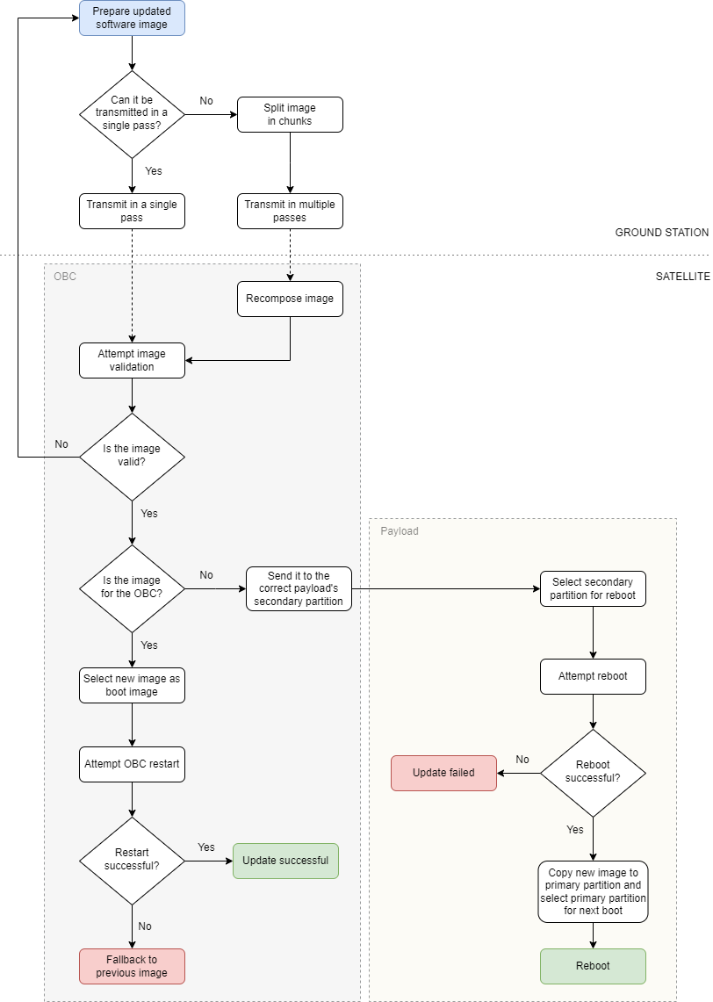

Figure : Software update procedure diagram

### Memory Budget

The on-board memory is to be considered as the union of every mass memory located in the satellite. Memory details provided by manufacturers for each processing unit with available storage present in the satellite are shown in Table 52.

Table 52: Processing unit with available storage present in the satellite

|  |  |  |  |  |
| --- | --- | --- | --- | --- |
| **OBC NanoMind A3200** | MCU internal flash | 512 | KB | Application software |
| NOR flash | 128 | MB | Data storage and Telemetry |
| FRAM | 32 | KB | Persistent configuration storage |
| SDRAM | 32 | MB | Running software |
| **ADCS CubeADCS model Y-momentum** | EEPROM | 32 | KB | Bootloader |
| MCU internal flash | 4 | MB | Running software |
| MicroSD | 1 | GB | Data storage and Telemetry |
| **IS ATmega128** | Flash | 128 | KB | Data storage and Telemetry |
| SRAM | 4 | KB |  |
| EEPROM | 4 | KB |  |
| **MVS STM32U585** | Flash | 2 | MB | Data storage and Telemetry |
| SRAM | 786 | KB |  |

Every flash memory is then partitioned with the same high-level mapping, which is dependent on the following data sources:

* Software images, comprehensive running image and backup image.
* Scientific data collected from payloads.
* Telemetry (TM), formed by housekeeping data generated from payload and subsystems.
* Telecommands (TC) packets sent and received from the ground, handled by the OBC.

#### OBC flash

The OBC flash storage of 128 MB is partitioned considering a first-iteration usage goal of 60% for payloads data, software images and Telemetry (close-out of requirements OBDH-FKT-506 and OBDH-FKT-2207 from ALB_TS-VCD_2024-03-10_v1.0).

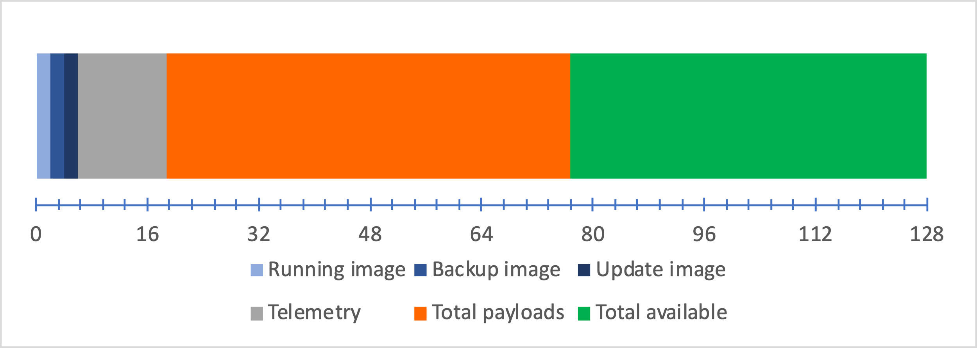

Figure : OBC flash

Considering three software images of 2 MB each and 10% of the total volume for Telemetry (12 MB), the remaining volume will be dedicated to payload data. The subdivision of the remaining 58 MB between payloads is calculated from a worst-case scenario of N=88 days of data production without GS contact. A high value of N represents a margin of safety for future iterations.

* Impact sensor payload is expected to produce 2.8 Kb per day, resulting in 31.3 KB allocated with N=88.
* MicroVibrations payload is expected to produce 5259 Kb per day, resulting in 57.8 MB allocated with N=88.
* Quantum Payload is not expected to produce any data since it is a passive payload.

Every subsystem and payload will also provide additional data in the form of a status check requested from the OBC. These data will compose the Telemetry and represent the primary mode for passive subsystems and payload, like Quantum Payload, to communicate their status (close-out of requirements OBSW-PRF-2107, OBSW-PRF-2113 and OBSW-INT-2115 from ALB_TS-VCD_2024-03-10_v1.0).

#### CPU budget

The team approach to perform computational analysis was to first identify every processing unit in the satellite and the amount of computational load that it will carry.

A computational load is considered to be a set of operations and algorithms run on a processor performing mathematical calculations and requesting resources like memory storage and time.

Here are listed all subsystems and payloads that shares computational load:

* ADCS: attitude control algorithms (heavy-weight tasks)
* IS & MVS: scientific data manipulation (light-weight tasks)
* OBS & QPL: mission operations and QPL control (light-weight tasks)

The ADCS computer will come with no option for changing its software configuration, hence, despite the heavy weightiness of its tasks, it is assumed to sustain its computational load. Benchmarks will be presented once the ADCS is purchased.

The IS software successfully completed a campaign of unit tests during vibrational and thermal vacuum tests.

The MVS payload software has not been completely developed yet; analysis and test results will be reported in future stages.

The QPL payload workload is minimal and carried entirely by the A3200. Analysis and test results will be reported in future stages.

The OBC subsystems is mainly responsible for health checks, mode switching and data storage, consequently a schedulability analysis will be presented to demonstrate the time performances of its tasks and related algorithms complexity.

In general, most of the basic information needed is strictly related to documentation availability policy from COTS vendors.

### Software Development and Verification Plan

#### Software Development Flow

The software development flow follows the hardware integration timeline (see Figure 58).

Three phases can be identified. In the first phase (starting Q4 2023) no integration is expected and the OBC team will focus on simulating the actual on-board computer using both simulated environment and embedded board. This phase allows the team to establish a solid workflow and define preliminary aspects, such as functional architecture, memory management, verification plan and software integration approach to other subsystems and payloads.

In the second phase (starting Q2 2024) it is expected that the flight hardware is available to develop on, as well as payloads to be almost assembled with components. Also, the list of software functions is expected to be defined at a high level, matching operational modes handling as well as OBC internal functionalities, like file system management.

In this phase the team will start to interface with the purchased hardware, testing the newly available SDK with the goal of switching to the actual final architecture. Previously used embedded board will be kept included in the software development flow providing a solid preliminary test environment.

The third phase (starting Q4 2024) is expected to start with the availability of defined software from every payload, allowing communication tests emulating nominal mode operations. Other subsystems hardware will be available for similar testing only in a strict quantity, depending on the purchase plan. In this phase the subsystem agnostic software of the OBC will be defined and tested.

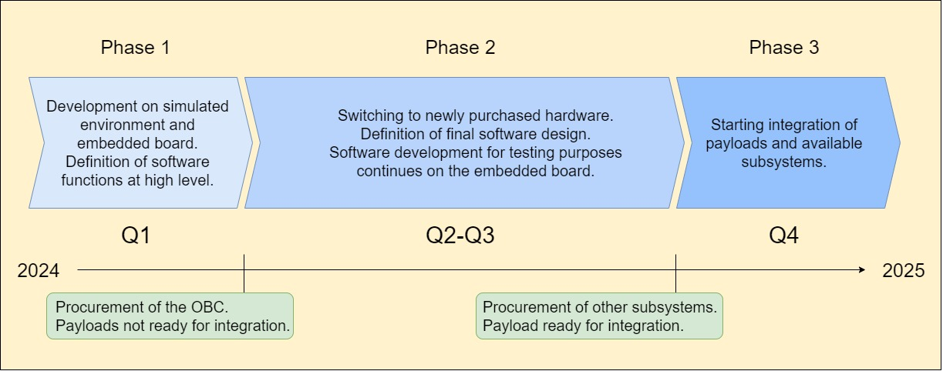

Figure : Software development plan.

#### Software Verification Plan

During the development phase, requirements are guiding the design and the implementation of the software. Verification of those requirements will take place during the Functional Test Phase. Time dedicated to tests should be comparable to development time. The goal of this is to extensively run the code to find bugs from unexpected arguments. The CI/CD pipelines are implemented on the Git repository also providing automated testing.

## Telemetry, Tracking and Command

### TT&C Quick Facts Table

|  |  |
| --- | --- |
| **Downlink** |  |
| Frequency | ~436.5 MHz (not yet allocated) |
| Modulation | GMSK |
| Coding | ASM+Golay |
| Bitrate | 9600 bps |
| RF Bandwidth | 25 KHz |
| BER | 1E-5 |
| Signal power at LNA input | -137.34 dBW |
| Link margin – Favourable | 8.90 dB |
| Link margin – Nominal | 7.49 dB |
| Link margin – Adverse | 6.02 dB |

|  |  |
| --- | --- |
| **Uplink** |  |
| Frequency | ~436.5 MHz (not yet allocated) |
| Modulation | GMSK |
| Coding | ASM+Golay |
| Bitrate | 9600 bps |
| RF Bandwidth | 25 KHz |
| BER | 1E-5 |
| Signal power at LNA input | -119.98 dBW |
| Link margin – Favourable | 34.75 dB |
| Link margin – Nominal | 34.09 dB |
| Link margin – Adverse | 33.34 dB |
|  | |
| **Safe Downlink** |  |
| Frequency | ~436.5 MHz (not yet allocated) |
| Modulation | GMSK |
| Coding | ASM+Golay |
| Bitrate | 2400 bps |
| RF Bandwidth | 25 KHz |
| BER | 1E-5 |
| Signal power at LNA input | -137.71 dBW |
| Link margin – Favourable | 9.69 dB |
| Link margin – Nominal | 8.28 dB |
| Link margin – Adverse | 6.81 dB |

|  |  |
| --- | --- |
| **Beacon** |  |
| Frequency | ~436.5 MHz (not yet allocated) |
| Modulation | GMSK |
| Coding | AX.25 |
| Bitrate | 1200 bps |
| RF Bandwidth | 25 KHz |
| BER | 1E-5 |
| Signal power at LNA input | -119.98 dBW |
| Link margin – Favourable | 17.79 dB |
| Link margin – Nominal | 16.51 dB |
| Link margin – Adverse | 15.04 dB |

### Functional architecture

The TT&C subsystem has the following functions:

* Sends housekeeping and payload data to the ground station, at a sufficient rate to match on average the rate at which data is produced.
* Receive commands from ground reliably and forward them to the OBC
* Periodically transmit a beacon signal, containing essential information about the status of the satellite
* Provide Ham radio payload functionality.

Data downlinked is of two types, treated differently:

* **Housekeeping Data:** essential data to determine the health status of the satellite, listed in detail in Link and Data Budget Analysis and Report (LINK-ARPT). The data unencrypted in order to be readable by radio amateurs. Telemetry (the collection of housekeeping data) is transmitted instantaneously as beacon and stored until it is also downlinked to the GS during the communication mode.
* **Payload Data:** measurements by the micro-vibrations and impact sensors. They are not transmitted in the beacon message but just in the communication mode.

All transmissions except beacon use the framing depicted in Figure 59 for packet encapsulation (further details are present in the LINK-ARPT document). This encapsulation method has been chosen from the available options because of its low header/data ratio compared to alternatives and the capability to detect and correct transmission errors.

Figure : Uplink/downlink packet structure

*ASM+Golay header*

7 B

*CSP header*

4 B

*CSP CRC-32*

4 B

*data*

<215 B

**Network layer**

**Data-link layer**

*RS(232,255)*

32 B

The beacon is encapsulated using the AX.25 protocol, for easier decoding by the radio amateurs community.

The subsystem implements the following features:

* The commands are framed using keyed-hash message authentication code (HMAC) to ensure the integrity and authenticity of commands.
* Carrier Sense Multiple Access with Collision Avoidance (CSMA/CA) is used during the communication phase.
* A downlink timer is implemented, as described in the concept of operation (CONOPS), to comply with IARU Radio Regulations 22.1 and 22.11.

### Physical architecture

The TT&C System is comprised of the ISIS AntS VHF/UHF antenna and the GomSpace NanoCom AX100 transceiver both selected among European off the shelf components that have already been flown in previous missions.

#### Transceiver

|  |  |  |
| --- | --- | --- |
| NanoCom AX100NanoCom AX100U | Manufacturer | GomSpace |
| TX power output | 1 W |
| Maximum power input | 4 W |
| Supply voltage | 3.3 V |
| Temperature range | -30°C to +85°C |
| Operating frequency | 430 to 440 MHz |
| Radio protocol | AX.25 |
| Dimensions | 65 x 40 x 6.5 mm |
| Mass | 24.5 g |
| Modulation | GMSK/GFSK |
| TX bandwidth | 25 KHz |

The transceiver will be mounted together with the OBC and GNSS module via four screws on the GomSpace NanoDock board, interfacing with it via a proprietary adapter trough which power will be supplied and data will be exchanged. It has an MCX 50 ohm port for RF connection to the antenna.

This transceiver is half-duplex but has a low TX-RX switching time and communicates using CSMA/CA, making it suitable for handling both uplink and downlink. The transceiver has been chosen among similar alternatives mainly for these factors:

* It uses the CAN-BUS data protocol.
* It has a very compact form factor.
* It is compatible and easily integrable with the OBC.
* Its parameters are fully reconfigurable in orbit.

The transceiver complies with Electrical requirements FDS-VCD 4.2.11, as the power output at transmitter antenna is necessarily less than the 1W that the transceiver can output. As shown in the table, the transceiver is capable of both GMSK and GFSK modulation: between the two GMSK has been chosen due to the higher spectral efficiency.

#### Antenna

|  |  |  |
| --- | --- | --- |
| AntS VHF/UHF antenna | Manufacturer | ISIS |
| Mass | 89 g |
| Dimensions (stowed) | 98x98x7 mm |
| Deployment power usage | 2 W |
| Supply voltage | 3-3.6 V |
| Thermal range | -20° to +60° C |
| Main beam gain | >0 dBi |
| Polarization | Circular |
| Configuration | UHF turnstile |

The antenna connects to the transceiver with an MMCX port. Power and data for the deployment mechanism are exchanged trough a 9 pin connector (Omnetics Bi-Lobe PN: A29100-009), and once the deployment is completed the system can be permanently switched off to save power.

The antenna is composed of four elements which will be tuned to UHF frequencies and linked together in a turnstile configuration, which gives the antenna a circular polarization. The antenna has a wide emission pattern with no direction receiving less than 3 dB of power level less than the maximum, which is located along the perpendicular to both dipoles. This allows to exchange data at every attitude, although GS pointing will still be done nominally in the communication phase to ensure an optimal link budget.

While the GomSpace catalogue has a UHF antenna the deployment mechanism it has is geometrically incompatible with the presence of the impact sensor, so an alternative supplier had to be found. The ISISpace antenna AntS was chosen among others because of the following reasons:

* It has a self-contained and compact deployment mechanism.
* The producer states its compatibility with GomSpace products.

The main criticality is that the antenna deployment system uses the I2C protocol to communicate, which will need to be implemented on the OBC to send the deployment command, but after which is not used. The antenna deployment system acts as an RF inhibit and since the power fed to the antenna is less than 1.5 W the system is compliant with electrical requirement FDS-VCD 4.2.11.

### Link and Data Budget Summary

The Link Budget, with a 3 dB margin already subtracted in the shown results, is summarized for various cases and links in Table 53, with contributions used in the calculation explicited in the next subsections. Details surrounding the assumptions used for the calculation are discussed in the LINK-ARPT.

Table 53: Link budget summary

|  |  |  |  |  |
| --- | --- | --- | --- | --- |
| cases | link | | | |
| **Downlink** | **Uplink** | **Beacon** | **Safe DL** |
| Adverse (A) | -0.26 dB | 21.53 dB | 8.78 dB | 0.54 dB |
| Nominal (N) | 3.35 dB | 25.18 dB | 12.38 dB | 4.15 dB |
| Favourable (N) | 6.67 dB | 28.16 dB | 15.79 dB | 7.75 dB |

The Downlink Adverse case is slightly negative but due to GS hardware limitations it has been deemed acceptable, considering that without the 3 dB margin the link budget would be at a positive value of 2.64 dB. This point is addressed in detail in the LINK-ARPT, where software solution to this problem are shown, to be implemented if the necessity arises.

**Downlink Link budget**

|  |  |  |  |  |  |  |  |  |
| --- | --- | --- | --- | --- | --- | --- | --- | --- |
| Parameter |  | | | | Value | | | |
| A | N | F | Unit | A | N | F | Unit |
| Spacecraft |  |  |  |  |  |  |  |  |
| Spacecraft transmitter power output |  | 1 |  | W | 0.00 | 0.00 | 0.00 | dBW |
| Spacecraft antenna gain |  | 0 |  | dB | 0.00 | 0.00 | 0.00 | dB |
| Antenna efficiency | 50 | 65 | 80 | % | -3.01 | -1.87 | -0.97 | dB |
| Total spacecraft EIRP | -3.01 | -1.87 | -0.97 | dBW |  |  |  |  |
| Downlink path |  |  |  |  |  |  |  |  |
| Elevation |  | 10 |  | ° |  |  |  |  |
| Orbit altitude |  | 500 |  | km |  |  |  |  |
| Polarization loss |  | 3 |  | dB | -3.00 | -3.00 | -3.00 | dB |
| Distance |  | 1695 |  | km |  |  |  |  |
| Atmospheric loss | 1.60 | 1.10 | 0.60 | dB | -1.60 | -1.10 | -0.60 | dB |
| Path loss |  | 149.83 |  | dB | -149.83 | -149.83 | -149.83 | dB |
| Ionospheric loss |  | 0.4 |  | dB | -0.40 | -0.40 | -0.40 | dB |
| Singnal Power level at ground station | -154.84 | -153.20 | -151.80 | dBW |  |  |  |  |
| Ground station |  |  |  |  |  |  |  |  |
| Ground station antenna gain |  | 16.7 |  | dB | 16.70 | 16.70 | 16.70 | dB |
| LNA noise figure |  | 0.4 |  | dB | -0.40 | -0.40 | -0.40 | dB |
| Switchbox insertion loss |  | 0.4 |  | dB | -0.40 | -0.40 | -0.40 | dB |
| SDR noise figure | 2 | 1.5 | 1 | dB | -2.00 | -1.50 | -1.00 | dB |
| External noise equivalent temperature | 2152 | 1726.00 | 1385 | K |  |  |  |  |
| External noise power spectral density | -195.27 | -196.23 | -197.19 | dBW/Hz | 195.27 | 196.23 | 197.19 | dBW/Hz |
| Noise power level at reciever (N0) | -150.89 | -152.35 | -153.80 | dBW |  |  |  |  |
| Signal to noise ratio | 9.95 | 13.55 | 16.91 | dB |  |  |  |  |
| Radio link parameters |  |  |  |  |  |  |  |  |
| Downlink bitrate |  | 9600 |  | bps | -39.82 | -39.82 | -39.82 | dBHz |
| Downlink frequency |  | 436.5 |  | MHz |  |  |  |  |
| Bandwidth |  | 14.4 |  | KHz |  |  |  |  |
| Required Eb/N0 for 1E-5 BER |  | 7.8 |  | dB | -7.80 | -7.80 | -7.80 | dB |
| Margin |  | 3 |  | dB | -3.00 | -3.00 | -3.00 | dB |
| Degradation | 20 | 10 | 0 | % |  |  |  |  |
| Degradation contribution | -0.97 | -0.46 | 0.00 | dB | -0.97 | -0.46 | 0.00 | dB |
| System Eb/N0 | 14.51 | 17.61 | 20.47 | dB |  |  |  |  |
| Link budget: |  |  |  |  | -0.26 | 3.35 | 6.67 | dB |

**Uplink Link Budget**

|  |  |  |  |  |  |  |  |  |
| --- | --- | --- | --- | --- | --- | --- | --- | --- |
| **Parameter** | **Value** | | | | **Contribution** | | | |
| A | N | F | Unit | A | N | F | Unit |
| **Ground station** |  |  |  |  |  |  |  |  |
| Ground station antenna power output |  | 15 |  | W | 11.76 | 11.76 | 11.76 | dBW |
| Ground station antenna gain |  | 16.7 |  | dB | 16.70 | 16.70 | 16.70 | dB |
| Total spacecraft EIRP | 28.46 | 28.46 | 28.46 | dBW |  |  |  |  |
| **Uplink path** |  |  |  |  |  |  |  |  |
| Elevation |  | 10 |  | ° |  |  |  |  |
| Orbit altitude |  | 500 |  | km |  |  |  |  |
| Polarization loss |  | 3 |  | dB | -3.00 | -3.00 | -3.00 | dB |
| Distance |  | 1695 |  | km |  |  |  |  |
| Atmospheric loss | 1.60 | 1.10 | 0.60 | dB | -1.60 | -1.10 | -0.60 | dB |
| Path loss |  | 149.83 |  | dB | -149.83 | -149.83 | -149.83 | dB |
| Ionospheric loss |  | 0.4 |  | dB | -0.40 | -0.40 | -0.40 | dB |
| Signals Power level at ground station | -123.37 | -122.87 | -122.37 | dBW |  |  |  |  |
| **Spacecraft** |  |  |  |  |  |  |  |  |
| Spacecraft antenna gain |  | 0 |  | dB | 0.00 | 0.00 | 0.00 | dB |
| Antenna efficiency | 50 | 65 | 80 | % | -3.01 | -1.87 | -0.97 | dB |
| LNA noise figure |  | 1 |  | dB | -1.00 | -1.00 | -1.00 | dB |
| Earth noise temperature | 310 | 290 | 270 | K |  |  |  |  |
| Galactic noise temperature | 337.61 | 168.81 | 84.40 | K |  |  |  |  |
| External noise equivalent temperature | 323.81 | 229.40 | 177.20 | K |  |  |  |  |
| External noise power spectral density | -203.50 | -205.00 | -206.12 | dBW/Hz | 203.50 | 205.00 | 206.12 | dBW/Hz |
| Noise power level at receiver (N0) | -157.90 | -160.54 | -162.56 | dBW |  |  |  |  |
| Signal to noise ratio | 30.53 | 34.80 | 38.23 | dB |  |  |  |  |
| **Radio link parameters** |  |  |  |  |  |  |  |  |
| Downlink bitrate |  | 9600 |  | bps | -39.82 | -39.82 | -39.82 | dBHz |
| Uplink frequency |  | 436.5 |  | MHz |  |  |  |  |
| Bandwidth |  | 14.4 |  | KHz |  |  |  |  |
| Required Eb/N0 for 1E-5 BER |  | 7.8 |  | dB | -7.80 | -7.80 | -7.80 | dB |
| Margin |  | 3 |  | dB | -3.00 | -3.00 | -3.00 | dB |
| Degradation | 20 | 10 | 0 | % |  |  |  |  |
| Degradation contribution | -0.97 | -0.46 | 0.00 | dB | -0.97 | -0.46 | 0.00 | dB |
| System Eb/N0 | 36.30 | 39.44 | 41.96 | dB |  |  |  |  |
| **Link budget:** |  |  |  |  | 21.53 | 25.18 | 28.16 | dB |

**Safe Downlink Link Budget**

|  |  |  |  |  |  |  |  |  |
| --- | --- | --- | --- | --- | --- | --- | --- | --- |
| **Parameter** | **Value** | | | | **Contribution** | | | |
| A | N | F | Unit | A | N | F | Unit |
| **Spacecraft** |  |  |  |  |  |  |  |  |
| Spacecraft transmitter power output |  | 0.3 |  | W | -5.23 | -5.23 | -5.23 | dBW |
| Spacecraft antenna gain |  | 0 |  | dB | 0.00 | 0.00 | 0.00 | dB |
| Antenna efficiency | 50 | 65 | 80 | % | -3.01 | -1.87 | -0.97 | dB |
| Total spacecraft EIRP | -8.24 | -7.10 | -6.20 | dBW |  |  |  |  |
| **Downlink path** |  |  |  |  |  |  |  |  |
| Elevation |  | 10 |  | ° |  |  |  |  |
| Orbit altitude |  | 500 |  | km |  |  |  |  |
| Polarization loss |  | 3 |  | dB | -3.00 | -3.00 | -3.00 | dB |
| Distance |  | 1695 |  | km |  |  |  |  |
| Atmospheric loss | 1.60 | 1.10 | 0.60 | dB | -1.60 | -1.10 | -0.60 | dB |
| Path loss |  | 149.83 |  | dB | -149.83 | -149.83 | -149.83 | dB |
| Ionospheric loss |  | 0.4 |  | dB | -0.40 | -0.40 | -0.40 | dB |
| Signal Power level at ground station | -160.07 | -158.43 | -157.02 | dBW |  |  |  |  |
| **Ground station** |  |  |  |  |  |  |  |  |
| Ground station antenna gain |  | 16.7 |  | dB | 16.70 | 16.70 | 16.70 | dB |
| LNA noise figure |  | 0.4 |  | dB | -0.40 | -0.40 | -0.40 | dB |
| Switchbox insertion loss |  | 0.4 |  | dB | -0.40 | -0.40 | -0.40 | dB |
| SDR noise figure | 2 | 1.5 | 1 | dB | -2.00 | -1.50 | -1.00 | dB |
| External noise equivalent temperature | 2152 | 1726.00 | 1358 | K |  |  |  |  |
| External noise power spectral density | -195.27 | -196.23 | -197.27 | dBW/Hz | 195.27 | 196.23 | 197.27 | dBW/Hz |
| Noise power level at eceiver (N0) | -156.91 | -158.37 | -159.91 | dBW |  |  |  |  |
| Signal to noise ratio | 10.74 | 14.34 | 17.79 | dB |  |  |  |  |
| **Radio link parameters** |  |  |  |  |  |  |  |  |
| Downlink bitrate |  | 2400 |  | bps | -33.80 | -33.80 | -33.80 | dBHz |
| Downlink frequency |  | 436.5 |  | MHz |  |  |  |  |
| Bandwidth |  | 3.6 |  | KHz |  |  |  |  |
| Required Eb/N0 for 1E-5 BER |  | 7.8 |  | dB | -7.80 | -7.80 | -7.80 | dB |
| Margin |  | 3 |  | dB | -3.00 | -3.00 | -3.00 | dB |
| Degradation | 20 | 10 | 0 | % |  |  |  |  |
| Degradation contribution | -0.97 | -0.46 | 0.00 | dB | -0.97 | -0.46 | 0.00 | dB |
| System Eb/N0 | 15.31 | 18.40 | 21.35 | dB |  |  |  |  |
| **Link budget:** |  |  |  |  | 0.54 | 4.15 | 7.55 | dB |

**Beacon Link Budget**

|  |  |  |  |  |  |  |  |  |
| --- | --- | --- | --- | --- | --- | --- | --- | --- |
| **Parameter** | **Value** | | | | **Contribution** | | | |
| A | N | F | Unit | A | N | F | Unit |
| **Spacecraft** |  |  |  |  |  |  |  |  |
| Spacecraft transmitter power output |  | 1 |  | W | 0.00 | 0.00 | 0.00 | dBW |
| Spacecraft antenna gain |  | 0 |  | dB | 0.00 | 0.00 | 0.00 | dB |
| Antenna efficiency | 50 | 65 | 80 | % | -3.01 | -1.87 | -0.97 | dB |
| Total spacecraft EIRP | -3.01 | -1.87 | -0.97 | dBW |  |  |  |  |
| **Downlink Path** |  |  |  |  |  |  |  |  |
| Elevation |  | 10 |  | ° |  |  |  |  |
| Orbit altitude |  | 500 |  | km |  |  |  |  |
| Polarization loss |  | 3 |  | dB | -3.00 | -3.00 | -3.00 | dB |
| Distance |  | 1695 |  | km |  |  |  |  |
| Atmospheric loss | 1.60 | 1.10 | 0.60 | dB | -1.60 | -1.10 | -0.60 | dB |
| Path loss |  | 149.83 |  | dB | -149.83 | -149.83 | -149.83 | dB |
| Ionospheric loss |  | 0.4 |  | dB | -0.40 | -0.40 | -0.40 | dB |
| Signal Power level at ground station | -154.84 | -153.20 | -151.80 | dBW |  |  |  |  |
| **Ground station** |  |  |  |  |  |  |  |  |
| Ground station antenna gain |  | 16.7 |  | dB | 16.70 | 16.70 | 16.70 | dB |
| LNA noise figure |  | 0.4 |  | dB | -0.40 | -0.40 | -0.40 | dB |
| Switchbox insertion loss |  | 0.4 |  | dB | -0.40 | -0.40 | -0.40 | dB |
| SDR noise figure | 2 | 1.5 | 1 | dB | -2.00 | -1.50 | -1.00 | dB |
| External noise equivalent temperature | 2152 | 1726.00 | 1358 | K |  |  |  |  |
| External noise power spectral density | -195.27 | -196.23 | -197.27 | dBW/Hz | 195.27 | 196.23 | 197.27 | dBW/Hz |
| Noise power level at receiver (N0) | -159.92 | -161.38 | -162.92 | dBW |  |  |  |  |
| Signal to noise ratio | 18.98 | 22.58 | 26.02 | dB |  |  |  |  |
| **Radio link parameters** |  |  |  |  |  |  |  |  |
| Downlink bitrate |  | 1200 |  | bps | -30.79 | -30.79 | -30.79 | dBHz |
| Downlink frequency |  | 436.5 |  | MHz |  |  |  |  |
| Bandwidth |  | 1.8 |  | KHz |  |  |  |  |
| Required Eb/N0 for 1E-5 BER |  | 7.8 |  | dB | -7.80 | -7.80 | -7.80 | dB |
| Margin |  | 3 |  | dB | -3.00 | -3.00 | -3.00 | dB |
| Degradation | 20 | 10 | 0 | % |  |  |  |  |
| Degradation contribution | -0.97 | -0.46 | 0.00 | dB | -0.97 | -0.46 | 0.00 | dB |
| System Eb/N0 | 23.54 | 26.64 | 29.59 | dB |  |  |  |  |
| **Link budget:** |  |  |  |  | 8.78 | 12.38 | 15.79 | dB |

**Data Budget**

|  |  |  |  |  |
| --- | --- | --- | --- | --- |
| **parameter** | **value** | unit | **contribution** | unit |
| Telemetry (TM) |  |  |  |  |
| Telemetry acquisition size | 136 | B |  |  |
| Telemetry acquisition size | 1088 | b |  |  |
| Telemetry data margin | 5 | % |  |  |
| TM acquisition repetition time | 60 | s |  |  |
| number of daily TM packets produced | 1440 |  |  |  |
| daily TM data produced | 1645,92 | kb | -1645,92 | kb |
| RS(255-223) forward error correction | 32 | B |  |  |
| CSP header + checksum | 8 | B |  |  |
| Golay + ASM encapsulation | 7 | B |  |  |
| total header size per packet | 376 | b |  |  |
| daily TM header data | 541,44 | kb | -541,44 | kb |
| daily TM downlinked data | 2187,36 | kb |  |  |
| Impact sensor (IS) |  |  |  |  |
| Data acquisition size | 592 | b |  |  |
| Maximum daily GS contacts | 4 |  |  |  |
| Margin | 20 | % |  |  |
| IS daily data + margin | 2,84 | kb |  |  |
| Micro vibration sensor (MV) |  |  |  |  |
| MV daily data production | 4380 | kb |  |  |
| total daily payload (PL) data production | 4382,84 | kb | -4382,84 | kb |
| Maximum data field size | 215 | B |  |  |
| number of daily PL packets | 2549 |  |  |  |
| daily PL header data | 958,42 | kb | -958,42 | kb |
| daily PL downlinked data | 5341,27 | kb |  |  |
| Average onboard data production rate | 69,78 | bps |  |  |
| Downlink capability |  |  |  |  |
| Daily GS visibility time (average) | 1200 | s |  |  |
| GS contact failure probability | 10 | % |  |  |
| Downlink bitrate | 9600 | bps |  |  |
| Uplink and acquisition margin | 20 | % |  |  |
| Average daily downlink-available time | 864 | s |  |  |
| Average daily downlink capacity | 8294,40 | kb | 8294,40 | kb |
| **Data budget** |  |  | 765,77 | kb |

## Structures

### Structures Quick Facts Table

|  |  |  |
| --- | --- | --- |
| ISIS 2U CubeSat structure | Manufacturer | ISIS |
| Mass | 206 g |
| Closeout panel ()mass | 10 g |
| Closeout panel () mass | 2 g |
| Closeout panel () mass | 11 g |
| Total mass at launch (worst case) | 2.596 kg |
| Dimensions (stowed) | 100 x 100 x 227 mm |
| Thermal range | -40° to +80° C |

### Physical architecture

The structure shall withstand launch loads and guarantee the right placement of components during all mission phases, so the COTSISISPACE 2-Unit CubeSat structure has been chosen. The main advantages of this choice are the flight heritage and the acceptance testing executed by ISISPACE before the shipment of the unit.

The ISISPACE 2-Unit CubeSat structure is developed as a generic, modular satellite structure based upon the CubeSat standard. The stack of PCBs and other flight modules can be built up first in the secondary structure and integrated with the load-carrying frames at the end of the process, ensuring accessibility of the flight avionics. In addition, the use of a load-carrying frame and detachable panels allows for access to all parts of the spacecraft avionics, even after final integration by removing one or more of the panels. The primary structure consists of side-frames, ribs and two kill switch mechanisms, shown in Figure 60.

The secondary structure consists of stack rods and closeout panels, specifically:

* one custom panel to house a Fine Sun Sensor and a CCR (Figure 61Figure a)
* one custom panel hosting a Fine Sun Sensor, a CCR and the GPS antenna (Figure 61b);
* one custom panel to mount the magnetometer (Figure 62a);
* the upper face is closed by the ISISPACE antenna;
* the bottom face is closed by a custom panel with a hole for MRR (Figure 62b);

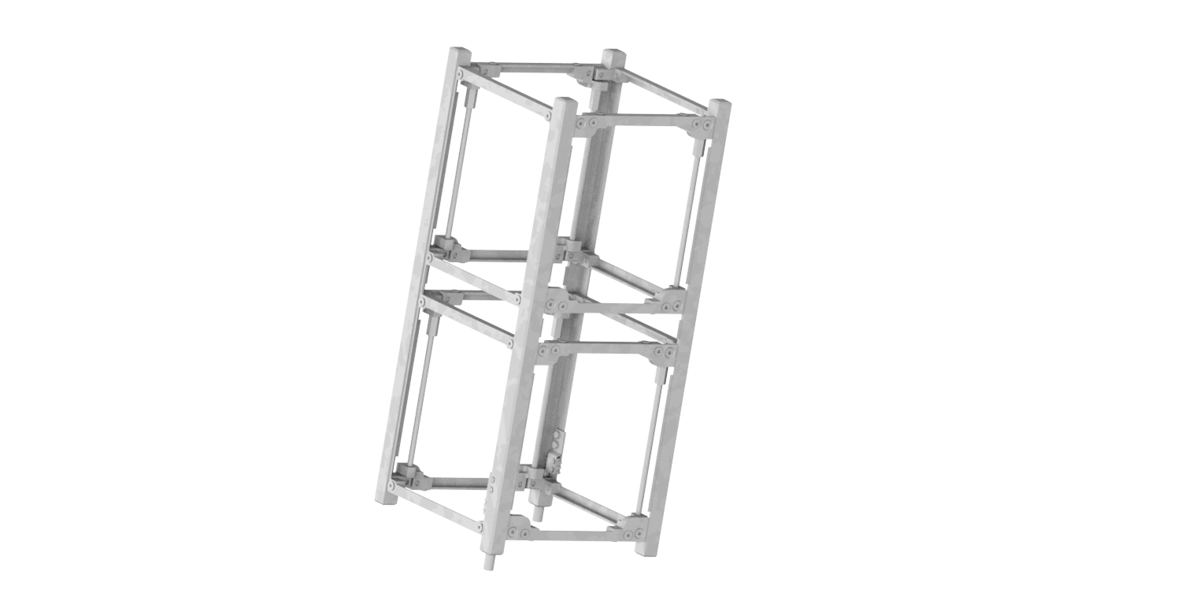

Figure : 2U CubeSat structure.

* a custom Teflon shield panel to which is part of the impact sensor (Figure Figure c).

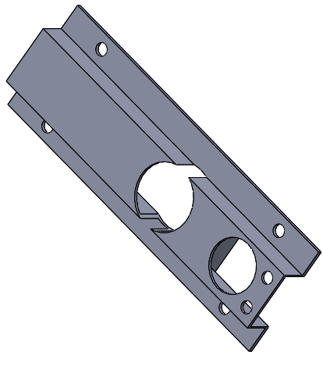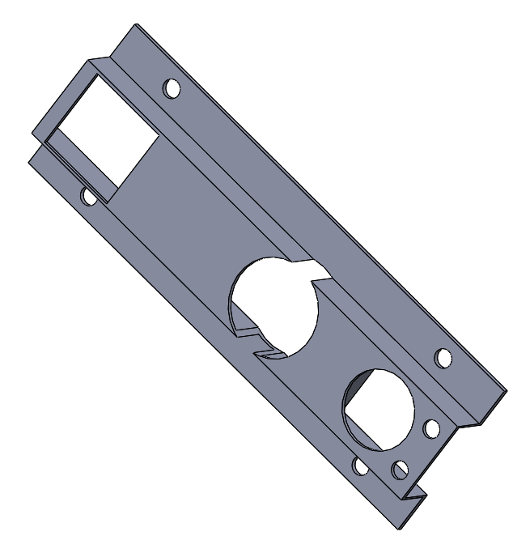

(a)

(b)

Figure : Panel with holes for mounting a CCR and a Fine Sun Sensor (a), panel with holes for mounting a CCR, a Fine Sun Sensor and the GPS antenna (b). Images not in scale.

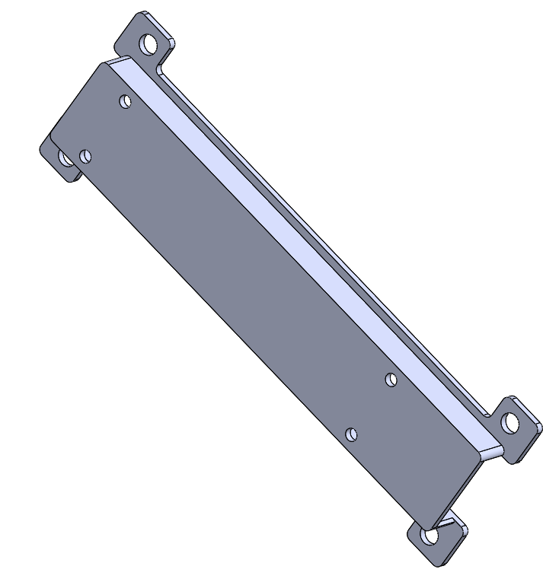

(a)

(b)

(c)

Figure : Magnetometer closeout panel (a), face panel with holes for host the MRR and with venting holes (b), Teflon shield panel (c). Images not in scale.



**Rails**

The rails, as can be seen from the CAD model, are not recessed. Therefore, we expect that the totality of the rails will be in contact with the deployer rails, thus satisfying requirement FDS-VCD 4.1.13. Requirement FDS-VCD 4.1.9 states that the rails shall have a surface roughness less than 1.6 μm. ISISpace didn’t share the exact value for roughness of the rails with the team because of a NDA, but they assured us that it is compliant with the characteristic requested. To further verify this requirement, the team researched typical values of surface roughness for AL6061-T6 (the material of the structure), and in “Examination of surface roughness values of 6061-T6 aluminum material after machining and after anodizing process”[1], the average surface roughness is estimated to be 0,3 μm.

**Venting clearances**

According to requirement FDS-VCD 4.10.6, the CubeSat shall have venting clearances such that V/A<50800 mm, with “V” the venting volume in mm3 and “A” the venting area in mm2. The team considered two circular venting clearances in the *+ZBODY* face panel, with a radius r of 2,5 mm and height h equal to the thickness of the panel that is 1 mm. Since the venting clearances are cylindrical, the following formulas were used to calculate the venting volume (V) and venting area (A)

Considering two venting clearances with the parameters choosen above results in V=19,63 mm3 and A=54,98 mm2, and a ratio of 0,36 mm thus verifying the requirement.

**Joints**

Bolted joints are extensively used in the CubeSat to fasten the components. In this way the solar panels and closeout panels can be removed and the accessibility to the internal parts of the CubeSat can be maintained (requirement FDS-VCD 4.6.1). The coarse sun sensors are fixed on the structure by epoxy resin. As per requirement FDS-VCD 4.1.19, a secondary locking feature shall be used for all fasteners and for any external components not confined by the spacecraft structure. The locking method is to be determined but the team expects to employ self-locking thread devices. FDS-VCD 4.1.20 requires that all mechanical fixtures shall have a defined required torque. At the moment of writing this document the team does not have this kind of information. No components are released on purpose by the CubeSat during the mission.

**Harness routing**

The team is aware of a need of a plan to consider harness routing within the CubeSat. In the process of formulating electrical schemes for interconnecting control boards across various subsystems, the targeted focus has been the region delineated between the Power Supply Subsystem (EPS) and the Control Board Subsystem (OBC). This aim to efficiently manage the concentration of cables in this critical spatial domain.

The calculation were based on the premise of using cables with a standardized diameter of 1 mm. According to the specifications outlined in the wiring diagram, there is a majority configuration of 2 cables per connector up to a maximum of 4 cables detected in one connector. It was also taken into account the required incorporation of 2 cables (positive and negative) per solar panel. The horizontal space between the boards and the solar panels was calculated to be about 4 to 5 mm. This dimension takes into account the need for a shrewd layout that accounts for intricate cable routing requirements. In addition, the current design provides for an overlap of about 3 cables, containing the possibility of storing the entire wiring within the CubeSat.

It is crucial to note that these calculations are preliminary and subject to refinement pending the completion of the electrical scheme. The team is considering an iteration involving the practical implementation of harness routing within a mock-up before the CubeSat integration, allowing for a more accurate assessment.

### Structural Materials

The CubeSat primary structure is made of Aluminum 6061-T6. It contains standard commercial off the shelf (COTS) components, electrical components, custom PCBs and solar cells. **Errore. L'origine riferimento non è stata trovata.** There are no pressure vessels, hazardous or exotic materials on the CubeSat. In the followings, some of the material used for the components of AlbaSat are detailed. For further information and for compliance with requirement FDS-VCD 4.1.23; 4.1.22; 4.1.24, see the document ALB_DML_2024-03-10_v1.0.

**Structure**

The structure (ISISPACE 2-Unit CubeSat) and the closeout panels are made of Al 6061-T6. Table 54 reports the mechanical properties of the material.

Table 54: Mechanical properties of aluminum 6061-T6

|  |  |
| --- | --- |
| E (Young’s modulus) [GPa] | 68.9 |
| ν (Poisson ratio) [-] | 0.33 |
| ρ (density) [g/cm3] | 2.7 |
| TML [%] | 0.15 |
| RML [%] | 0.00 |
| CVCM [%] | 0.07% |

The CubeSat rails and standoff are surface treated to be hard anodized aluminum to prevent any cold welding within the deployer (*CubeSat Design Specification REV 13,* requirement 3.2.16; FDS-VCD 4.1.22). This anodization also results in electrical isolation between the CubeSat and dispenser.

**Payloads**

The four payloads are made of different components. The material of each component is listed in Table 55.

Table 55: Materials of the components of the payloads

|  |  |  |
| --- | --- | --- |
| Payload | Component | Material |
| Impact Sensor | Shield | Teflon |
| Detector | Kapton and copper |
| Multiplexer | Electrical material |
| Dedicated board | PCB glass/polyimide |
| Micro-Vibration sensor | Transducer | Electrical material |
| Dedicated board | PCB glass/polyimide |
| CCR | Edmund CCR | N-BK7 |
| Mounting structure | Aluminum |
| QuantumFuture Payload | MRR | N-BK7 |
| Mounting structure | Aluminum (TBC) |
| Dedicated board | PCB glass/polyimide |

The subsystems are made of COTS components. The materials used are flight proven. The materials of each subsystem are listed in Table 56. The GPS antenna kit and the CubeADCS-Y momentum datasheets do not provide all the material used for the components in their datasheet, so further investigation is required.

Table 56: Materials used in the components of the subsystems

|  |  |  |
| --- | --- | --- |
| Subsystem | Component | Material |
| ADCS | ADCS Y-momentum | Not available |
| ADCS | GPS antenna kit | Not available |
| EPS | Solar panel | * Cell base material: GaInP/GaAs/Ge on Ge substrate * Panel base material: space qualified glass/polyimide laminate with 2 internal copper ground planes |
| EPS | Nanopower BP4* | Lithium-ion battery |
| TTC | ISISpace antenna | NiTi-alloy |
| TTC | GOMspace Transceiver AX100 | PCB glass/polyimide |
| OBC | NanoDock DMC-3 | PCB material glass/polyimide |
| OBC | OBC NanoMind A3200 | PCB glass/polyimide |

For what concerns the Nanopower BP4 reported in Table 56, the datasheet reports that samples from every lot are tested according to “Requirements for flight certification and acceptance of commercial off the shelf (COTS) Lithium-Ion (Li-Ion) batteries,” JSC 66548, for physical characteristics, overcharge and external short. Every cell goes through the flight acceptance test (FAT), which is based on the documents “Flight Acceptance Test Requirements for Lithium-ion Cells and Battery Packs” by NANORACKS, document n. NR-SRD-139 Rev. C and “NASA Aerospace Flight Battery Program” by NASA, document n. RP-08-75 Rev. 1.0. The cells are checked for their physical and electromechanical characteristics, i.e., any occurrence of deformations, open-circuit voltage, capacity and internal resistance.

### Interfaces

The electronics boards inside the CubeSat respect the PC104 form factor. This allows to stack the boards one on top of the other in the rods of the structure using a standoff between the boards. As mentioned above, the stack of PCBs and other flight modules can be built up first in the secondary structure and integrated with the load-carrying frames at the end of the process, ensuring accessibility of the flight avionics.

In the positioning of the components inside the CubeSat, the requirements defined by the subsystems were considered.

* The ADCS shall be positioned close to the geometric center of the satellite as required in the TS-VCD. It should be borne in mind that the sun sensor must have an unobstructed view of the outside.
* The antenna should be placed on the face and the antennas deployment shall not be obstructed by the impact sensor that cover the totality of the face.

There are two different classes of dispensers that use two different kinds of interfaces: the rails or the tabs of the CubeSat. The rails or tabs are meant to be the sole mechanical interface between the dispenser and the CubeSat. The rail system utilizes the four corners of the CubeSat for constraint. The tab systems utilize the +X, -Y and -X, -Y corners to constrain the CubeSat.

In the current design of the CubeSat, the QPF protrudes 5 mm normal to the face. The impact sensor exceeds 3.4 mm normal to the face. The antenna and solar panel protrudes 6.2 mm normal to the face. Hence, the CubeSat is compliant with the requirements defined in the CubeSat Design Specification REV 13 (requirement CDS 3.2.3 and FDS-VCD 4.1.4).

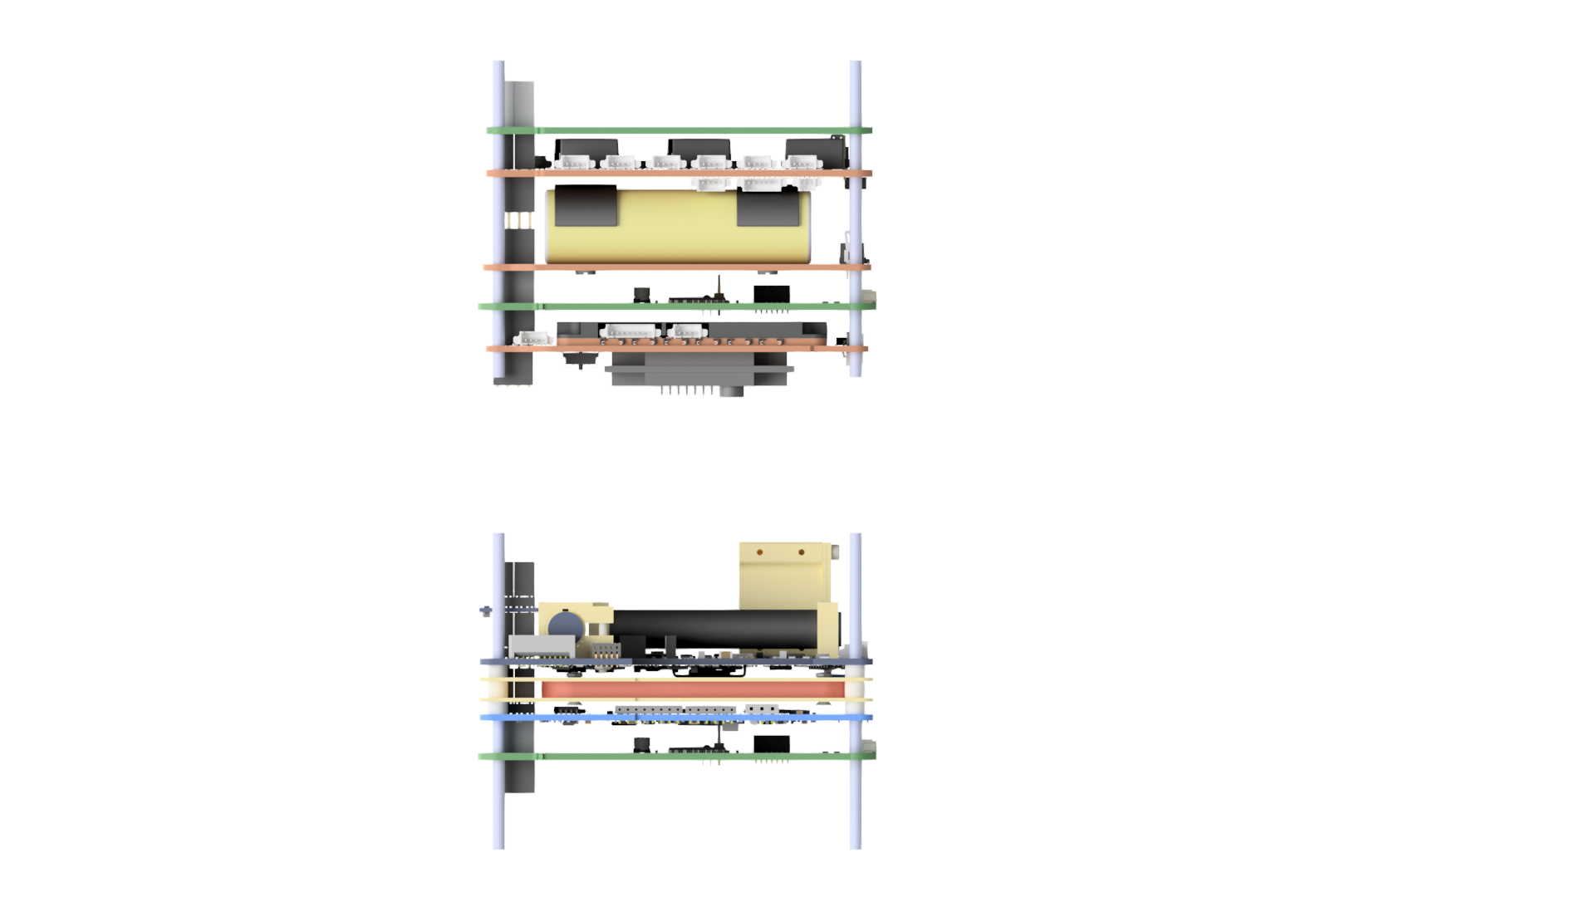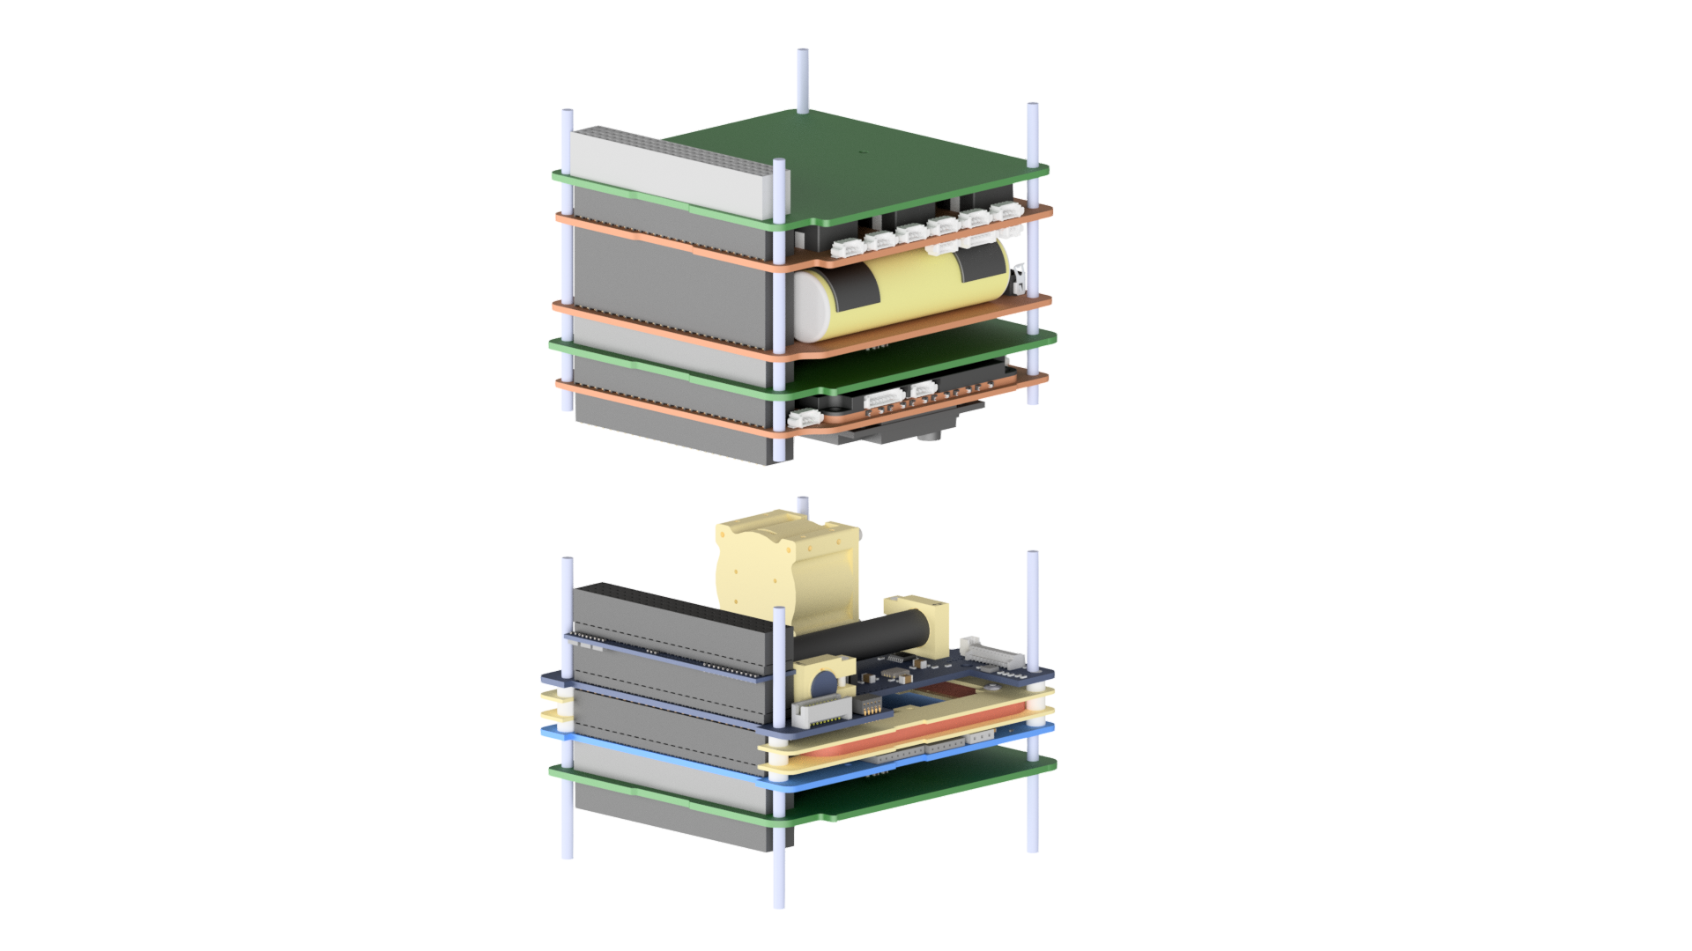

Figure : Stack of PCB built on secondary structures before being integrated in the primary structure of the CubeSat.

### Mass budget and Moments of Inertia

**Mass Budget**

|  |  |  |  |  |  |  |
| --- | --- | --- | --- | --- | --- | --- |
| **Subsystem** | **Component** | | **Mass (g)** | **Margin** | **Mass + margin (g)** | **Source** |
| **ST&M** | ISISPACE 2U CubeSat structure | | 206 | 5% | 216,3 | Datasheet |
| Closeout panel CubeSense + CCR | | 9,56 | 20% | 11,47 | CAD |
| Closeout panel CubeSense + CCR + GPS antenna | | 9,14 | 20% | 10,97 | CAD |
| Closeout panel magnetometer | | 7,92 | 20% | 9,5 | CAD |
| Closeout panel MRR | | 20,66 | 20% | 24,79 | CAD |
| **ADCS** | CubeADCS_Y momentum | CubeComputer | 56 | 5% | 58,8 | Datasheet |
| CubeControl | 47 | 5% | 49,3 | Datasheet |
| CubeRod Small (x2) | 28*2 | 5% | 29,4*2 | Datasheet |
| CubeCoil Single | 46 | 5% | 48,3 | Datasheet |
| CubeWheel Small | 50 | 5% | 52,5 | Datasheet |
| CubeSense (x2) | 19,7*2 | 5% | 20,7*2 | Datasheet |
| CubeMag Deployable | 8 | 5% | 8,4 | Datasheet |
| CubeMag Redundant | 3,5 | 5% | 3,7 | Datasheet |
| Coarse Sun Sensors (x6) | 0,2*6 | 5% | 0,21*6 | Datasheet |
| CubeConnect Standard | 50 | 5% | 52,5 | Datasheet |
| **EPS** | Solar panel P110A (x2) | | 26*2 | 5% | 27,3*2 | Datasheet |
| Solar panel P110B (x4) | | 26*4 | 5% | 27,3*4 | Datasheet |
| Solar panel P110C | | 29 | 5% | 30,5 | Datasheet |
| Batteries pack | NanoPower BP4 | 258 | 5% | 270,9 | Datasheet |
| NanoPower P31u power supply  (without batteries) | 100 | 5% | 105 | Datasheet |
| **OBC** | OBC NanoMind A3200 | | 24 | 5% | 25,2 | Datasheet |
| NanoDock DMC-3 | | 51 | 5% | 53,6 | Datasheet |
| **TTC** | Transceiver AX100 | | 24,5 | 5% | 25,7 | Datasheet |
| Antenna ISISPACE | | 89 | 5% | 93,45 | Datasheet |
| GPS antenna kit | NovAtelGPS module | 31 | 5% | 32,6 | Datasheet |
| Inventek antenna | 14 | 5% | 14,7 | Datasheet |
| **PL_CCR** | CCR (x2) | | 2*2 | 5% | 2,1*2 | Datasheet |
| Frame for CCR (x2) | | 4*2 | 20% | 4,8*2 | CAD |
| **PL_IS** | Impact sensor | Conductive stripes | 16,19 | 20% | 19,43 | Measured |
| Dedicated board | 53,65 | 10% | 59,02 | Measured |
| Support plate | 116,65 | 20% | 139,98 | Measured |

|  |  |  |  |  |  |  |
| --- | --- | --- | --- | --- | --- | --- |
| **PL_MVS** | Micro-vibration sensor | Micro-vibration sensor | 0,4 | 5% | 0,42 | Datasheet |
| Micro-controller unit | 1,8 | 5% | 1,89 | Datasheet |
| Dedicated board | 40 | 10% | 44 | Measured |
| **PL_QF** | Quantum Future | MRR | 225 | 20% | 270 | Measured |
| Dedicated board | 40 | 10% | 44 | Measured |
|  | TOTAL**:** | | 1892,57 |  | 2055,85 |  |
|  | Harness | | 102,79 |  | 102,79 | Calculated |
|  |  | **TOTAL (with harness):** | 1995,36 |  | 2158,64 |  |
|  |  | **TOTAL DRY MASS AT**  **LAUNCH (worst case +20%):** |  |  | **2590,37** |  |

The following margins and calculations were made according to the ESA document *Margin philosophy for science assessment studies*.

* The 5% margin was applied because the components are off-the-shelf products without modifications (ECSS Category: A / B, see *ECSS-E- ST-10-02C*).
* The 10% margin was applied because the component is an off-the-shelf product requiring minor modifications (ECSS Category: C, see *ECSS-E-ST-10-02C*). The top face of the antenna system from ISISPACE will be customized with a hole for accommodating a CCR and cables from the solar panel on top.
* The 20% margin was applied because the components are newly designed and developed products (ECSS Category: D, see *ECSS-E-ST-10-02C*).

According to *CubeSat Design Specification REV 13* (requirement *3.2.1*2) and FDS-VCD 4.1.14 the maximum mass of a 2U CubeSat shall be 2,66 kg. The nominal dry mass at launch includes the design maturity mass margins to be applied at equipment level.

* Nominal dry mass at launch (without harness mass): 2055,85 g

Harness mass shall be at least 5% of nominal dry mass.

* Harness mass: 102,79 g
* Nominal dry mass at launch (with harness mass): 2158,64 g

The total dry mass at launch of the spacecraft shall include an ESA system level mass margin of 20% of the nominal dry mass at launch.

* Total dry mass at launch (with harness mass): **2590,37 g**

According to *CubeSat Design Specification REV 13* (requirements 3.2.14 and 3.2.14.3) and FDS-VCD 4.1.15 and 4.1.16 the 2U CubeSat centre of gravity (or centre of mass) shall be located within 2 cm from its geometric center in the and direction and within 4,5 cm from its geometric center in the direction.

From the CAD of AlbaSat, the Centre of Mass (CoM) with respect to the spacecraft geometric center has the following coordinates:

**Stowed configuration:**

**Deployed Configuration:**

The matrices of the moments of inertia are reported hereunder.

|  |  |  |  |
| --- | --- | --- | --- |
| **Stowed w.r.t. CoM** | **Moments of Inertia [** | | |
| 10119509,87 | -137284,06 | 88723,21 |
| -137284,06 | 10014465,56 | -80907,26 |
| 88723,21 | -80907,26 | 3266539,37 |

|  |  |  |  |
| --- | --- | --- | --- |
| **Stowed w.r.t. BODY frame** | **Moments of Inertia [** | | |
| 10156123,96 | -121431,45 | 68424,70 |
| -121431,45 | 10055325,26 | -98668,79 |
| 68424,70 | -98668,79 | 3298527,60 |

|  |  |  |  |
| --- | --- | --- | --- |
| **Deployed w.r.t. CoM** | **Moments of Inertia [** | | |
| 10111353,39 | -21791,85 | 87913,88 |
| -21791,85 | 10081527,14 | -81674,91 |
| 87913,88 | -81674,91 | 3240632,85 |

|  |  |  |  |
| --- | --- | --- | --- |
| **Deployed w.r.t. BODY frame** | **Moments of Inertia [** | | |
| 10147532,44 | -8012,67 | 68391,87 |
| -8012,67 | 10121457,51 | -98719,56 |
| 68391,87 | -98719,56 | 3268445,36 |

### Structural Analysis Summary

For our structural analysis with a finite element program, we considered 3 analyses:

1. Modal analysis.
2. Quasi-static load analysis.
3. Random vibration analysis.

For now, we have not taken into account: the sine vibration analysis and the shock loads, because it will have to be confirmed depending on the selection of the launch vehicle. In any case to begin to satisfy requirement FDS-VCD 4.10.5 about shock loads, the team plans to ask suppliers if the COTS components have shock qualification.

The first natural frequency shall be >115 Hz (*Small Spacecraft Mission Service VEGA C User’s Manual*), and the calculated Margin of Safety (MoS) for the different analyses shall be >0 to testify that the structure can withstand the design loads. In the following tables there is a summary of the results obtained with our analyses. Requirements FDS-VCD 4.10.1, FDS-VCD 4.10.2, FDS-VCD 4.10.2.1, FDS-VCD 4.10.3 and FDS-VCD 4.1.4.1 are met. For further details see the document ALB_STR-ARPT_2024-03-10_v1.0.

Table 57: Natural frequency for the first mode shape calculated in modal analysis.

|  |  |
| --- | --- |
| **Mode Shape** | **Frequency [Hz]** |
| 1 | 191,88 |

Table 58: Calculated MoS for quasi-static and random vibration analysis

|  |  |  |  |
| --- | --- | --- | --- |
|  | **Material** | **MoS - yield** | **MoS - ultimate** |
| **Quasi-static analysis** | Al 6061-T6 | 1,42 | 0,74 |
| Stainless steel A-286 | 9,06 | 8,15 |
| Ni-Ti alloy | 24,51 | 62,78 |
| FR-4 | 3,01 | 3,01 |
| Teflon | 21,38 | 17,04 |
| **Random vibration analysis** | Al 6061-T6 | 0,56 | 0,12 |
| Stainless steel A-286 | 15,05 | 13,59 |
| Ni-Ti alloy | 122,46 | 307,64 |
| FR-4 | 0,52 | 0,52 |
| Teflon | 4,03 | 3,06 |

## Mechanisms

### Mechanisms Quick Facts Table

Three mechanisms are present in the system: the deployable magnetometer, the deployable antenna and the momentum wheel.

|  |  |
| --- | --- |
| Component | Mechanism |
| Deployable magnetometer | Spring burn wire |
| Antenna | Spring tensioned burn wire |
| Momentum wheel | Spinning wheel |

### Deployable magnetometer

The deployable magnetometer is part of the CubeADCS Y-Momentum system, it is designed to mount to an external surface of the satellite. The overall dimensions of the magnetometer in the stowed position are shown in Figure 64. The mounting instruction are provided in the user manual of the CubeADCS – Y momentum.

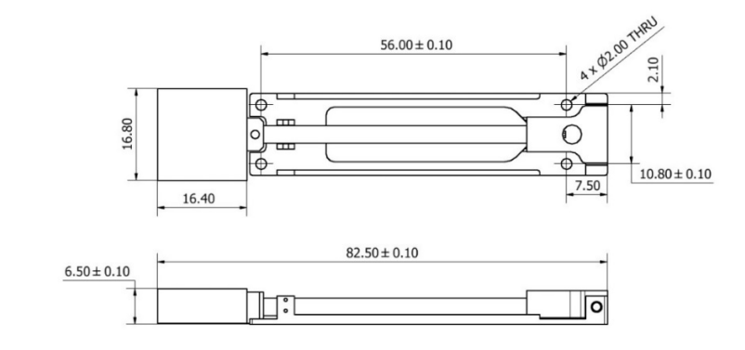

Figure : Deployable magnetometer

The magnetometer will be constrained solely by the CubeSat itself (compliancy with requirement FDS-VCD 4.1.7)

The magnetometer is supplied with a deployable boom. The deployable boom consists of a rod with the magnetometer in its enclosure at one end and a mounting bracket with a spring on the other. The spring provides a torque of 0.014 Nm at the base of the boom. The boom separates the magnetometer by 8 cm from the satellite body, limiting/minimizing the effect of electromagnetic interference and lowering the measurement noise. The magnetometer is mounted on the outside of the satellite at the centre of the structure between two solar panels. In this way it is not placed near the two antennas in our CubeSat (ISISPACE antenna system and Tallysman antenna from GOMSpace), which may cause electromagnetic disturbances.

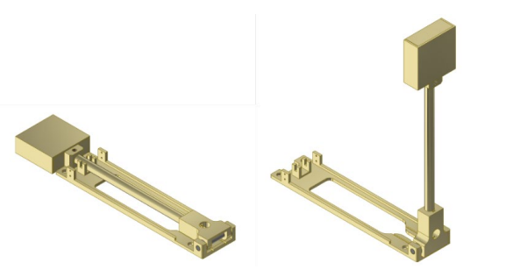

Figure : Magnetometer mechanism. Stowed (left), deployed (right)

The magnetometer will be supplied in the stowed position and deployment can be done in-flight via TC command. When the “deploy magnetometer” command is given, the nichrome burn circuit is activated for 5 s. It will draw 0.62 A for a battery supply voltage of 8 V.

Deployment should occur while ground contact with the satellite has been established (during a ground station overpass). Real-time magnetometer measurements at 1 second is required to evaluate if the deployment was successful. It is also better that the satellite is still in a slow tumble (e.g. Y-Thomson spin), otherwise the magnetometer deployment might be difficult to observe through analysis of the magnetometer channel measurements. Moreover, the control mode should be set to none (no control must be taking place). There is a switch that is depressed when stowed and then releases when the magnetometer deploys. Moreover, magnetometer readings can be post-processed and compared against a redundant magnetometer or against other sensors to determine if the deployment is not 90 degrees. The magnetometer deployment event will show up as a step change in the RAW magnetometer measurements. The estimated angular rates will also show an exchange between two of the X, Y and Z components as a result of successful deployment, the third axis around which the magnetometer deployment took place, should show no change in estimated angular rate. The electric current telemetry will also be instrumental to show if deployment was attempted. There is no additional sensor to assess the angle at which the boom deploys (partial deployment). Gen 2 magnetometers are now supplied by CubeSpace. Unlike Gen 1 magnetometers, Gen2s have refubrishable capability for ground testing and verification purposes. The HDRM consists of a burning wire. The technical data are available under a Non Disclosure Agreement (NDA).

### Deployable antenna system

The ISISPACE deployable antenna system consists of up to four antenna elements which are rolled-up and stowed inside the antenna housing (Figure 66). They are deployed from all four sides of the box upon command. Thesystem contains up to four tape spring antennas of up to 17 cm in length in the case of UHF. In case of a failure of the release mechanism of the antennas no communication with the ground station can be done. The team will procure the component in the early phases of the assembly and integration phase in order to test the mechanism. This failure is critical for the mission.

An aluminum bracket creates an enclosure in which the antenna is stowed and contains a polycarbonate lid to release and deploy the antenna in orbit. The lid is kept closed by a spring tensioned burn wire which is made of dyneme wire. The deployment of each antenna is achieved by melting the small wire which holds down the lid of its antenna box. The wires are melted using two redundant heating elements per wire, controlled by two redundant microcontrollers. Once the wires are melted, the lid is released. Once the antennas deployed, the microcontroller gets a feed-back from the feed-back switches, providing feedback about the status of deployment.

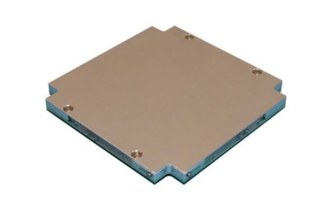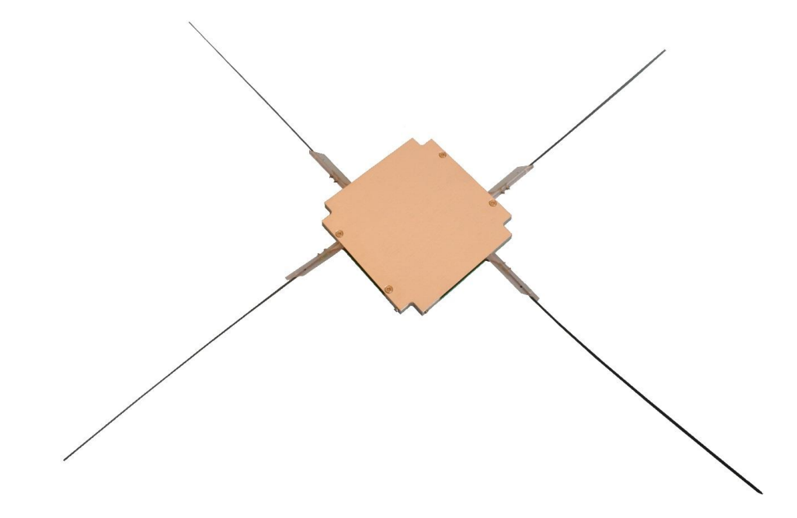

Figure : Antenna in the stowed configuration (left) and in the deployed configuration (right)

The Antenna elements are made of a NiTi-alloy based shape memory alloy in order to reduce the required antenna envelope in stowed configuration. The antenna is connected to a SSMCX connector through a flex-rigid PCB. The antenna housing will be constrained solely by the CubeSat itself (compliancy with requirement FDS-VCD 4.1.7)

### Momentum wheel

The Momentum Wheel is integrated in the CubeADCS Y-Momentum system. The small CubeWheel mounting instructions are reported in the user manual provided with the CubeADCS datasheet. In the case of AlbaSat, the momentum wheel is mounted on the CubeConnect (which is a component of the ADCS) and integrated onto CubeADCS. The technical drawing of the momentum wheel is shown in Figure 67. An additional 1.5 mm is required on one side of the CubeWheel for internal harnesses.

The CubeWheels have a turn-on threshold of 6.5 V, but lower voltages are tolerated without damage to them. The maximum tested bus voltage is 16.0 V. For the wheels to perform optimally, a battery voltage of at least 8V is recommended.

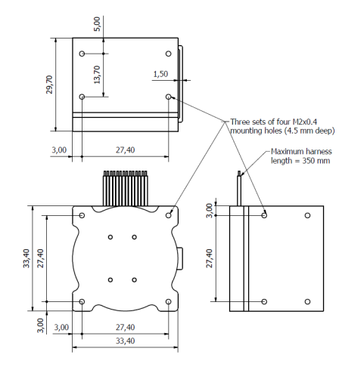

Figure : Momentum wheel technical drawing.

The momentum wheel has a turn-on threshold of 6.5 V, but lower voltages are tolerated without damage to them. The maximum tested bus voltage is 16.0 V. For the wheels to perform optimally, a battery voltage of at least 8 V is recommended.

### Mechanisms Analysis Results

Due to the preliminary status of the project the analyses of the mechanisms have not been performed at the time of writing the document.

### Separation springs and deployment switches

The ISISPACE 2U structure frame features two kill switch mechanisms on the rails that points in the direction. When the satellite is placed in its orbital deployer the kill switches are pressed down and interrupt the electrical circuit of the satellite, so that the satellite cannot power up (requirement FDS-VCD 4.2.4). As soon as the satellite is released, the electric circuit is closed and the satellite can be powered. In the actuated state, the kill switches are at the level of the rail in which they are embedded, thus satisfying requirement FDS-VCD 4.2.4.1. The separation springs are included in the structure and are integrated with the kill switch mechanism. The team still does not have the characteristics of the springs due to problems with NDA, but ISISpace assured us that they are compliant with the characteristics listed in Table 59.

Table 59: Recommended characteristics for separation springs in CubeSat

|  |  |  |  |
| --- | --- | --- | --- |
| **End Force [N]** | **Initial Force [N]** | **Throw length [mm]** | **Source** |
| 0.62 | 4 | 4, above the standoff surface | *CDS rev 13* |
| 2.224 | 6.672 | 1.27, min. above the standoff surface | *ISO 17770:2017* |

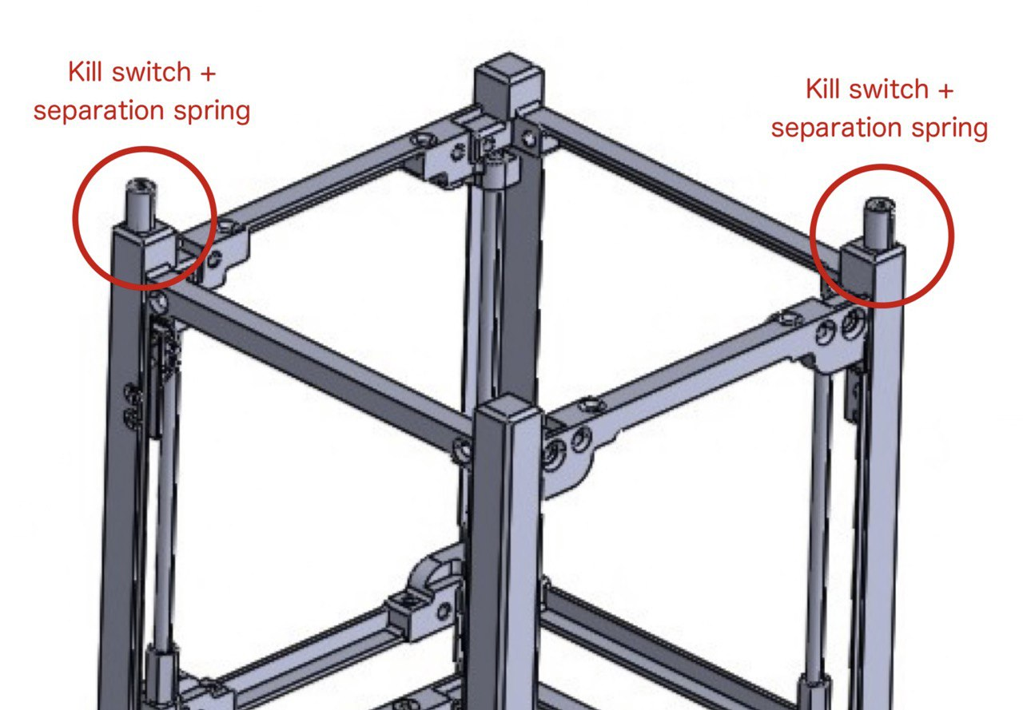

Figure : Position of the kill switch mechanism and separation springs on the 2U ISISpace structure.

## Thermal Control

### Thermal Quick Facts Table

|  |  |
| --- | --- |
| TCS design | passive |
| Number of temperature sensors | 13 |
| Number of heaters | 1 (battery) |

### Functional and physical description

The TCS shall maintain the components in their operative temperature ranges during the whole mission. In order to do so, the TCS needs temperature sensor to measure their temperatures and shall manage the heat flux. The analysis suggested that the TCS can rely on passive techniques for temperature regulation of most components. The only exception is the heater integrated in the EPS subsystem which has the purpose to heat the battery in the Worst Cold Case, since its thermal range is narrower than the other components. Several COTS components feature integrated temperature sensors. Hence, The TCS exploit them to measure the temperature onboard. The temperature sensors currently onboard are:

* two temperature sensors integrated in the antenna board;
* one temperature sensor per each solar panel;
* four temperature sensors integrated in the EPS;
* one temperature sensor integrated in the OBC.

The most sensitive components are the batteries that require a demanding temperature range (0°C to +50°C). However, even if the TCS is generally passive, an electric heater (integrated in the EPS board) is used to keep the batteries inside the operating temperature in the WCC.

### Component temperature limits

The following table shows the temperature ranges for each component or assembly. The value reported for the batteries is the charge operational temperature range, due to the limited gap that it features. The temperature ranges make the entire CubeSat compliant with requirement FDS-VCD 4.10.7.

Table 60: Temperatures ranges of the components used in the satellite

|  |  |  |  |  |
| --- | --- | --- | --- | --- |
| **Component/Subsystem** | **Operational temperature limits [°C]** | | **Non-operational temperature limits [°C]** | |
|  | **Min** | **Max** | **Min** | **Max** |
| **ADCS - Computer** | -40 | +85 | -40 | +85 |
| **ADCS – Fine Sun Sensor** | -20 | +70 | -20 | +70 |
| **ADCS – Magnetorquer** | -20 | +70 | -20 | +70 |
| **ADCS – Control board** | -10 | +70 | -10 | +70 |
| **ADCS – Magnetometer** | -20 | +85 | -20 | +85 |
| **ADCS – Connectors** | -10 | +60 | -10 | +60 |
| **ADCS – Coarse Sun Sensor** | -40 | +125 | -40 | +125 |
| **ADCS – Momentum Wheel** | -10 | +60 | -10 | +60 |
| **EPS - PCDU** | -40 | +85 | -40 | +85 |
| **EPS- battery** | 0 | +50 | -20 | +75 |
| **EPS – solar panels** | -40 | +85 | -40 | +85 |
| **OBC** | -40 | +85 | -40 | +85 |
| **TT&C – antenna** | -30 | +85 | -30 | +85 |
| **TT&C – transceiver** | -20 | +60 | -40 | +80 |
| **PL – MVS** | -10 | +70 | -10 | +70 |
| **PL - QFP** | -10 | +70 | -10 | +70 |

### Thermal Analysis Summary

The analyses have been performed considering two extreme orbital scenarios: Dawn-Dusk orbit and Midday-Midnight orbit with the following parameters:

|  |  |  |
| --- | --- | --- |
|  | **Dawn Dusk orbit** | **Midday Midnight orbit** |
| Altitude | 500 km | 500 km |
| Eccentricity | 0.001 | 0.001 |
| LTAN | 06:00 | 12:00 |

In order to simulate the variations of the environmental conditions with the alternation of the season, for each orbit, four different periods of the year have been investigated:

* 30 March 2027 (Launch date)
* 21 June 2027 (summer solstice)
* 22 September 2027 (autumn equinox)
* 21 December 2027 (winter solstice)

To have the most representative description of temperatures distribution throughout the CubeSat, an internal heat dissipation from each sub-system has been imposed. In the first instance, the heat-waste values were considered to be equal to the power consumption of the single sub-systems. Four different cases have been studied, based on the orbit and on thermal power dissipation: the Safe Mode and the Nominal Mode.

A 20% margin has been added to the values of the internal generation, as Table 61 and Table 62 show.

Table 61: Internal heat dissipation in Midday-Midnight orbit

|  |  |  |  |  |
| --- | --- | --- | --- | --- |
| **Midday-**  **Midnight**  **orbit** | **Nominal Mode** | | **Safe Mode** | |
| **Power Consumption [W]** | **PC + 20% margin [W]** | **Power Consumption [W]** | **PC + 20% margin [W]** |
| ADCS | 0.6837 | 0.8204 | 0.1393 | 0.1672 |
| EPS | 0 | 0 | 0 | 0 |
| OBC&TTC | 0.7922 | 0.9506 | 0.7237 | 0.8684 |
| IS | 0.25 | 0.3 | 0 | 0 |
| MVS | 0.03 | 0.036 | 0 | 0 |
| QP | 0.5 | 0.6 | 0 | 0 |

Table 62: Internal heat dissipation in Dawn-Dusk orbit.

|  |  |  |  |  |
| --- | --- | --- | --- | --- |
| **Dawn-Dusk**  **orbit** | **Nominal Mode** | | **Safe Mode** | |
| **Power Consumption [W]** | **PC + 20% margin [W]** | **Power Consumption [W]** | **PC + 20% margin [W]** |
| ADCS | 0.6837 | 0.8204 | 0.1393 | 0.1672 |
| EPS | 1.9975 * | 2.397 * | 0 | 0 |
| OBC&TTC | 0.7922 | 0.9506 | 0.7237 | 0.8684 |
| IS | 0.25 | 0.3 | 0 | 0 |
| MVS | 0.03 | 0.036 | 0 | 0 |
| QP | 0.5 | 0.6 | 0 | 0 |

During the Dawn-Dusk orbit in Nominal Mode (WHC), the power stored in the battery pack has also been taken into consideration as heat-waste dissipation. Only in this case, the battery has a heat dissipation of 2.397 W, while in all other cases, dissipation is zero. The value is obtained from the total power generation during the Dawn-Dusk orbit.

More details about the geometrical mathematical model, the thermal mathematical model and the results of the analysis are reported in the ALB_THR-ARPT_2024-03-10_v1.0 file, in particular, in the section 6 all the temperatures are organized and presented based on subsystems.

## Electromagnetic Compatibility (EMC)

### EMC Control plan

At the moment of writing the document, the design of the satellite is preliminary. Hence, only a first EMC study have been performed. Further analyses will be performed in the next iterations of the design.

In the first EMC study, the various components of the satellite have been classified in *sources* of or *victims* (sensitive elements) of Electro-Magnetic Interference (EMI). The characteristic that is used to define if a component is a source or a victim is the frequency it operates at. If the frequency is high, then the element is considered a source otherwise it is considered a victim. For each component the EMC classification is reported hereunder.

**TT&C**

|  |  |  |  |  |  |  |  |  |
| --- | --- | --- | --- | --- | --- | --- | --- | --- |
| **Component** | **Frequency** | **Nominal current** | **Max current** | **Nominal voltage** | **Max voltage** | **Nominal power** | **Max power** | **Definition** |
| Antenna | 430-440 Hz (UHF) | 11 mA | NA | 3.3 V | 3.6 V | 40 mW | 2 W | Source |
| Transceiver | 430-440 Hz (UHF) | 55 mA | 120 mA | 3.3 V | 3.4 V | 30 dBm | 31 dBm | Source |

The main components of the communication subsystem operate at high frequencies and this causes them to represent **SOURCES** of EMI.

**ADCS**

|  |  |  |  |  |  |  |  |  |
| --- | --- | --- | --- | --- | --- | --- | --- | --- |
| **Component** | **Frequency** | **Nominal current** | **Max current** | **Nominal voltage** | **Max voltage** | **Nominal power** | **Max power** | **Definition** |
| Fine Sun Sensor | 2 Hz | 2 mA |  | 3.3 V |  | 100 mW | 200 mW | Victim |
| Coarse sun sensor | 1 Hz |  |  |  |  | <5 mW |  | Victim |
| Magnetometer | 1 Hz |  |  | 3.3 V |  | 35 mW |  | Victim |
| Magnetorquers |  | 0.62 A | 150 mA |  |  |  | 0.69 W | Source |
| Momentum wheel | 33 Hz (average) |  |  | 3.3 V |  | 150 mW | 0.65 W | Source |

In the ADCS coexist components that works at low frequencies and high frequencies. Specifically, the sensors are classified as **VICTIMS** while the actuators are classified as **SOURCES**. For what concerns the momentum wheel the operative frequency has been set equal to the average rotation speed of the wheel provided by the datasheet. Since the magnetometer is considered as a victim it has been decided to employ a deployable magnetometer to mitigate the effects of the sources on it.

**EPS**

For the EPS subsystem it is observed that all the components including solar panels, batteries (NanoPower P31u), MPPT and converters work at low frequencies and are therefore classified as **VICTIMS** of EMI.

**OBC**

The OBC working frequencies is generally higher than the other components of the system. Hence, as a first assumption, it is considered a **SOURCE**.

**QuantumFuture Payload**

The QuantumFuture payload is currently under development. However, it is known from the requirements that a mirror is deformed at frequencies up to 10 kHz. Hence, the electronics of the QuantumFuture Payload is considered as a **SOURCE**.

**Impact sensor**

The impact sensor samples at a frequency of 1 Hz. Having components that operate at low frequencies, this payload is classified as a **VICTIM**.

**Micro-vibration sensor**

The micro-vibration sensor samples at a frequency of maximum 600 Hz. Hence, as a first assumption, having components that work at high frequency it is considered a **SOURCE**.

Table 63: List of working frequencies of the components of the satellite. Beside the payloads, the components are COTS. Information about their internal components and their working frequencies are protected by NDA.

|  |  |  |  |  |
| --- | --- | --- | --- | --- |
| **Subsystem** | **Component** | **Hardware** | **Working frequency [Hz]** | **Classification** |
| ADCS | Fine Sun Sensor | Internal electronics | N.A. | N.A. |
| Camera | 2 | Victim |
| Coarse Sun Sensor |  | 1 | Victim |
| Magnetometer | Internal electronics | N.A. | N.A. |
| Signal conditioning circuit | N.A. | N.A. |
| Magnetorquers |  | N.A. | N.A. |
| Momentum wheel | Internal electronics | N.A. | N.A. |
| Motor driver | N.A. | N.A. |
| Motor powering circuit | 33 (avg.) | Victim |
| Computer | Real time clock | N.A. | N.A. |
| MCU | N.A. | N.A. |
| FPGA | N.A. | N.A. |
| SoC | N.A. | N.A. |
| Control | Internal elecronics | N.A. | N.A. |
| Signal MCU | N.A. | N.A. |
| MotorMCU | N.A. | N.A. |
| EPS | PCDU | Photovoltaic power converter | N.A. | N.A. |
| MCU | N.A. | N.A. |
| Power conditioning electronics | (TBC) | N.A. |
| Power distribution electronics | N.A. | N.A. |
| Batteries |  | N.A. | N.A. |
| Solar Panels |  | N.A. | N.A. |
| OBC | OBC | MCU | (avg)  (min-max) | Source |
| FPGA | N.A. | N.A. |
| PWM switch |  | Source |
| Magnetometer driver | 10 (avg.) | Victim |
| Gyroscope driver | N.A. | N.A. |
| Analog Digital Converters | N.A. | N.A. |
| Real time Clock | (avg)  (min-max) | Source |
| FRAM | N.A. | N.A. |
| SDRAM | N.A. | N.A. |
| TTC | Antenna | RF phasing |  | Source |
| MCU | N.A. | N.A. |
| Transciver | Real time clock | N.A. | N.A. |
| FRAM | N.A. | N.A. |
| Buck-converter | N.A. | N.A. |
| LNA | N.A. | N.A. |
| TCXO (oscillator) |  | Source |
| Power amplifier | N.A. | N.A. |
| IS | Control board | MCU | N.A. | N.A. |
| Mux | 1 | Victim |
| Demux | 1 | Victim |
| MVS | Micro-vibration sensor | MCU | N.A. | N.A. |
| Accelerometer | 820 |  |
| Analog Digital Converter | N.A. | N.A. |
| QPL | Control Board | MCU | N.A. | N.A. |
| Internal electronics | N.A. | N.A. |
| MRR | 100 | Victim |

#### EMI mitigation techniques

There are several EMI mitigation techniques that can be applied to components to reduce or eliminate the interference produced by electromagnetic waves. Usually, COTS components already have these types of protection while self-produced components must be integrated to guarantee the passing of the tests related to EMI. Due to the preliminary design of the CubeSat, it is not certain which of the following EMI mitigation technique will be applied.

* **SHIELDING**: It must be ensured that the printed circuits are multilayered as this allows to protect the RF components. In addition, components that have been found to be sources of EMI from the previous analyzes should be housed within a metal housing.
* **PARTITIONING:** Components that operate at high frequencies must be located separately from components that operate at low frequencies. Clock, bus, high-speed components and chip select signals should be located away from I/O lines and connectors.
* **GROUNDING:** A solid, continuous ground plane should be placed as close as possible to the traces. A reference ground plane should be created and connected to the ground plane using a via method. Control unwanted crosstalk by minimizing the distance between traces and the reference ground plane.
* **MATCHING:** obtain a correspondence between the impedance of the source and that of the load, in order to minimize the reflection of the electromagnetic waves that are generated during the propagation of the signal.
* **FILTERING:** consists in the use of filters, i.e. electronic circuits specifically designed to attenuate certain frequencies of the electrical signal. Filters can be passive or active and can be configured in a variety of ways.
* **DECOUPLING:** consists in the use of capacitors or inductors to isolate and decouple the parts of the circuit that have different levels of electric potential or different background noises. Electrical decoupling is particularly useful for preventing so-called "feedback effects" and for protecting electronic components from damage caused by voltage or current changes.

### Grounding scheme

Due to the preliminary design of the system, only a first study of the grounding scheme has been performed. Further investigation will be done in the next iterations of the design.

In the CubeSat setup the PC104 boards are stacked one on top of each other and each board has a pin intended to function as a ground pin which turns out to be a ground pin for all boards in the PCB stack. In this way, to protect the components from electromagnetic interference, it is sufficient to connect the ground pin of the PCB (Printed Circuit Board) to the upper or lower part of the CubeSat frame.

As a first grounding scheme design an hybrid solution approach has been chosen. The grounding scheme appears to be hybrid as it presents two types of grounding based on the classification of the components (EMI sources or victims), and it is identified as follows:

* In an SPG (Single Point Ground) strategy (a), all electronic components are connected to a single common ground point, in order to minimize potential differences between the various components and reduce the risk of forming ground loops. This technique is often used in low frequency systems (EMI victims).
* In an MPG (Multiple Point Ground) strategy (Figure b), multiple ground points are used, thus dividing the circuit into separate sections, each with its own reference point. This technique is often used in high frequency systems (EMI sources).

The SPG and MPG techniques are often not enough to provide grounding for this reason ground planes are inserted which can be of two types. For high frequency components, analog ground planes are typically used and connected to the external structure of the satellite via capacitors to provide grounding. Instead, for low-frequency components, resistors are used that connect to the digital ground planes.

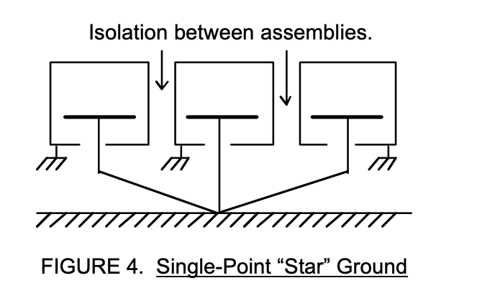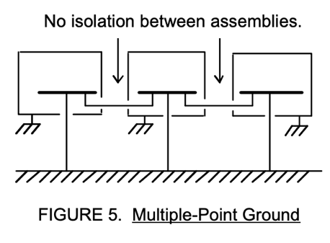

(a)

(b)

Figure : Representation of: (a) single point ground strategy and (b) multiple point ground strategy

## Ground Segment

### GS Quick Facts Table

|  |  |
| --- | --- |
| Frequency | 435 MHz |
| Antenna | Cross Yagi (UHF) mounted on one rotator |
| Location | Università degli Studi di Padova – DII |
| Coordinates | 45°N 11°E |
| Altitude | ~12 m |
| Minimum elevation | 10 deg |

### Physical architecture

The ground segment will consist of one UHF channel divided into transmission of telecommands and reception of either telemetry or payload data.

For the uplink chain, the telecommands (TC) will be generated by the mission control software (MCS) and transmitted to the software defined radio (SDR) through an USB port. Then the signal will travel to a preamplifier and will be transmitted by the antenna after passing a RF switch that selects the active line.

The downlink signal will travel through the switch and to a low noise amplifier (LNA), then the desired frequency will be selected using a bandpass filter and the signal will be transmitted to the SDR and to the MCS and servers. A block diagram of the described architecture is shown in Figure .

The team has performed a selection of the components that will be purchased in the next phase of the mission, in compliance with the requirements 4.9.7 and 4.12.3 cited in the FDS-VCD.

* **Antenna**

For the antenna selection we have chosen the *Big LEO Pack for Satellites LEO*, it consists of a *2m Yagi antenna 2m14CROSS* with an added RHCP Kit and a *70cm Yagi antenna 70cm30CROSS* with the same universal RHCP Kit. The antenna will be mounted in an azimuth-elevation rotator Yaesu G-5500CDC controlled by the mission control software (Gpredict).

* **Rotator**

The rotor chosen is the Yaesu G-5500CDC model and it too will be purchased through the hamradio site. The rotor will allow the antenna to accurately track the passage of the satellite over the Ground Station to minimize signal loss.

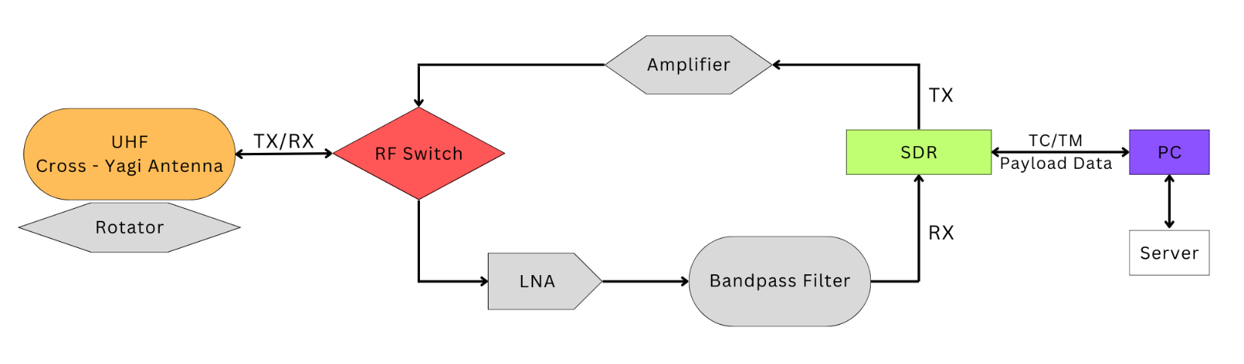

Figure : Ground Station physical architecture.

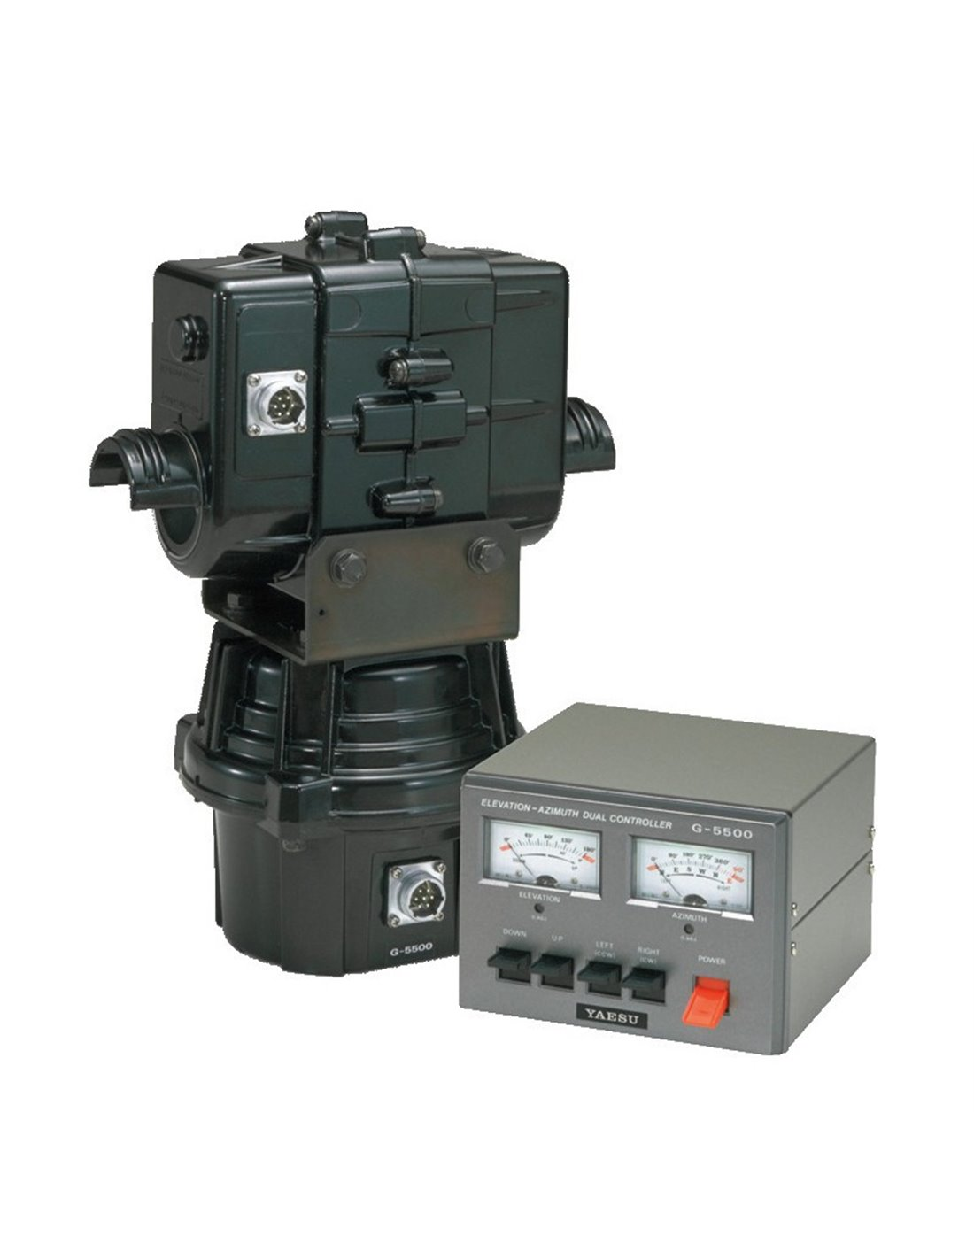

Figure : Yaesu G-5500CDC (Source: hamradio shop)

* **RF switch**

The division of the reception and transmission channels will be accomplished with a F2972 switch that will be purchased by the team from the radio amateurs’ shop *hamradio* (TBC). The F2972 is a single-pole, dual-output reflective RF switch featuring high linearity and wide bandwidth. This device is optimized from 5MHz to 1.8GHz and operates up to 10GHz.

* **Low-Noise Amplifier (LNA)**

A low-noise amplifier (LNA) is used as a microwave preamplifier in the receiving chain of the earth station. This low-noise amplifier is broadband: a single amplifier simultaneously amplifies all carriers leaving the receiving port of the antenna diplexer.

* **Software Defined Radio (SDR)**

The full-duplex communication is accomplished using a LimeSDR Mini. This component was selected since its project is supported by ESA and it is built specifically for amateur satellite communications.

### Functional architecture

The ground segment will be controlled by the Mission Control Software that is yet to be defined. The team is performing a trade-off between available MCS, in particular between SCOS-2000 and Yamcs. The MCS will be interfaced to a GNURadio application that will perform the necessary elaboration of the signal. The level of automation is yet to be defined.

### Software (optional for BDR)

Our chosen software suite offers efficient and user-friendly control of our ground station.

* **SDR-Console** manages rotor control due to its simplicity, compatibility, and being free and open-source software.
* **Gpredict** will be also used to control rotator.
* **WispDDE**, another software program, enhances the connection with the ST2-0522-USB-TTL interface.
* **Orbitron**, another free and open-source software, handles satellite tracking and ground station control, allowing us to command the rotator and track our CubeSat.
* **SatNOs** serves as our primary software for receiving and decoding telemetry packets from satellites.

Additionally, all three programs demonstrate compatibility amongst themselves.

### Database (optional for BDR)

### Operational interfaces (optional for BDR)

The ST2-0522-USB-TTL interface by Foxdelta was chosen to connect the Yaesu G-5500 rotator to the PC. It is compatible, affordable, and easy to use, offering two different types of communication, one with a standard USB interface and the other with a remotely placed controller using a RS485 or 2.4 GHZ adapter connected to its TTL port.

### Licensing

To comply with the requirements 4.12.7 and 4.12.4 and 4.12.2 from the FDS-VCD, the team is currently in contact with the local radio amateurs’ group (ARI Padova). The team members of the GS, TTC and OPS sections are preparing to take the necessary exams to obtain the licenses. The coordination with IARU for the allocation of the frequencies is in program with the support of ARI Padova.

#### Radio amateur payload

Since AlbaSat employs radio amateur frequencies, the mission offers a payload that will encourage the radio amateur community worldwide to actively engage in space research and communication. The interest of the radio amateur community towards the space activities is growing as several initiatives are promoted by AMSAT itself.

In addition, during previous CubeSat missions, the radio amateur community was helpful in establishing a first contact with deployed CubeSats or to find them after radio contact issues. Beside the growing interest in the satellite communication, many amateur ground stations are inefficient for communicating with CubeSats as, for instance, they are characterized by omni-directional antennas or are not able to track the satellite.

The main goal of the payload, which AlbaSat will provide to the radio amateur community, is to support the radio amateurs in the creation of ground stations that are able to communicate with satellites. Moreover, this payload will provide to the radio amateurs the possibility to communicate all over the world. It will be offered to radio amateurs (with an official radio amateur licence) the possibility to transmit any message from AlbaSat to ground to any region of the world. Since the message will be customizable it can be used for tuning a radio amateur ground station or it can be used to communicate to remote region of Earth.

Over the university's data transmission zones, the satellite's software will be updated periodically to ensure mission success and radio amateur service. In this way, passages for radio amateurs are guaranteed which will increase as the mission progresses.

|  |  |  |
| --- | --- | --- |
| Mission’s year | University payload passages | Radioamateur payload passages |
| 1 | 10/10 | 0/10 |
| 2 | 9/10 | 1/10 |
| 3 | 8/10 | 2/10 |
| 4 | 7/10 | 3/10 |
| 5 | 6/10 | 4/10 |
| Mission end | 5/10 | 5/10 |

The mission webpage will have a section allocated to the radio amateur payload where a radio amateur can fill out a form where it can be specified what message the CubeSat must deliver and the Earth region where it must be transmitted. After the request has been accepted by the team, the operation team will command AlbaSat to add the message to the heartbeat when it passes over the selected region.

The radio amateur will be notified, and it will be communicated the characteristics of the signal transmitted (e.g., frequency, power…). In this fashion, the radio amateur can verify the functionality of its ground station or can send a message to a remote radio amateur. The messages that can be transmitted needs to respect some constraints:

* The message shall not be greater than 2048 b (TBC);
* The message shall be transmittable using AX.25 package;
* The form shall be filled out at least 1 week before the passage.

Beside the form, on the website there will be reported the good practices to follow when assembling a ground station together with the experiences and lessons learned by the team while assembling its own ground station. All the documentation concerning the AlbaSat ground station will be available on the website.

### Secondary or back-up ground station(s)

The ground station will be part of the SatNOGS Network. This will allow to have a network of ground stations around the world that will receive the S/C telemetry trough the periodic beacon emitted by the satellite. This will help the FOT during LEOP and the operational lifetime by reducing the time without the status of the satellite. The SatNOGS network will not be able to send TC and therefore the download of the payload data, as well as specific telemetry, can be performed only at the university GS.

## Quantum Ground Station

In the following section the Quantum Ground Station (QGS) that will be used as the transceiver station for the QPL is introduced and described.

### Scheme of the QPL QGS

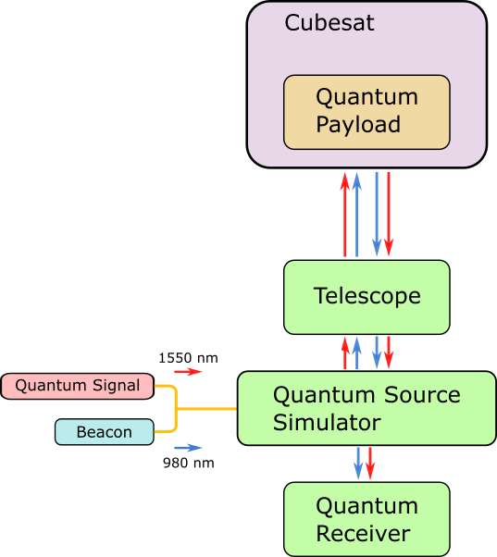The QPL team will perform its tasks exploiting the usage of a proper designed apparatus, composed in its most general form by a transmitter/receiver optical system and a professional telescope. A schematic representation is reported in figure 71.

Figure : Schematic representation of the Quantum Ground Station with both the transmitter and receiver stages.

### The QGS GaliQEye telescope

|  |  |  |
| --- | --- | --- |
| The telescope that will be exploited for the accomplishment of the QPL objectives it the so called “GaliQEye”, property of the DEI department of the University of Padua. In table below the principal features are reported, while in APPENDIX B some pictures of the telescope and the relative dome are reported.**Parameter** | **Value** | **Unit** |
| Primary Mirror Diameter | 410 | mm |
| Secondary Mirror Obstruction | 170 | mm |
| Focal Length | 3200 | mm |
| f Number | 8 |  |
| Coating | Alluminum |  |
| Reflectivity | > 80% ( @ 532-1550 nm) |  |
| Configuration | Ritchey-Chretién |  |
| Coarse tracking pointing precision | ~100÷150 | µ rad |
| Mount Type | German Equatorial Mount (GEM) |  |
| Mount model | Paramount ME II (Software Bisque) |  |
| Mount Control Software | TheSkyX (Software Bisque) |  |
| Dome diameter | 3 | m |
| Dome model | ScopeDome 3M |  |
| Weather Station | Lunatico CloudWatcher SOLO |  |

### The QGS transceiver apparatus

In order to generate and collect photons respectively transmitted and received by the GaliQEye telescope, a quantum optical station is exploited.

This station can be considered as a transceiver one since it is allocated both for the generation of the uplink signal and the reception of the modulated retroreflected light.

Both the 1550 nm signal and the 980 nm beacon laser beams are emitted from the Quantum Source Simulator (QSS), routed toward the telescope and then collimated before being launched in the direction of the QPL. The reflected beams, once reflected from the MRR, are recollected at the ground level from the telescope and coupled in a single mode optical fiber placed in the receiver end. At this point the collected photons are routed towards the Quantum Receiver to be properly analysed. The receiver is directly connected to a Superconducting Nanowire Single Photon Detector (SNSPD), capable of identifying the single photon arrivals, which is supported by a Time to Digital Converter (TDC) in order to collect the information about the time of arrival of the photons.

# Manufacturing, assembly, integration and verification plan

## CubeSat Model Philosophy

### Space Segment model philosophy

The model philosophy (system level) that will be followed during the CubeSat implementation includes two models, namely: Engineering Model (EM) and ProtoFlight Model (PFM).

The team will follow this philosophy for mainly three reasons: (1) keep the development cost low and (2) fast development. The amount of financial support that will be provided by the university and sponsors is uncertain and the development cost of the mission are high (see Sec. 5.3). In addition, the development should be fast since a student stay at university is limited and too many handovers on the same project risk wrecking it.

For what concern the payloads, i.e., IS, MVS and QPL, a dedicated model philosophy will be followed for each payload since they are not COTS components. For IS the DM+EQM+FM approach is employed, for the MVS is DM+EQM+FM, for the QPL is DM+EQM+FM and for the CCRs follows the model philosophy of the platform (EM+PFM).

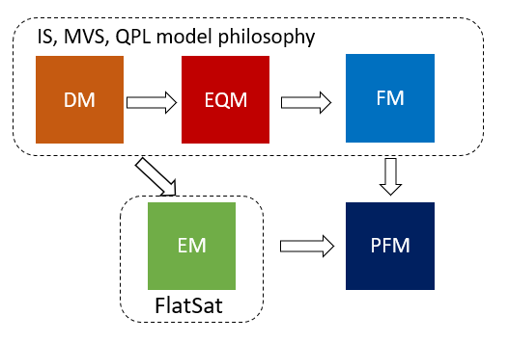

Figure : Space segment model philosophy scheme.

The team will develop a FlatSat from the early stages of the development. Firstly, this will be created the EM using PFM COTS components of subsystems and EQM of the payloads. Then, the PFM of the CubeSat will be integrated using the PFM components tested on the FlatSat. This permits to reduce the mission cost. A presentation of the purposes of each model is provided hereunder, Figure Figure shows a scheme of the CubeSat model philosophy.

**Engineering Model**

The Engineering model of AlbaSat will be realized using the PFM of the COTS components and the EQM of the payloads. Hence, all the components of the FlatSat will be flight representative. The FlatSat EM will be used to test the interfaces, the functionalities and the communications between the subsystems. In addition, FlatSat will be employed to test a first version of the Flight Software. The results will be useful to refine the system budgets and to finalize the design of the system. The FlatSat EM will be used for testing the satellite operations. With this aim, it will feature an antenna to remotely communicate with the Ground Station. These tests will be helpful to familiarize with the operations phase and for procedures and timelines assessment.

**ProtoFlight Model**

The PFM approach will allow a less use of resources since only a single flight-grade model will be realized. However, some risks are inherent in this approach. Issues may rise during the implementation and assembly phase if the team is not experienced and a human error or a technical issue may result in a long project delay. Another reason why the team selected the PFM approach is that COTS components will be extensively used in the satellite. The only components that will not be COTS are the IS, the MVS and the QPL. The development of these will follow the DM+EQM+FM approach. The FM of these payloads will be integrated in the PFM of the satellite. The model will undergo both ambient testing and then environmental testing at qualification levels and acceptance durations. Thermal vacuum tests will be done on the components and the entire satellite to ensure bake-out prior to launch following ECSS-Q-ST-70-02C guidelines and ESA or the launch authority indications. As requested from requirement [FDS-VCD 4.10.9] and [FDS-VCD 4.7.5].

### Ground segment model philosophy

The ground segment model philosophy differs from the one of the space segment. Only one final model will be realised. This approach has been chosen since the team can rely on the help of radioamateurs of Padova (ARI Padova) that have heritage on the development, assembly and integration of a Ground Station for satellite communication. The realization of only one model will allow the fast development of the GS and so its early testing. The team, followed by the radioamateurs, will develop the GS using COTS components and an open-source software available on-line.

## System Development Overview

|  |  |  |  |  |  |  |  |  |
| --- | --- | --- | --- | --- | --- | --- | --- | --- |
| **Subsystem name** | **Subsystem model** | **IHD/**  **COTS** | **Manufacturer/Supplier** | **Qualification status** | **Heritage from previous mission** | **Milestone** | **Procurement process start date** | **Estimated lead time or manufacturing time (weeks)** |
| IS | DM | IHD | Alba CubeSat | TRL 4 | N | 26/06/2023 | 01/03/2023 | 12 |
| EQM | IHD | SCEN | TRL 6 | 05/02/2024 | 30/07/2023 | 30 |
| FM | IHD | NA | TRL 7 | / | / | / |
| MVS | DM | IHD | Alba CubeSat | TRL 4 | 26/06/2023 | 01/03/2023 | 12 |
| EQM | IHD | NA | TRL 6 | 05/02/2024 |  | 31 |
| FM | IHD | NA | TRL 7 | / | / | / |
| QPL | DM | IHD |  | TRL 4 |  |  |  |
| EQM | IHD |  | TRL 6 | 31/02/2024 |  |  |
| FM | IHD |  | TRL 7 | / | / |  |
| CCR | EM | COTS/IHD | Edmund Optics (CCR)/  UniPD (structure) | TRL 6 | Y | 05/02/2024 | / | 31 |
| PFM | COTS | Edmund Optics (CCR)/  UniPD (structure) | TRL 8 |  | / | / | / |
| ADCS | EM | COTS | CubeSpace | TRL 9 |  | 05/02/2024 | / | 31 |
| PFM | COTS | CubeSpace | TRL 9 | / | / | / |
| EPS | EM | COTS | GOMspace | / | 05/02/2024 | / | 31 |
| PFM | COTS | GOMspace | TRL 9 | / | / | / |
| OBC | EM | COTS | GOMspace | / | 05/02/2024 | / | 31 |
| PFM | COTS | GOMspace | TRL 9 | / | / | / |
| STM | EM | COTS | ISIS | / | 05/02/2024 | / | 31 |
| PFM | COTS | ISIS | TRL 9 | / | / | / |
| TTC | EM | IHD | GOMspace | / | 05/02/2024 | / | 31 |
| PFM | COTS | GOMspace (transceiver)/  ISIS(Antenna) | TRL 9 | / | / | / |
| GS | FM | COTS | Alba CubeSat | / | Y | 13/11/2023 | / | 36 |

We are not planning to change the CubeSat configuration (hardware, software, data, according to requirement [FDS-VCD 4.8.1]

## System Verification Plan

### Development flow during the FYS!-DB programme

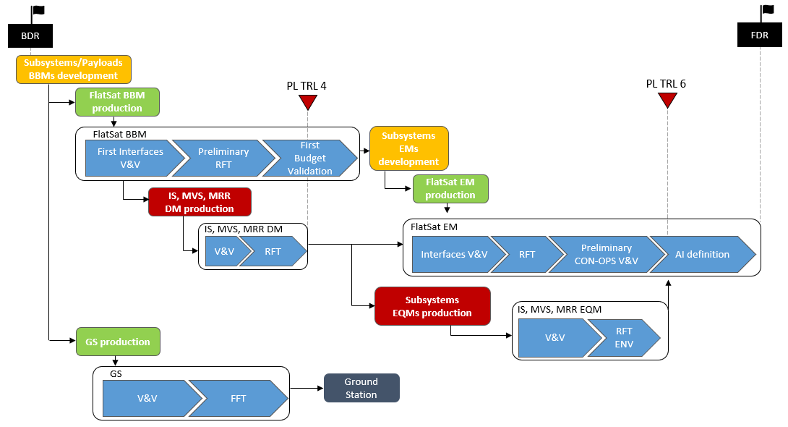

Figure : High level description of the development flow of the CubeSat system under FYS!-DB programme

Figure shows the development flow of AlbaSat under the FYS!-DB programme from the BDR to the FDR. After the BDR, the team will start developing the BBM and will produce the BBM FlatSat. This will be used for a first validation and verification (V&V) of the interfaces, for the validation of the preliminary system budgets and for preliminary Reduced Functional Tests (RFT). In parallel, the DM of the IS, MVS and QPL will be produced. The payloads will be validated and verified and an RFT campaign will be performed. At the end of these activities the IS, MVS and QPL will reach a TRL of 4.

Then, the BBMs of the subsystems will be replaced with the EMs of the subsystems to produce, together with the DMs of the payloads, the EM FlatSat. The interfaces verification, the RFT, the preliminary CON-OPS validation and verification and the assembly & integration verification will be performed on the EM FlatSat. The development of the IS, MVS and QPL will be carried on in parallel. The EQMs of these will be produced, validated and verified and will undergo a Reduced Functional Tests. In these tests the critical functions are verified and the performance is demonstrated in relevant environment. At the end of the test campaign the payloads will reach a TRL of 6. The EQMs, together with the EM components of the FlatSat, are going to be used to test the assembly and integration procedures.

For what concern the GS, its production will start after the BDR. Verification and validation tests will be performed on the GS before conducting a Full Functional Test (FFT) campaign. The project milestones and verification activities are presented in Table .

Table 64: Major milestones (grey) and verification activities during the FYS!-DB programme

|  |  |  |  |
| --- | --- | --- | --- |
| **Name** | **Object** | **Description** | **Documentation** |
| **BDR** | All | Baseline Design Review | See FYS-DRD (Table 1) |
| First Interfaces V&V | FlatSat BBM | Validation and Verification of the interfaces between the FlatSat components. | * V&V test report |
| Preliminary Reduced Functional Test (PRFT) | FlatSat BBM | Preliminary verification of the major functions of the item under test, with a sufficiently high degree of confidence, in a relatively short time | * PRFT test report |
| First Budget Validation | FlatSat BBM | Validate the system budgets (data, power consumption) through dedicated tests | * System budget review |
| V&V | IS, MVS, MRR | Validation and Verification of components under tests | * Payload TS-VCD review * Payload design review |
| RFT | IS, MVS, MRR | Verify the major functions of the item under test, with a sufficiently high degree of confidence, in a relatively short time | * Payload RFT test report |
| **PL TRL 4** | IS, MVS, MRR | Element functional performance is demonstrated by DM testing in laboratory environment. | * Preliminary performance requirements with definition of functional performance requirements. * Conceptual design of the element. * Full Functional Test plan. * DM test reports. |
| Interfaces V&V | FlatSat EM | Validation and Verification of the interfaces between the FlatSat components. | * V&V test report |
| Preliminary CON-OPS V&V | FlatSat EM | Tests for a preliminary validation and verification of the CON-OPS | * Preliminary CON-OPS review |
| EQMs V&V | IS, MVS, MRR | Validation and verification of the EQMs of the components. | * EQMs V&V test report |
| RFT ENV | IS, MVS, MRR EQMs | Verify the major functions of the item under test, with a sufficiently high degree of confidence in a relevant environment | * RFT test report |
| AI  definition | FlatSat EM +  IS, MVS, MRR EQMs | Define the procedure for assembly and integration. Test the procedure using the EM of the subsystems. | * Assembly and Integration test review * Assembly and Integration procedures guidelines |
| **PL TRL 6** | IS, MVS, MRR | Critical functions of the element are verified, performance is demonstrated in the relevant environment and representative model(s) in form, fit and function | * Definition of performance requirements and of the relevant environment * Identification and analysis of the element critical functions * Design of the element, supported by appropriate models for the critical functions verification * Critical function test plan * Model definition for the critical function verifications * Model test reports |
| V&V | GS | Validation and verification of the GS | * GS V&V test report |
| FFT | GS | Comprehensive test that demonstrates the integrity of all functions of the item under test, in all operational modes, including back-up modes and all foreseen transitions | * GS FFT report * GS user manual |
| **FDR** | All | Final Design Review | See FYS-DRD (Table 1) |

### Development flow after the FYS!-DB programme

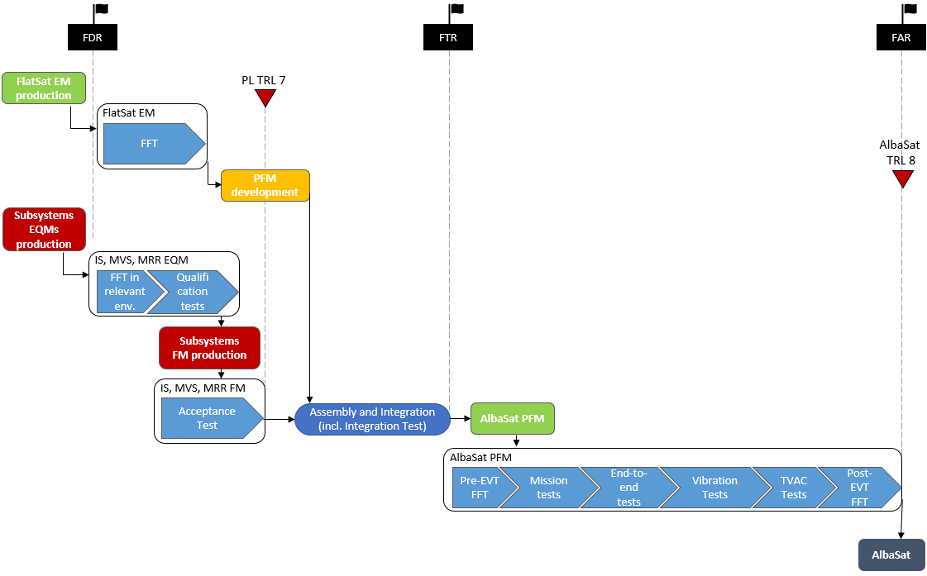

Figure : High level description of the development flow of the CubeSat system after FYS!-DB programme

Figure shows the development flow of AlbaSat from the FDR (closure event of FYS!-DB) to the Final Acceptance Review (FAR). After the FDR, FFT will be performed on the FlatSat EM. In parallel, FFT in relevant environment and qualification tests are performed on the EQMs of the IS, MVS and QPL, then the FMs are produced and tested (acceptance tests).

AlbaSat AIV activities will start when both the PFM of the subsystems and the FM of the payloads are obtained. After the assembly & integration, and related tests, the environmental tests (EVT) campaign will take place. First, the system will undergo pre-EVT FFT campaign. Subsequently, the mission tests will be performed and, after them, end-to-end tests with the ground station that has been previously realized will be conducted. Then, AlbaSat PFM will undergo vibration and termovacuum tests and, at the end of these, post-EVT FFT will be performed. The PFM will be integrated with the deployer. After that, no activation, checkout or maintenance to the CubeSat will be performed [FDS-VCD 4.9.2]. The project milestones and verification activities after the FDR are presented in Table .

Table 65: Major milestones (grey) and verification activities after the FYS!-DB programme

|  |  |  |  |
| --- | --- | --- | --- |
| **Name** | **Object** | **Description** | **Documentation** |
| FFT | FlatSat EM | Comprehensive test that demonstrates the integrity of all functions of the item under test, in all operational modes, including back-up modes and all foreseen transitions | * FFT report |
| FFT in relevant environment | IS, MVS, MRR,  EQMs | Comprehensive test in relevant environment that demonstrates the integrity of all functions of the item under test, in all operational modes, including back-up modes and all foreseen transitions | * Payload FFT report |
| Qualification tests | IS, MVS, MRR,  EQMs | Tests to provide evidence that the space segment element or equipment performs in accordance with its specifications in the intended environments with the specified qualification margins. | * Qualification tests report |
| Acceptance Tests | IS, MVS,  MRR FM | Tests to provide evidence that the space segment element or equipment performs in accordance with the specifications in the intended environments with the specified acceptance margins. | * Acceptance tests report |
| PL TRL 7 | IS, MVS, MRR | Performance is demonstrated for the operational environment, on the ground. A representative model, fully reflecting all aspects of the flight model design, is build and tested with adequate margins for demonstrating the performance in the operational environment. | * Definition of performance requirements, including definition of the operational environment. * Model definition and realization. * Model test plan. * Model test results. |
| Assembly and integration | System | Assembly and integration of the PFM. | * Assembly and Integration review |
| FTR | AlbaSat PFM | Functional Tests Review | * Functional Tests Review documentation |
| Pre-EVT FFT | AlbaSat PFM | Comprehensive test performed before the environmental tests campaign that demonstrates the integrity of all functions of the item under test, in all operational modes, including back-up modes and all foreseen transitions | * PRE-EVT FFT report |
| Mission tests | AlbaSat PFM | Humidity tests, Life tests according to ECSS-E-ST-10-03C Rev.1 | * Mission tests report |
| End-to-end tests | AlbaSat PFM | End-to-end tests with the GS developed by Alba CubeSat | * End-to-end tests report |
| Vibration tests | AlbaSat PFM | Random vibration test, acoustic test, sinusoidal vibration test, shock test according to ECSS-E-ST-10-03C Rev.1 | * Vibration tests report |
| TVAC tests | AlbaSat PFM | Thermal vacuum tests according to ECSS-E-ST-10-03C Rev.1 | * TVAC test report |
| Post-EVT FFT | AlbaSat PFM | Comprehensive test performed after the environmental tests campaign that demonstrates the integrity of all functions of the item under test, in all operational modes, including back-up modes and all foreseen transitions | * POST-EVT FFT report |
| PL TRL 8 | AlbaSat PFM | Flight model is qualified and integrated in the final system ready for flight | * Flight Acceptance review documentation |
| FAR | AlbaSat PFM | Flight Acceptance Review | * Flight Acceptance Review documentation |

## Subsystems Development and Verification Plan

The mission model philosophy is different between the subsystems and the IS, MVS and MRR payloads. Indeed, the former follows a BBM+EM+PFM model philosophy while the latter follow a BBM+DM+EQM+FM approach. This has been chosen since, while COTS components are used for the subsystems, the payloads are developed in house. The subsystems (ADCS, EPS, TCS, TT&C) follow a common development logic. The OBC development logic slightly differs from the one of the other subsystems to permit the implementation of the OBSW directly in the COTS component that will be used in the PFM. For what concerns the CCRs, they follow a BBM+EM+PFM approach as the rest of the subsystems. The final model of the GS will be directly realized without using prototypes or developing models.

This section provides a high-level description of the activities that will be conducted from the design of the subsystems/payloads to their integration in the CubeSat system.

### ADCS, EPS, TCS, TT&C development process

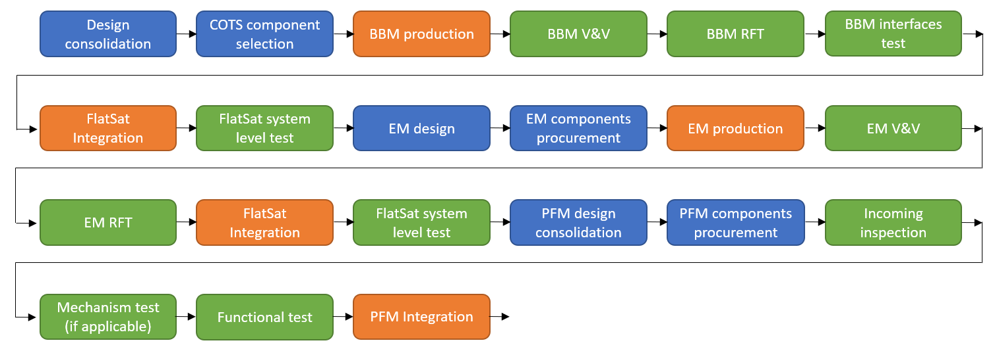

Figure : ADCS, EPS, TCS and TT&C development process.

The development process of the ADCS, EPS, TCS and TT&C is shown in Figure . After the consolidation of the design at system level, the selection of the COTS components that compose the satellite is reviewed and confirmed. Subsequently, the BBM of the components/subsystems are produced to obtain hardware representative of the PFM subsystems functions and interfaces. The BBM are validated and verified before executing tests at component/subsystem level. Specifically, firstly the interfaces are tested, then RFT are performed. The BBMs of the subsystems are integrated in the FlatSat BBM in order to perform the tests at system level.

After the end of the system level tests, the EMs are designed, the components needed for their realization are procured and they are produced. A test campaign similar to the one performed on the BBMs (V&V + RFT) is conducted on the subsystems before their integration in the FlatSat for the system level tests.

The tests conducted at system level and the experience gained from the hand-on activities on the BBM and EM are used for the PFM design consolidation. When the critical design is reached, the components are procured. Before the integration in the PFM of the satellite, the COTS components/subsystems are inspected and tests (mechanism and functional) are performed. After the integration the environmental tests are performed at system level.

### OBC development process

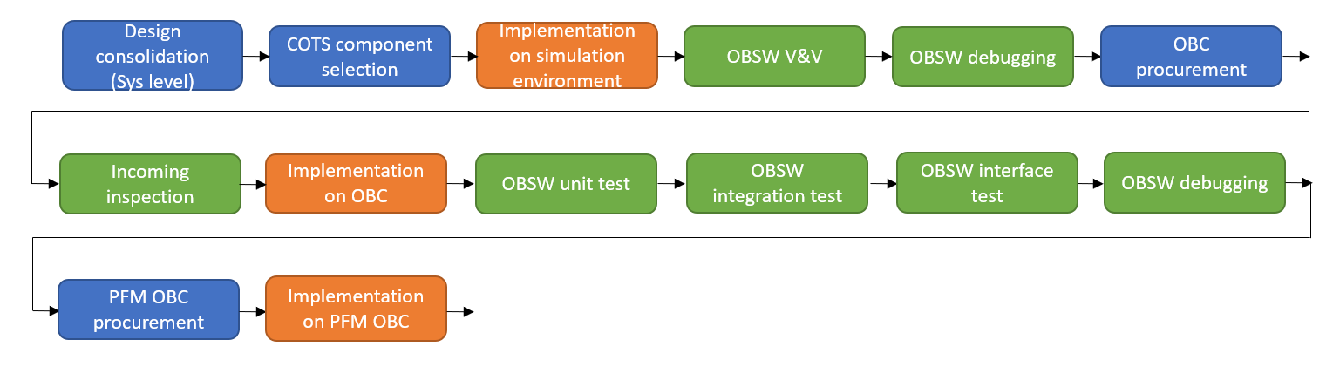

Figure : OBC and OBSW development process.

Figure shows the development process of the OBC and OBSW. After the consolidation of the design at system level, the selection of the COTS OBC is consolidated. The OBSW is implemented on a simulation environment on a PC. Here, the OBSW undergoes a V&V campaign and is debugged. In this fashion a first version of the OBSW is obtained.

The COTS OBC is procured to develop the software on a representative environment since the early stages of the development. After an inspection of the component, the OBSW is implemented on the OBC and the following tests are performed together with the debugging of the code:

* Unit test: test the single functions of the OBSW
* Integration test: test code blocks that are logically connected
* Interface: test the interaction between two software

Finally, the PFM OBC is procured, the OBSW is implemented on it and is integrated into the CubeSat before performing the system level environmental tests.

### CCR development process

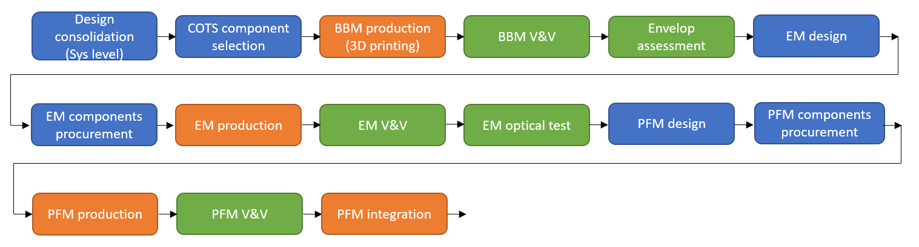

Figure : CCRs development process.

Figure shows the development process of the CCRs. After the consolidation of the design at system level, the selection of the COTS CCR is reviewed and confirmed. The EM is designed and the components are procured. The CCRs are purchased by specialized industries (e.g.,Edmund Optics) while the structure is produced in house using the facilities present at our university. A validation and verification test campaign is conducted on the EM and optical tests are performed.

The results are used to consolidate the design of the PFM. Once that the critical design is reached, the CCRs are procured and the structure is produced. After a validation and verification test campaign they are integrated in the PFM of the system. Environmental tests are performed at system level.

### IS, MVS and QPL development process

#### Impact Sensor model philosophy

**IS DEVELOPMENT MODEL (DM)**

The Development Model will be representative of interfaces, critical functionalities, materials and critical manufacturing processes.

The purpose of this model is to:

1. Verify the assembly and interfaces of the sensor, especially between the plate and the Detector
2. Verify the manufacturing limits for the Detector flexible PCB.
3. Verify the capability of the sensor to detect an impact in a relevant environment.
4. Verify the capability of the sensor to resist launch loads.

The DM will be composed of:

* a simplified version of the Detector (IS_DET);
* a mock-up of the Control Board (IS_CB) representative of the electrical interfaces;
* a FM equivalent Support Plate (IS_SP).

The DM IS_DET will be a flex PCB with 64 conductive stripes, with the same thickness and spacing as the Flight Model. This will allow the team to test the manufacturing limits of the PCB, while still being able to easily handle the prototype due to the reduced number of stripes. One line will be designed as already broken and one will be shorted on the IS_CB so that it cannot be broken. These lines will be used as a reference in the tests. The conductive stripes are arranged so that to cover the same sensitive area of the FM. This is required to have a high probability to collect an impact during the LGG tests. The external dimensions of the PCB will be the same as the FM, in order to test the physical interfaces of the detector with the CubeSat structure.

The IS_DET will be mounted on a Teflon support plate with a thickness of 3 mm and the same dimensions as the FM. It has rounded edges to verify the bending capability of the flex PCB as required for the FM since the detector will perform a bending of 180° with a radius of 1.5 mm. The plate has holes representative of the physical interfaces between the plate and the IS_DET (and with the CubeSat structure).

A bonding tape with low outgassing properties (3M 9460) ECSS‐Q‐ST‐70‐02C compliant will be used to fix the IS_DET to the IS_SP.

The IS_CB is represented by a breadboard with COTS EEE components representative of the functions of the Flight Model (FM) components. The DM IS_CB will still be based on an Arduino Uno board, which can simulate the data interfaces with the OBC that will be used in the FM. Table describes the different tests the DM will undergo.

Table : Test to be performed on the IS DM

|  |  |  |
| --- | --- | --- |
| **TEST** | **OBJECTIVE** | **FACILITY** |
| Functionality test | Verify the interface between IS_DET and IS_CB. Verify that a severed line is detected. | Laboratory |
| Vacuum |  | CISAS TVAC chamber |
| Hyper Velocity Impact | Verify the effects of HVI on the sensor assembly. Measure the dimension of craters created by HVI on IS_DET. | CISAS LGG |
| Random vibration  (DM Detector only) | Verify the capability of the assembly and, in particular, of the flex PCB lines to withstand launch loads. | CISAS shaker |

If all the tests are successful, this model will allow the Impact Sensor to reach TRL 4.

**IS ENGINEERING QUALIFICATION MODEL (EQM)**

The Engineering Qualification Model will be representative of the Flight Model in all its properties, components and interfaces, as it will be used for the qualification tests.

This means it will be composed of a full-scale Detector (440 lines), mounted on the support plate with a suitable bonding tape (possibly the same used in the DM, if the tests are successful), and a PC-104 Control Board embedding the multiplexer and demultiplexer, as well as the MCU selected for the FM. If all the tests are successful, the Impact Sensor will reach TRL 6.

Table : Test to be performed on the IS EQM

|  |  |  |
| --- | --- | --- |
| **TEST** | **OBJECTIVE** | **FACILITY** |
| Functionality test | Verify the interface between IS_DET and CB. | Laboratory |
| Thermo-vacuum | Qualification | ESEC thermo-vac chamber |
| Hyper Velocity Impact | Qualification | CISAS LGG |
| Vibration | Qualification | ESEC shaker |

#### Micro Vibration Sensor model philosophy

For what concern the MVS, the development model is described as reported in Figure . The new model philosophy has been updated to reduce the development effort.

The qualification model, QM, is the starting point to reach the TRL6 level for the payload and eventually obtain the flying model FM



Figure : Model philosophy for MVS payload

**MVS QUALIFICATION MODEL (QM)**

Since both the accelerometer and microprocessor are a proven technology, the first model produced will be the Qualification Model (QM). The MVS QM consists in a commercial three axis accelerometer that will be chosen after the consolidation of the design. The accelerometer is mounted on a PCB104 that also hosts a microprocessor for the data handling process. During the development of the payload it will be assessed if radiation mitigation has to be performed on the sensor. The QM undergo an environmental test campaign that will bring the MVS to a TRL of 6. The full functional tests will be performed or using the low friction table of the Space System Laboratory of the university or by suspend a mockup of the satellite. In both cases the aim is to decuple the system from any constraint that may change the mechanical response of the system. However, in both the test conditions the test results will be affected by gravity. So, the tests couldn’t be used to tune the sensor but to assess its functionality. The tests are reported in Table .

Table 68: tests to be performed on the MVS QM

|  |  |  |
| --- | --- | --- |
| **TEST** | **OBJECTIVE** | **FACILITY** |
| Interface test | Verify the interface between the MVS and the OBC | Lab |
| Functional Functional Tests | Assess the full functionality of the MVS QM. | LAB – low friction table or free-free configuration |
| Random vibration (qualification level) | Verify the capability of the MVS to withstand launch loads. | CISAS shaker |
| Thermo-vacuum test (qualification level) | Verify the MVS functionality in relevant environment | CISAS TermoVacuumChamber |

**MVS QUALIFICATION MODEL (FM)**

The MVS Flight Model is the model that will be integrated in the satellite. Hence, it has the same components of the QM. The same tests reported in Table will be performed on the FM but at an acceptance level.

#### Quantum payload model philosophy

The quantum payload will be developed by means of Development Model (TRL 4), Equivalent Qualification Model (TRL 6) and Protoflight model (PFM). The models will be realized by an external company called Dynamic Optics: the first one for end of October, and the second one for the beginning of the next Fly Your Satellite Programme. The Development Model will be used for performing and optimizing the functional tests. It will comprise the MRR and the driver for the MRR. The drive will not have the interface compliant to the FlatSat but will be realize with space qualifiable materials. The output knowledge obtained from performing test on that model will be used to create the EQM model. The EQM model will have a compliant interface with the FlatSat and will be used to perform the environmental test: vibrational, thermal-vacuum, shock, and electromagnetic compatibility.

This choice was made to simplify the development and save costs while accepting more risks in the development. In particular, with the DM model we will be able to:

* Understand the possible attainable improvements related to the development of a second (more reliable) version of the device
* Increase the reliability of the CCR once it will be mounted and tested in a real case scenario
* Understand the criticalities related to the development of a brand-new device.
* Validate and verify the requirements

With the EQM we will be able to produce a space-qualifiable component from the knowledge collected with the DM model.

With the completion of DM model a TRL 4 will be reached since the entire MRR apparatus will be proven working correctly, modulating an incoming optical signal within the chosen frequency range, showing the possibility of achieve an intensity modulation protocol with the proposed device.

## Manufacturing, Assembly & Integration, Preparation for Testing

At the time of writing the document, the team is consolidating the analyses performed for the sizing of the subsystems. The process will bring to the definition of the COTS components that will be purchased during the satellite development. In parallel, the team is sizing the mission payloads taking into consideration the manufacturing process. In this aim, the team is searching for industries to product the payloads. The manufacturing process, system assembly & integration procedures, testing and non-conformance process and reporting are not known to the team since they will be investigated in the next phases of the project, when the design is consolidated.

### Preparation for testing

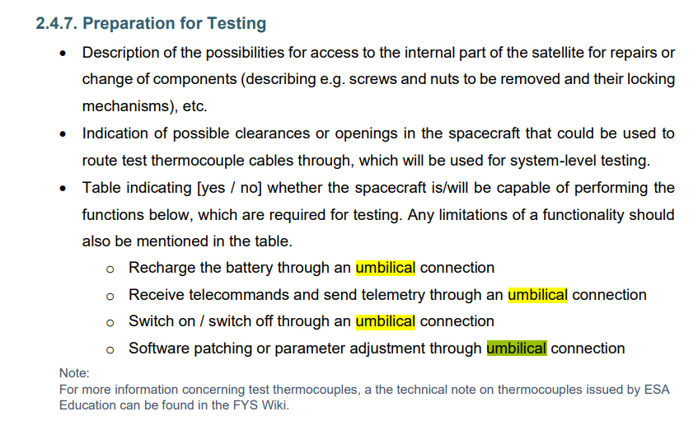

The internal part of the CubeSat can be accessed for repairs or change of components removing the six lateral solar panels, as shown in Figure .

In the current design, the CubeSat has two venting clearances that could be used to route test thermocouple cables through, positioned on the custom panel on the direction. Figure shows the two venting clearances on the CubeSat. The number and position of the venting clearances can be updated when the team will gather more information about the position of the thermocouples used for system-level testing.

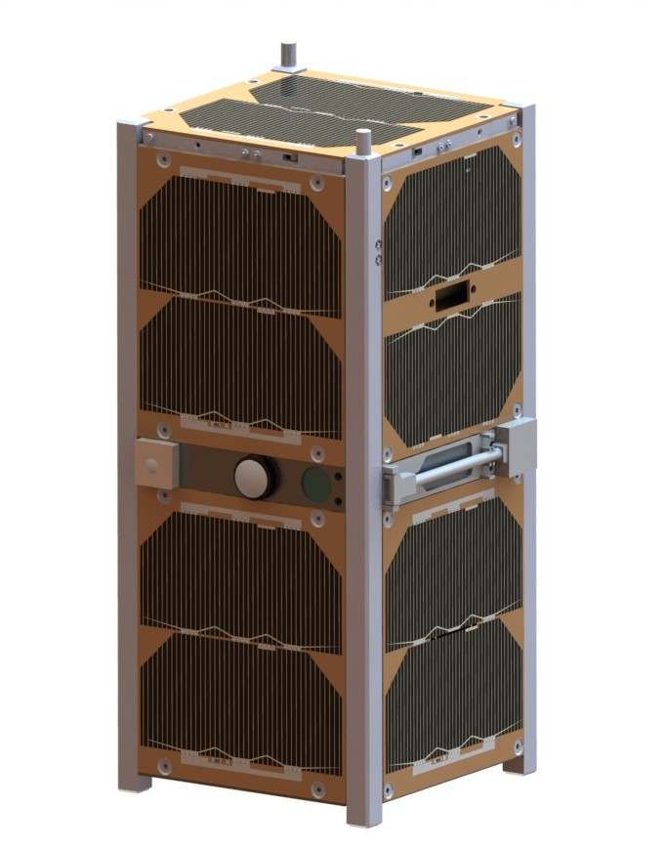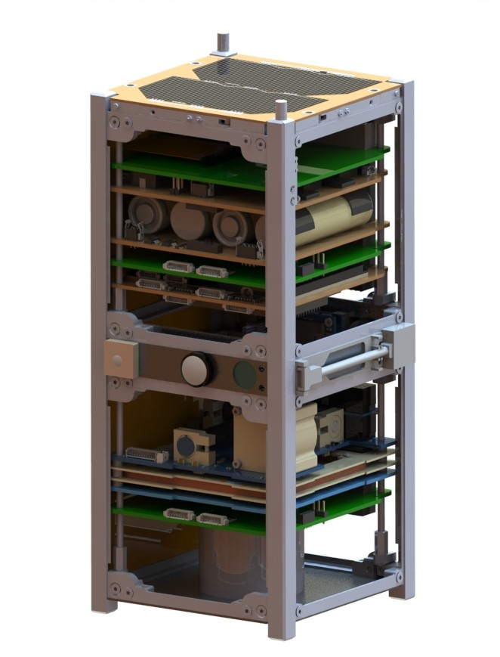

Figure : CubeSat with six solar panels removed.

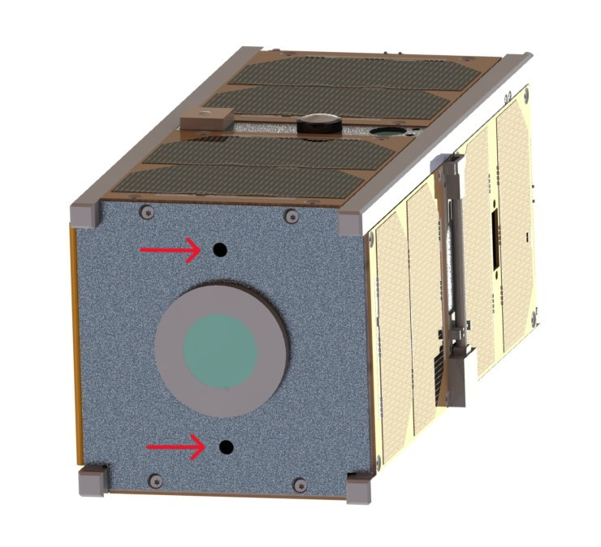

Figure : Position of the two venting clearances on the closeout custom panel on the direction, indicated by red arrows.

Table : Functions of the CubeSat useful for testing

|  |  |
| --- | --- |
| **Function** | **Is/will the CubeSat be capable of performing it?** |
| Recharge the battery through an umbilical connection | YES  (FDS-VCD 4.6.5) |
| Receive telecommands and send telemetry through an umbilical connection | YES  (FDS-VCD 4.6.4) |
| Switch on / switch off through an umbilical connection | YES |
| Software patching or parameter adjustment through umbilical connection | YES |

Accordingly to Table , OBC and EPS will be accessible when the CubeSat is fully integrated through an umbilical connection (FDS-VCD 4.6.2). The choice of the COTS umbilical connectors to OBC and EPS will be guided by the requirement of the FDS-VCD 4.7.3, so the cables will have a length greater than 3 m.

In order to fulfill requirement FDS-VCD 4.2.6 about the position of the umbilical connector, the team wants to use a custom solar panel built in accordance with DHV, with a hole for the umbilical connector at the center of the panel where solar cells are not housed, as shown in Figure . This solar panel will be placed on the face, near the EPS and OBC PCBs.

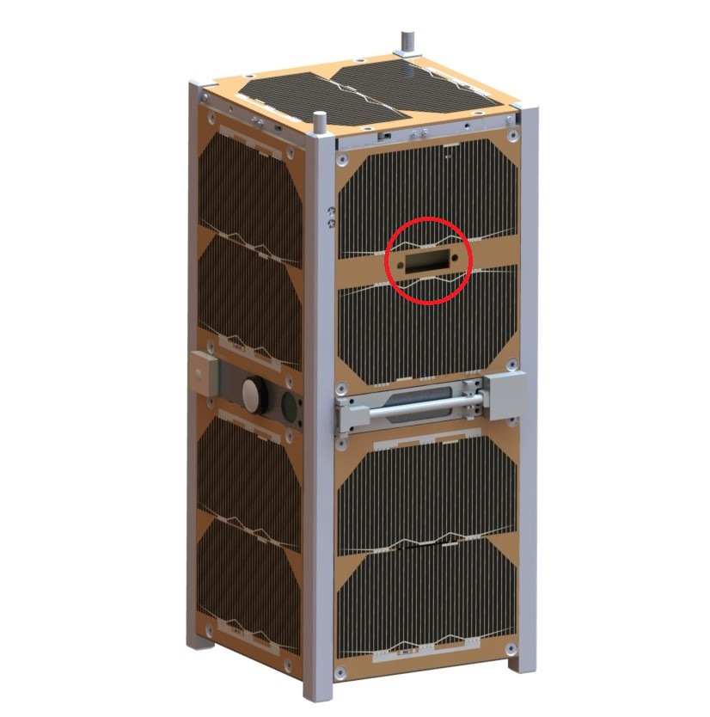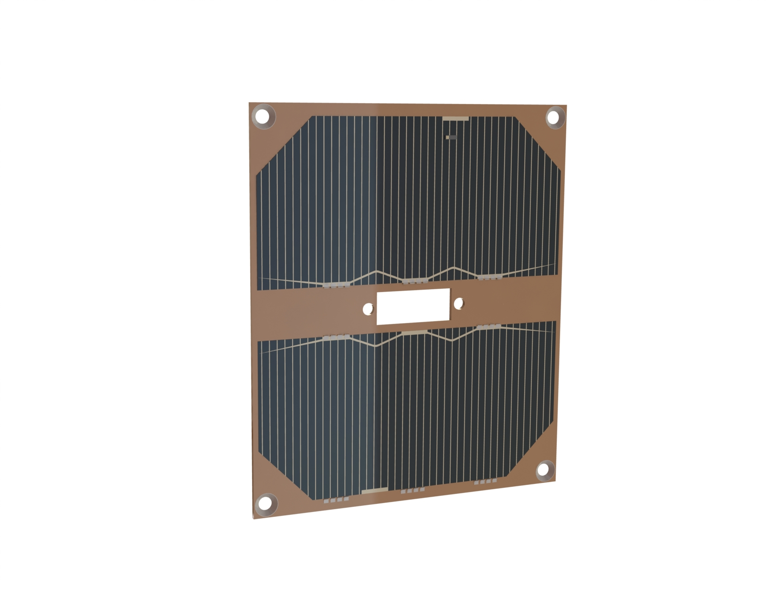

Figure : Position of the umbilical connection port on the solar panel on the face, inside the red circle

## Facilities

The University of Padova and, specifically, the Centre of Studies and Activities for Space “Giuseppe Colombo”(CISAS), has more than 30 years of experience in the design, development and testing of instruments for space missions (HASI for NASA Cassini Huygens, PFS for ESA Mars Express and Venus Express, WAC and NAC for ESA Rosetta, SIMBIO SYS for ESA Bepi Colombo, DREAMS for ESA Exomars) as well as the realization of technological demonstrators (autonomous robot MOLE, deployable antenna HILDRA, container MARS SAMPLE) and probes for missions with stratospheric balloons (HASI Balloon Missions 2002 and 2003, SORA Balloon Mission 2009). In these years CISAS has developed state-of-the-art laboratories for the realization and verification of instruments and payloads for scientific missions, for the integration of optics and mechanisms and for the simulation of hyper-fast impacts with space debris.

**Laboratories for the space qualification**

The laboratories, to which the team has access, host: clean rooms (class 10000 to class 100, in compliance with requirement FDS-VCD 4.7.1), climate chambers for thermovacuum tests with temperature control in the range of 80-420 K and control volume of about 1000 litres and electrodynamic shakers (maximum power up to 10 kN, frequency range 5-5000 Hz) capable of performing mechanical tests with sinusoidal excitation, random and shock. The laboratories are situated in Padova in the same building of the Space System Laboratory, in which the FlatSat will be developed. Appendix B reports the figures of the facilities.

**Laboratories hyper-velocity impacts**

In the past decades a hyperfast impact generation facility based on a two-stage light gas accelerator (LGG) has been developed. To date, the CISAS Hyperspeed Laboratory is a European benchmark in its field and has been involved in numerous studies conducted under EU contracts, with ESA, ASI and several companies operating in both the space and defense fields.

The gun can accelerate projectiles up to 100 mg (metal or plastic material with a maximum diameter of 12 mm) to a maximum velocity of 5.5 km/s. The gun features a vacuum chamber capable of reach a maintain pressure between 0.01 bar and 1 bar. The facility is situated in the surrounding of the Department of Industrial Engineering in which the team is based.

**QuantumFuture facilities**

The QuantumFuture group has available seven state-of-the-art laboratories. Relevant to the project are the following tools: optical ground station and telescopes for free-space link tests and demonstrations including a 320 mm reflector and a 320 and 120 mm refractors; free-space and fiber optics components; several pulsed and continuous wave diode lasers; a high power mode-locked Ti:Sa laser; a high power mode-locked Yb amplified laser system, several single photon detectors including SNSPD, SPAD with large active area (diameter of 200 micron); several time tagging units up to 1 ps temporal resolution; heralded photon sources by Spontaneous Parametric Down Conversion; FPGA controllers with programming and fast analog electronics; testing rig for fiber to photonics chip coupling and testing.

The QuantumFuture group can count on the facilities provided by the University of Padua, such as cleanroom and mechanical workshop plus seven research laboratories equipped with scientific grade optical tables. QuantumFuture has close collaboration with other Research Groups at the Department of Information Engineering, doing research on telecommunications, control system theory, photonics, microelectronics.

Moreover, the company Officina Stellare S.p.A. has granted an in-kind support, thanks to its long-term collaboration with QuantumFuture, for accessing to its facilities (thermal vacuum chamber and clean room).

## Ground Support Equipment (GSE)

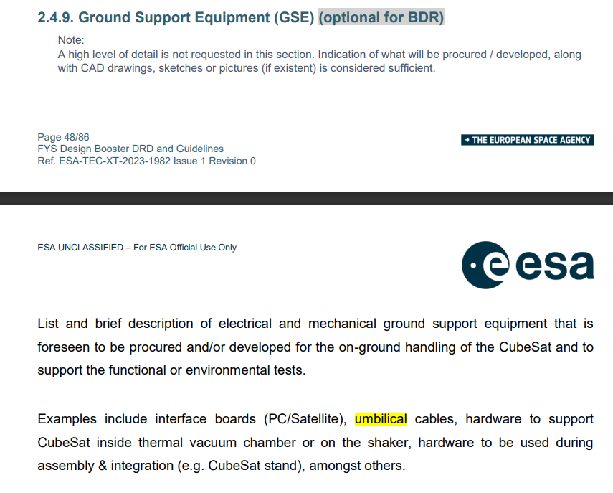

The GSE will consist of two main components: the Mechanical Ground Support (MGSE) and the Electrical Ground Support Equipment (EGSE).

1. **MGSE**

1.1. The MGSE will serve as the mechanical interface to establish a stable working environment during integration and testing, and to protect the satellite sub-systems from Electrostatic Discharges (ESD). Various Commercial Off-The-Shelf (COTS) solutions are available for MGSE on the market. However, at the moment, an in-house built solution cannot be excluded due to budget constraints.

**2. EGSE**

2.1. Power Supply Unit (PSU); The PSU provides stable power to the CubeSat during testing, and should have adjustable voltage and current settings for different test scenarios.

2.2. Computer

2.3. CSP-Term installed on the computer; CSP-Term is freely available and is needed to run the GomSpace Shell (GOSH), necessary to interface with EPS (P31u) and OBSW (A3200). For example, for the P31u, the P31u commands can be executed from several different sources, depending on where you have access to a GOSH shell. Whether issuing from the Ground-station, TNC or OBC, the underlying CSPprotocol will ensure to route the commands correctly to the P31u and back again.

2.4. Umbilical cables (specificare che tipi/ a che pin si connettono??)

2.5. Cose che simulano GS o comunque necessarie per testare TTC???

# Project Management Plan

## Organigram

Team Leader

|  |  |
| --- | --- |
| *Name* | Federico Basana |
| *Job title or level of studies* | PhD student |
| *University* | Università degli Studi di Padova |
| *Department* | Centre of Studies and Activities for Space “Giuseppe Colombo” (CISAS) |

Endorsing Professor

|  |  |
| --- | --- |
| *Name* | Alessandro Francesconi |
| *Job title or level of studies* | Professor |
| *University* | Università degli Studi di Padova |
| *Department* | Department of Industrial Engineering |

System Engineers

|  |  |
| --- | --- |
| *Name* | Stefano Polese |
| *Job title or level of studies* | MCs |
| *University* | Università degli Studi di Padova |
| *Department* | Department of Industrial Engineering |
| *Name* | Sofia Farinella |
| *Job title or level of studies* | MCs |
| *University* | Università degli Studi di Padova |
| *Department* | Department of Industrial Engineering |

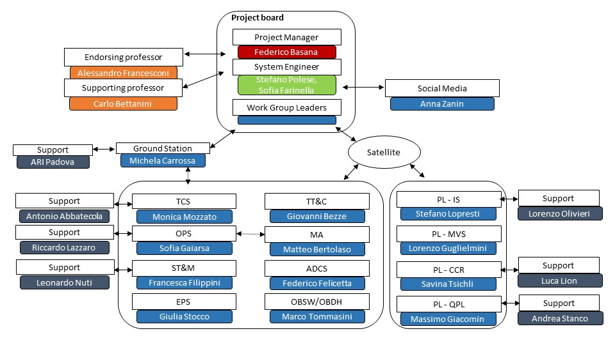

Figure : Scheme of the team organization.

The team by a total of 81 students. The team members have been divided in small workgroups; each one focuses on a subsystem of the satellite. The subsystem workgroups are led by experienced students (Master level) and, possibly, supported by an expert of the university. The group that are supported by an expert are reported in **Errore. L'origine riferimento non è stata trovata.** where a brief presentation of the supporting experts is provided.

Table : Team supporting experts

|  |  |  |
| --- | --- | --- |
| **Work group** | **Supporting expert** | **Brief presentation** |
| PL – IS | Lorenzo Olivieri | Dr. Lorenzo Olivieri is a research fellow at the Center of Space Studies and Activities "Giuseppe Colombo" of the University of Padova. He got a PhD in Measures for Space in 2015, with a thesis on small satellites docking. His research activities are in the field of space debris protection and remediation and small satellites technologies. |
| PL – CCR | Luca Lion | Mr. Luca Lion is a PhD student at CISAS, University of Padova. His research activity are focuses on the inspection and image reconstruction on space debris. Additionally, he is developing a docking system for CubeSats. He collaborated in the foundation of the project and he is part of it from the start of the activities. |
| PL – QPL | Andrea Stanco | Dr. Andrea Stanco got his master’s degree in Electronic Engineering in 2014 and a Ph.D. in Information Engineering in 2019 under the supervision of Prof. Paolo Villoresi. His thesis works focused on Field Programmable Gate Array systems for Quantum Communication and Quantum Random Number Generation applications. Currently, he is a Research Fellow (RTDA) in Electronics at the Department of Information Engineering and he is working on Digital Electronics for Quantum Communication and Quantum Computing. His interests also cover Satellite Quantum Communication, Radiation and Electronics for Space. |
| TCS | Antonio Abbatecola | Mr. Antonio Abbatecola is a PhD student in the Department of Industrial Engineering at the University of Padova. In 2019, he obtained the bachelor degree in mechanical engineering from the University of Cassino, followed by a master degree in energy engineering from the University of Padova in 2022. Currently, his research interests lie in the field of thermodynamics and heat transfer (also for space applications), with a focus on the topic of dropwise condensation. |
| Ground Station | ARI Padova | The ARI Padova is a group of radioamateurs of Padova. They have experience in radio communication in radioamateurs band and in the realization of ground stations. Beside the technical aspects, they know the national and international laws concerning the radio communication. In addition, they organize preparation courses for taking the radioamateurs licence. |

Together with the system engineers and the project manager, the workgroup leaders form the board of the project. The project manager is the founder of the team and currently is a PhD student. The team is supported by the professor Alessandro Francesconi (endorsing professor) who holds the courses of Aerospace Systems and Satellite Attitude Control and by the professor Carlo Bettanini Fecia di Cossato who holds the course of Aerospace Flight Dynamics. The project collaborates with a University project from the department of Information Engineering called QuantumFuture which is responsible for the development of the quantum payload. In addition, it collaborates with the radioamateurs of Padova (ARI Padova) which offered to share their knowledge to support the development of the GS of the University.

The students dedicate at least one day per week to the project development. In order to make the most of their experience in the team, students are invited to develop their thesis in the framework of the project. In this manner, students can work full-time to the project for the period of their thesis (~ 6 months). The students that are developing/ are going to develop their thesis in the framework of the project are reported in Sec. 5.4. **Errore. L'origine riferimento non è stata trovata.** reports the team members names, their field and level of studies, the developing of a thesis in the framework of the project, the work group and the WP to which they are assigned and their role inside the work group.

The team board meet every week to discuss the status of the project. Each work group leader exposes the development status of the payload/subsystem, eventual changes in the design are discussed and the tasks to be achieved are consolidated and assigned. In this fashion, not only the project manager but also the work group leaders are constantly updated on the status of the project.

Table : List of members of the project.

|  |  |  |  |  |  |
| --- | --- | --- | --- | --- | --- |
| **Name** | **Surname** | **Level** | **Thesis** | **Group** | **Role** |
| Giacomo | Battaglia | MCs | N | PL - IS | PL development responsible |
| Samuele | Enzo | MCs | N | PL - IS | PL development responsible |
| Giovanni | Trevisanuto | MCs | N | PL - IS | IS development |
|  |  |  |  |  |  |
| Federico | Marin | MCs | N | PL - IS | IS development |
| Andrea | Vittadello | BCs | N | PL – IS | IS development |
| Lorenzo | Olivieri | PhD | N | PL - IS | Supervisor |
| Lorenzo | Guglielmini | MCs | N | PL - MVS | PL development responsible |
| Zhilong | Zhou | BCs | N | PL - MVS | MVS development/ electric |
| Nunzio | Micali | MCs | Y | PL - MVS | MVS development |
| Leonardo | Brunettin | MCs | Y | PL - CCR | PL development responsible |
| Elena | Pilone | MCs | N | PL - CCR | CCR development |
| Luca | Lion | PhD Student | N | PL - CCR | Supervisor |
| Federico | Berra | PhD Student | N | PL – QPL | QPL external consultant |
| Massimo | Giacomin | PhD Student | N | PL – QPL | QPL development responsible |
| Luca | Massaro | PhD Student | N | PL-QPL | MRR development expert |
| Laura Marie | Schulze | MCs | N | PL-QPL | QPL test/simulation |
| Andrea | Stanco | PhD, RTD-A | N | PL - QPL | Supervisor |
| Vittorio | Bonato | MCs | Y | ADCS | Development responsible |
| Giulia | Stocco | MCs | N | EPS | Development responsible |
| Martina | Imperatrice | MCs | N | EPS | EPS development |
| Marco | Ghedin | MCs | N | EPS | EPS development |
| Michela | Carrossa | MCs | N | GS | Development responsible |
| Sepideh | Sepehri | BCs | N | GS | GS development |
| Maria | Bazzicalupo | MCs | N | GS | GS development |
| Ilaria | Calzia | MCs | N | GS | GS development |
| Riccardo | Lazzaro | MCs | Y | MA/CON-OPS | Development responsible |
| Sebastiano | Buson | MCs | N | MA | MA simulations |
| Matteo | Bertolaso | MCs | N | MA | MA simulations |
| Federico | Semenzato | PhD student | N | MA | MA simulations |
| Francesco | Fontanot | MCs | N | MA | External consultant |
| Marco | Tommasini | MCs | N | OBSW/OBDH | Development responsible |
| Edoardo | Bortolozzo | MCs | N | OBSW | Software development |
| Filippo | Donegà | MCs | N | OBSW | Software development |
| Francesca | Filippini | MCs | Y | ST&M | Development responsible |
| Leonardo | Nuti | MCs | N | ST&M | CAD and structural analyses |
| Jacopo | La gamba | BCs | N | ST&M | CAD and structural analyses |
| Stefano | Polese | MCs | N | System Eng. | Responsible |
| Sofia | Farinella | MCs | N | System Eng. | System engineering |
| Monica | Mozzato | MCs | Y | TCS | Development responsible |
| Mattia | Martello | MCs | Y | TCS | Thermal analyses |
| Antonio | Abbatecola | PhD student | N | TCS | Supervisor |
| Giovanni | Bezze | MCs | N | TT&C | Development responsible |
| Riccardo | Miglietta | MCs | Y | TT&C | TTC development |
| Fattokh | Sadriddinov | MCs | N | TT&C | TTC development |

## Handover plan

During its activities, the team has carried out a recruitment activity every year. The recruitments are organized as follows:

1. The recruiting is promoted by posters and social media posts.
2. A presentation is organized in dual mode (telematic mode and in presence) to give an overview of the project and show the future activities.
3. A meeting between the board of the team and the new members is scheduled.

Usually, the new members of the team lack of both knowledge on space missions and practical experience. In order to fill the gaps, peer tutoring activities are conducted with the experienced members of the team. In addition, dedicated webinars are organized to help the new members dealing with the mission. Information on mission objectives, mission phases, project management, work organization, are provided in the webinars. In addition, Alba CubeSat UniPD uses a Microsoft Teams where information on the project is stored. Here, every member has free access to project documentation, ESA training weeks presentations and useful scientific literature.

## Cost Budget

The cost breakdown of the mission is presented in this section. It is divided for the three model that the team will realise during the project.

### FlatSat EM

In the breakdown of the cost of the FlatSat EM are considered the cost the realization of both the DM and EQM of the IS, MVS and QPL. A 20% margin is applied at subsystem and system level since the design of the FlatSat EM will be defined in the next steps of the project. The facility rent cost has been evaluated considering a rental cost per day equal to 1000 euros and multiplying it for the expected test days (10). The cost breakdown of the FlatSat EM and of the development of the payloads DM and PFM is shown in Table .

Table : Cost breakdown for the realization of the FlatSat EM and the development of the DM and EQM model of the payloads.

|  |  |  |
| --- | --- | --- |
| **SubSystem/Payload** | **Cost [euros]** | **Cost + 20% margin [euros]** |
| ADCS | 3.000 | 3.600 |
| EPS | 1.000 | 1.200 |
| OBC | 5.000 | 6.000 |
| ST&M | 200 | 240 |
| TTC | 1.000 | 1.200 |
| IS DM | 1.000 | 1.200 |
| MVS DM | 1.000 | 1.200 |
| QPL DM | 1.000 | 1.200 |
| IS EQM | 10.000 | 12.000 |
| MVS EQM | 5.000 | 6.000 |
| QPL EQM | 10.000 | 12.000 |
| Facility rent | 10.000 | 12.000 |
| Ground Support Equipment | 1.000 | 1.200 |
| Total | 50.100 | 60.120 |
| Total + 20% |  | 72.144 |

### ProtoFlight Model (PFM)

The PFM of AlbaSat will not be realized during the Fly Your Satellite! – Design Booster programme. The cost breakdown of each subsystem/payload is reported in Table . The values reported are taken considering the prices provided by the quotations. A 10% margin is considered at system level.

In the cost breakdown, the expected facility rent costs and experts counsellors costs are considered. The first are evaluated estimating a rental cost per day equal to 1000 euros and multiplying the value for the expected day amount (50) to test the payloads FM and the system PFM; the latter are evaluated considering the cost of a specialized manhour equal to 50 euros, so allocating fundings for 500 hours of consultancy. These values are obtained considering the worst-case scenario in which the team has to rent the facilities for the tests.

However, the team can count on the facilities already present at the University of Padova for the tests. In addition, the team plans to perform some of the tests required at the facilities that ESA provides to CubeSat student team as already done to test the IS. In addition, since the PFM components that are used in the EM are going to be used for assembly AlbaSat, the COTS components will not be bought again. The only reason for buying a new COTS component is the case in which one of the ones used in the FlatSat is needs to be changed (e.g., not working, not compliant). Hence, Table reports the worst case in which the team has to buy again all the components of AlbaSat.

Table : Cost breakdown for the realization and test of the PFM.

|  |  |  |
| --- | --- | --- |
| **SubSystem/Payload** | **Cost** | **Cost + 20% margin** |
| ADCS | 40.000 | 48.000 |
| EPS | 70.000 | 84.000 |
| OBDH | 10.000 | 12.000 |
| OBSW | 50.000 | 60.000 |
| ST&M | 3.000 | 3.600 |
| TTC | 20.000 | 24.000 |
| IS | 30.000 | 36.000 |
| MVS | 5.000 | 6.000 |
| CCR | 10.000 | 12.000 |
| QPL | 30.000 | 36.000 |
| Ground Support Equipment | 5.000 | 6.000 |
| Facility rent | 50.000 | 60.000 |
| Experts Counsellors | 25.000 | 30.000 |
| Total | 348.000 | 417.600 |
| Total+10% |  | 458.700 |

### Ground Station

Only one model of the GS will be realized. During the realization, the team will rely on the advice of the radioamateurs. A margin of 10% is considered at components level and at system level since the design is consolidated but the components are not ordered yet, hence the price may change. The VAT is considered in the prices reported.

Table : Cost breakdown of the realization of the GS.

|  |  |  |
| --- | --- | --- |
| **GS SubSystems** | **Cost [euros]** | **Cost + 10% margin [euros]** |
| Antenna | 620 | 872 |
| Rotator | 826 | 908 |
| LNA | 20 | 22 |
| SDR | 80 | 88 |
| RF switch | 194 | 213 |
| Amplifier | 200 | 220 |
| Cables | 100 | 110 |
| Bandpass filter | 100 | 110 |
| Structure | 200 | 220 |
| Total | 2513 | 2764 |
| Total+10% |  | 3040 |

### Project funding

The expected cost during the FYS!-DB programme are:

|  |  |  |
| --- | --- | --- |
|  |  | € |
| Ground station realization | 3.040 | € |
| FlatSat EM realization + payloads DM | 18.120 | € |
| Payloads EQMs realization and test | 42.000 | € |
| Total | 65.312 | € |

The team has asked for a funding of 5.000 euros to the Department of Industrial Engineering. These will cover the majority of the costs for the development of the GS and the FlatSat BBM. The team is going to ask for a funding to the University of Padova in the framework of the call for innovative student project. The expected funding that the team will gain is 15.000 euros, that will be used to cover the majority of the expenses for the realization of the FlatSat EM and the payloads DM. In this fashion the team will have the funding to reach the TRL 4 of the payloads and the FlatSat EM, which will permit to consolidate the design of the spacecraft. The costs for the development and testing of the EQMs of the payloads are not covered by the budget of the team. This is a point of concern of the project, so a first search for sponsors has been initiated. Among others, the team expects to receive contributions from the Regione Veneto and from a variety of local industries that could be involved in the project.

## Academic outputs

The thesis produced in the framework of the project are reported in Table . Table reports the thesis that are being produced at the time being.

Table : Thesis produced in the framework of the project.

|  |  |  |
| --- | --- | --- |
| **Name Surname** | **Level** | **Title** |
| Nunzio Micali | MSc | Development of a sensor for microvibrations measurement in the AlbaSat CubeSat mission |
| Riccardo Miglietta | MSc | Design of a FlatSat for the AlbaSat mission |
| Vittorio Bonato | MSc | Development of the ADCS of a 2U CubeSat |
| Riccardo Lazzaro | MSc | Design and development of AlbaSat satellite operation |
| Leonardo Brunettin | MSc | Sviluppo di un payload per nanosatelliti per determinazione orbitale e di assetto attraverso laser ranging |
| Laura Callegari | BSc | Alba CubeSat: determinazione orbitale precisa attraverso Satellite Laser Ranging |
| Mattia Martello | BSc | Studio preliminare del sottosistema di controllo termico di un CubeSat 2U |
| Francesca Filippini | BSc | Progettazione strutturale preliminare di un CubeSat 2U |
| Mattia Sartor | BSc | Analisi dell’ambiente micro-vibrazionale su un CubeSat 2U |
| Enrico Bez | MSc | Sviluppo di un sensore per CubeSats per la rilevazione di impatti di piccoli detriti spaziali |

Table : Thesis under development/ future thesis in the framework of the project.

|  |  |  |  |
| --- | --- | --- | --- |
| **Name Surname** | **Level** | **Argument** | **Under Development (UD)/Expected (E)** |
| Monica Mozzato | MCs | Thermal Control of the spacecraft | UD |
| Vittadello Andrea | BCs | Thermal test on the impact sensor | UD |
| Stefanon Francesco | BCs | FMEA of AlbaSat | UD |
| Farinella Sofia | MCs | FMEA of AlbaSat | E |
| Francesca Filippini | MCs | Structural analyses of AlbaSat | E |
| Federico Basana | PhD | Development and management of AlbaSat | UD |
| Luca Lion | PhD | Development of CCR for AlbaSat mission | UD |
| Stefano Lopresti | PhD | Development and test of the Impact Sensor | E |
| Samuele Enzo | PhD | Development and test of the Impact Sensor | E |

The team has published an article at the 4th Symposium on Space Educational Activities [1]. Two papers [2,3] have been published at the International Astronautical Congress (IAC) 2023 that that was held in Baku. An article will present the development of the impact sensor and the preliminary results of the tests executed to reach TRL4, another one will present the environmental test campaign performed at ESEC on the impact sensor. An abstract that present the AlbaSat mission has been submitted to the 4S symposium, while two abstracts have been submitted to the International Astronautical Congress (IAC) 2024 that will be held in Milan. One presents the CCR payload while the other present the lessons learned from the FYS!-DB programme. The team has presented a poster in the “Giornata Nazionale dello Spazio" 2023 (Appendix A).

The team aims at publishing in scientific journal once that the design is consolidated and the first results from tests are obtained. Specifically, the papers will present (1) the AlbaSat mission, (2) the micro-vibrations sensor and (3) the QuantumPayload.

[1] Basana, F., et al., Development of a multi-payload 2U CubeSat: the Alba project. A: "4th Symposium on Space Educational Activities". Universitat Politècnica de Catalunya, 2022, 10.5821/conference-9788419184405.084

[2] F. Basana, L. Lion, G. Battaglia, F. Berra, S. Enzo, M. Mozzato, L. Guglielmini, R. Lazzaro, L. Nuti, L. Olivieri, A. Stanco, A. Francesconi, AlbaSat: an educational satellite for a multi-objectives mission in LEO, 74th International Astronautical Congress (IAC), Baku, Arzebaigian, 1-7 October 2023

[3] G. Battaglia, S. Enzo, G. Trevisanuto, S. Lopresti, F. Marin, G. Bezze, L. Olivieri, F. Basana, A. Francesconi, A CubeSat-sized in-situ space debris impact sensor, 74th International Astronautical Congress (IAC), Baku, Arzebaigian, 1-7 October 2023

[4] M. Mozzato, S. Enzo, R. Lazzaro, M. Minato, G. Bemporad, D. Visentin, F. Filippini, A. Dalla Via, A Farina, E. Pilone, F. Basana, L. Olivieri, G. Colombatti, A. Francesconi, Concept and feasibility analysis of the Alba CubeSat mission, AIDAA XXVII International Congress, 4-7 September 2023, Padova

## Outreach

Currently, the team has the following accounts on the social media:

Instagram: @albacubesat

LinkedIn: Alba CubeSat Unipd

The team has decided to use Instagram as main communication platform since it is used by the majority of the high school and university students. Therefore, a large number of students can be acknowledged of the activities of the team. The Instagram account will not only be used for showing the project but also for presenting space mission, with a focus on CubeSat mission and curiosities on space environment. The team goal is to create an Instagram post and a story every week.

The team has got in contact with the communication office of the Department and of the University to enhance the sharing of the social media posts and to produce articles to present to the public the AlbaSat mission and the activities of the team. A page dedicated on the project is under construction on the Department webpage. The webpage not only will present the project but will provide information as, for instance, how to join the team, thesis opportunities, participation to events. In addition, students can interact with the team through a dedicated forum on the page.

The team has already participated to communication activities and other events are planned in future. Table reports the events and their date.

Table : Events in which Alba CubeSat UniPD has participated/ are going to participate.

|  |  |  |
| --- | --- | --- |
| **Name** | **Description** | **Date** |
| NEXT – il festival di ingegneria | Open stand to present the activities of the project to the University students. | 20-21/10/2021 |
| NEXT – il festival di ingegneria | Open stand to present the activities of the project to the University students. | 11-13/05/2023 |
| Scegli con noi | University open day for high school students | 14/02/2023 |
| Open day DII | Department open day for high school students that are interested in the aerospace engineering studies | 24/03/2023 |
| StoryTime | Participation to a radiophonic program to present the AlbaSat mission | 20/05/2023 |
| Space System Laboratory | Laboratory course where the lessons learned from the Alba CubeSat UniPD project are transmitted to students through a hand-on experience that will retrace the 0/A phases of the mission. | 28/02/2023 to 06/06/2023 |
| Italian Association of Aeronautics and Astronautics (AIDAA) XXVII conference | Presentation of the mission to the AIDAA conference | 04/09/2023 to 07/09/2023 |
| European Researchers Night | Public event to present the research activity of the project | 30/09/2023 |
| International Astronautical Congress (74th IAC) | Present the AlbaSat mission at the International Astronautical Congress in Baku. | 01/10/2023 to 08/10/2023 |
| 3rd National Space Day | Presentation of the AlbaSat mission at the Italian Ambassy in Berlin | 28/11/2023 |
| National Space Day | Presentation of the AlbaSat mission in occasion of the national space day at Officina Stellare | 18/12/2023 |

# Legal & Regulatory Compliance Plan

## List of international treaties ratified by Italy

According to the *Status of International Agreements relating to activities in outer space as at 1 January 2023* ([AC105_C2_2023_CRP03E.pdf (unoosa.org)](https://www.unoosa.org/res/oosadoc/data/documents/2023/aac_105c_22023crp/aac_105c_22023crp_3_0_html/AC105_C2_2023_CRP03E.pdf)) Italy has ratified the following international treaties:

**A. United Nations treaties:**

* 1967 OST Treaty on Principles Governing the Activities of States in the Exploration and Use of Outer Space, including the Moon and Other Celestial Bodies
* 1968 ARRA Agreement on the Rescue of Astronauts, the Return of Astronauts and the Return of Objects Launched into Outer Space
* 1972 LIAB Convention on International Liability for Damage Caused by Space Objects
* 1975 REG Convention on Registration of Objects Launched into Outer Space

**B. Other agreements**

**General**

* 1963 NTB Treaty Banning Nuclear Weapon Tests in the Atmosphere, in Outer Space and under Water
* 1974 BRS Convention Relating to the Distribution of Programme-Carrying Signals Transmitted by Satellite

**Institutions**

* 1971 ITSO Agreement Relating to the International Telecommunications Satellite Organization (ITSO)
* 1975 ESA Convention for the Establishment of a European Space Agency (ESA)
* 1976 IMSO Convention on the International Mobile Satellite Organization
* 1982 EUTL Convention Establishing the European Telecommunications Satellite Organization (EUTELSAT)
* 1983 EUM Convention for the Establishment of a European Organization for the Exploitation of Meteorological Satellites (EUMETSAT)
* 1992 ITU International Telecommunication Constitution and Convention

## National registry of space objects launched into outer space

In 1975, Italy acceded to the 'Convention on Registration of Objects Launched into Outer Space' (commonly referred to as the '1975 REG'), which was formalized through Italian Law No. 153 on July 12, 2005. The primary purpose of the Registration Convention is to facilitate the identification of space objects. It requires contracting States, in accordance with methods they can autonomously define, to establish a national registry of objects launched into space and to provide the information stipulated in Article IV of the Convention to the Secretary-General of the United Nations.

Italian Law No. 153/2005 assigns ASI (Italian Space Agency) the task of establishing and maintaining the national registry of objects launched into space.

The updated version of the national registry of Italian objects launched into space is available on the [ASI website](https://www.asi.it/lagenzia/risorse_informative/registro-nazionale-degli-oggetti-lanciati-nello-spazio/informazioni-sul-registro-nazionale-degli-oggetti-lanciati-nello-spazio-2/) [*link verified 24 September 2023*].

To register a space object, it is necessary to submit the [**required form**](https://www.asi.it/wp-content/uploads/2023/04/Nuovo-Modulo-immatricolazione-oggetti-lanciati.docx) [*link verified 22 October 2023*] through the certified email address (PEC) [**registronazionale@asi.postacert.it**](mailto:registronazionale@asi.postacert.it).

## National space law

Italy currently lacks a comprehensive space law, as emphasized by Giorgio Saccoccia, the President of the Italian Space Agency (ASI) during the 2023 activity presentation press conference. While governance aspects in the space sector are already regulated, there is a critical absence of legislation regarding space activities.

As of today, the space-related laws enacted by Italy are[2]:

* Law No. 23, 25 January 1983: Norms for the implementation of the Convention on International Liability for Damage Caused by Space Objects signed in London, Moscow and Washington on 29 March 1972 (Official Gazette, General Series, No. 35, 5 February 1983)

[Italian version](https://www.gazzettaufficiale.it/eli/id/1983/02/05/083U0023/sg) (external link) [link verified 24 September 2023]

* Law No. 153, 12 July 2005: Accession of the Italian Republic to the Convention on Registration of Objects Launched into Outer Space (New York, 14 January 1975) and its implementation (Official Gazette, General Series, No. 177, 1 August 2005).

[Italian version](https://www.gazzettaufficiale.it/eli/id/2005/08/01/005G0174/sg) (external link) [link verified 24 September 2023]

* Law Decree No. 128, 4 June 2003, Reorganization of the Italian Space Agency (A.S.I.)

[Italian version](https://www.asi.it/wp-content/uploads/2019/11/d-lgs-128-2003-agg-18-09-2018.pdf) (external link) [link verified 24 September 2023]

* Law No. 7, 11 January 2018: Measures for the coordination of space and aerospace policy and provisions concerning the organization and operation of the Italian Space Agency (18G00025) (Official Gazette, General Series, No. 34, 10 February 2018)

[Italian version](https://www.gazzettaufficiale.it/eli/id/2018/2/10/18G00025/sg) (external link) [link verified 24 September 2023]

## Governmental interfaces

The appropriate governmental entity responsible for communication with international organizations in Italy would primarily be the **Ministry of Foreign Affairs and International Cooperation** (Ministero degli Affari Esteri e della Cooperazione Internazionale). This ministry typically handles diplomatic relations and international communications on behalf of the Italian government, including those related to space activities and international space organizations such as the United Nations Office for Outer Space Affairs (UNOOSA).

However, the **Italian Space Agency** (Agenzia Spaziale Italiana or ASI) also plays a significant role in representing Italy's interests in space-related matters at the international level. ASI collaborates with various international space agencies and organizations, including the European Space Agency (ESA) and UNOOSA, to promote Italy's participation in space activities and initiatives.

MISE DGTCSI-ISCTI (**Ministry of Enterprises and Made in Italy**, also called MIMIT) is the national guarantor of the frequency coordination requests towards ITU (International Telecommunication Union).

## Legal practices and required administrative procedures

Legal practices and administrative procedures required to comply with the regulatory aspect of the satellite mission can be summarized as follows:

1. State authorization, as delineated in article VI of Outer Space Treaty. In cases where national space legislation is absent or ambiguous, a clarification of the situation with the government becomes imperative to ensure compliance.
2. Registration of the CubeSat after the launch. Initially, a national registration through the ASI (Italian Space Agency) is mandatory. Subsequently, ASI will proceed to report the registration to the United Nations.
3. Insurance, if mandated by Italian space law, must be secured to mitigate potential risks and liabilities associated with the mission.
4. Space debris mitigation.

In order to comply to the FDS-VCD requirement 4.12.8 “*CubeSat developers should register their satellite with the 18SPCS to help lessen the risk to all spacecraft by providing information to 18SPCS on launch and deployment plans”*, the team must register AlbaSat at Space-Track.org with 18 SDS as described at the following link: <https://www.space-track.org/documentation#odr> . The form to fill in order to register the CubeSat can be found [here](https://www.space-track.org/documents/New_Satellite_Registration_Form.docx). At the moment, the team is aware of the procedure to follow, but registration will be done only when there is a concrete launch opportunity selected, as recommended in the FDS.

Also, frequency registration is needed and the step-by-step procedure to follow is described here.

STEP 1: Preparing for Coordination

* Confirm compliance with ITU Radio Regulations Article 25 for Amateur Services.
* Contact the national telecommunication administration (MISE) with proof of radio-amateur license of the ground station operator. The national telecommunication administration will make a proposal for use of a specific frequency band;
* Coordinate with IARU: Identify ground station with its own call sign and appropriate Licensee (if the ground station call sign does not exist yet, it shall be obtained from MISE), request amateur call sign for the spacecraft at MISE, define frequencies, and inform national and international interfaces.

STEP 2: ITU Advance Publication of Information (API) (minimum 2 years and maximum 7 years before launch)

* Prepare API using ITU software (SpaceCap) and submit it to the national telecommunication administration. The Bureau, 2 months later, will then publish an API/A special section in its International Frequency Information Circular.
* After 4 months API/B will be published, if needed, by ITU Bureau and any issues/comments raised by other administrations must be addressed.

It is strongly recommended to follow the ITU RR and to submit the basic information about the CubeSat at the beginning of the project. Also, the API details can be changed before final frequency notification.

STEP 3: IARU Frequency Coordination

* Submit coordination filing to IARU for handling and publication.

STEP 4: ITU Notification

* Through national telecommunication administration, notify the Bureau of the frequency assignment for amateur-satellite service.
* Ensure entry in ITU Space Master International Frequency Register (SMIFR) to secure frequency use.

## Preparatory steps undertaken

### IARU frequency coordination

The team filled in most of the application form for the Amateur Satellite Frequency Coordination Request.

### ITU frequency notification

The team is in contact with the radio-amateurs based in their city and is filling the application form for the ITU frequency request.

### Mission authorisation

After failing to find information about an Italian law concerning Article VI of the Outer Space Treaty, the team decided to reach out to ASI to request clarification or guidance on the procedure to follow. The team contacted via mail Dr. Nicoletta Bini from the Legal Affairs Service of ASI, who confirmed that, regarding the legal aspects of space activities, the provisions of Article VI of the Outer Space Treaty have not yet been incorporated into the Italian legal system. Consequently, the competent national authority for issuing authorizations and providing continuous supervision of the activities of non-governmental bodies has not been designated.

Dr. Bini added that, as previously done, ASI will instead assure ESA that once successfully launched, AlbaSat will be registered in the Italian Registry of Objects Launched into Space. (FDS-VCD 4.12.5)

### UNOOSA Registration

According to Article 3, Paragraph 6 of Italian Law No. 153 dated 12 July 2005, ASI communicates the entries made on the Italian Registry of Objects Launched into Space, as referred to in Paragraph 1, to the Ministry of Education, University and Research, the Ministry of Enterprises and Made in Italy, and the Ministry of Foreign Affairs. These ministries are responsible for fulfilling the international obligations outlined in the Convention.

The registration of space objects with the Secretary-General (UNOOSA) will be performed by the Italian Government through the Permanent Mission of Italy to the United Nations. (FDS-VCD 4.12.6)

Proof of past registration submissions from the Permanent Mission of Italy to the United Nations can be accessed at the following link on the UNOOSA website: <https://www.unoosa.org/oosa/en/spaceobjectregister/submissions/italy.html> [link verified 06 February 2024].

# Appendix a – poster

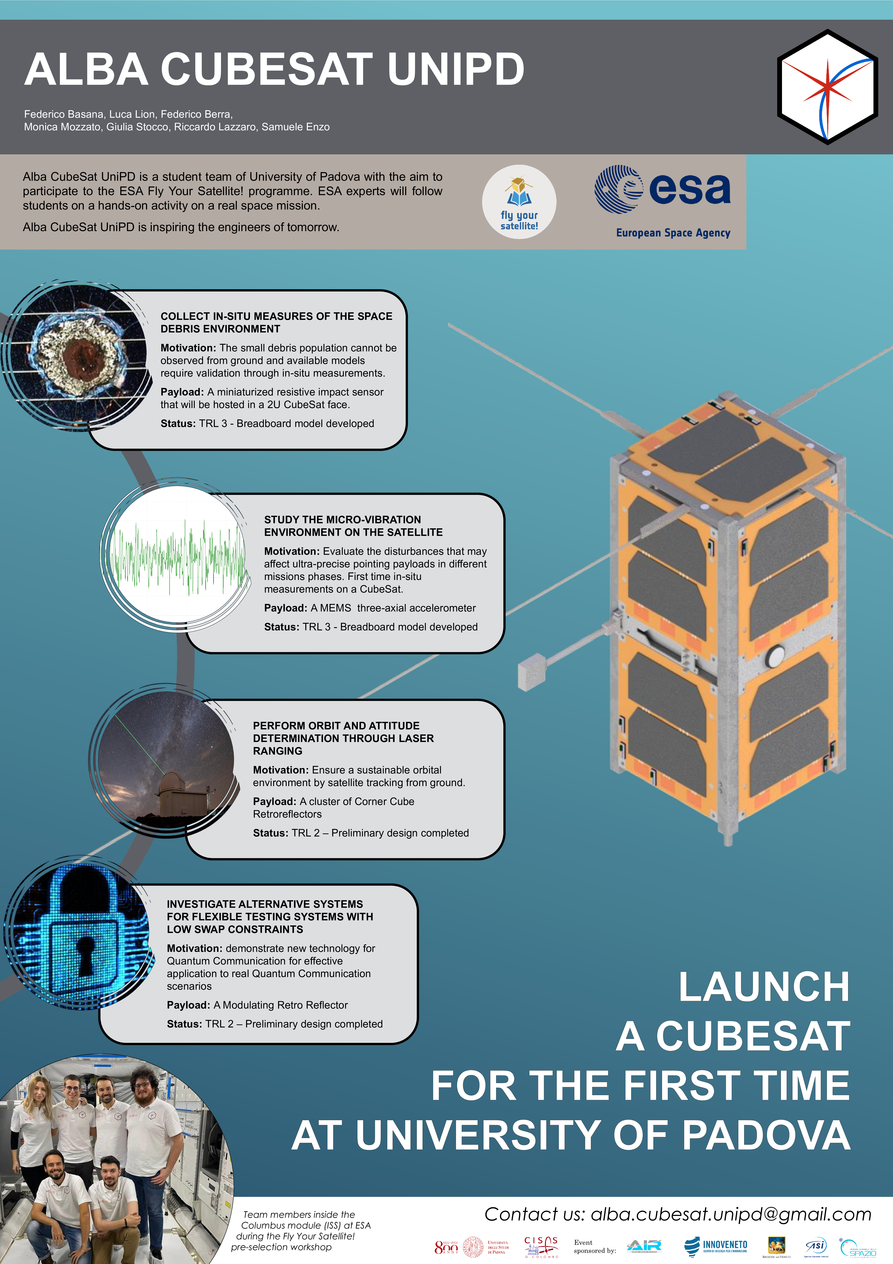

# Appendix B – Facilities images

**Vertical and horizontal thermovacuum chambers**

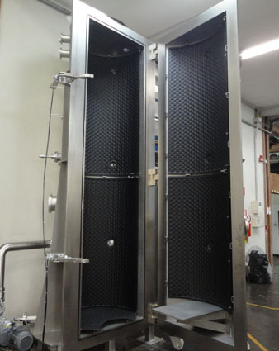

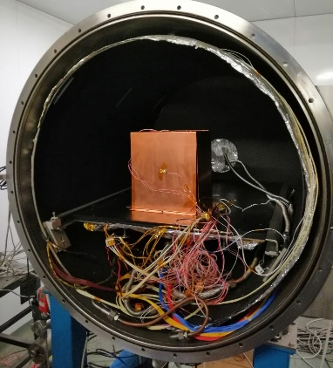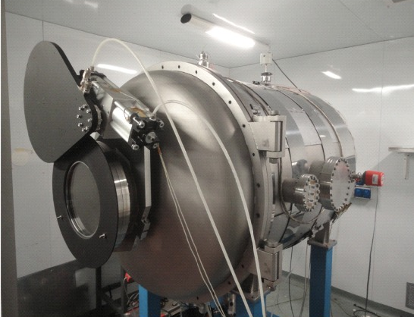

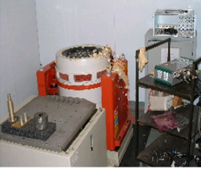**Vibration test bed**

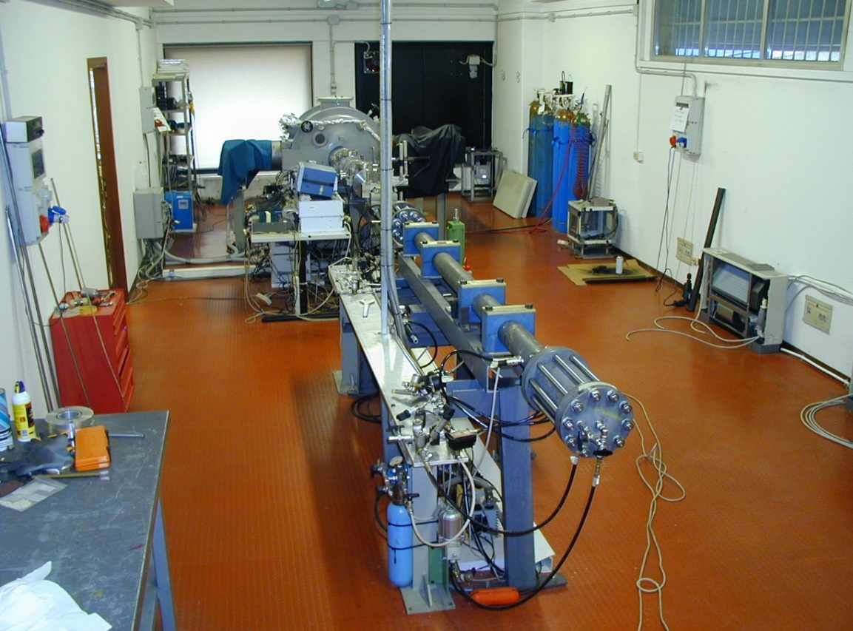**Hypervelocity Impact Facility**

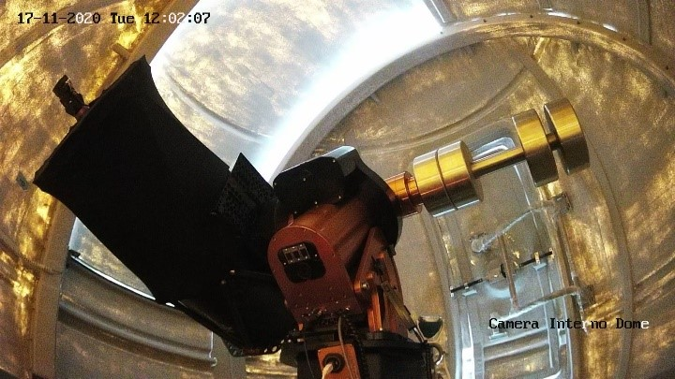**GaliQEye: the German mount**

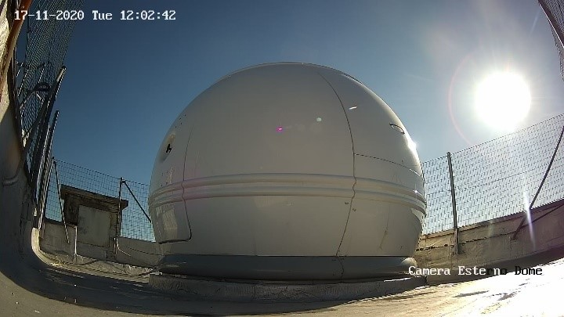 **GaliQEye: external dome on top of the building DEI/G, part of the Department of Information Engineering at University of Padova.**

1. Erdal Karakoç, Orhan Çakır, “Examination of surface roughness values of 6061-T6 aluminum material after machining and after anodizing process”, Materials Today: Proceedings, Volume 80, Part 1, 2023, Pages 32-39
2. Source: https://www.unoosa.org/oosa/en/ourwork/spacelaw/nationalspacelaw/index.html